AGRICOM ASSURANCE
Blog Content & Publication Plan

Prepared by Emem Onuigbo - MA Advertising
Department of Communication, University of Ghana

Purpose: Five SEO-oriented blog articles prepared for Agricom Assurance manager review and approval, with recommended imagery and a proposed publication sequence.

October 2026

Recommended Publication Order
The order below is designed to move the audience from broad awareness and education to practical agricultural solutions, then into long-term financial resilience. It also gives Agricom a coherent content series rather than five disconnected product posts.
1. The Modern Farmer Has More Tools Than Ever—But Which Ones Matter?
Why this position: Launch the series with Agricom’s broader resilience story. It introduces the ecosystem—knowledge, inputs, insurance, data, and financial planning—before the individual solution articles.
2. When the Rain Doesn't Come: Why Agricultural Insurance Matters
Why this position: Move from the broad resilience conversation to one of the most immediate risks farmers face: climate and production uncertainty.
3. Seeds Today, Pay After Harvest: Understanding Input Financing
Why this position: After discussing risk, address a practical production constraint: having the right inputs at the right time. This creates a natural bridge from protection to productivity.
4. What Happens When Your Farm Becomes a Business?
Why this position: Shift from individual products to farm management, profitability, records, cash flow, and risk. This strengthens Agricom’s agribusiness positioning.
5. The Farmer's Greatest Investment May Not Be on the Farm
Why this position: Close the series on the farmer personally, introducing FarmerCare and long-term financial planning. This provides a strong human-interest ending.

Suggested Publishing Rhythm
Recommended cadence: three articles per day for three days consecutively. (Monday 5th to Wednesday 7th October, 2026)

ARTICLE 1

When the Rain Doesn't Come: Why Agricultural Insurance Matters by Emem Onuigbo
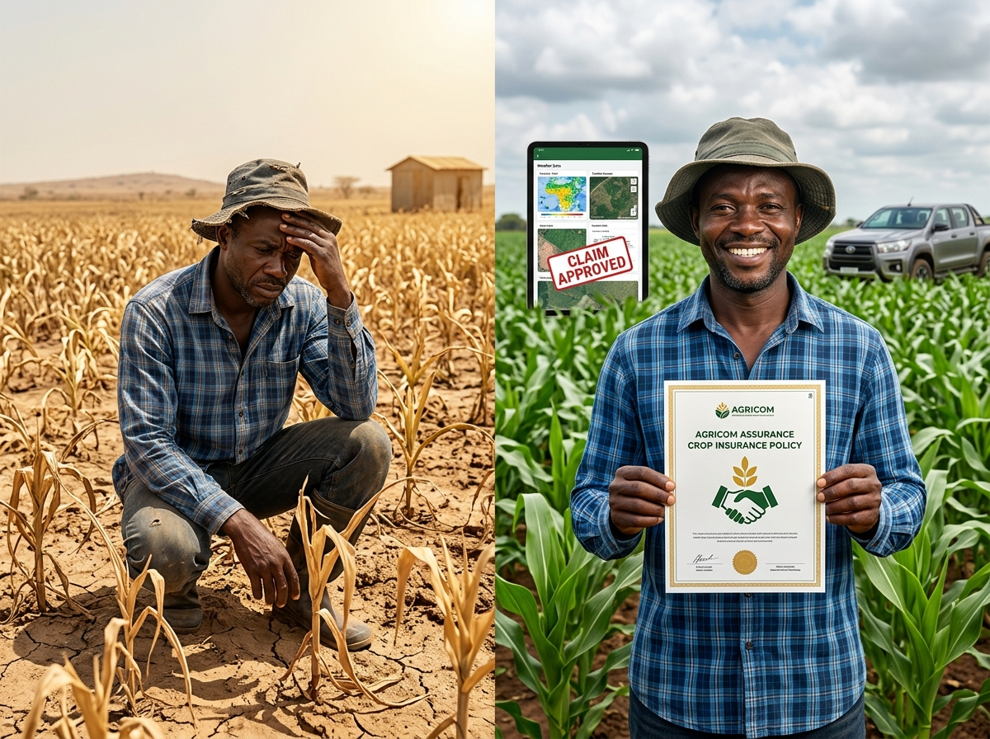
Image: Agricultural Insurance Matters
Primary keyword: agricultural insurance in Ghana
Secondary keywords: crop insurance Ghana; agricultural risk management; climate risk farming; farmer insurance; climate-smart agriculture

When the Rain Doesn't Come
A farmer can do everything right and still lose everything.
The land may be prepared on time. The right seeds may be planted. Fertiliser may be applied. Weeds may be controlled. The farmer may even follow the advice of an extension officer and carefully monitor the crop.
But then the rain does not come. Or it comes too heavily.
A flood washes away the crop. A pest infestation spreads across the field. Excessive rainfall damages a harvest that took months to produce.
This is one of the difficult realities of agriculture: not every risk is within the farmer's control.
And as climate patterns become increasingly unpredictable, managing agricultural risk is becoming just as important as improving productivity.
Farmers understand risk better than most people. For the average farmer, every farming season comes with questions.
Will the rains come on time?
Will there be enough rainfall?
Will pests attack the crops?
Will the market price remain favourable?
Will production costs increase?
Some risks can be reduced through good farming practices, timely information, quality inputs, and proper planning.
But some risks cannot be completely prevented.
That is where agricultural insurance becomes important.
Agricom Assurance's crop insurance offering is designed to protect farms against risks including drought, floods, excessive rainfall, pests, and other climate-related risks. Its approach combines insurance with satellite intelligence, weather data, and digital claims processing.
Instead of relying only on physical inspections, modern agricultural insurance can use weather information, satellite imagery, and other forms of data to monitor conditions.
So, are you a farmer, cooperative, agribusiness, or agricultural organisation looking for ways to better manage agricultural risk?
Explore Agricom Assurance's agricultural insurance solutions and learn how technology-driven protection can help you build greater resilience into your farming operation. (Agricom Assurance)
Protect your farm before the next season.
\#AgricomAssurance #AgriculturalInsurance #CropInsurance #ClimateSmartAgriculture #GhanaAgriculture #Farmers #AgriculturalRisk #ClimateResilience #AgriTech #FarmingInGhana

Recommended CTA for Manager Approval
Explore Agricom Assurance’s agricultural insurance solutions and learn how technology-driven protection can help strengthen your farm’s resilience.
Suggested hashtags: #AgricomAssurance #GhanaAgriculture #Farmers #Agribusiness #ClimateResilience #AgriTech

ARTICLE 2

Seeds Today, Pay After Harvest: Understanding Input Financing by Emem Onuigbo
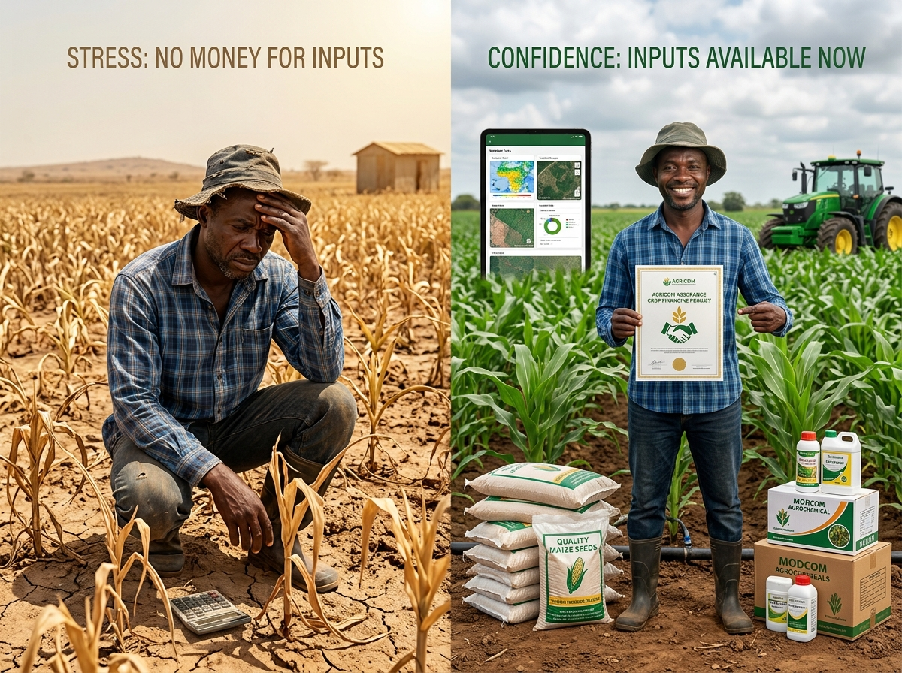
Image: Seeds Today, Pay After Harvest: Understanding Input Financing
Primary keyword: input financing for farmers
Secondary keywords: agricultural finance Ghana; farm financing; farm inputs; pay after harvest; agri-finance

Seeds Today, Pay After Harvest

The problem isn't always the Farm. Sometimes a farmer knows exactly what needs to be done.
The land is ready, the season is approaching, and the farmer knows which inputs are needed.
But there is one problem:
The money is not available yet.
This is one of the challenges of agricultural production.
Farmers often have to buy seeds, fertiliser, agrochemicals, labour, and other inputs before they earn money from the harvest.
In other words, the farmer may need money today to produce the income that will come tomorrow.
Agriculture is a business of timing. Plant too late and the farmer may miss the appropriate planting window. Delay fertiliser application and crop performance can be affected.
Wait too long to control pests and the damage may become more difficult and expensive to manage.
This means that access to inputs is not simply about having money.
It is also about having the right resources at the right time. And this is where input financing can become useful.

So, What Is Input Financing?
Input financing provides farmers with access to essential agricultural inputs when they need them, with repayment structured around the agricultural cycle.
Rather than requiring the farmer to have the full cash amount upfront, financing can help bridge the gap between the beginning of production and the eventual harvest.
Agricom Assurance's input financing solution enables farmers to access seeds, fertilisers, agrochemicals and other essential inputs at the beginning of the season and repay after harvest.
This approach recognises something important about agricultural income:
Farmers do not always earn when they spend.
Consider a typical production cycle. First, the farmer prepares the land, then comes planting.
Inputs are purchased and applied. As the crop grows, the farmer manages pests, weeds, and other challenges.
Finally, the crop is harvested and sold. So, income may come much later than many of the expenses.
This creates a cash-flow gap.
Input financing can help address part of that gap by making essential production resources available when they are required. However, farmers should approach financing carefully, as access to finance should come with responsibility.
Before accepting any financing arrangement, understand:
- How much you are receiving.
- What you are expected to repay.
- When repayment is due.
- What the repayment terms mean.
- What happens if the harvest is delayed or affected.
- Whether the financing matches the scale of your farming operation.
Good financing should support the business rather than create unnecessary pressure.
Agricom's wider solution approach brings together financing, protection, advisory, and data-driven tools to support farmers and agricultural institutions.
This is important because resilience is rarely created by one product alone.
It is built through several good decisions working together.
If access to inputs is one of the challenges affecting your farming operation, explore financing options that are designed around the agricultural cycle.
You cannot harvest what you did not plant—and you cannot plant effectively without the right resources.
So, are you a farmer or agricultural organisation looking for timely access to quality farm inputs?
Explore Agricom Assurance's input financing solution and learn how you can access essential inputs at the beginning of the season and repay after harvest, subject to the applicable terms and eligibility requirements. (Agricom Assurance)
Prepare today. Produce tomorrow.
\#AgricomAssurance #InputFinancing #AgriculturalFinance #FarmFinancing #GhanaFarmers #Agribusiness #FarmInputs #AgricultureGhana #AgriFinance #Farming

Recommended CTA for Manager Approval
Explore Agricom Assurance’s input financing solution and check the applicable eligibility and repayment terms for your farming operation.
Suggested hashtags: #AgricomAssurance #GhanaAgriculture #Farmers #Agribusiness #ClimateResilience #AgriTech

ARTICLE 3

Planting for Tomorrow by Emem Onuigbo

Image: Securing the Future, Pension Aba!
Primary keyword: FarmerCare Ghana
Secondary keywords: farmer pension; retirement planning for farmers; agricultural workers; micro-pension Ghana; financial security

Planting for tomorrow by Emem Onuigbo
When we think about investment in agriculture, we usually think about land, seeds, fertiliser, machinery, livestock, or irrigation.
But there is another investment that is often overlooked: the farmer.
A farmer can spend years investing in the farm, expanding production and providing for a family, but what happens when age begins to slow down the person behind the farm?
Farming is physically demanding. For many farmers, their ability to earn is closely connected to their ability to work. As long as the body is strong, the farm can produce, and income can come in.
But strength does not last forever.
This is why planning for the future should be part of farming today.
Every farmer understands the importance of planning ahead.
You prepare the land before planting. You plant before you harvest. You invest today because you expect a return tomorrow.
Retirement planning works in much the same way.
Small, consistent steps taken during your working years can help you prepare for a time when you may not want—or may no longer be able—to work as hard as you do today.
And retirement planning is not only for people who sit behind office desks.
It is for farmers, traders, agro-processors, extension workers, farmhands, transporters, input dealers, and everyone whose livelihood is connected to agriculture.
Agriculture is a business, and every serious business needs a plan for continuity.
Farmers already plan for bad weather, pests, market prices, and production costs. Financial planning for later life deserves the same attention.
So, the question is not simply, “How much can I make from farming today?”
It is also:
“What am I building for myself when I can no longer farm as I do today?”
That is where pension planning becomes important.
With solutions such as FarmerCare, agricultural workers can begin thinking beyond today's harvest and towards tomorrow's security.
Because after a lifetime of planting for others, you deserve to enjoy your own harvest.
Save today. Retire with dignity.
FarmerCare by Agricom Assurance is designed to help people in Ghana's agricultural value chain prepare financially for retirement.

Recommended CTA for Manager Approval
Explore FarmerCare by Agricom Assurance and learn how flexible pension and protection solutions can support long-term financial security.
Suggested hashtags: #AgricomAssurance #GhanaAgriculture #Farmers #Agribusiness #ClimateResilience #AgriTech

ARTICLE 4

What Happens When Your Farm Becomes a Business? By Emem Onuigbo
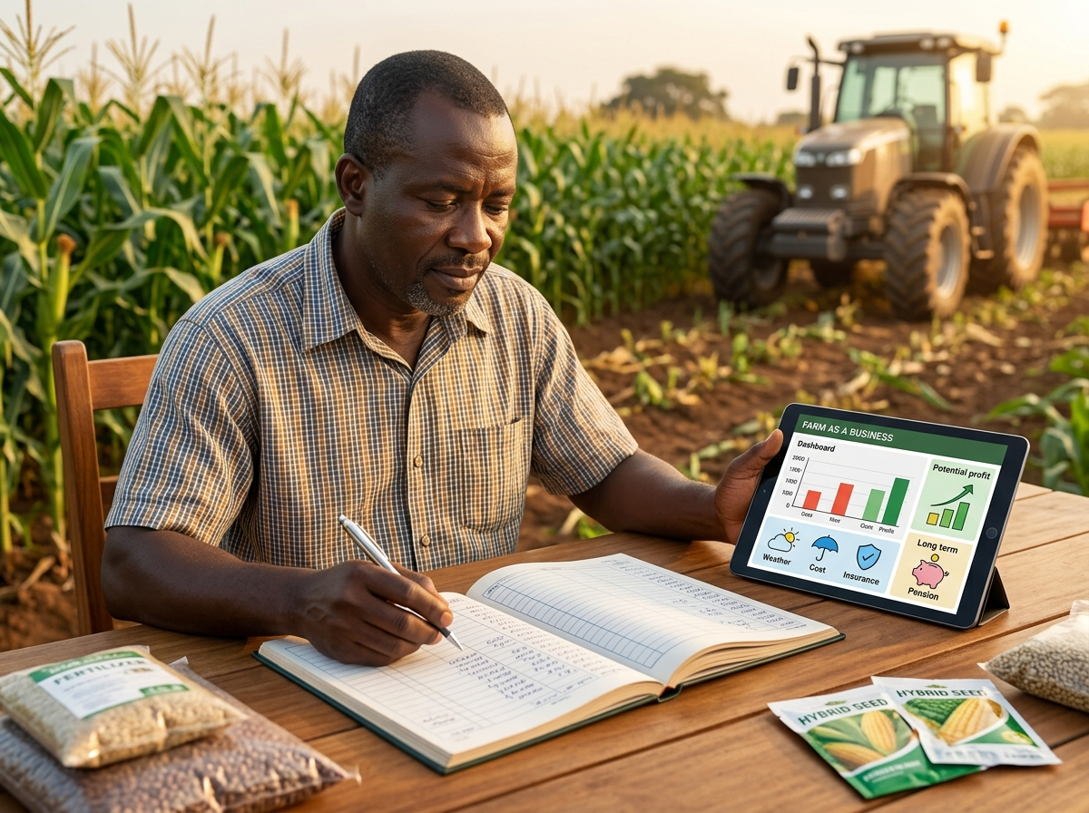Image: When Farming Becomes a Business
Primary keyword: farm business management
Secondary keywords: agribusiness Ghana; farm profitability; farm management; agricultural entrepreneurship; farm finance

Farming is indeed hard work. But Is It a Business? Yes!
Farming requires hard work, early mornings, long days, unpredictable weather, rising input costs, market uncertainty, and sometimes, a harvest that does not turn out as expected.
But there is another side of farming that deserves attention. And that is Management.
A farmer may produce a good harvest and still struggle financially if costs are not properly tracked.
That is why modern farming requires more than production. It requires business thinking.
The traditional question might be: “How much did I harvest?”
An agribusiness-minded farmer asks: “How much did I make?”
There is a difference.
Suppose you harvested 100 bags of maize. This sounds impressive, but how much did you spend on land preparation?
What did the seed cost? How much went into fertiliser? What did you spend on labour, Transportation, Storage, Pest control, and financing? And after all those expenses, what is left?
Understanding the difference between revenue and actual profit is one of the foundations of running a farm as a business.

1. Know Your Numbers
You do not have to be a financial expert to start keeping records.
Record what you spend, what you produce, what you sell, your debts, and your income.
These simple records can help you understand whether your farming operation is growing, stagnating, or losing money.
They can also help you make better decisions before the next season.

2. Think About Cash Flow
Agriculture has a unique cash-flow challenge. Money often goes out before it comes in.
The farmer spends at planting and production stages and may only receive significant income at harvest.
This means cash-flow planning matters.
If you spend everything from one harvest immediately, what will finance the next production cycle?
If you borrow, when will repayment be due? If input prices increase, how will that affect your production plan?
These are business questions that the farmer must answer to build and maintain a successful agricultural enterprise.

3. Manage Risk
A good business does not only ask how to make money.
It also asks: What could make me lose money?
For farmers, risks can include drought, floods, excessive rainfall, pests, disease, and other production challenges.
Agricultural insurance can form part of a broader risk-management strategy.
Agricom's agricultural insurance solutions are designed to protect against several climate and production risks, while its technology approach uses weather and satellite information to support monitoring.
The point is not to assume that something will go wrong. Rather, It is to prepare for uncertainty.

4. Use the Right Inputs at the Right Time
Productivity depends on many factors, including access to appropriate inputs.
But inputs also require cash. This is where financing can become part of farm management.
Agricom's Input Financing solution is designed to help eligible farmers access essential inputs at the beginning of the season and repay after harvest.
For farmers, the bigger lesson is this: Finance should support production, not simply consumption.
When financing is used strategically, it can help a farm maintain its production cycle.

5. Think Beyond One Harvest
A successful farm should not only survive one season. It should build towards the next one.
That means thinking about reinvestment. It also means thinking about the farmer.
What happens when the farmer becomes older? What happens if the farmer can no longer work at the same pace? What happens to the income-generating capacity of the farm?
Long-term financial planning, including retirement savings, should therefore be part of the conversation.
FarmerCare, Agricom's flexible micro-pension and protection solution, is designed for farmers and informal-sector workers seeking to build long-term financial security.
So, whether you are a smallholder farmer, agribusiness owner, or agricultural entrepreneur, building a resilient farm begins with good decisions.
Remember, Your farm is a business. Plan it like one. (Agricom Assurance)
\#AgricomAssurance #Agribusiness #FarmBusiness #FarmManagement #AgriculturalEntrepreneurship #FarmProfitability #GhanaAgriculture #Farmers #AgriculturalFinance #AgriBusiness

Recommended CTA for Manager Approval
Explore Agricom Assurance’s integrated solutions for insurance, financing, data and long-term financial resilience.
Suggested hashtags: #AgricomAssurance #GhanaAgriculture #Farmers #Agribusiness #ClimateResilience #AgriTech

ARTICLE 5

The Modern Farmer Has More Tools Than Ever—But Which Ones Matter? By Emem Onuigbo
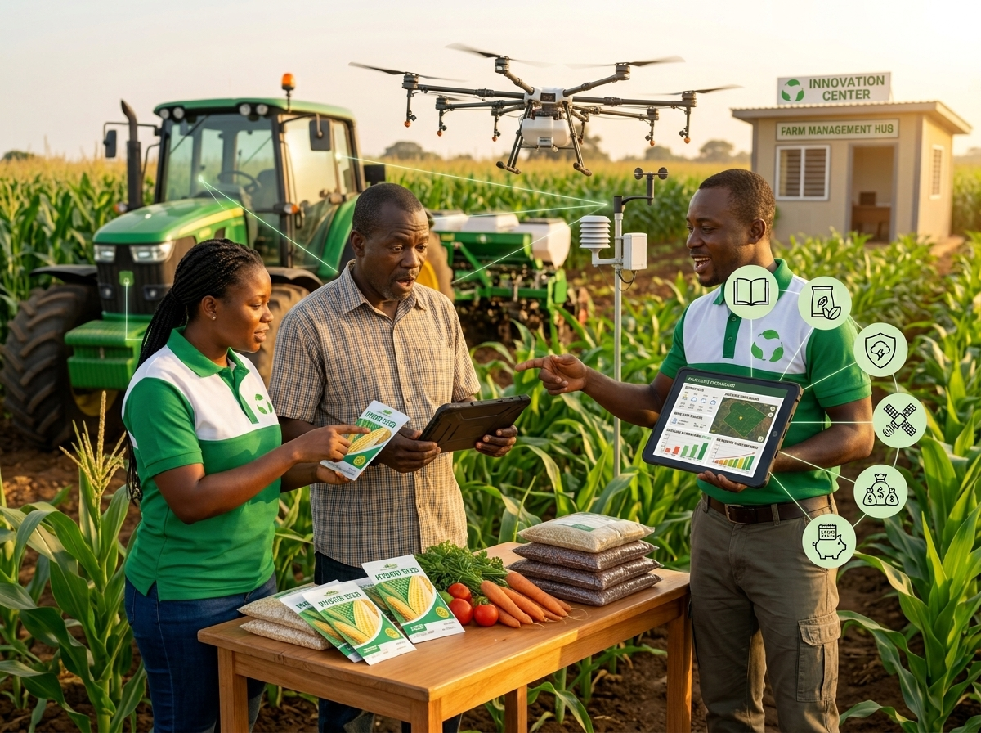
Image: An Integrated Ecosystem for Agricultural Resilience
Primary keyword: resilient agriculture Ghana
Secondary keywords: agricultural technology; crop insurance; input financing; climate intelligence; FarmerCare; digital agriculture

Agriculture is changing; the image of the farmer is changing.
The farmer of today may still wake up before sunrise and work the land, but they are increasingly connected to a much larger world.
A mobile phone can provide information.
Digital platforms can connect farmers to services.
Satellite technology can provide information about farms and weather.
Financial products can help farmers manage production costs and protect their livelihoods.
And pension solutions can help farmers think beyond their productive years.
The modern farmer therefore needs more than a good harvest. They need resilience.
Here are six tools that can help.

1. Agricultural Information: The first tool is knowledge.
Knowing when to plant, how to manage pests, which inputs are appropriate, and how weather conditions may affect production can make a difference.
This is where extension officers, agronomists, researchers, and agricultural organisations remain important. Technology may change the way information is delivered, but good agricultural knowledge remains essential.

2. Quality Inputs: Good production begins with the right resources.
Seeds, fertilisers, agrochemicals and other inputs are important parts of the production process.
But access can be a challenge when farmers have to pay upfront before earning income from the harvest. Input financing can help address this timing challenge.
Agricom's solution allows eligible farmers to access essential inputs at the beginning of the season and repay after harvest, according to the applicable financing terms.

3. Agricultural Insurance: The farmer can control many things but not everything.
Weather conditions can change, floods can occur, drought can affect production, and pests can damage crops.
This is why agricultural insurance matters.
Agricom's crop insurance offering is designed to protect farms against risks including drought, floods, excessive rainfall, and pests. It helps farmers prepare for the financial consequences.

4. Data and Technology: Farmers and agricultural organisations increasingly have access to technologies that can support better decision-making.

These technologies include satellite imagery, GPS mapping, weather data, digital farmer profiles, and analytics.
These tools can help stakeholders understand agricultural conditions and manage farms and farmers more efficiently.
Agricom's Climate Intelligence Infrastructure brings several of these capabilities together for insurers, agribusinesses, governments, NGOs, cooperatives, and financial institutions.

5. Financial Planning: A farm can generate income, but income alone does not guarantee financial security.

Farmers need to think about how they manage what they earn.
They need to know what portion of their income goes back into production, what portion covers household needs, what portion is saved, and what happens when income falls.
Financial planning helps farmers think beyond today's expenses and tomorrow's harvest.

6. Retirement Planning: Here is a question farmers do not ask often enough -
What happens when I no longer want to or cannot afford to work as hard as I do today?
For someone whose livelihood depends heavily on physical work, this is an important question.
FarmerCare is Agricom's flexible micro-pension and protection solution designed for farmers and informal-sector workers.
The idea is simple: start preparing for the future while you are still earning.
Because retirement planning is not about stopping work.
It is about making sure your financial security does not stop when your active working years change.
Furthermore, these six tools are not separate ideas. They are connected.
Good information can improve production decisions.
The right inputs can support productivity.
Financing can help farmers access those inputs.
Insurance can help manage agricultural risks.
Data can improve decision-making. And long-term financial planning can help protect the farmer beyond the current season.
This is the thinking behind integrated agricultural solutions.
Agricom Assurance positions its work around protecting farms, empowering farmers, digitising agriculture, and building financial resilience.
Whether you are a farmer, cooperative, agribusiness, extension professional, financial institution, or development organisation, building a resilient agricultural sector requires connected solutions.
Click (Agricom Assurance) to view more on Agricom Assurance's solutions for insurance, input financing, climate intelligence, digital agriculture, and long-term financial security.
Protect your farm. Empower your future. Build resilience.
Agricom’s website positions its solutions around exactly this broader ecosystem: crop insurance, FarmerCare MicroPensions, climate intelligence infrastructure and input financing, alongside data-driven insights, satellite services and integrated finance/advisory/protection. (Agricom Assurance)
\#AgricomAssurance #ModernFarming #ResilientAgriculture #GhanaAgriculture #AgriTech #CropInsurance #InputFinancing #ClimateIntelligence #FarmerCare #DigitalAgriculture #Agribusiness

Recommended CTA for Manager Approval
Explore Agricom Assurance’s solutions for insurance, input financing, climate intelligence, digital agriculture, and long-term financial security.
Suggested hashtags: #AgricomAssurance #GhanaAgriculture #Farmers #Agribusiness #ClimateResilience #AgriTech

