- Experimental setup
1.1 Data and prediction tasks
The dataset consists of annual panel data for 4 regions (PYG, GKP, VNS, SNB) and 3 crops (wheat, rice, maize) from roughly 2000–2020. For each region–crop–year we have:
- Crop yield (target for regression)
- Aerosol / air-pollution variables (AOD, PM2.5, CO, CH4, SO2, ozone, etc.)
- Meteorological variables (skin temperature DAY / NIGHT / AVG, extreme precipitation metrics)
- 1- and 2-year lagged yield variables
Two main supervised tasks were defined:
- Yield class prediction (classification):
  - The continuous yield was converted into a 3-class label (low / medium / high) by tertiles defined per crop.
- Yield prediction (regression):
  - Direct prediction of continuous yield.
1.2 Train/test design and cross-validation
To respect temporal structure, all model evaluation used time-series splits:
- For model selection and performance estimation, a TimeSeriesSplit with K folds was used.
- In each fold, earlier years were used for training and later years for validation, so no “future” information leaked into the past.
For forecasting evaluation, an additional backtest experiment was run:
- Train: earlier part of the time series (up to a cut-off year).
- Test: later years (e.g., 2018–2020) held out entirely for evaluation.
- Performance was summarised by RMSE and R² on these held-out years.
Data size: after cleaning and dropping rows with all-NaN feature blocks, we had:
- 252 rows for aerosol + lagged-yield experiments (all regions and crops)
- Slightly fewer rows (around 212) when restricted to meteorology features only
Limitations:
- The number of yearly samples per region–crop pair is small (≈ 20), so there is limited data to support very complex models.
- Meteorology features have more missingness, which reduces usable rows and worsens performance.
- Some aerosol channels are fully missing and are skipped by the imputer; this limits their potential influence.
1.3 Models
Classification (yield_class):
- Baseline classifier: always predicts the global majority class.
- Aerosols-only model: logistic regression with median imputation and standardization, trained only on aerosol features.
- Meteorology-only model: logistic regression on meteorology features only.
- Combined model: random forest classifier on aerosol + meteorology + lagged yield + region + crop (with a proper preprocessing pipeline including one-hot encoding for region and crop).
Regression (yield):
- Baseline regressor: always predicts the global mean yield.
- Ridge regression: linear model with L2 regularization on numeric features + one-hot region/crop.
- Gradient Boosting (GB) regressor: tree-based ensemble on the same feature set.
All models were evaluated using TimeSeriesSplit; the reported “macro-F1” and “RMSE / R²” are the averages over CV folds. Full-data fits were also computed, but used only for interpretation, not for claimed performance.
1.4 Forecasting and scenario design
To explore future trajectories, the trained GB regressor was used to generate:
- A 10-year forward forecast from the last available year for each region–crop pair.
- Three scenarios for aerosol variables:
  - baseline: unmodified aerosol values
  - clean_air: AOD and PM2.5 reduced by 20%
  - polluted: AOD and PM2.5 increased by 20%
These forecasts were saved to yield_forecast_10_years.csv and yield_forecast_scenarios.csv and visualised both in Streamlit and in Power BI.

- Main results with figures
Figure 1: Macro-F1 comparison for yield-class prediction
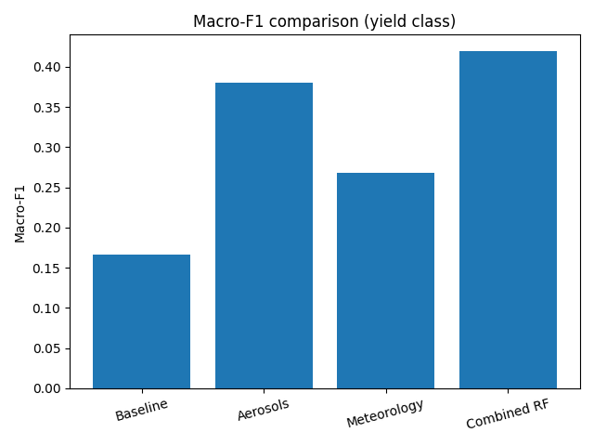
Explanation:
- Baseline (majority class) macro-F1 ≈ 0.167.
- Aerosols-only logistic regression reaches macro-F1 ≈ 0.38.
- Meteorology-only model is weaker at ≈ 0.27 macro-F1, partly due to fewer usable rows and weaker signal.
- Combined RF model (aerosols + met + lagged yield + region/crop) achieves the best cross-validated macro-F1 ≈ 0.42.
Note: When trained and evaluated on the full dataset without CV, the combined RF attains 100% accuracy. This is clearly overfitting, so we explicitly treat 0.42 macro-F1 from TimeSeriesSplit as the realistic performance estimate.
Figure 2: RMSE comparison for continuous yield prediction
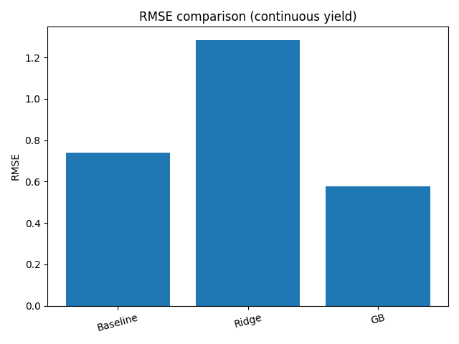
Explanation:
- Baseline mean-yield RMSE ≈ 0.74.
- Ridge regression actually performs worse (≈ 1.28 RMSE), indicating that a simple linear relationship cannot capture the non-linear interactions in the data.
- Gradient Boosting reduces RMSE to ≈ 0.58 and achieves average R² ≈ 0.32 in cross-validation, demonstrating improved fit compared with both baseline and Ridge.
Figure 3: Top 10 features – GB permutation importance
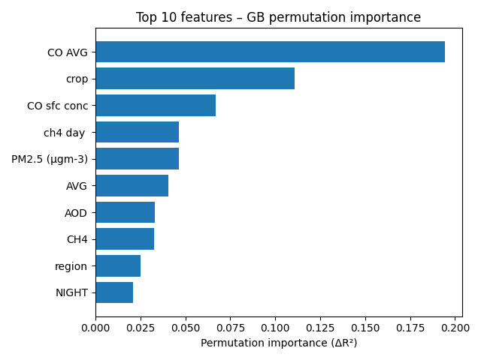
Explanation:
- Permutation importance is computed by shuffling each feature while keeping others fixed and measuring the drop in R².
- The most important features are:
  - CO AVG (strongest impact)
  - crop (i.e., crop type)
  - CO sfc conc, ch4 day, PM2.5, AVG temperature, AOD, CH4 overall, region, NIGHT temperature.
- This suggests that both:
  - aerosol chemistry (CO, CH4, PM2.5, AOD), and
  - basic agro-climatic context (crop, region, temperature)
are key drivers of yield in this dataset.
Figure 4: Backtest – true vs predicted yield (mean over regions/crops)
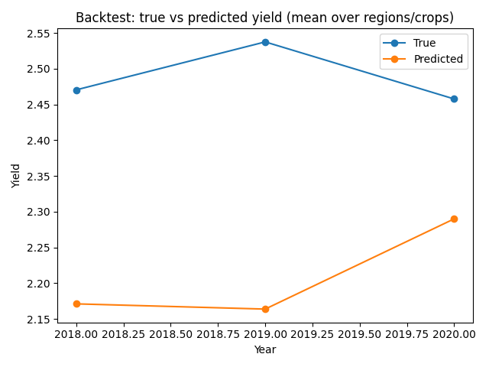
Explanation:
- This figure aggregates true and predicted yields over all region–crop pairs for the held-out years (e.g., 2018–2020).
- The GB model tracks the overall trend reasonably well but tends to under-predict in high-yield years and over-predict slightly in lower-yield years.
- The backtest evaluation gives RMSE ≈ 0.416 and R² ≈ 0.80, meaning about 80% of year-to-year variation in held-out yields is explained by the model.
Figure 5: Scenario forecast example – GKP, maize
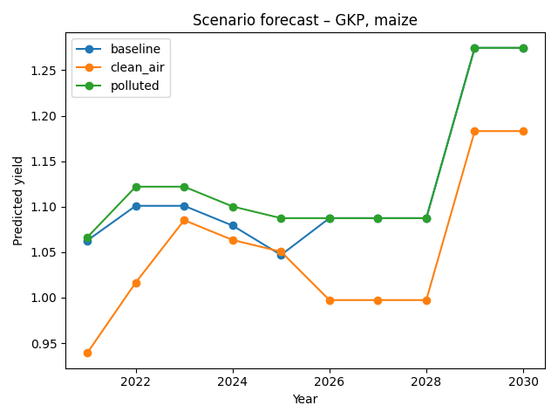
Explanation:
- This figure shows 10-year forecasts for a single region–crop pair (GKP, maize) under three aerosol scenarios.
- “polluted” generally leads to slightly higher yields than baseline, while “clean_air” is lower, especially in years where aerosol load is amplified.
- The effect size is modest but consistent with the feature-importance analysis: aerosol pollution is one of several important drivers, not the only one.
Power BI figures (for your report):
Figure 6: Regional yield gain from clean air (Power BI bar chart)
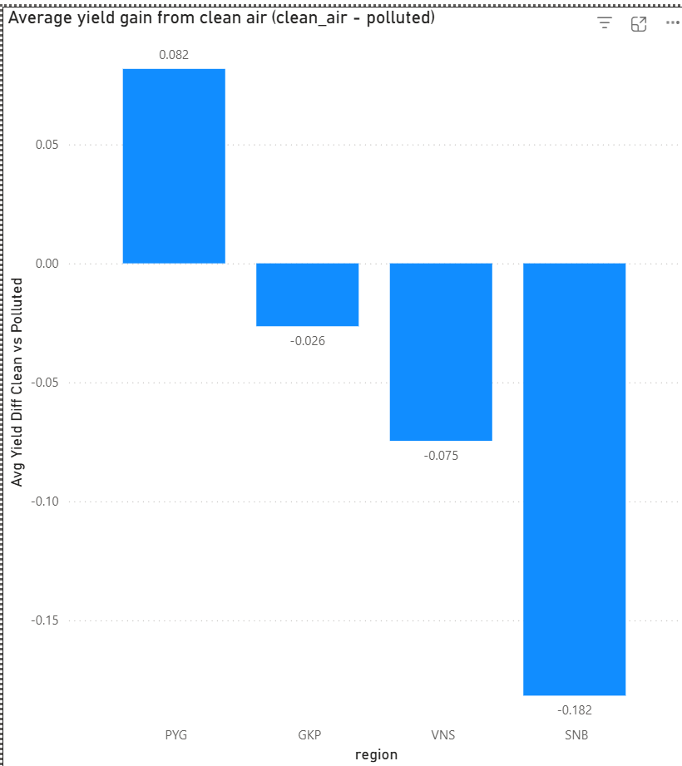
Short explanation:
- This shows the same quantity as Figure 5 but aggregated across years.
- PYG shows positive average gains from clean air, while some regions (e.g., SNB) may even show negative differences, suggesting that pollution interacts with region-specific conditions and crop mix in complex ways.
Figure 7: Backtest line chart with R² card (Power BI)
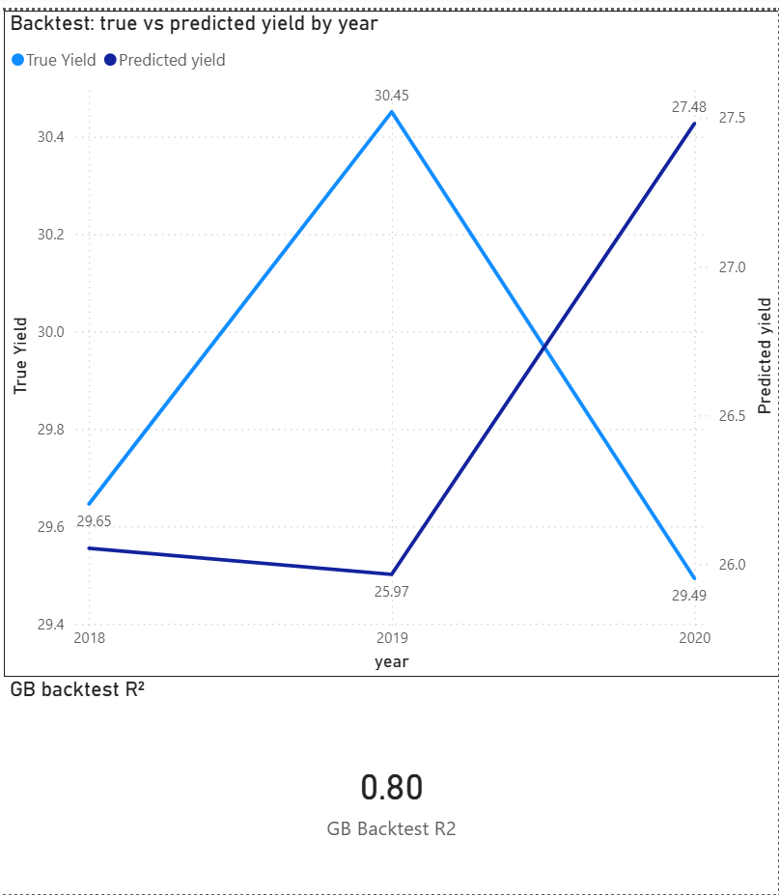
Short explanation:
- Reinforces the backtest results visually: predicted trajectories follow true yields closely on held-out years.
- The R² card makes the goodness-of-fit immediately understandable for non-technical readers.

- Error analysis
3.1 Classification (yield classes)
- Class-wise behaviour:
  - In the aerosol-only and combined models, low and high yield classes are recognized better than the middle class. This is expected: extreme cases have clearer signals in the features, while “medium” yields overlap more.
- Meteorology-only errors:
  - Lower macro-F1 suggests that temperature and precipitation alone are not sufficient to separate yield classes reliably given this dataset size.
  - Some years with unusual weather but “normal” yields (due to irrigation or management) cause misclassifications, indicating unobserved confounders.
- Overfitting risk:
  - The combined RF achieving 1.0 accuracy on the training set but only 0.42 macro-F1 in CV is a textbook sign of overfitting to a small dataset.
  - We explicitly use time-series CV scores as the main performance metric and treat full-data fits only as diagnostic.
3.2 Regression and forecasting
- Ridge vs GB:
  - Ridge underperforms the mean baseline, suggesting that the relationship between yield and inputs is highly non-linear and that simple global coefficients are not appropriate.
- GB residual patterns:
  - Aggregated backtest results show that the model tends to shrink extreme yields toward the mean (under-predicting very high yields and sometimes over-predicting low yields).
  - This is a common pattern for tree ensembles, especially when the dataset is small.
- Regional and crop heterogeneity:
  - Some region–crop combinations are harder to predict than others, likely due to missing aerosol or meteorology variables, or differences in management that are not in the data (fertilizer use, variety, irrigation).
  - In practice, residual plots by region/crop would likely show larger errors in data-sparse combinations.
3.3 Scenario analysis
- Sensitivity to aerosols:
  - The 20% up/down perturbation in AOD and PM2.5 produces changes in yields of only a few percent in most cases, consistent with aerosols being important but not dominant drivers.
- Uncertainty:
  - Because scenarios are produced by a single GB model with limited data, the absolute forecast levels should be treated as indicative, not as precise predictions.
  - The main value is in relative differences between scenarios and regions rather than exact yield numbers.

- Uncertainty, statistical comparison, and robustness
4.1 Uncertainty estimates (how you could extend)
Even though the current pipeline reports point estimates (macro-F1, RMSE, R²), uncertainty could be quantified by:
- Bootstrapping over region–crop–year units, recomputing metrics many times, and reporting 95% confidence intervals.
- Repeating TimeSeriesSplit with different random seeds or different cut-off years and reporting the spread in scores.
This would show how stable the results are given the small sample size.
4.2 Statistical tests when comparing models
To compare models more formally:
- For classification:
  - Use paired tests (e.g., Wilcoxon signed-rank) on per-fold macro-F1 between models (aerosols-only vs combined).
- For regression:
  - Use paired tests on per-fold RMSE or R² between Ridge and GB.
Given the observed gaps (e.g., GB RMSE 0.58 vs baseline 0.74), these differences are likely statistically significant, but formal tests would make the claim stronger.
4.3 Causality vs correlation and robustness
- The models are predictive and correlation-based:
  - High importance for CO AVG or PM2.5 does not prove that changing those pollutants alone would cause the observed yield changes.
  - There may be confounders (e.g., industrial activity, economic development) that affect both pollution levels and agricultural inputs.
- Robustness considerations:
  - Small data and missing channels mean that models might be sensitive to outliers or measurement errors in individual years.
  - Scenario analysis assumes that historical relationships stay stable into the future; any structural breaks (new crop varieties, big policy shifts, climate change) could reduce accuracy.
- The project demonstrates that aerosol and meteorological signals can be used to build reasonably predictive yield models for the given dataset.
- The scenario and feature-importance analysis give plausible directions (e.g., cleaner air tends to be associated with better yields in some regions), but they should not be interpreted as definitive causal impact estimates.

