
SCHOOL OF COMPUTER APPLICATIONS
LOVELY PROFESSIONAL UNIVERSITY
PROJECT REPORT
ToolPool: Social Tool Sharing Platform
Submitted by:
Student Name | Registration No.
Agrim Jain | 12502316
Anjana Rajbhar | 12521413
Divansh Sharma | 12527898
Tamnya | 12501938
Vipul Yadav | 12501793
Deployed Project Link: https://toolpool.onrender.com/
Project Guide: Mr. Bharath Reddy
Course Code: SCAS002
Institution Name: Lovely Professional University

S.no. | Table of Contents | Page No.
1. | Abstract | 3
2. | Introduction | 4
3. | Objectives | 4
4. | System Architecture | 5
5. | Technologies Used | 6
6. | Frontend Structure | 7
7. | Backend Structure | 8
8. | Database Design | 9
9. | API Documentation | 10-12
10. | Application Screenshots | 13-14
11. | Real-Time features and practical use | 15
12. | Advantages, limitations and what’s next | 16
13. | Conclusion | 17
INDEX

ABSTRACT
Most of us own tools we barely use — a drill that comes out twice a year, a ladder that sits in the storeroom, a lawn mower nobody touches after the first month. ToolPool was our attempt at solving that in a small, practical way: a full-stack MERN web app where people in the same neighbourhood can list tools they own and borrow tools their neighbours own, instead of everyone buying their own copy of everything.
The app covers the whole loop — signing up, listing a tool, sending a borrow request, the owner approving or rejecting it, chatting once the request is approved, marking the tool as returned, and leaving a review afterward. Under the hood it's a Node.js/Express backend with MongoDB, and a React + Vite frontend. We didn't use any backend-as-a-service platform — every one of the 48 API routes in this project is something we wrote ourselves, split across 9 route files. The live chat between borrower and lender uses Server-Sent Events (SSE) so messages show up instantly without refreshing the page.
In short, the project focuses on:
- Letting people share tools instead of buying duplicates
- A proper request lifecycle (pending → approved/rejected → returned)
- Role-based access for customers, tool owners and admins
- Real-time chat that only unlocks once a request is approved

1. INTRODUCTION
The idea behind ToolPool came from a pretty common situation — needing a tool for a one-off job (like a drill to hang a shelf, or a pressure washer to clean a driveway once a year) and either buying it and never using it again, or just not doing the task at all. At the same time, someone two houses down probably already owns that exact tool and would happily lend it if there was an easy, trustworthy way to ask.
It isn't a general marketplace like OLX, and it isn't a rental business either — it's meant to work at the scale of one housing society, one street, or one campus, where people already have some baseline trust in each other. The problems we were trying to solve:
- Tools sit unused most of the year after a one-time purchase
- There's no simple way to track who borrowed what, or when it's due back
- Communication between borrower and owner is usually just a random WhatsApp message with no record
Our approach was to treat every tool as structured data rather than a casual listing — tied to an owner, a category, a price, and an availability flag — and to build a proper request workflow around it so both sides always know exactly where things stand.

2. OBJECTIVES

2.1 What we set out to build
- A single place to list and discover tools that neighbours can borrow
- Secure login/registration with hashed passwords and server-side sessions
- A way for owners to add, edit and manage their own tool listings
- A clear borrow-request flow: request → approve/reject → return
- Direct messaging between borrower and lender once a request is approved
- Reviews and favourites, so trust builds up over repeated use

2.2 Things that mattered for the build itself
- Keeping the database schema normalized (no duplicated data across collections)
- Writing every API route ourselves instead of relying on an auto-generated backend
- Splitting the Express backend into small, per-feature route files
- Using SSE for live chat instead of pulling in an external real-time service
- Enforcing role checks (customer / owner / admin) at the middleware level

3. SYSTEM ARCHITECTURE
ToolPool is a standard three-tier MERN setup: a React (Vite) frontend, an Express REST API in the middle, and MongoDB at the bottom, connected through Mongoose. There's no managed backend service doing the heavy lifting here — the whole API layer, all 48 routes across 9 modules, is written by hand.
Roughly, it breaks down into four layers:
- Presentation — the React app, which renders the UI and talks to the backend through a single api.js helper file
- API layer — 9 Express route files, one per resource (auth, users, tools, requests, favorites, reviews, messages, notifications, admin)
- Middleware / services — session auth, role checks, the SSE engine for chat, and notification logic
- Data layer — 8 MongoDB collections accessed through Mongoose models
A typical flow looks like this: a user logs in, the server checks the hashed password and creates a session; the frontend then uses that session for every protected call, like fetching tools or sending a borrow request. Once an owner approves a request, an SSE connection opens up for that specific request and chat messages start flowing live between the two people involved.
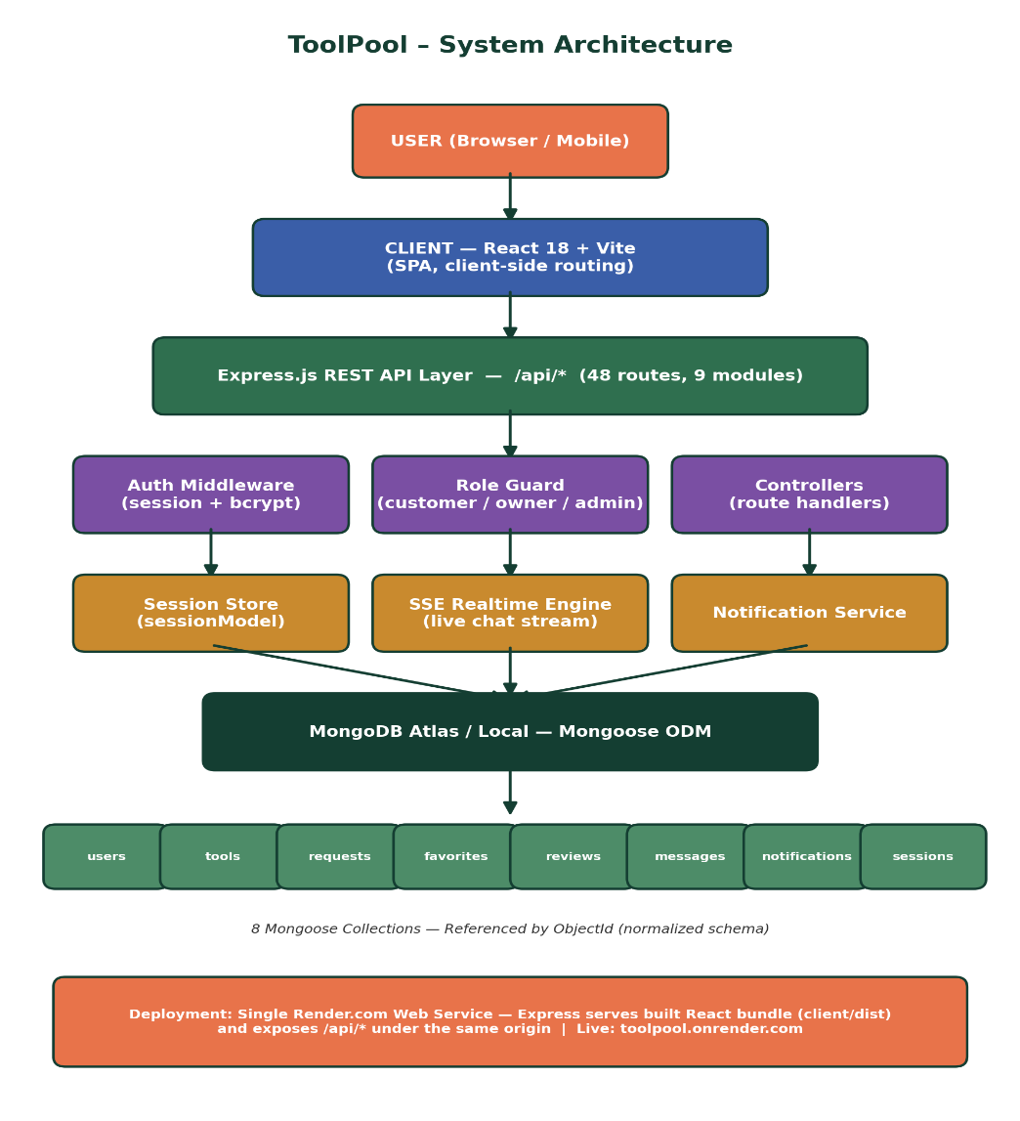
Fig. 1 — How the pieces fit together: client, API layer, middleware, and the MongoDB data layer.

4. TECHNOLOGIES USED
We stuck to the MERN stack for this — it kept the data format consistent (JSON) all the way from the database to the screen, and it's what we were most comfortable building in for a college-timeline project.

4.1 Database — MongoDB & Mongoose
MongoDB stores everything as documents, which suited a project where the schema kept evolving as we added features. Mongoose sits on top of it to enforce structure and validation, and to manage references (ObjectIds) between collections. Locally we run it at mongodb://127.0.0.1:27017/toolpool; in production it's backed by MongoDB Atlas.

4.2 Backend — Node.js & Express.js
Express 4.19 handles all the routing. Every route is grouped by feature into its own file under server/routes, with a shared middleware/auth.js handling session checks and role-based permissions. CORS is set up so the client can talk to the API cleanly.

4.3 Frontend — React 18 & Vite
The UI is broken into about a dozen components — landing page, auth page, browse page, tool cards, modals for adding a tool or requesting one, a lender dashboard, a chat modal, and an admin page. Vite gives a fast dev server and builds an optimized bundle for production.

4.4 Auth & Security
Passwords are hashed with bcryptjs before they ever touch the database. We built our own session model instead of pulling in an auth-as-a-service tool, and every sensitive route checks the caller's role before doing anything.

4.5 Real-time layer
Chat updates are pushed using Server-Sent Events — a single persistent connection from server to browser. It's a much lighter option than setting up Socket.io for something as simple as one-way message pushes, and it's built directly into Express.

4.6 Deployment
The whole thing runs as one Render.com web service. The build step compiles the React app and Express serves both the static frontend and the /api/* routes from the same origin, which sidesteps a lot of CORS headaches in production. Live at toolpool.onrender.com.

5. FRONTEND STRUCTURE
Everything frontend-related lives inside client/src. App.jsx handles routing and top-level state; each screen is its own component:
Component | What it's for
LandingPage.jsx | The public homepage — headline, hero image, get started/explore buttons
AuthPage.jsx | Combined login and register screen
Header.jsx | Top nav bar; changes based on whether you're logged in
BrowsePage.jsx | Search, filter and browse tools
ToolCard.jsx | The reusable card for one tool in a list
AddToolModal.jsx | Form for listing a new tool
BorrowModal.jsx | Form for sending a borrow request
LenderPage.jsx | Owner's dashboard for managing requests on their tools
MyRequestsPage.jsx | Borrower's dashboard for tracking their own requests
ChatModal.jsx | The live chat window (SSE) for an approved request
ProfilePage.jsx | Profile info and favourites
AdminPage.jsx | Admin stats and moderation tools

api.js keeps every fetch call in one place so components never hard-code an endpoint URL directly; data.js just holds the static category list, and styles.css has the whole design system in it.

6. BACKEND STRUCTURE
The server/ folder is split by feature, each route file backed by its own Mongoose model:
File / Folder | What it's for
server.js | Express entry point, mounts every route module
db.js | Connects to MongoDB via Mongoose
middleware/auth.js | Session checks + role checks (customer / owner / admin)
routes/authRoutes.js | 5 routes — register, login, me, logout, change password
routes/userRoutes.js | 7 routes — admin-only user management
routes/toolRoutes.js | 10 routes — listing, browsing, filters, availability
routes/requestRoutes.js | 10 routes — the full borrow-request lifecycle
routes/favoriteRoutes.js | 3 routes — add / remove / list favourites
routes/reviewRoutes.js | 3 routes — post / list / delete reviews
routes/messageRoutes.js | 4 routes — chat history, inbox, and the SSE stream
routes/notificationRoutes.js | 2 routes — list and mark-as-read
routes/adminRoutes.js | 2 routes — platform stats and sample-data reset
models/*.js | 8 schemas: user, tool, request, favorite, review, message, notification, session

7. DATABASE DESIGN
MongoDB doesn't force a rigid schema the way a SQL database would, but we still designed it to behave like one — references between collections instead of copy-pasting data everywhere. Every relationship is a stored ObjectId, not a duplicated field.
Collection | What it stores
users | Name, email (unique), password hash, role, contact info
tools | Owner reference, title, category, price/day, availability flag
requests | Tool reference, borrower, lender, date range, status
favorites | Which tools a user has bookmarked
reviews | Ratings and comments tied to a tool
messages | Chat messages tied to one approved request
notifications | System alerts for a user, e.g. 'request approved'
sessions | Active login sessions used for auth

The main relationships are: users ↔ tools through the owner field, tools ↔ requests through toolId, and requests ↔ messages through requestId. Favourites, reviews, notifications and sessions all hang off a userName reference back to users.
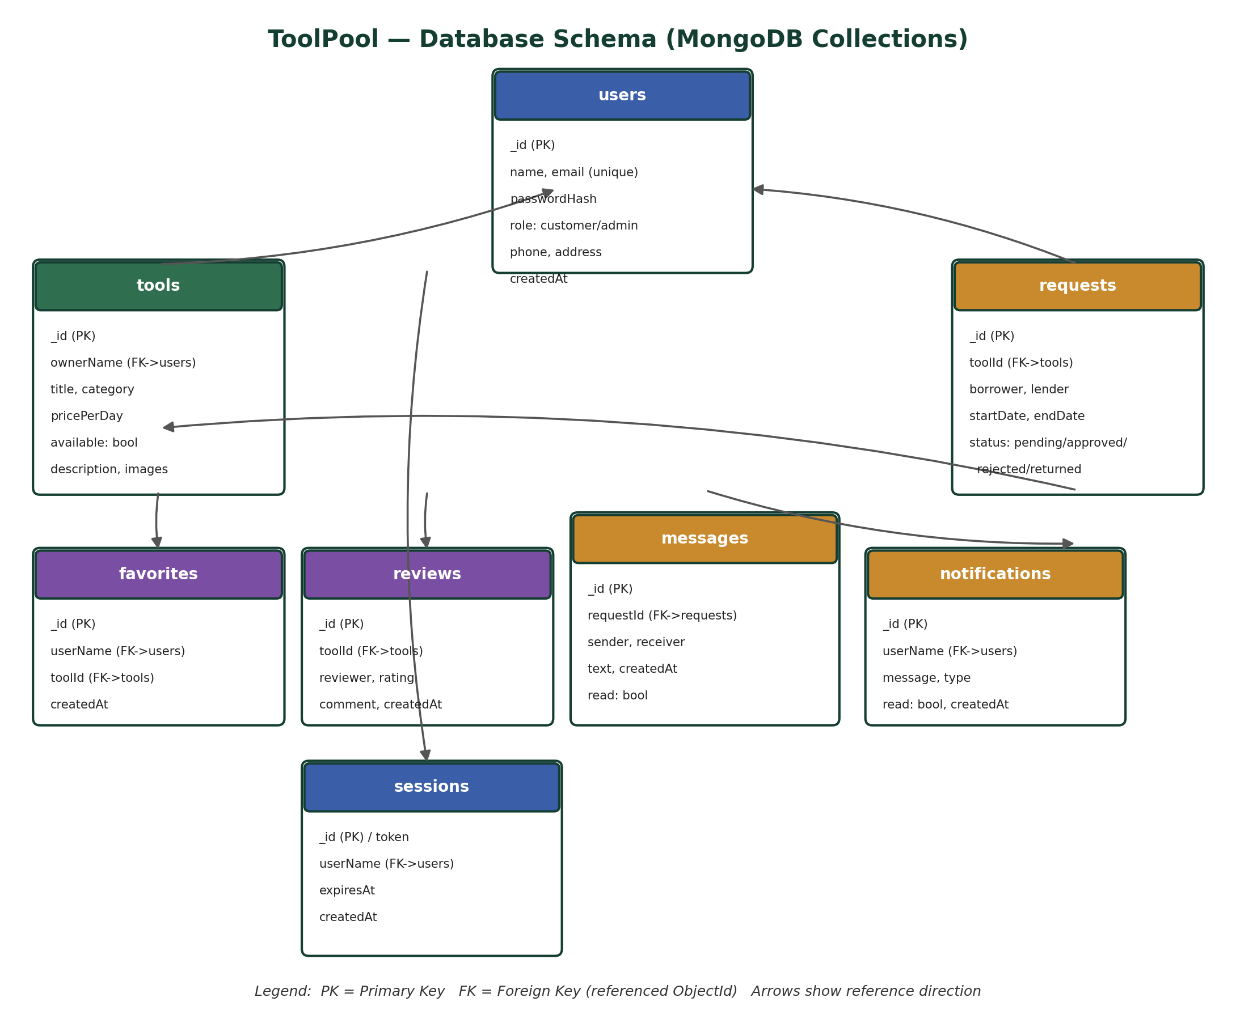
Fig. 2 — The 8 MongoDB collections and how they reference each other.

8. API DOCUMENTATION
This is the full list — 48 routes, all written by us, spread across 9 modules. No = anyone can call it, Yes = you need to be logged in, Owner = you have to own the resource, and Admin = the account needs admin rights.

1. Basic (2 routes)
# | Method | Endpoint | What it does | Auth
1 | GET | /api | Shows API info and the route list | No
2 | GET | /api/health | Health check for the server | No

2. Auth (5 routes)
# | Method | Endpoint | What it does | Auth
3 | POST | /api/auth/register | Registers a new user | No
4 | POST | /api/auth/login | Logs a user in with email + password | No
5 | GET | /api/auth/me | Returns the current logged-in user | Yes
6 | POST | /api/auth/logout | Logs the user out, destroys the session | Yes
7 | PATCH | /api/auth/password/:id | Changes account password | Yes

3. Users (7 routes) — admin only
# | Method | Endpoint | What it does | Auth
8 | GET | /api/users | Lists all users | Admin
9 | GET | /api/users/admins | Lists admin users | Admin
10 | GET | /api/users/customers | Lists customer users | Admin
11 | GET | /api/users/:id | Gets one user | Admin
12 | POST | /api/users | Creates a user | Admin
13 | PATCH | /api/users/:id | Updates a user | Admin
14 | DELETE | /api/users/:id | Deletes a user | Admin

4. Tools (10 routes)
# | Method | Endpoint | What it does | Auth
15 | GET | /api/tools | Browses tools, with search / category filters | Yes
16 | GET | /api/tools/featured | Gets the 6 cheapest available tools | No
17 | GET | /api/tools/categories | Gets the list of distinct categories | No
18 | GET | /api/tools/available | Gets every currently available tool | No
19 | GET | /api/tools/owner/:owner | Gets all tools listed by one owner | No
20 | GET | /api/tools/:id | Gets one tool's details | No
21 | POST | /api/tools | Creates a new tool listing | Yes
22 | PATCH | /api/tools/:id | Updates a tool's details | Owner
23 | DELETE | /api/tools/:id | Deletes a tool and its related data | Owner
24 | PATCH | /api/tools/:id/availability | Toggles a tool's availability flag | Owner

5. Borrow Requests (10 routes)
# | Method | Endpoint | What it does | Auth
25 | GET | /api/requests | Lists requests, filtered by role | Yes
26 | GET | /api/requests/pending | Lists pending requests | Yes
27 | GET | /api/requests/mine/:borrower | Gets one borrower's requests | Yes
28 | GET | /api/requests/:id | Gets a single request | Yes
29 | POST | /api/requests | Creates a new borrow request | Yes
30 | PATCH | /api/requests/:id/status | Updates a request's status | Yes
31 | PATCH | /api/requests/:id/approve | Approves a request, marks tool unavailable | Owner
32 | PATCH | /api/requests/:id/reject | Rejects a borrow request | Owner
33 | PATCH | /api/requests/:id/return | Marks the tool returned + available again | Owner
34 | DELETE | /api/requests/:id | Deletes a borrow request | Yes

6. Favorites (3 routes)
# | Method | Endpoint | What it does | Auth
35 | GET | /api/favorites/:userName | Gets a user's favourite tools | No
36 | POST | /api/favorites | Adds a tool to favourites | No
37 | DELETE | /api/favorites/:userName/:toolId | Removes a tool from favourites | No

7. Reviews (3 routes)
# | Method | Endpoint | What it does | Auth
38 | GET | /api/reviews/tool/:toolId | Gets all reviews for a tool | No
39 | POST | /api/reviews | Creates a new review | No
40 | DELETE | /api/reviews/:id | Deletes a review | No

8. Messages (4 routes) — includes the SSE stream
# | Method | Endpoint | What it does | Auth
41 | GET | /api/messages/request/:requestId/stream | Live SSE chat stream for a request | Yes
42 | GET | /api/messages/inbox/:userName | Gets a user's inbox | Yes
43 | GET | /api/messages/request/:requestId | Gets chat history for a request | Yes
44 | POST | /api/messages | Sends a chat message | Yes

9. Notifications (2 routes)
# | Method | Endpoint | What it does | Auth
45 | GET | /api/notifications/:userName | Gets a user's notifications | No
46 | PATCH | /api/notifications/:id/read | Marks a notification as read | No

10. Admin (2 routes)
# | Method | Endpoint | What it does | Auth
47 | GET | /api/admin/stats | Gets overall platform statistics | Admin
48 | POST | /api/admin/reset-sample | Resets all sample/seed data | Admin

9. APPLICATION SCREENSHOTS
A few screens from the live app, to show what all of this actually looks like once it's running.
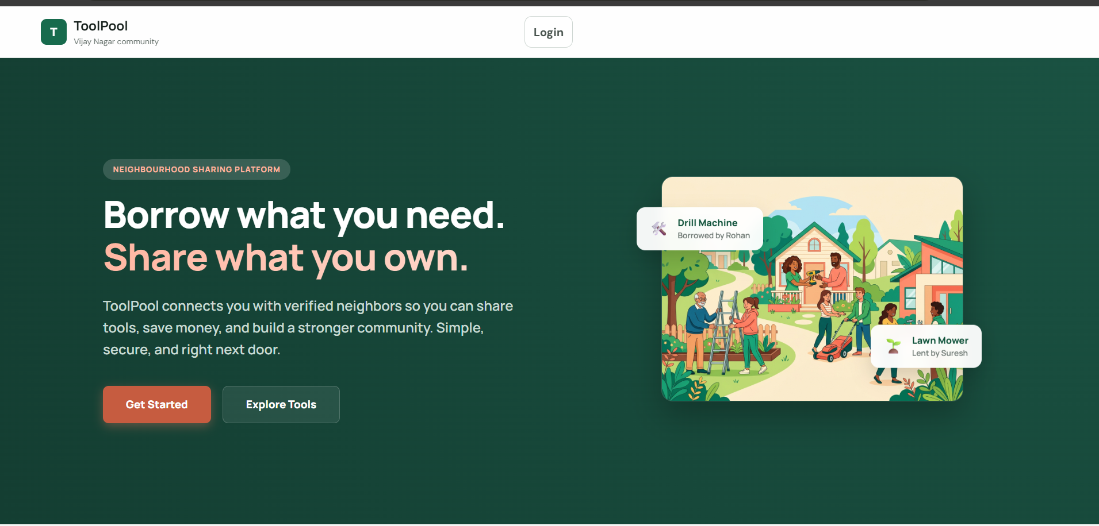
Fig. 3 — Landing page: 'Borrow what you need, share what you own.'

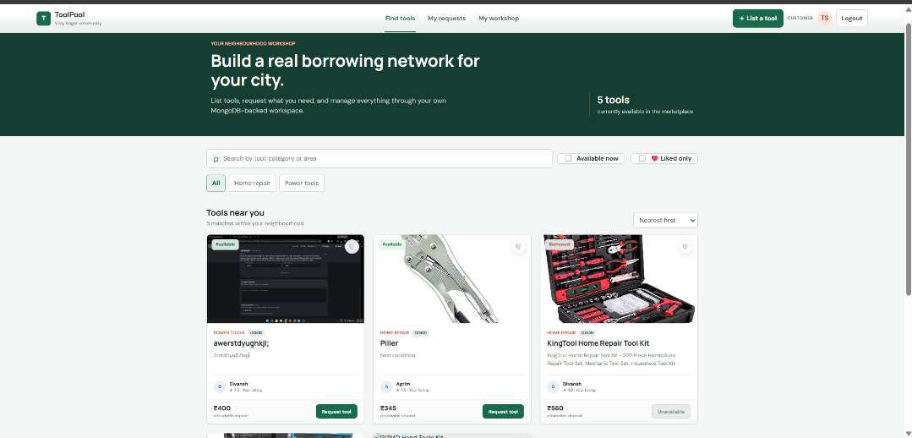
Fig. 4 — Login / register screen, with a short pitch on the left.

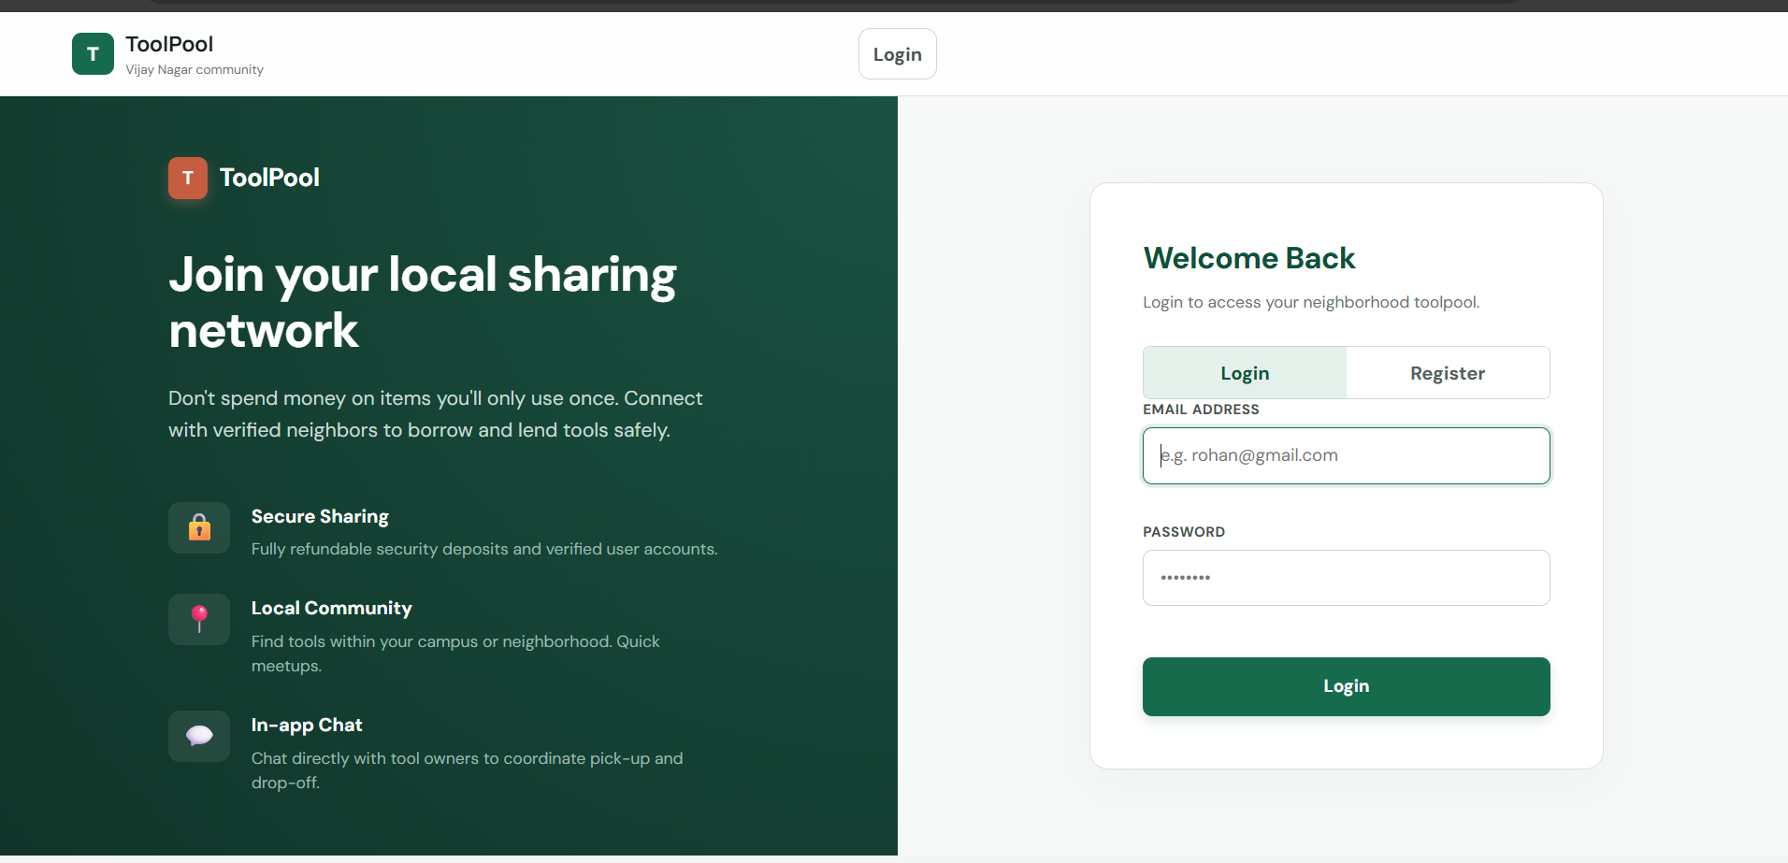
Fig. 5 — Browse page: search, filters, and tool cards with live availability.

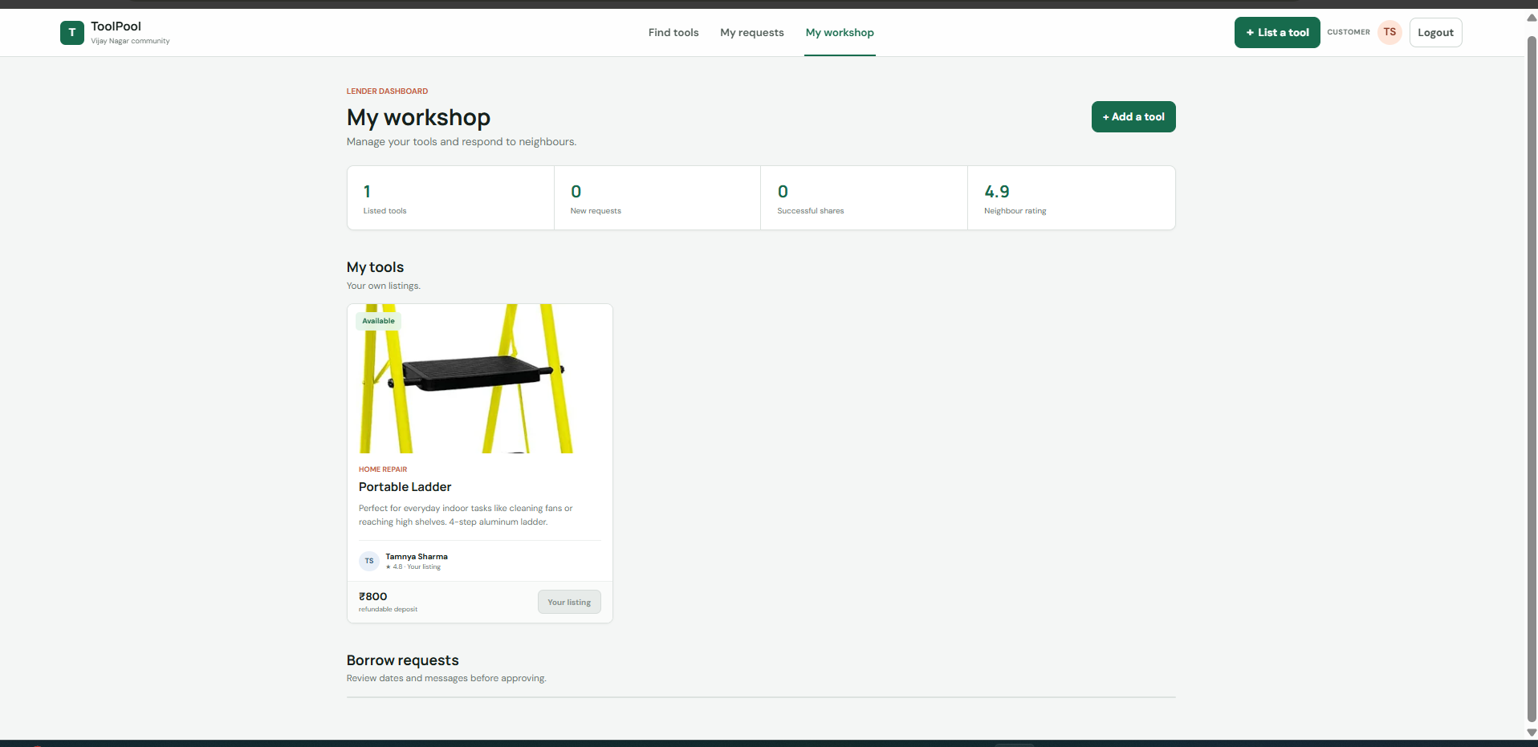
Fig. 6 — 'My workshop' — the lender dashboard for managing your own listings and requests.

10. REAL-TIME FEATURES & PRACTICAL USE
The one real-time piece in this project is the chat between borrower and lender, and it only unlocks after the owner approves a request — so nobody can message a stranger about a tool that isn't even confirmed yet. Once approved, the client opens a connection to /api/messages/request/:id/stream and just stays open. Any time someone posts a new message through POST /api/messages, the server writes it to MongoDB and pushes it straight down that open connection to both people. No refreshing, no polling every few seconds — the chat modal just updates the moment a message event comes in.
In everyday use, this is what the app is meant to solve: someone lists a pressure washer they use twice a year, a neighbour needing it for a weekend borrows it instead of buying one. The owner has a clear record of who has the tool and when it's due back. Chat only opens up once there's an actual agreement in place, so it doesn't turn into a spam inbox. Reviews build up over time so reliable people stand out, and an admin can step in if something needs moderating — useful for a housing society or a campus running this at scale.

11. ADVANTAGES, LIMITATIONS & WHAT'S NEXT

11.1 What works well
- Cuts down on buying tools you'll use once — better for both the wallet and the clutter
- Every API route is hand-written, so we control validation and permissions completely, unlike a BaaS setup
- The request lifecycle (pending → approved/rejected → returned) means there's never any ambiguity about a tool's status
- Chat updates instantly through SSE, without needing an external real-time service
- Role-based access keeps admin-only actions (like resetting data or managing users) properly locked down
- One Render service serves both frontend and backend, so deployment stays simple

11.2 Where it falls short right now
- Auth is session-based only — no Google/OAuth login yet, and sessions live on the server rather than being stateless
- There's no actual payment or deposit handling — the platform just tracks status, not money
- Trust is based on reviews only, there's no identity verification for higher-value tools
- SSE connections are held in-process, so scaling chat across multiple servers would need something like Redis pub/sub
- Categories are a static list in the code rather than something an admin can manage live

11.3 What we'd add next
- A payment gateway for rental fees and refundable deposits
- Location-based browsing, so people only see tools within walking distance
- A basic trust score based on completed, on-time returns
- Push/email notifications instead of just in-app alerts
- A mobile version — React Native or just a PWA wrapper
- Simple recommendations based on past borrowing history

12. CONCLUSION
Building ToolPool end-to-end — the schema, all 48 routes, the React frontend, and the SSE chat — was a good exercise in putting a full MERN stack together without leaning on a managed backend service. The core idea (borrow instead of buy, from someone you can actually trust because they're nearby) came together into something that works: you can list a tool, request one, get approved, chat, and leave a review, all inside one app.
It's still a college-project version of the idea — no payments, no verified identity, no horizontal scaling for chat — but the foundation is solid enough that most of those additions are extensions of what's already there rather than rewrites. For a first full-stack build, it does what it set out to do.

