Afrimash Customer Intelligence Solution

Team AgroX
Technical Documentation & Recommendations
Date: October 25, 2025

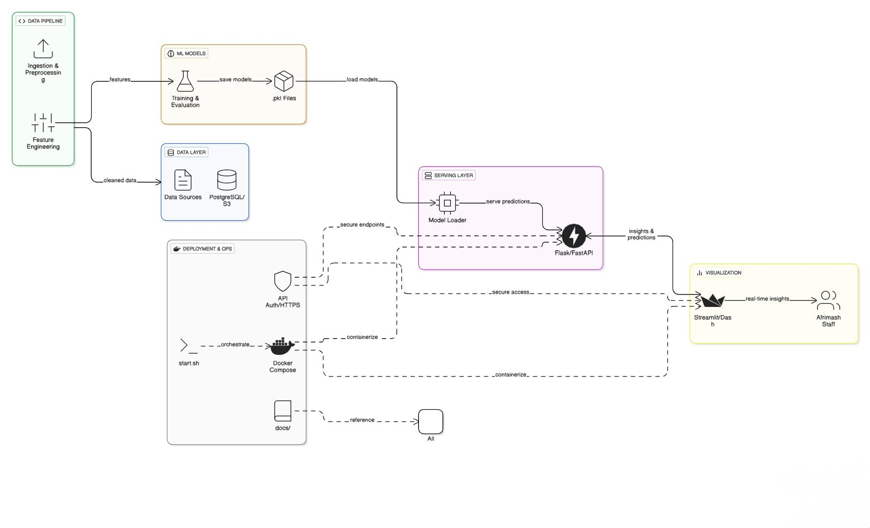

1. Executive Summary
This document provides high-level system architecture, component interactions, recommended technologies, implementation roadmap, and operational recommendations for the Afrimash Customer Intelligence project. The system is designed to ingest customer and transaction data, train and serve machine learning models for segmentation, retention prediction, and recommendations, and present near-real-time insights through a dashboard.

2. Project Goals
Primary objectives:
- Segment customers into meaningful behavioral and demographic groups.
- Predict customer behavior and purchasing patterns (e.g., churn, CLTV).
- Improve customer retention with targeted actions and product recommendations.
- Provide an interactive dashboard for real-time insights.
- Ensure the solution is scalable, secure, and easy to deploy (Dockerized).

3. High-level System Components
The architecture is divided into the following main components:
- Data Ingestion & ETL: Collects raw data from sources (CSV uploads, transactional DB, message queues). Includes validation, enrichment and feature store writes.
- Feature Store: Centralized store for raw and engineered features (parquet, Delta Lake, or feature store).
- Model Training: Jupyter notebooks and training pipelines to produce and evaluate models, outputting .pkl artifacts.
- Model Registry & Storage: Versioned storage for model artifacts and metadata (MLflow, S3/GCS).
- Model Serving / API: Serves predictions through REST/gRPC endpoints (FastAPI), batch scoring jobs and streaming.
- Dashboard & Reporting: Interactive UI for business users with visualizations and reports (Streamlit/React+D3/Metabase).
- Recommendation Engine: Online/nearline service that provides personalized product recommendations (approximate nearest neighbors or NN).
- Monitoring & Observability: Logs, metrics, model drift detection, alerting (Prometheus, Grafana, Sentry).
- Orchestration & Scheduling: Pipeline orchestration for ETL and retraining (Airflow, Prefect, or Dagster).
- Storage & Infra: Databases (Postgres), object storage (S3-compatible), container registry, and Kubernetes for scaling.

4. Data Flow & Component Interaction
1. Data sources (transactional DB, CSV uploads, tracking events) → ingested by the Data Ingestion service. Validation and enrichment occur here.
2. Cleaned data is stored in the raw zone in object storage and written to the feature store after feature engineering.
3. Model Training pipelines read features from the feature store and produce model artifacts (.pkl). Models are registered in a Model Registry along with metrics and metadata.
4. Model Serving uses the best-registered model to expose prediction endpoints via an API. Batch scoring runs periodically for bulk updates.
5. The Dashboard queries the API and feature store/analytical DB for real-time and aggregated views. It also triggers A/B experiments or retention campaigns.
6. Monitoring collects logs, metrics, and retraining triggers: if data drift or performance degradation is detected, an automated or manual retraining workflow is started.

5. Recommended Technologies & Rationale
- Language & libraries: Python 3.10+, pandas, numpy, scikit-learn, xgboost/lightgbm, joblib
- Notebooks & Experimentation: JupyterLab; use papermill or nbconvert for automated runs
- Model registry: MLflow for model tracking, artifacts, and experiment metadata
- Feature store & storage: Delta Lake on S3 or Parquet datasets in object storage; Feast if real-time features needed
- Orchestration: Airflow or Prefect for ETL and retrain scheduling
- Serving & API: FastAPI for model endpoints; Gunicorn + Uvicorn workers behind a load balancer
- Dashboard: Streamlit for quick prototype dashboards; React + Plotly/D3 for production-grade UI. Consider Metabase or Superset for BI.
- Recommendation engine: Faiss or Annoy for vector similarity; replace with approximate NN service or use Neural Collaborative Filtering for model-based recommendations.
- Containerization & infra: Docker for packaging; Kubernetes (EKS/GKE/AKS) for orchestration; Helm charts for deployment.
- Databases: Postgres for relational data; Redis for caching and online features; ClickHouse or BigQuery for analytics at scale.
- Monitoring & logging: Prometheus + Grafana for metrics; ELK or Loki for logs; Sentry for error tracking.
- CI/CD: GitHub Actions or GitLab CI for pipelines; use image scanning, unit tests, and model validation steps.

6. Best Practices
Scalability:
- Use partitioned object storage for large datasets and columnar formats (Parquet/Delta).
- Move heavy compute to distributed processing (Dask, Spark) when single-node processing is insufficient.
- Serve models via Kubernetes autoscaling and use caching (Redis) for repeated queries.
Maintainability:
- Keep training code in versioned pipelines with reproducible environments (requirements.txt, conda, or poetry).
- Use MLflow and clear model versioning; include model cards describing data, metrics, and limitations.
- Separate concerns: ETL, feature engineering, training, and serving are distinct modules with well-defined contracts.
Security & Privacy:
- Encrypt data at rest and in transit (TLS, SSE for S3).
- Implement role-based access control for data and model registries.
- Avoid storing PII in model artifacts; use tokenization or hashing for sensitive fields.
- Log access and use secure secrets management (HashiCorp Vault or cloud provider secrets manager).

7. Implementation Roadmap (High-level)

- Phase 0: Preparation (10–20 mins)
- Gather & profile available data (transactions, customers, product catalog).
- Set up repo structure, environment, and CI pipeline (unit tests, linting).
- Provision basic infra: object storage, Postgres, and container registry.

- Phase 1: Ingestion & Feature Store (20–40 mis)
- Implement data ingestion pipelines (CSV uploads, DB connectors).
- Create feature engineering scripts and store outputs in feature store or parquet datasets.

- Phase 2: Modeling (30–60 mins)
- Develop segmentation, retention, and recommendation models in notebooks.
- Establish MLflow tracking and create reproducible training pipelines.
- Evaluate models and finalize serialization to .pkl (or better: ONNX/torchscript for advanced serving).

- Phase 3: Serving & Dashboard (20–40 mins)
- Build FastAPI service to serve model predictions and batch scoring jobs.
- Develop Streamlit/React dashboard with key metrics, funnels, and cohort analyses.
- Implement authentication (OAuth2/JWT) for dashboard access.

- Phase 4: Automation & Monitoring (20–40 mins)
- Add Airflow/Prefect DAGs for scheduled ETL and retraining.
- Add monitoring dashboards, alerts, and data drift detectors.

- Phase 5: Scale & Harden (ongoing)
- Migrate to Kubernetes with autoscaling, configure Redis caching and a robust CI/CD pipeline.
- Run load testing, security audits, and optimize cost/performance.

8. Architecture Diagram (Textual Description)
At the left of the diagram are data sources: transactional DB, CSV uploads, tracking events, and 3rd-party enrichment APIs. An ingestion layer (API + batch processors) funnels data into object storage (raw zone) and a transactional Postgres DB. A feature engineering layer reads raw data, emits features to a feature store (or parquet datasets). Training pipelines pull features into ephemeral compute, register models in MLflow, and store artifacts in object storage. A model serving cluster (FastAPI on Kubernetes) accesses the model registry and feature store to produce predictions. A dashboard (Streamlit or React) consumes the API and writes user actions/events back to tracking storage for continuous learning. Monitoring tools tap into logs and metrics across all layers.

9. Security & Compliance
- Use TLS everywhere for transport security.
- Encrypt sensitive data at rest and in transit; limit access via IAM.
- Maintain audit logs for data access and model deployments.
- Implement least-privilege for service accounts and RBAC for team members.
- Use dependency scanning and container image scanning in CI.
- Ensure local data retention policies comply with relevant regulations (e.g., GDPR where applicable).

10. Actionable Recommendations
1. Start with a lightweight MVP stack: FastAPI + Streamlit + Postgres + S3-compatible storage. Prove value quickly before investing in heavy infra.
2. Use MLflow from the beginning to track experiments and avoid model sprawl.
3. Build an automated data quality process (Great Expectations or custom checks) to prevent training on bad data.
4. Design models to be explainable: include SHAP summaries for retention and recommendation features to support business decisions.
5. Prioritize batch scoring first and add online features later. This reduces complexity while delivering value.
6. Keep model artifacts and preprocessing code together (e.g., using a pipeline object) to avoid mismatch in production.
7. Regularly schedule retraining (or retrain-on-drift) and maintain training metadata for reproducibility.
8. Instrument business KPIs (retention, repeat purchase rate, AOV) and tie them to ML experiments.
11. Note To Reviewers / Collaborators
All code segments related to MODEL TRAINING and FITTING have been intentionally provided as COMMENTS for documentation and reproducibility.
This approach ensures that:
1. The full model development pipeline, including data preprocessing, feature selection, model instantiation, and evaluation is transparentand traceable for review or adaptation.
2. The script can be safely executed in non-training environments (e.g., during data inspection, integration testing, or CI/CD pipelines) without unintentionally triggering computationally expensive training tasks.
3. End users can selectively uncomment relevant blocks when actual training is intended, ensuring controlled model runs and consistent experiment replication.

13. Closing Notes
This document was prepared to help Afrimash move from exploration to a production-grade Customer Intelligence platform. If you would like, I can also produce: a detailed sequence diagram, a cost estimate for AWS/GCP deployments, or concrete example FastAPI and Streamlit starter templates tailored to your team's stack.

