Multilevel Model With Gutten Tree Data

# Tree Height By Location

|  |  |  |  |  |
| --- | --- | --- | --- | --- |
| location | Total | Average | Max | Min |
| 1 | 209 | 22.49426 | 43.5 | 1.6 |
| 2 | 28 | 26.08214 | 38.1 | 4 |
| 3 | 121 | 19.44215 | 37.4 | 1.5 |
| 4 | 107 | 16.11308 | 34.6 | 1.6 |
| 5 | 518 | 16.38205 | 39.3 | 1.5 |
| 6 | 102 | 14.92059 | 29.7 | 1.5 |
| 7 | 115 | 12.59044 | 30.2 | 1.9 |

# Spaghetti Plot

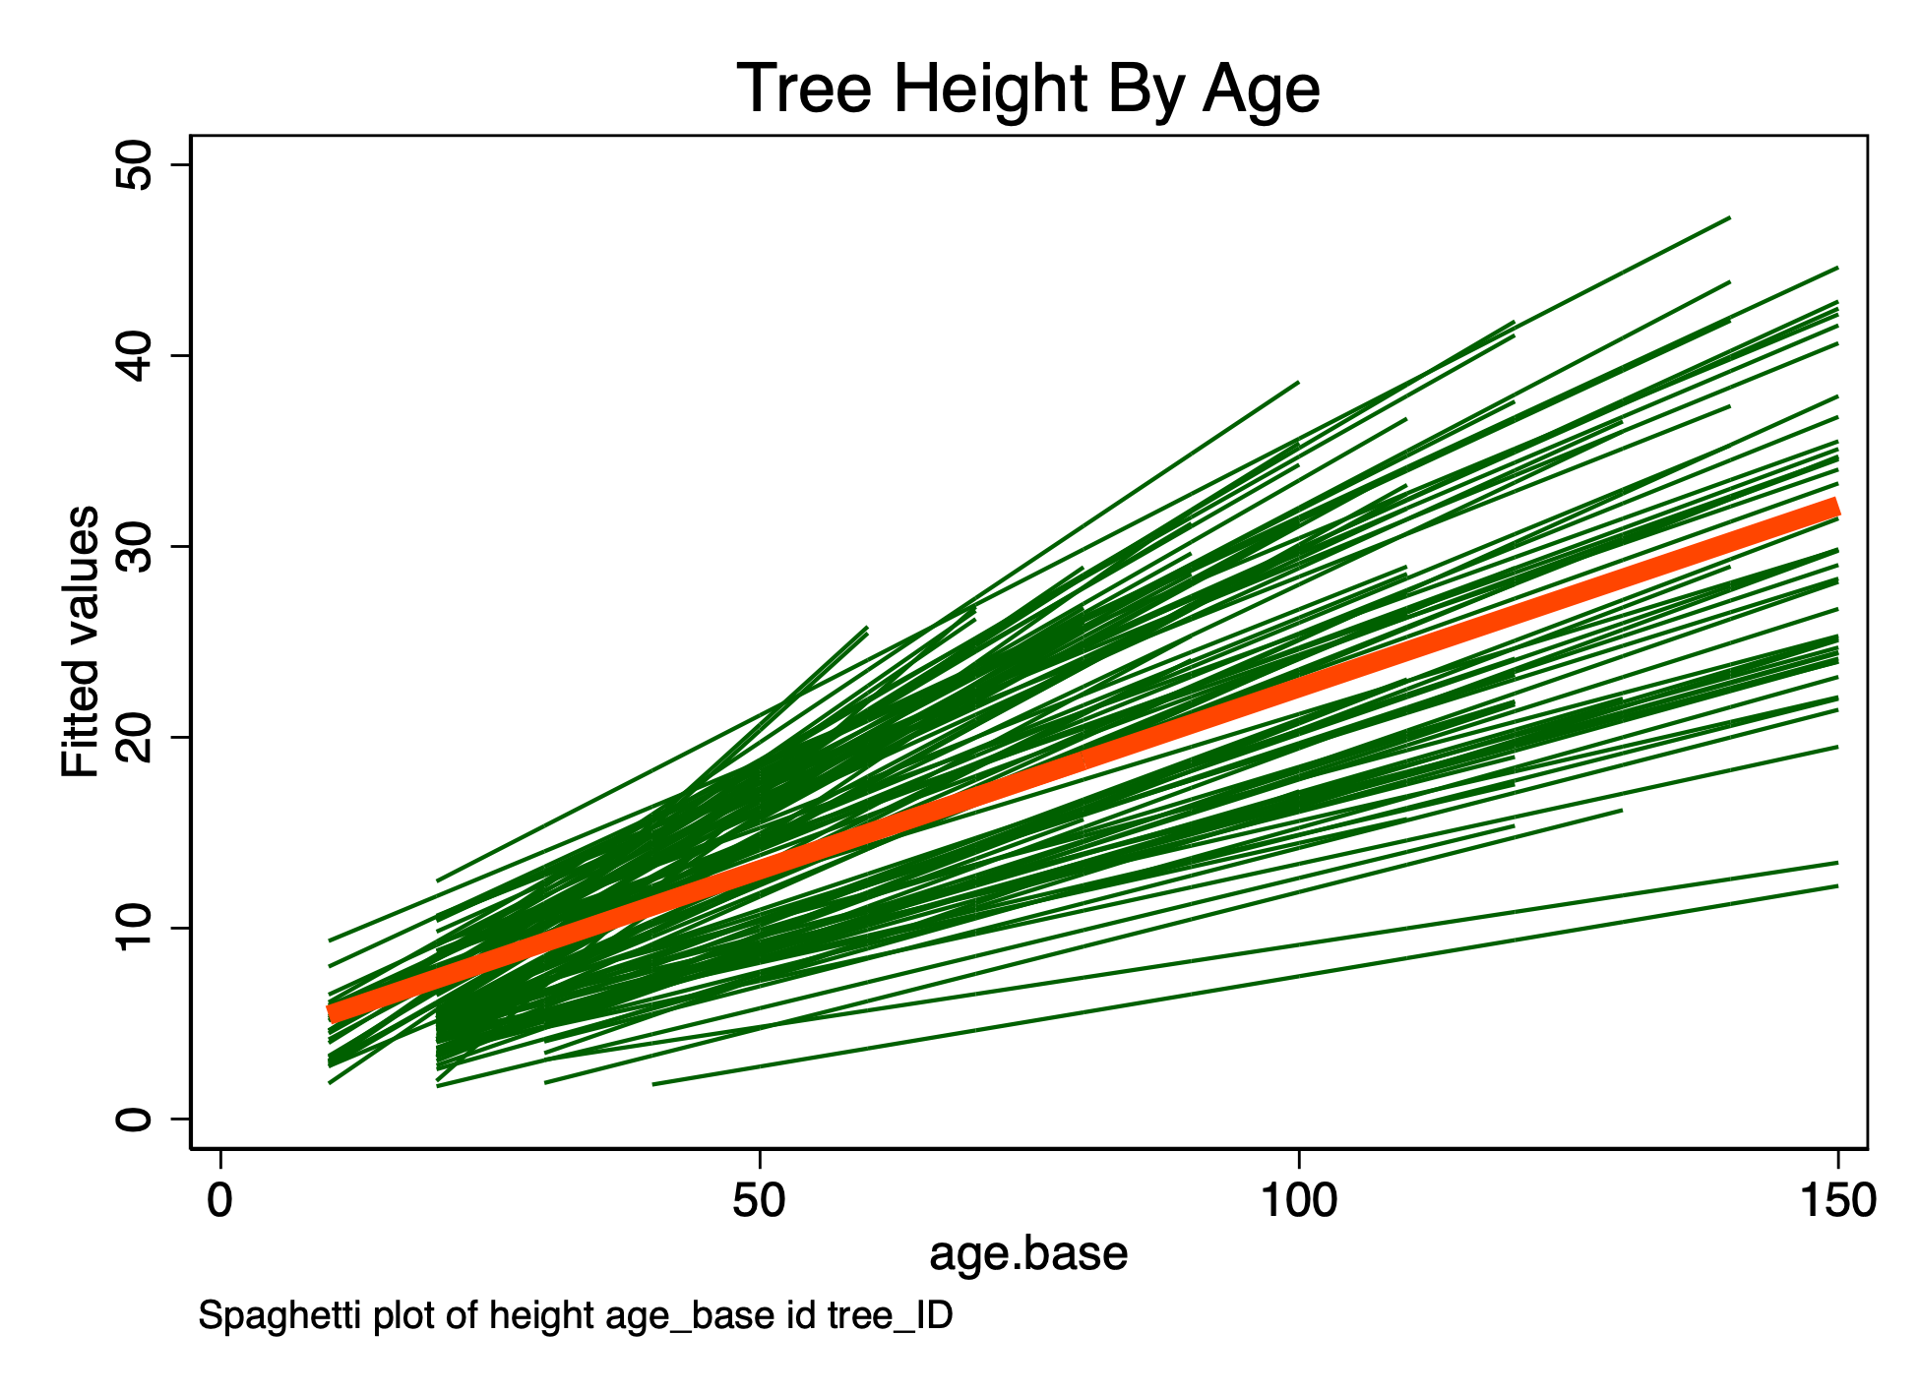

# Multilevel Model

|  |  |
| --- | --- |
| Variable | model1 |
| height |  |
| age_base | 0.214*** |
|  |  |
| site |  |
| 1 | (empty) |
| 2 | -3.316*** |
| 3 | -8.095*** |
| 4 | -11.510*** |
| 5 | -15.866*** |
|  |  |
| _cons | 8.233*** |
| tree_ID |  |
| var(_cons) | 2.171*** |
| Residual |  |
| var(e) | 8.393*** |