Better Graphing in Stata

Andy Grogan-Kaylor

8 Dec 2019 19:19:49

# Introduction

* Stata is a powerful and intuitive data analysis program.
* Learning how to graph in Stata is an important part of learning how to use Stata. Yet, the default graphs in Stata can sometimes be less than optimal.
* This document is an introduction to (a) basic graphing ideas in Stata; and (b) some simple ways to make your Stata graphs look more professional.
* If this document is presented as slides, navigation links are in the corner of this slide deck.
* If this document is presented as slides, you can generate a printable version of these slides, by clicking on the “Ø”.

# Data

We are going to use the famous “iris” data collected by Ronald Fisher.

.   
. use "iris.dta", clear  
  
.   
. summarize  
  
 Variable │ Obs Mean Std. Dev. Min Max  
─────────────┼─────────────────────────────────────────────────────────  
Sepal_Length │ 150 5.843333 .8280661 4.3 7.9  
 Sepal_Width │ 150 3.057333 .4358663 2 4.4  
Petal_Length │ 150 3.758 1.765298 1 6.9  
 Petal_Width │ 150 1.199333 .7622377 .1 2.5  
 Species │ 150 2 .8192319 1 3  
  
.

# Basic Graphs

# Continuous Variable histogram

.   
. histogram Petal_Length  
(bin=12, start=1, width=.49166667)  
  
.

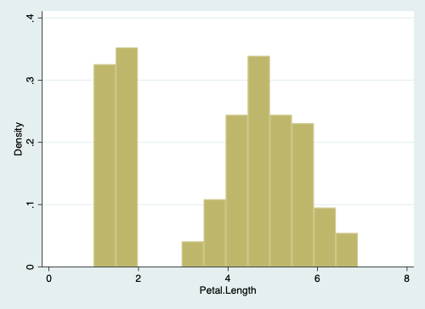

Histogram of Petal Width

# Categorical Variable graph bar

.   
. graph bar, over(Species)  
  
.

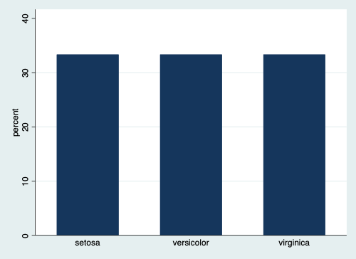

Bar Graph of Species

# Continuous by Continuous twoway

.   
. twoway scatter Petal_Length Petal_Width  
  
.

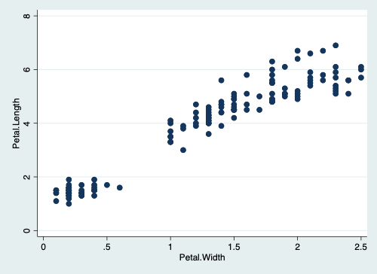

Scatterplot

# Categorical by Categorical graph bar

.   
. recode Petal_Length ///  
> (min/3.758 = 0 "below mean") ///  
> (3.758/max = 1 "above mean"), ///  
> generate(Petal_Group) // dichotomize Petal_Length  
(150 differences between Petal_Length and Petal_Group)  
  
.   
. graph bar, over(Species) over(Petal_Group)  
  
.

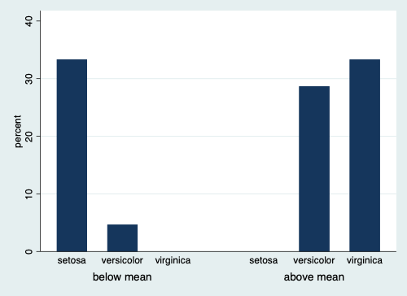

Bar Graph of Species by Category of Petal Length

# Continuous by Categorical graph bar

.   
. graph bar Petal_Length, over(Species)  
  
.

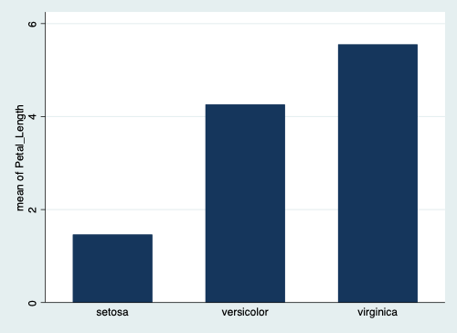

Bar Graph of Petal Length by Species

# Titles and Labels , title(...) xtitle(...) ytitle(...)

.   
. twoway scatter Petal_Length Petal_Width, scheme(s1rcolor) ///  
> title("Petal Length by Petal Width") ///  
> xtitle("Petal Width") ytitle("Petal Width") ///  
> caption("Iris Data")   
  
.

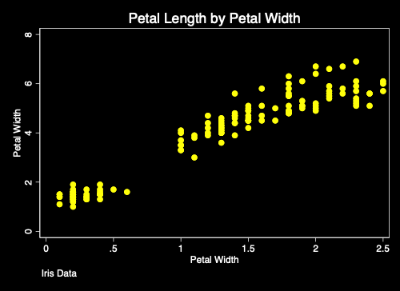

Graph With Titles and Labels

# Better Graphing With Schemes ,scheme(...)

The easiest method to make better Stata graphs is through the use of predefined Stata graphing schemes.

# Pre-Defined Schemes

Some schemes, e.g. economist, sj and s1rcolor are pre-installed with Stata.

# Economist Scheme

.   
. twoway scatter Petal_Length Petal_Width, scheme(economist)  
  
.

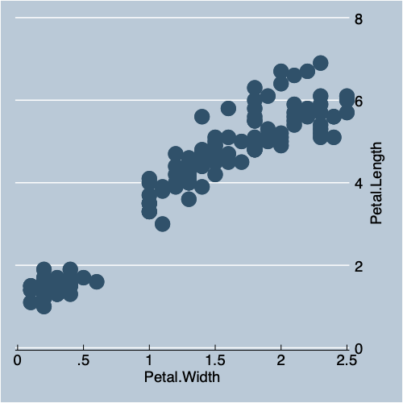

Scatterplot with Economist Scheme

# *Stata Journal* Scheme

.   
. twoway scatter Petal_Length Petal_Width, scheme(sj)  
  
.

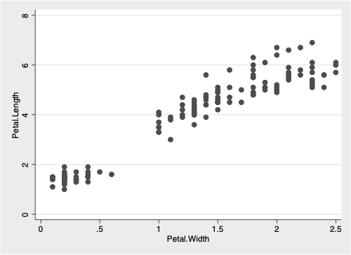

Scatterplot with *Stata Journal* Scheme

# s1rcolor Scheme

.   
. twoway scatter Petal_Length Petal_Width, scheme(s1rcolor)  
  
.

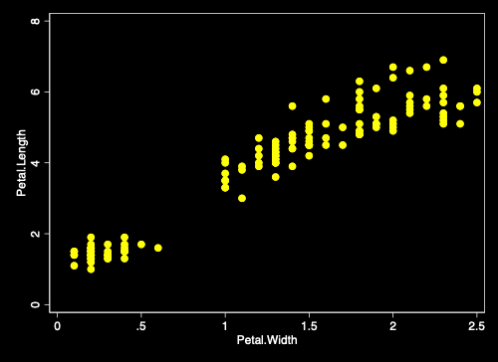

Scatterplot with s1rcolor Scheme

# User Written Schemes

Two of the best user written schemes are plottig and lean2.

Use the findit command e.g. findit lean2 to find these schemes.

# lean2 Scheme

.   
. twoway scatter Petal_Length Petal_Width, scheme(lean2)  
  
.

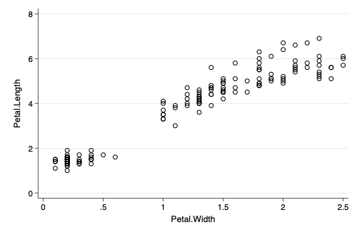

Scatterplot with lean2 Scheme

# Michigan graph scheme

I have written a michigan graph scheme described [here](https://agrogan1.github.io/Stata/).

.   
. twoway (scatter Petal_Length Petal_Width) ///   
> (lfit Petal_Length Petal_Width), scheme(michigan)  
  
.

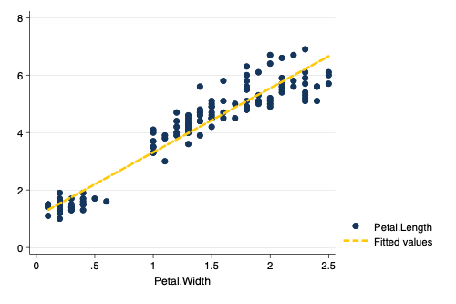

Scatterplot with michigan Scheme

# Schemes as a Base for Further Tweaking

Schemes can be used as a base that can then be further modified.

.   
. twoway (scatter Petal_Length Petal_Width, msymbol(0) mcolor(red)) ///  
> (lfit Petal_Length Petal_Width), ///  
> scheme(lean2)   
(note: named style 0 not found in class symbol, default attributes used)  
  
.

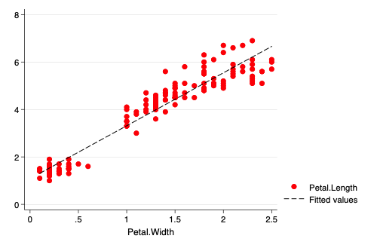

Modified Scatterplot with lean2 Scheme as a Base

# Even More Tweaks

Based upon an example at <https://blog.stata.com/2018/10/02/scheming-your-way-to-your-favorite-graph-style/>

.   
. twoway scatter Sepal_Length Sepal_Width Petal_Width Petal_Length, ///   
> color(%50 %50 %50) /// transparency   
> title("Multiple Iris Characteristics") /// title  
> scheme(s1rcolor) // scheme  
  
.

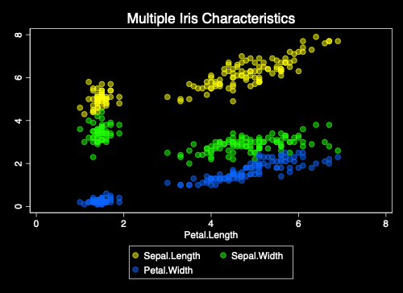

Modified Scatterplot with s1rcolor Scheme as a Base

# More Information

See also [Two Page Stata](http://www-personal.umich.edu/~agrogan/stata/TwoPageStata.pdf)

Created by <agrogan@umich.edu>