Be Less Wrong

Why Use Quantitative Methods?

Andy Grogan-Kaylor

2025-01-01

“What we see and how we see is of course determined by our perspective, by the place from which we begin our examination of history; but it is determined also by reality itself.” (Martín-Baró 1994)

Across the globe, there are definite concrete *realities* of abuse, neglect, suffering, exploitation, violence, discrimination, and other associated problems that we are trying to understand, and to reduce.

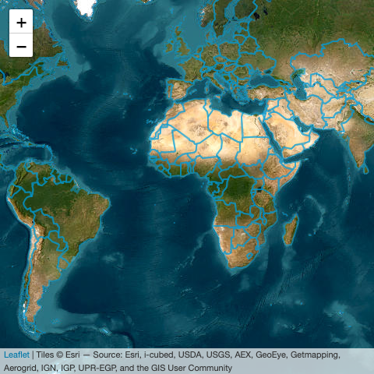

Countries of the World from ESRI

We hope that our research will inform efforts to change these *realities*. Yet, at the same time we must recognize that our understandings are at best *iterative* and *contingent.* While we will never have a perfect understanding of social reality, we can always improve our understandings, and move in the direction of being *less wrong*.

As Silverman (1998) wrote:

“… there is no way to know when our observations about complex events in nature are complete. Our knowledge is finite, Karl Popper emphasised, but our ignorance is infinite. … [W]e can never be certain about the consequences of our interventions, we can only narrow the area of uncertainty. This admission is not as pessimistic as it sounds: claims that resist repeated energetic challenges often turn out to be quite reliable. Such ‘working truths’ are the building blocks for the reasonably solid structures that support our everyday actions…” (Silverman 1998)

This recalls the famous saying by the statistician George Box about statistical models, reported in many places, and well captured in the passage by Hand (2014):

“In general, when building statistical models, we must not forget that the aim is to understand something about the real world. Or predict, choose an action, make a decision, summarize evidence, and so on, but always about the real world, not an abstract mathematical world: our models are not the reality—a point well made by George Box in his oft-cited remark that ‘all models are wrong, but some are useful’ (Box, 1979 in Launer and Wilkinson (1979)).” (Hand 2014)

A key task then, of using quantitative methods is to use them to try to be progressively *less wrong* about the answers we are finding to important questions about improving human wellbeing.

“All models are wrong, but some are useful.” (Box 1979)

Let’s consider a simple visual model based upon some simulated data. Two key variables in this model are the *intervention* (a treatment or program that we hope does some good), and the *outcome* (an improved or beneficial mental health or psychological outcome).



Here is a first model. What do these results say about the relationship of the *intervention* and the *outcome*?

|  |
| --- |
| Figure 1 |

These simple straightforward results suggest that the *intervention* is associated with a worsening of the *outcome*.

## The Intervention is *Not* Recommended

Based upon these results we would *not* recommend using this intervention.

Let’s now consider a slightly more complex model. In addition to examining the *intervention* and the *outcome*, we account for the fact that individuals come from different *groups*. This could be any kind of group, e.g. a racial, ethnic, religious, cultural, or economic group.

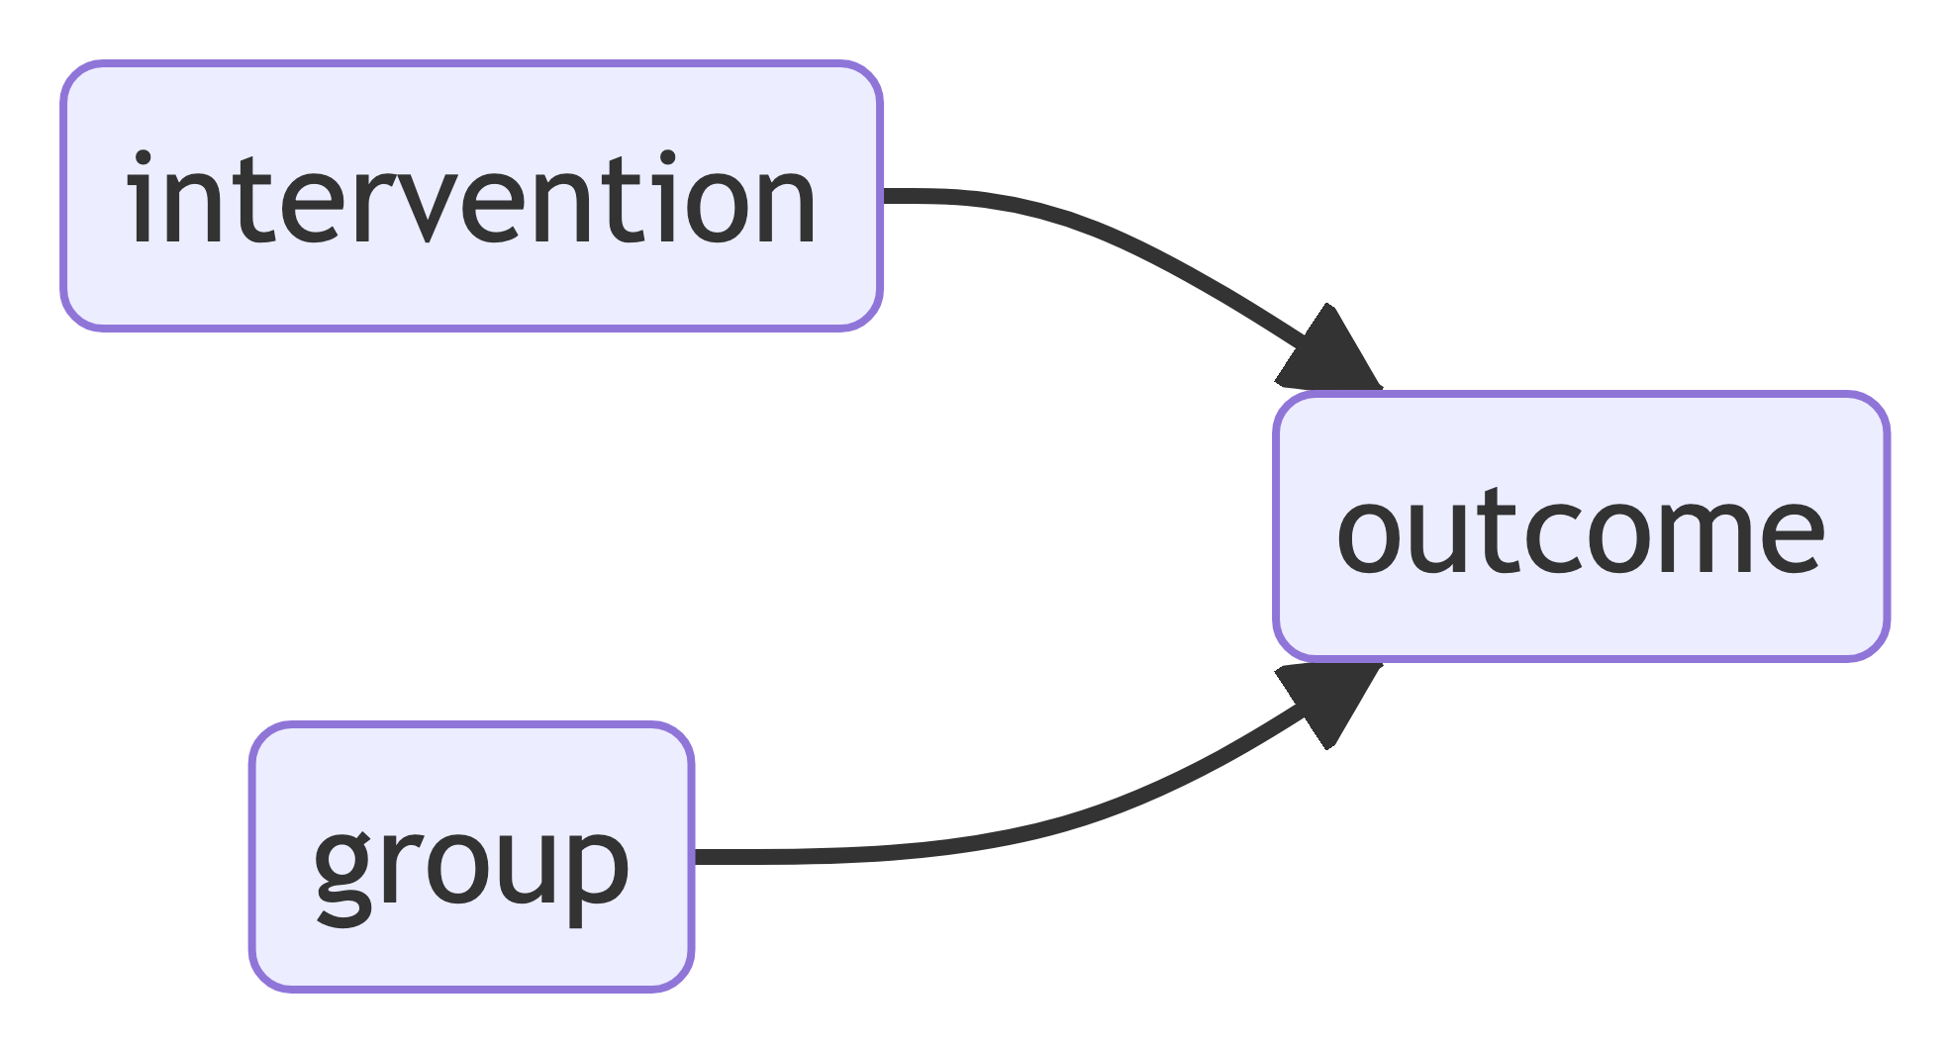

Our conclusion seems to have flipped!

## The Intervention is Recommended

Based upon these results we *would* recommend using this intervention.

|  |
| --- |
| Figure 2 |

The fact that statistical results–and analogously visual results–can flip when more variables are accounted for is known as Simpson’s Paradox (Simpson 1951).[1]

## Simpson’s Paradox

Put briefly, and intuitively, our evidence based “story” can change–sometimes quite dramatically–as we add more and more factors to our model.

Adding more variables will not always *flip* our conclusions.

## Multivariate Processes

Frequently, adding additional variables means that an original conclusion that we thought was substantively or statistically significant is no longer significant. This is an aspect of *multivariate processes* where an *outcome* is influenced by *multiple factors*.

We need to include as many variables as we can in our visual and statistical models.

Failure to include all of the relevant variables in our model–whether that model is visual or statistical–may lead to very wrong conclusions.

## A Strategy for Modeling

If those variables are observed, and included in our data set, it may be straightforward to build them into our model. If those variables are not observed, and not present in our data set, more complicated modeling strategies may be necessary.

At first the scenario I’ve just presented seems almost like a trick, or a puzzle, designed to confound us, or to illustrate a convoluted statistical scenario. Yet, upon reflection, the scenario I’ve just presented is surprisingly plausible.

## A Thought Experiment

Imagine a situation in which an intervention is administered based upon the situation in a local community. Quite possibly, the intervention might be provided at higher levels in communities where outcomes are less good. At the same time the intervention might be beneficial to individuals. Such a scenario would present us with exactly the data that we see reflected in Figure 1 and Figure 2.

|  |
| --- |
| Figure 3 |

My point? Simple models feel intuitive and have a commonsense appeal. Yet, with even slightly complicated social issues, simple models may be wrong.

What I have illustrated here is only one set of ideas about how we need to complicate our quantitative thinking to try to be a *little less wrong* in thinking about social problems.

Other more advanced statistical techniques may be seen as attempts to deal with other complications of the data, in an effort to be *less wrong*.

## Be Less Wrong

We need to keep the model as simple as possible so that it remains a useful abstraction, but to make the model complicated enough to reflect the complications of reality.

Box, George. 1979. “Robustness in the Strategy of Scientific Model Building.” In *Robustness in Statistics*, edited by Robert L. Launer and Graham N. Wilkinson. Academic Press, Inc. [Harcourt Brace Jovanovich, Publishers], New York-London.

Gelman, Andrew, Boris Shor, Joseph Bafumi, and David Park. 2007. “Rich State, Poor State, Red State, Blue State: What’s the Matter with Connecticut?” *Quarterly Journal of Political Science* 2 (November): 345–67. <https://doi.org/10.2139/ssrn.1010426>.

Hand, David J. 2014. “Wonderful Examples, but Let’s not Close Our Eyes.” *Statistical Science* 29 (1): 98–100. <https://doi.org/10.1214/13-STS446>.

Launer, Robert L., and Graham N. Wilkinson. 1979. “Robustness in Statistics.” In *Proceedings of a Workshop Held at the Army Research Office, Research Triangle Park, N.C., April 11–12, 1978*, edited by Robert L. Launer and Graham N. Wilkinson, xvi+296. Academic Press, Inc. [Harcourt Brace Jovanovich, Publishers], New York-London.

Martín-Baró, Ignacio. 1994. “Toward a Liberation Psychology.” In *Writings for a Liberation Psychology*, edited by Adrianne Aron and Shawn Corne. Harvard University Press.

Nieuwenhuis, Rense. 2015. “Association, Aggregation, and Paradoxes: On the Positive Correlation Between Fertility and Women’s Employment.” *Demographic Research* 32 (March). <https://www.demographic-research.org/volumes/vol32/23/>.

Silverman, William A. 1998. “Non-Replication of the Replicable (1996).” In *Where’s the Evidence? Debates in Modern Medicine*. Oxford University Press.

Simpson, E H. 1951. “The Interpretation of Interaction in Contingency Tables.” *Journal of the Royal Statistical Society. Series B (Methodological)* 13: 238–41. <http://www.jstor.org/stable/2984065>.

1. An analogous process can occur with *multilevel* data, in which there are often many groups, such as many schools, many neighborhoods, or many countries. Failure to account for the grouping of the data–in schools, neighborhoods or countries–can sometimes lead to dramatically incorrect results (Gelman et al. 2007; Nieuwenhuis 2015).