The Spillover of Violence in Low- and Middle-Income Countries
Global Families Research Team
2026-10-05
library(ggplot2)
library(readr)
library(plotly)
library(dplyr)
library(countrycode)
Scroll down to explore ⬇️
⬇️
⬇️
⬇️
Through violence socialization processes, exposure to higher rates of violence in the macro context may spill over to family violence, including caregivers’ use of physical child abuse.

This study examined the associations of violence occurring in macro contexts with parental physical abuse, after accounting for norms justifying women’s exposure to intimate partner violence (IPV) and parental physical punishment against children.

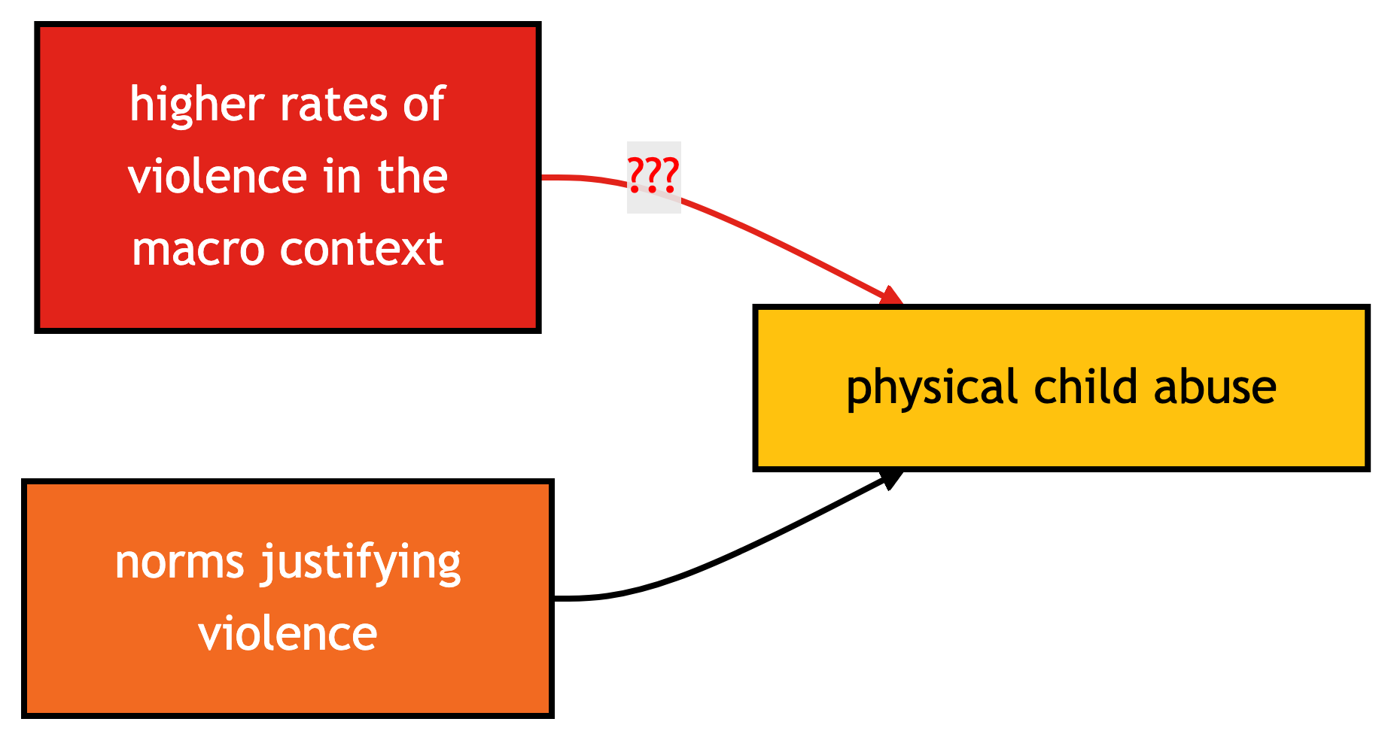

We used data from 435,131 households with a reference child aged 1 to 17 years across 43 countries from rounds 4 and 5 of the UNICEF Multiple Indicator Cluster Surveys.
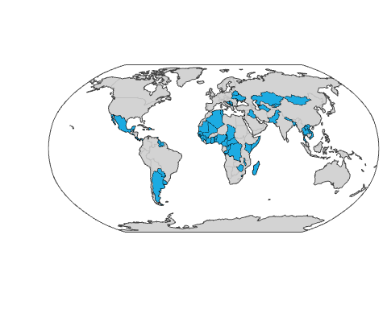
Figure 1: Countries in UNICEF MICS Data
We employed multilevel logistic regression models.
We estimated the factors associated with parental physical abuse.
We controlled for country-level violence—measured by rates of terrorism and political conflict, homicide, and women’s exposure to IPV
We also controlled for other covariates, including norms justifying violence against women and children and socio-demographic factors.
We accounted for the country in which study participants lived.
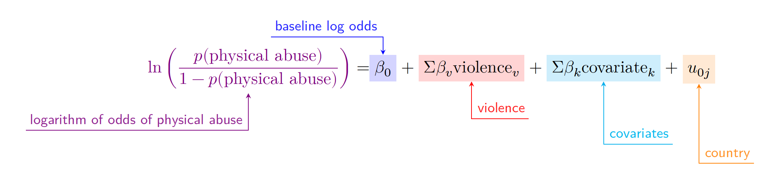
Multilevel Logistic Regression
Results indicated that higher levels of endorsement of IPV (OR = 1.024, p < .001) and attitudes endorsing the use of physical punishment with children (OR = 1.016, p < .05) were both associated with higher odds of severe physical child abuse after controlling for covariates.

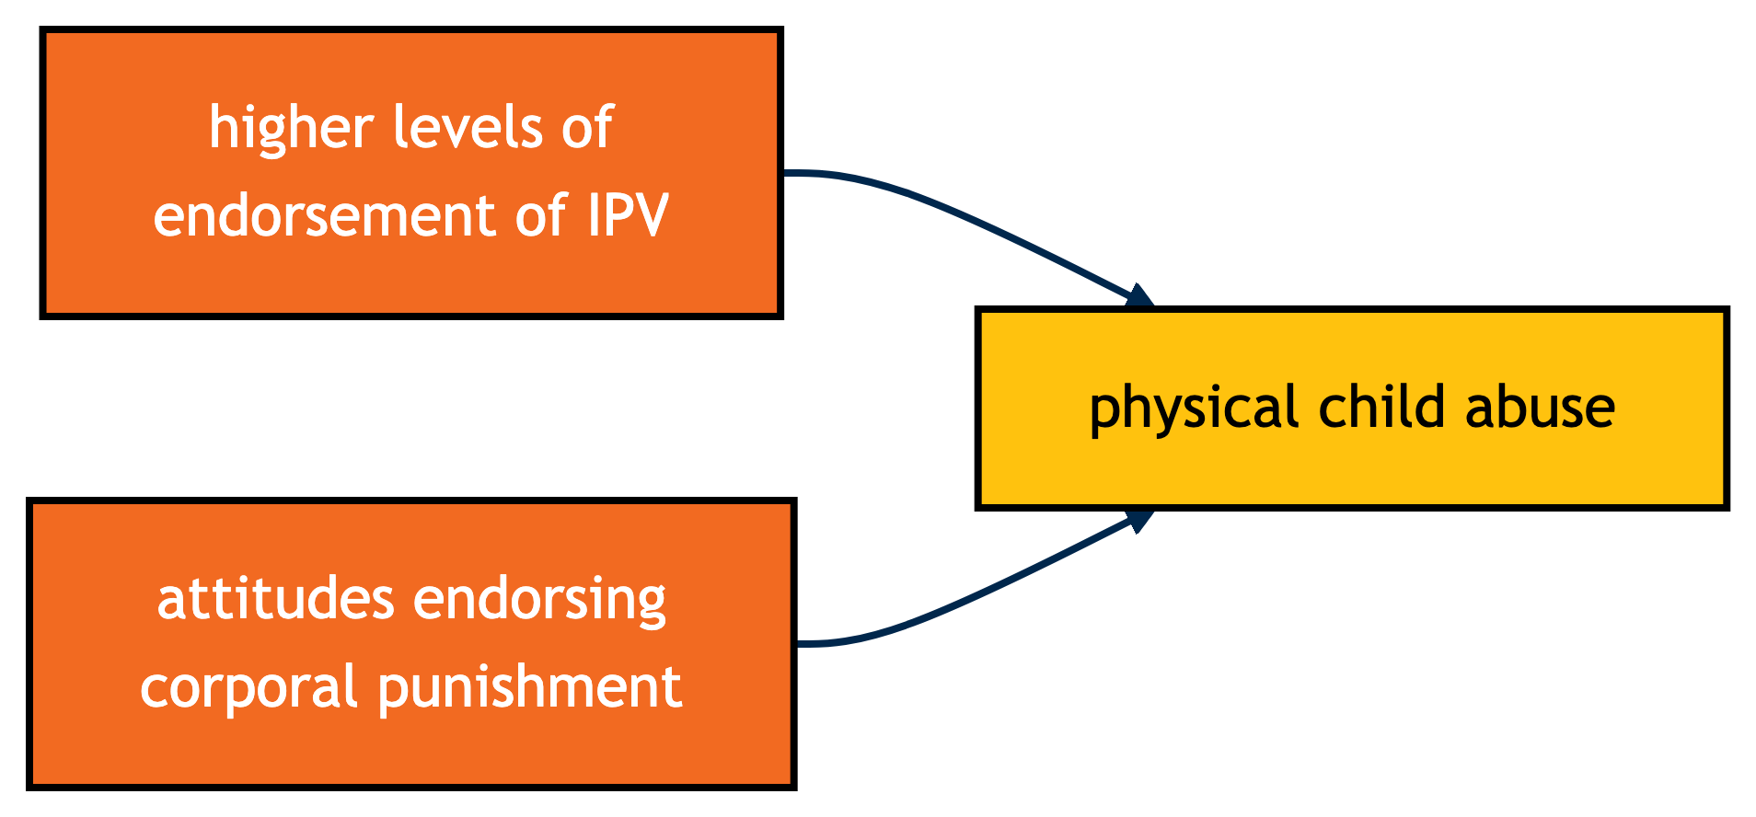

The association of terrorism and political violence with severe physical abuse was mediated (statistically connected) by norms that legitimize IPV (indirect b = 0.027, p = .005).
spillover <- read_csv("spillover.csv")
m <- list(
l = 50,
r = 50,
b = 100,
t = 200,
pad = 4
)
p_spillover <- plot_ly(data = spillover,
x = ~percentile,
y = ~abuse,
text = ~paste("percentile of political violence and terrorism: ",
percentile,
'<br>probability of abuse:',
abuse),
hoverinfo = 'text',
marker = list(size = 15,
color = '#E2231A',
line = list(color = 'black',
width = 2)),
type = 'scatter',
mode = 'lines+markers',
height = 700) %>%
layout(title = 'As political violence and terrorism increase, <br>so does the probability of physical abuse.',
xaxis = list(title = "percentile of political violence and terrorism"),
yaxis = list(title = "probability of abuse"),
hoverlabel = list(bgcolor = "white"),
margin = m) %>%
config(displayModeBar = FALSE)
p_spillover # replay
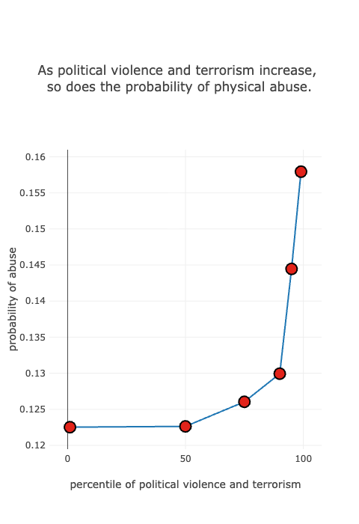
Interventions aimed at reducing abusive parenting practices in LMICs may benefit from efforts to reduce social norms that support violence against women and children.
These interventions should be responsive to trauma-informed approaches that recognize the effects of macro-level violence.

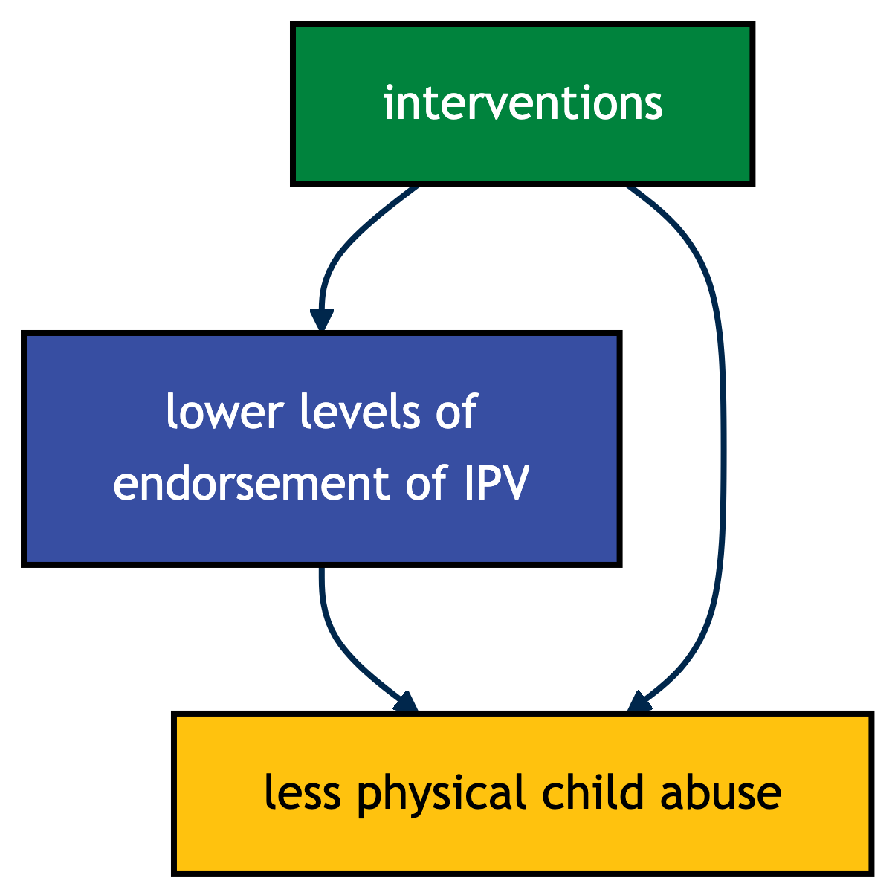

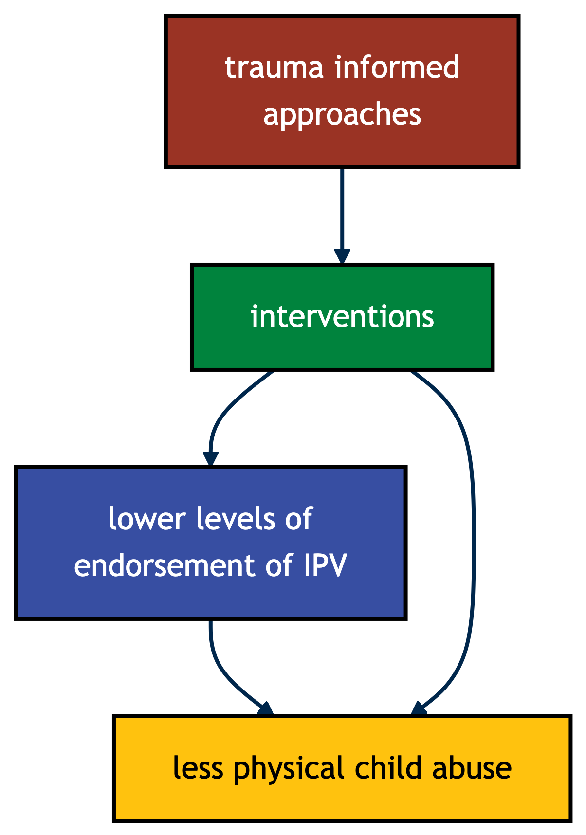

Ma, Julie, Andrew Grogan-Kaylor, Kaitlin P. Ward, Elizabeth H. Boyle, Olivia D. Chang, and Garrett T. Pace. 2025. “Spillover of Macro-Level Violence to Parental Physical Abuse of Children in Low- and Middle-Income Countries.” Child Abuse & Neglect 164 (June): 107468. https://doi.org/10.1016/j.chiabu.2025.107468.

