Social Service Agency Example

Andy Grogan-Kaylor

10/9/2020

Table of Contents

## Social Service Agency

This is an example report using the *simulated* social service agency data.

library(readxl) # to read Excel data  
  
social_service_agency <- read_excel("social-service-agency.xlsx",   
 sheet = "clients")

## Including Plots

You can also embed plots, for example:

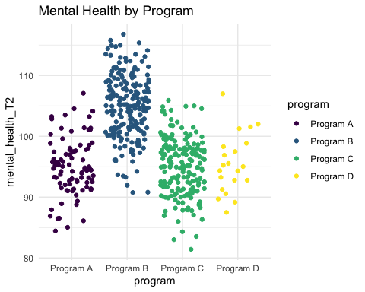

Remember that more ideas for geometries are here: <https://agrogan1.github.io/myposts/comparing-program-outcomes-with-ggplot2.html>

Note that the echo = FALSE parameter was added to the code chunk to prevent printing of the R code that generated the plot.