Data Driven Document Demo

Andrew Grogan-Kaylor

2025-04-22

Table of contents

# 1. Background

Life expectancy differs in countries around the world. Life expectancy and *per capita* *Gross Domestic Product* (GDP) appear to be related.

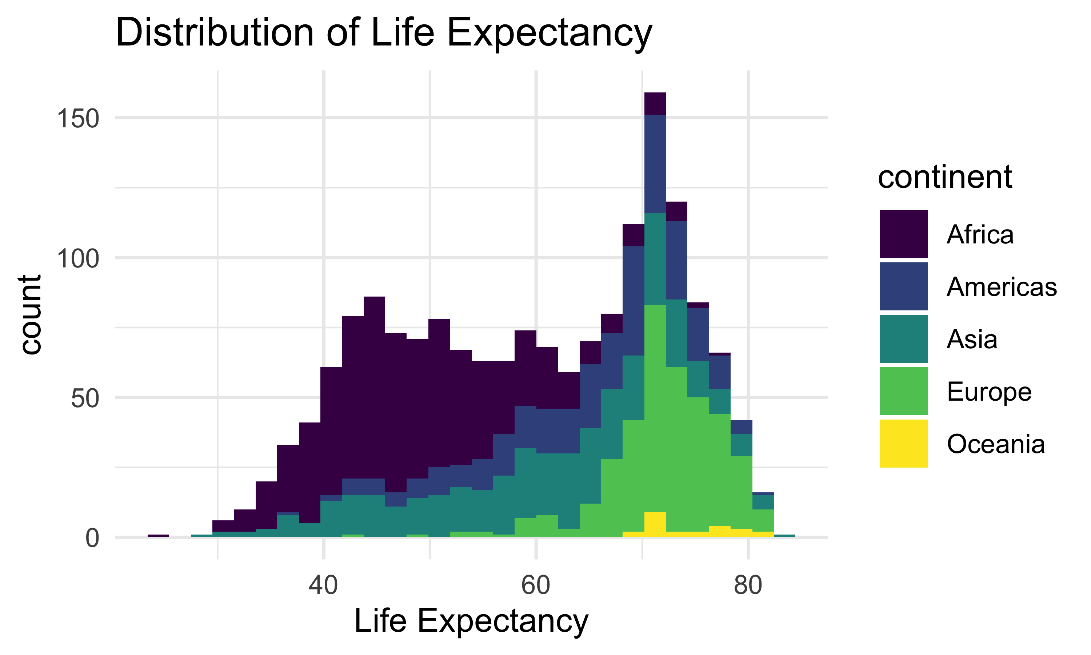

# 2. Methods

Data were provided via the gapminder library which provides a sample of data available on [gapminder.org](http://www.gapminder.org)

# 3. Results

Results indicate the per capita GDP and life expectancy are related in a non-linear way.

## 3.1 Graph

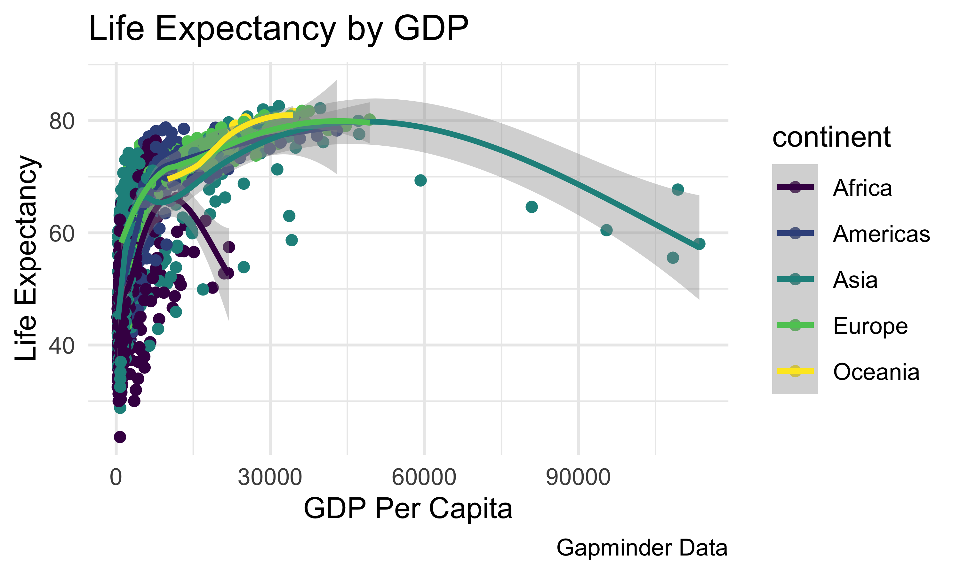

## 3.2 Table

Life Expectancy

| Min. | 1st Qu. | Median | Mean | 3rd Qu. | Max. |
| --- | --- | --- | --- | --- | --- |
| 23.6 | 48.2 | 60.71 | 59.47 | 70.85 | 82.6 |

GDP Per Capita

| Min. | 1st Qu. | Median | Mean | 3rd Qu. | Max. |
| --- | --- | --- | --- | --- | --- |
| 241.2 | 1202 | 3532 | 7215 | 9325 | 113523 |

# 4. Discussion

*Per capita* GDP and life expectancy appear to be related. These findings may have implications for public health policy, for development policy, for intervention, and for advocacy.