Workshop on Multilevel Modeling

Andy Grogan-Kaylor

8 Feb 2023 12:17:17

# Navigation

When this document is presented in slide show format, some slides may be long, and you may need to scroll down to see the full slide. In slide show format b makes text bigger, and s makes text smaller.

# Cross Sectional Model

## Get Data

. use "../multilevel-thinking/simulate-and-analyze-multilevel-data/simulated_multilevel_data.d  
> ta", clear

## The Equation

## Descriptive Statistics

. summarize // descriptive statistics  
  
 Variable │ Obs Mean Std. dev. Min Max  
─────────────┼─────────────────────────────────────────────────────────  
 country │ 3,000 15.5 8.656884 1 30  
 HDI │ 3,000 64.76667 17.24562 33 87  
 family │ 3,000 50.5 28.87088 1 100  
 id │ 0  
 group │ 3,000 1.496 .5000674 1 2  
─────────────┼─────────────────────────────────────────────────────────  
physical_p~t │ 3,000 1.516 1.884744 -2 5  
 warmth │ 3,000 2.543667 2.431336 -2 7  
 outcome │ 3,000 53.45039 6.884502 25.02363 81.63657

## Spaghetti Plot

. spagplot outcome warmth, id(country) scheme(s1color)  
  
.   
. graph export spagplot1.png, width(1000) replace  
file /Users/agrogan/Desktop/GitHub/multilevel-workshop/spagplot1.png saved as PNG format

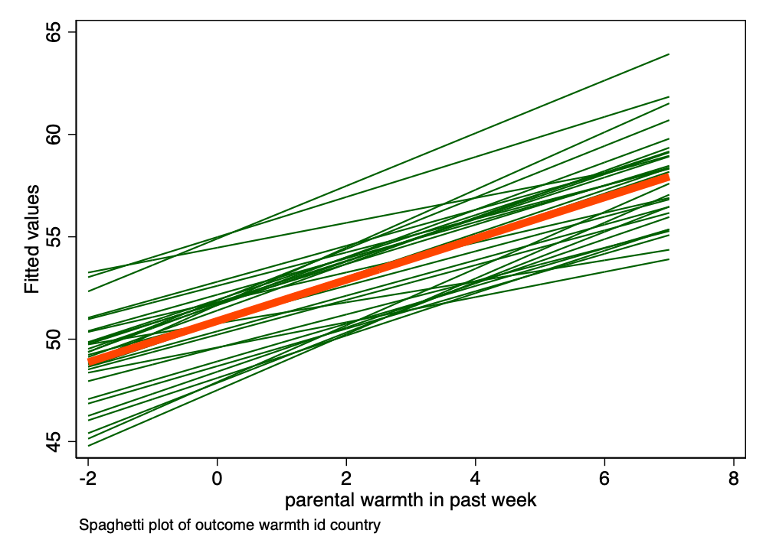

Spaghetti Plot of Outcome by Warmth by Country

## Unconditional Model

### Model

. mixed outcome || country: // unconditional model  
  
Performing EM optimization:   
  
Performing gradient-based optimization:   
  
Iteration 0: log likelihood = -9956.6096   
Iteration 1: log likelihood = -9956.6096   
  
Computing standard errors:  
  
Mixed-effects ML regression Number of obs = 3,000  
Group variable: country Number of groups = 30  
 Obs per group:  
 min = 100  
 avg = 100.0  
 max = 100  
 Wald chi2(0) = .  
Log likelihood = -9956.6096 Prob > chi2 = .  
  
─────────────┬────────────────────────────────────────────────────────────────  
 outcome │ Coefficient Std. err. z P>|z| [95% conf. interval]  
─────────────┼────────────────────────────────────────────────────────────────  
 _cons │ 53.45039 .3702932 144.35 0.000 52.72463 54.17615  
─────────────┴────────────────────────────────────────────────────────────────  
  
─────────────────────────────┬────────────────────────────────────────────────  
 Random-effects parameters │ Estimate Std. err. [95% conf. interval]  
─────────────────────────────┼────────────────────────────────────────────────  
country: Identity │  
 var(_cons) │ 3.676471 1.062168 2.086944 6.476667  
─────────────────────────────┼────────────────────────────────────────────────  
 var(Residual) │ 43.70413 1.134121 41.53688 45.98446  
─────────────────────────────┴────────────────────────────────────────────────  
LR test vs. linear model: chibar2(01) = 175.05 Prob >= chibar2 = 0.0000

### ICC

. estat icc  
  
Intraclass correlation  
  
─────────────────────────────┬────────────────────────────────────────────────  
 Level │ ICC Std. err. [95% conf. interval]  
─────────────────────────────┼────────────────────────────────────────────────  
 country │ .0775944 .0207813 .0454528 .129384  
─────────────────────────────┴────────────────────────────────────────────────

## Full Model

. mixed outcome warmth physical_punishment || country: warmth // multilevel model  
  
Performing EM optimization:   
  
Performing gradient-based optimization:   
  
Iteration 0: log likelihood = -9622.5983   
Iteration 1: log likelihood = -9622.076   
Iteration 2: log likelihood = -9622.0697   
Iteration 3: log likelihood = -9622.0697   
  
Computing standard errors:  
  
Mixed-effects ML regression Number of obs = 3,000  
Group variable: country Number of groups = 30  
 Obs per group:  
 min = 100  
 avg = 100.0  
 max = 100  
 Wald chi2(2) = 749.92  
Log likelihood = -9622.0697 Prob > chi2 = 0.0000  
  
────────────────────┬────────────────────────────────────────────────────────────────  
 outcome │ Coefficient Std. err. z P>|z| [95% conf. interval]  
────────────────────┼────────────────────────────────────────────────────────────────  
 warmth │ .9822454 .0445447 22.05 0.000 .8949394 1.069551  
physical_punishment │ -.9259144 .0574361 -16.12 0.000 -1.038487 -.8133417  
 _cons │ 52.35557 .3833106 136.59 0.000 51.6043 53.10685  
────────────────────┴────────────────────────────────────────────────────────────────  
  
─────────────────────────────┬────────────────────────────────────────────────  
 Random-effects parameters │ Estimate Std. err. [95% conf. interval]  
─────────────────────────────┼────────────────────────────────────────────────  
country: Independent │  
 var(warmth) │ 4.83e-15 4.20e-14 1.95e-22 1.20e-07  
 var(_cons) │ 3.442879 .9792352 1.971606 6.01206  
─────────────────────────────┼────────────────────────────────────────────────  
 var(Residual) │ 34.91739 .9061059 33.18587 36.73927  
─────────────────────────────┴────────────────────────────────────────────────  
LR test vs. linear model: chi2(2) = 210.33 Prob > chi2 = 0.0000  
  
Note: LR test is conservative and provided only for reference.  
  
.   
. est store crosssectional // store estimates

# Longitudinal Model

## Setup

. use "../multilevel-thinking/simulate-and-analyze-multilevel-data/simulated_multilevel_longit  
> udinal_data.dta", clear

## The Equation

## Descriptive Statistics

. summarize // descriptive statistics  
  
 Variable │ Obs Mean Std. dev. Min Max  
─────────────┼─────────────────────────────────────────────────────────  
 country │ 9,000 15.5 8.655922 1 30  
 HDI │ 9,000 64.76667 17.2437 33 87  
 family │ 9,000 50.5 28.86767 1 100  
 id │ 0  
 group │ 9,000 1.496 .5000118 1 2  
─────────────┼─────────────────────────────────────────────────────────  
 t │ 9,000 2 .8165419 1 3  
physical_p~t │ 9,000 1.517111 1.884289 -2 5  
 warmth │ 9,000 2.533778 2.449075 -2 7  
 outcome │ 9,000 54.43846 7.019933 25.02363 81.63657

## Alternate Plot

. encode id, generate(idNUMERIC) // numeric version of id  
  
.   
. * spagplot outcome t if idNUMERIC <= 10, id(idNUMERIC) scheme(s1color)  
.   
. twoway (lfit outcome t) (scatter outcome t) if idNUMERIC <= 10, by(idNUMERIC) scheme(s1color  
> )  
  
.   
. graph export spagplot2.png, width(1000) replace  
file /Users/agrogan/Desktop/GitHub/multilevel-workshop/spagplot2.png saved as PNG format

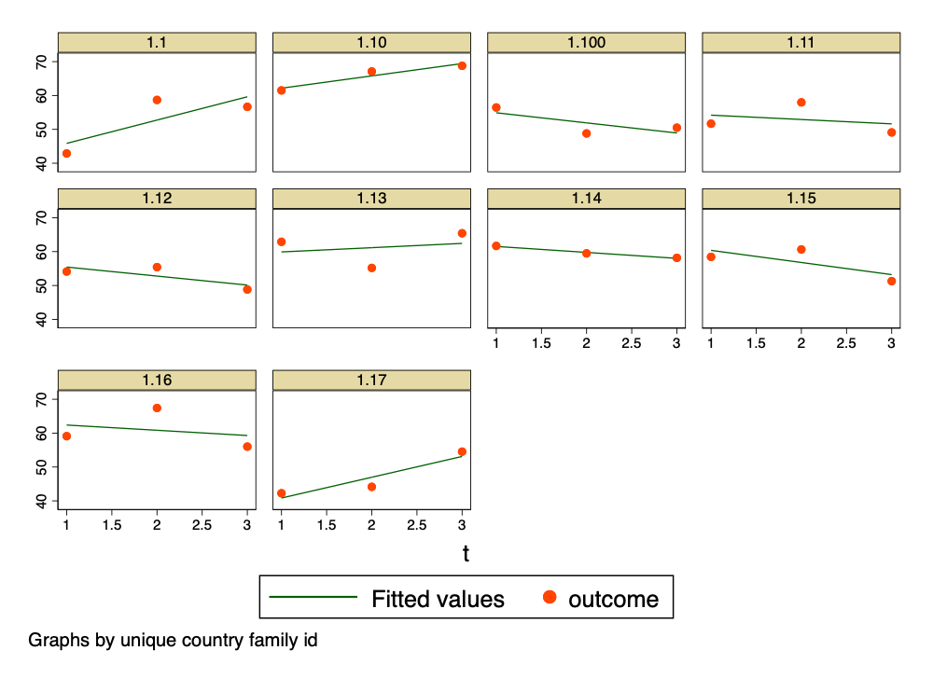

Alternate Plot of Outcome by Time by Individual; First 10 Observations

## Unconditional Model

### Model

. mixed outcome || country: || id: // unconditional model  
  
Performing EM optimization:   
  
Performing gradient-based optimization:   
  
Iteration 0: log likelihood = -29398.984   
Iteration 1: log likelihood = -29398.984   
  
Computing standard errors:  
  
Mixed-effects ML regression Number of obs = 9,000  
  
 Grouping information  
 ────────────────┬────────────────────────────────────────────  
 │ No. of Observations per group  
 Group variable │ groups Minimum Average Maximum  
 ────────────────┼────────────────────────────────────────────  
 country │ 30 300 300.0 300  
 id │ 3,000 3 3.0 3  
 ────────────────┴────────────────────────────────────────────  
  
 Wald chi2(0) = .  
Log likelihood = -29398.984 Prob > chi2 = .  
  
─────────────┬────────────────────────────────────────────────────────────────  
 outcome │ Coefficient Std. err. z P>|z| [95% conf. interval]  
─────────────┼────────────────────────────────────────────────────────────────  
 _cons │ 54.43846 .3767998 144.48 0.000 53.69995 55.17698  
─────────────┴────────────────────────────────────────────────────────────────  
  
─────────────────────────────┬────────────────────────────────────────────────  
 Random-effects parameters │ Estimate Std. err. [95% conf. interval]  
─────────────────────────────┼────────────────────────────────────────────────  
country: Identity │  
 var(_cons) │ 3.995172 1.099853 2.329182 6.85279  
─────────────────────────────┼────────────────────────────────────────────────  
id: Identity │  
 var(_cons) │ 16.98591 .7068169 15.65556 18.42931  
─────────────────────────────┼────────────────────────────────────────────────  
 var(Residual) │ 28.29352 .5165663 27.29897 29.3243  
─────────────────────────────┴────────────────────────────────────────────────  
LR test vs. linear model: chi2(2) = 1819.49 Prob > chi2 = 0.0000  
  
Note: LR test is conservative and provided only for reference.

### ICC

. estat icc  
  
Intraclass correlation  
  
─────────────────────────────┬────────────────────────────────────────────────  
 Level │ ICC Std. err. [95% conf. interval]  
─────────────────────────────┼────────────────────────────────────────────────  
 country │ .0810797 .0205569 .0488675 .1315879  
 id|country │ .4257992 .0163912 .3940284 .4581946  
─────────────────────────────┴────────────────────────────────────────────────

## Full Model

. mixed outcome t warmth physical_punishment || country: warmth || id: t // multilevel model  
  
Performing EM optimization:   
  
Performing gradient-based optimization:   
  
Iteration 0: log likelihood = -28560.856   
Iteration 1: log likelihood = -28539.271   
Iteration 2: log likelihood = -28539.01   
Iteration 3: log likelihood = -28538.97   
Iteration 4: log likelihood = -28538.966   
Iteration 5: log likelihood = -28538.966   
  
Computing standard errors:  
  
Mixed-effects ML regression Number of obs = 9,000  
  
 Grouping information  
 ────────────────┬────────────────────────────────────────────  
 │ No. of Observations per group  
 Group variable │ groups Minimum Average Maximum  
 ────────────────┼────────────────────────────────────────────  
 country │ 30 300 300.0 300  
 id │ 3,000 3 3.0 3  
 ────────────────┴────────────────────────────────────────────  
  
 Wald chi2(3) = 1796.70  
Log likelihood = -28538.966 Prob > chi2 = 0.0000  
  
────────────────────┬────────────────────────────────────────────────────────────────  
 outcome │ Coefficient Std. err. z P>|z| [95% conf. interval]  
────────────────────┼────────────────────────────────────────────────────────────────  
 t │ .9929284 .0658203 15.09 0.000 .863923 1.121934  
 warmth │ 1.047035 .0336035 31.16 0.000 .9811738 1.112897  
physical_punishment │ -.9405095 .0383163 -24.55 0.000 -1.015608 -.8654109  
 _cons │ 51.22522 .3885182 131.85 0.000 50.46373 51.9867  
────────────────────┴────────────────────────────────────────────────────────────────  
  
─────────────────────────────┬────────────────────────────────────────────────  
 Random-effects parameters │ Estimate Std. err. [95% conf. interval]  
─────────────────────────────┼────────────────────────────────────────────────  
country: Independent │  
 var(warmth) │ .0064869 .0085229 .0004939 .0851915  
 var(_cons) │ 3.557187 .9801715 2.072816 6.104534  
─────────────────────────────┼────────────────────────────────────────────────  
id: Independent │  
 var(t) │ 2.16e-07 1.79e-07 4.26e-08 1.09e-06  
 var(_cons) │ 8.894507 .4833934 7.995788 9.894241  
─────────────────────────────┼────────────────────────────────────────────────  
 var(Residual) │ 25.99026 .4745961 25.07652 26.9373  
─────────────────────────────┴────────────────────────────────────────────────  
LR test vs. linear model: chi2(4) = 1340.10 Prob > chi2 = 0.0000  
  
Note: LR test is conservative and provided only for reference.  
  
.   
. est store longitudinal // store estimates

# Nice Table of Results

. est table crosssectional longitudinal, ///  
> b(%9.3f) star stats(N ll chi2) ///  
> varwidth(20) modelwidth(15)  
  
─────────────────────┬──────────────────────────────────────────  
 Variable │ crosssectional longitudinal   
─────────────────────┼──────────────────────────────────────────  
outcome │  
 warmth │ 0.982*** 1.047***   
 physical_punishment │ -0.926*** -0.941***   
 t │ 0.993***   
 _cons │ 52.356*** 51.225***   
─────────────────────┼──────────────────────────────────────────  
lns1_1_1 │  
 _cons │ -16.482*** -2.519***   
─────────────────────┼──────────────────────────────────────────  
lns1_1_2 │  
 _cons │ 0.618*** 0.634***   
─────────────────────┼──────────────────────────────────────────  
lnsig_e │  
 _cons │ 1.776*** 1.629***   
─────────────────────┼──────────────────────────────────────────  
lns2_1_1 │  
 _cons │ -7.674***   
─────────────────────┼──────────────────────────────────────────  
lns2_1_2 │  
 _cons │ 1.093***   
─────────────────────┼──────────────────────────────────────────  
Statistics │   
 N │ 3000 9000   
 ll │ -9622.070 -2.85e+04   
 chi2 │ 749.924 1796.701   
─────────────────────┴──────────────────────────────────────────  
 Legend: * p<0.05; ** p<0.01; *** p<0.001

# QUESTIONS???