Bayesian Longitudinal Multilevel Models

2021-08-24

Table of Contents

# Gutten Tree Data

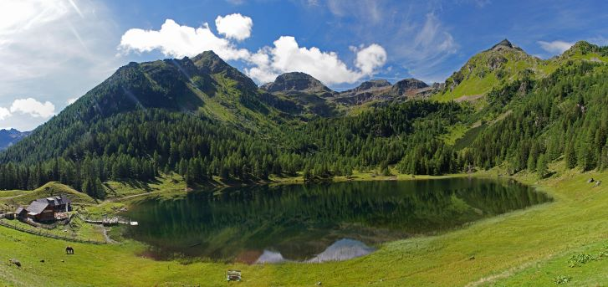

Norway Spruce and Larch Forest in Austrian Alps, <https://ec.europa.eu/jrc/en/research-topic/forestry/qr-tree-project/norway-spruce>

The data used in this example are derived from the R package *Functions and Datasets for “Forest Analytics with R”*.

According to the documentation, the source of these data are: “von Guttenberg’s Norway spruce (Picea abies [L.] Karst) tree measurement data.”

The documentation goes on to further note that:

“The data are measures from 107 trees. The trees were selected as being of average size from healthy and well stocked stands in the Alps.”

# Import The Data 🌲

## # A tibble: 1,200 x 9  
## site location tree age_base height dbh_cm volume age_bh tree_ID  
## <dbl+lbl> <dbl+lbl> <dbl> <dbl> <dbl> <dbl> <dbl> <dbl> <dbl+lbl>  
## 1 1 [1] 1 [1] 1 20 4.2 4.6 5 9.67 1 [1.1]  
## 2 1 [1] 1 [1] 1 30 9.3 10.2 38 19.7 1 [1.1]  
## 3 1 [1] 1 [1] 1 40 14.9 14.9 123 29.7 1 [1.1]  
## 4 1 [1] 1 [1] 1 50 19.7 18.3 263 39.7 1 [1.1]  
## 5 1 [1] 1 [1] 1 60 23 20.7 400 49.7 1 [1.1]  
## 6 1 [1] 1 [1] 1 70 25.8 22.6 555 59.7 1 [1.1]  
## 7 1 [1] 1 [1] 1 80 27.4 24.1 688 69.7 1 [1.1]  
## 8 1 [1] 1 [1] 1 90 28.8 25.5 820 79.7 1 [1.1]  
## 9 1 [1] 1 [1] 1 100 30 26.5 928 89.7 1 [1.1]  
## 10 1 [1] 1 [1] 1 110 30.9 27.3 1023 99.7 1 [1.1]  
## # … with 1,190 more rows

# Variables 🌲

site Growth *quality* class of the tree’s habitat. 5 levels.

location Distinguishes tree *location*. 7 levels.

tree An identifier for the tree within location.

age.base The tree age taken at ground level.

height Tree height, m.

dbh.cm Tree diameter, cm.

volume Tree volume.

age.bh Tree age taken at 1.3 m.

tree.ID A factor uniquely identifying the tree.

# A Basic Multilevel Model

$${\text{height}}_{it}=β_{0}+β\text{age_base}+β\text{site}+u_{0\text{ tree.ID}}+e_{it}$$