Multilevel Models with the Von Guttenberg Tree Data

Andy Grogan-Kaylor

25 Aug 2021 10:06:11

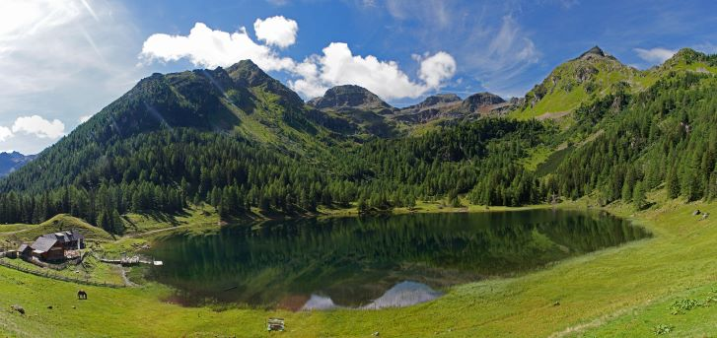

Norway Spruce and Larch Forest in Austrian Alps, https://ec.europa.eu/jrc/en/research-topic/forestry/qr-tree-project/norway-spruce

# Data Source 🌲

The data used in this example are derived from the R package *Functions and Datasets for “Forest Analytics with R”*.

According to the documentation, the source of these data are: “von Guttenberg’s Norway spruce (Picea abies [L.] Karst) tree measurement data.”

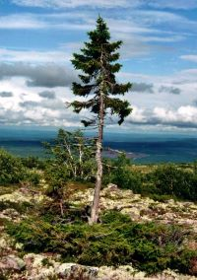

Old Tjikko, a 9,550 Year Old Norway Spruce in Sweden

The documentation goes on to further note that:

“The data are measures from 107 trees. The trees were selected as being of average size from healthy and well stocked stands in the Alps.”

. use gutten.dta, clear

use "https://github.com/agrogan1/newstuff/raw/master/mlm-R2-gutten/gutten.dta", clear should work to obtain the data over the web. Please let me know if it does not.

# Variables 🌲

site Growth *quality* class of the tree’s habitat. 5 levels.

location Distinguishes tree *location*. 7 levels.

tree An identifier for the tree within location.

age.base The tree age taken at ground level.

It might be best to use a centered age variable, centered at the grand mean of tree age:

. egen ageMEAN = mean(age_base)

. generate ageCENTERED = age_base - ageMEAN

height Tree height, m.

dbh.cm Tree diameter, cm.

volume Tree volume.

age.bh Tree age taken at 1.3 m.

tree.ID A factor uniquely identifying the tree.

# Your Quantitative Forestry Tasks (Should You Choose To Accept Them) 🌲

I clearly need to learn more about quantitative approaches to forestry, but I would like to model tree height as a function of tree age (measured at base), site, and location.

# Spaghetti Plot 🌲

Use spagplot to examine these relationships. Remember that the spagplot syntax is spagplot y x, id(id). What is the most appropriate id variable here?

. spagplot height ageCENTERED, id(tree_ID) scheme(michigan)

. graph export myspagplot.png, width(500) replace  
file /Users/agrogan/Desktop/GitHub/multilevel/mlm-gutten/myspagplot.png saved as PNG format

spagplot height ageCENTERED, id(tree_ID) scheme(s1rcolor) also works well here.

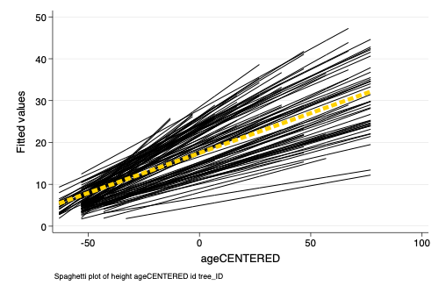

Spaghetti Plot of Predicted Height by Age

# Multilevel Models 🌲

## Unconditional Model

Run an unconditional model with mixed. What Stata syntax do you use? What is the corresponding equation? What question is this syntax and equation asking and answering? Calculate the ICC. What does this number tell you?

## Conditional Model

Now run a model with mixed where you examine the relationship of tree age, site, and location with tree height. Do any of your variables need to be treated as indicator (i.) variables?

What Stata syntax do you use? What is the corresponding equation? What question is this syntax and equation asking and answering? What do you find?

What if you examine as part of your model?

generate ageMEAN2 = ageMEAN^2

Does the ICC have any meaning after your *conditional* model?