Contingency Tables

Andy Grogan-Kaylor

9 Sep 2023

# Key Concepts and Commands

* Matrices of data
* Probabilities, risks, and odds
* Tests
* tabulate x y, row col chi2

# Flipping Two Coins



Coin Emoji From Apple



Coin Emoji From Apple

# Setup

. clear all

. set seed 3846

Good value labels are **key** here.

. label define nickel ///  
> 1 "heads for nickel" ///   
> 0 "tails for nickel" // define value label

. label define quarter ///   
> 1 "heads for quarter" ///   
> 0 "tails for quarter" // define value label

. set obs 1000 // 1000 observations  
Number of observations (_N) was 0, now 1,000.

. * curiously it takes around 1000 obs for the proportions  
. * below to "take hold"

. generate nickel = rbinomial(1, .75) // unfair nickel

. generate quarter = rbinomial(1, .5) // fair quarter

. label values nickel nickel // assign value label

. label values quarter quarter // assign value label

# The Graph We Think We Want But Don’t

. graph bar, over(nickel) scheme(burd) title(Nickel) name(nickel)

. graph bar, over(quarter) scheme(burd) title(Quarter) name(quarter)

. graph combine nickel quarter, title(Nickel And Quarter) scheme(burd)

. graph export unhelpfulgraph.png, width(500) replace  
file  
 /Users/agrogan/Desktop/GitHub/newstuff/categorical/contingency-tables/unhelpfulgraph.p  
 > ng saved as PNG format

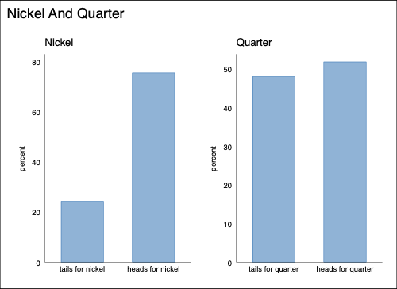

A Graph That May Not Be That Helpful

# Crosstabulation

. tabulate nickel quarter, row col  
  
┌───────────────────┐  
│ Key │  
├───────────────────┤  
│ frequency │  
│ row percentage │  
│ column percentage │  
└───────────────────┘  
  
 │ quarter  
 nickel │ tails for heads for │ Total  
─────────────────┼──────────────────────┼──────────  
tails for nickel │ 104 140 │ 244   
 │ 42.62 57.38 │ 100.00   
 │ 21.62 26.97 │ 24.40   
─────────────────┼──────────────────────┼──────────  
heads for nickel │ 377 379 │ 756   
 │ 49.87 50.13 │ 100.00   
 │ 78.38 73.03 │ 75.60   
─────────────────┼──────────────────────┼──────────  
 Total │ 481 519 │ 1,000   
 │ 48.10 51.90 │ 100.00   
 │ 100.00 100.00 │ 100.00

# Graphing (Mosaic Plot)

. * ssc install spineplot // mosaicplots (spineplots)

. * ssc install scheme-burd, replace // BuRd graph scheme

. spineplot nickel quarter, scheme(burd)

. graph export nickel-quarter.png, width(500) replace  
file  
 /Users/agrogan/Desktop/GitHub/newstuff/categorical/contingency-tables/nickel-quarter.p  
 > ng saved as PNG format

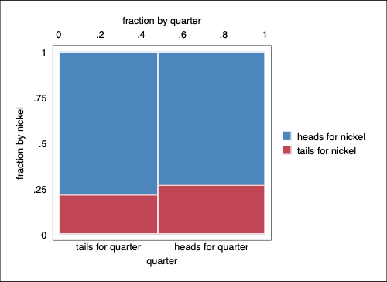

Mosaic Plot

# Bar Chart

Does a bar chart work to visualize these relationships?

. graph bar, over(quarter) over(nickel) scheme(burd)

. graph export nickel-quarter-bar1.png, width(500) replace  
file  
 /Users/agrogan/Desktop/GitHub/newstuff/categorical/contingency-tables/nickel-quarter-b  
 > ar1.png saved as PNG format

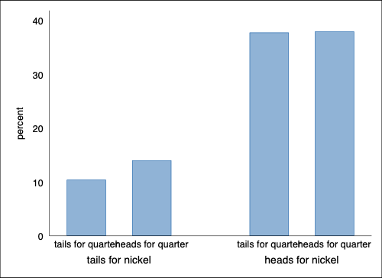

Bar Chart 1

# Bar Chart (2)

Option asyvars adds a crucial color element.

. graph bar, over(quarter) over(nickel) scheme(burd) asyvars

. graph export nickel-quarter-bar2.png, width(500) replace  
file  
 /Users/agrogan/Desktop/GitHub/newstuff/categorical/contingency-tables/nickel-quarter-b  
 > ar2.png saved as PNG format

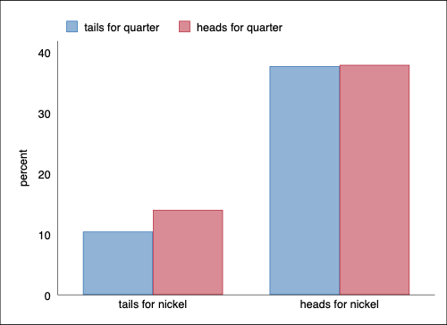

Bar Chart 2

# Horizontal Bar Chart

And hbar may improve legibility even more.

. graph hbar, over(quarter) over(nickel) scheme(burd) asyvars

. graph export nickel-quarter-bar3.png, width(500) replace  
file  
 /Users/agrogan/Desktop/GitHub/newstuff/categorical/contingency-tables/nickel-quarter-b  
 > ar3.png saved as PNG format

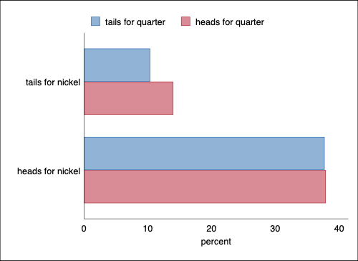

Bar Chart 3

# 1961 French Skiiers

. clear all

# Define Matrix

. matrix input FrenchSkiiers = (31, 109 \ 17, 122)

. matrix rownames FrenchSkiiers = Placebo AscorbicAcid

. matrix colnames FrenchSkiiers = Cold NoCold

. matrix list FrenchSkiiers  
  
FrenchSkiiers[2,2]  
 Cold NoCold  
 Placebo 31 109  
AscorbicAcid 17 122

# Theme Music

[Polo And Pan on Spotify](https://open.spotify.com/track/260V7huyJrXnyYe0dFv2Fa)

# Try Making a Data Set From Matrix

. svmat FrenchSkiiers, name(count)  
number of observations will be reset to 2  
Press any key to continue, or Break to abort  
Number of observations (_N) was 0, now 2.

. list  
  
 ┌─────────────────┐  
 │ count1 count2 │  
 ├─────────────────┤  
 1. │ 31 109 │  
 2. │ 17 122 │  
 └─────────────────┘

# Enter Data By Hand

There are many alternative commands to do this, but the easiest way is using edit.

I have already done this. Note the structure of the data is different from above.

. use "FrenchSkiiers.dta", clear

. list // list the data  
  
 ┌─────────────────────────────────┐  
 │ Tx Outcome Count │  
 ├─────────────────────────────────┤  
 1. │ Ascorbic Acid Cold 17 │  
 2. │ Ascorbic Acid No Cold 122 │  
 3. │ Placebo Cold 31 │  
 4. │ Placebo No Cold 109 │  
 └─────────────────────────────────┘

# Mosaic Plot

. spineplot Tx Outcome, scheme(burd)

. graph export FrenchSkiiers1.png, width(500) replace  
file  
 /Users/agrogan/Desktop/GitHub/newstuff/categorical/contingency-tables/FrenchSkiiers1.p  
 > ng saved as PNG format

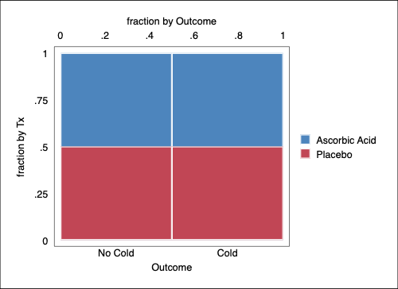

Mosaic Plot Attempt 1

# Mosaic Plot (2)

. spineplot Outcome Tx [fweight=Count], scheme(burd) // order matters to interpretability

. graph export FrenchSkiiers2.png, width(500) replace  
file  
 /Users/agrogan/Desktop/GitHub/newstuff/categorical/contingency-tables/FrenchSkiiers2.p  
 > ng saved as PNG format

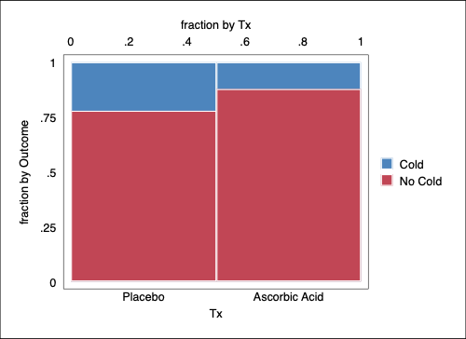

Mosaic Plot Attempt 2

# Definitions and Notation

## Counts

## Probabilities

# Terms

are *joint* probabilities.

and are *marginal* probabilities.

and are *conditional* probabilities.

# Formulas

## Counts

## Probabilities

## Expected Probabilities and Counts or Frequencies

Observed counts are represented by while expected counts are represented by .

# Fundamental Rule

. tabulate Tx Outcome [fweight = Count], cell row col  
  
┌───────────────────┐  
│ Key │  
├───────────────────┤  
│ frequency │  
│ row percentage │  
│ column percentage │  
│ cell percentage │  
└───────────────────┘  
  
 │ Outcome  
 Tx │ No Cold Cold │ Total  
──────────────┼──────────────────────┼──────────  
 Placebo │ 109 31 │ 140   
 │ 77.86 22.14 │ 100.00   
 │ 47.19 64.58 │ 50.18   
 │ 39.07 11.11 │ 50.18   
──────────────┼──────────────────────┼──────────  
Ascorbic Acid │ 122 17 │ 139   
 │ 87.77 12.23 │ 100.00   
 │ 52.81 35.42 │ 49.82   
 │ 43.73 6.09 │ 49.82   
──────────────┼──────────────────────┼──────────  
 Total │ 231 48 │ 279   
 │ 82.80 17.20 │ 100.00   
 │ 100.00 100.00 │ 100.00   
 │ 82.80 17.20 │ 100.00

. display 6.09 / 49.82  
.12224006

. display 17/139  
.12230216

# Independence (Robert Mare)

If independence is true, then joint probabilities = products of marginal probabilities.

That is, under independence, the conditional distribution equals the marginal distribution.

Under independence, row membership provides no information about the column distribution; and column membership provides no information about the row distribution.

Independence is a model, which is never exactly true in the real world.

# Observed vs. Expected

. tabulate Tx Outcome [fweight = Count]  
  
 │ Outcome  
 Tx │ No Cold Cold │ Total  
──────────────┼──────────────────────┼──────────  
 Placebo │ 109 31 │ 140   
Ascorbic Acid │ 122 17 │ 139   
──────────────┼──────────────────────┼──────────  
 Total │ 231 48 │ 279

. scalar N = 31 + 109 + 17 + 122

. scalar A = ((31 + 17)*(31 + 109)) / N // expected count

. scalar B = ((31 + 109)*(109 + 122)) / N // expected count

. scalar C = ((31 + 17) * (17 + 122)) / N // expected count

. scalar D = ((17 + 122) * (109 + 122)) / N // expected count

. matrix FS = (A, B \ C, D) // matrix of expected values

. matrix rownames FS = Placebo AscorbicAcid // rownames

. matrix colnames FS = Cold NoCold // column names

. matrix list FS  
  
FS[2,2]  
 Cold NoCold  
 Placebo 24.086022 115.91398  
AscorbicAcid 23.913978 115.08602

# Chi-Square Test

. scalar chisquare = (31 - 24.086022)^2 / 24.086022 + ///   
> (109 - 115.91398)^2 / 115.91398 + ///  
> (17 - 23.913978)^2 / 23.913978 + ///   
> (122 - 115.08602)^2 / 115.08602

. scalar list chisquare  
 chisquare = 4.8114124

# Compare With Tabulate

. use "FrenchSkiiers.dta", clear

. tabulate Tx Outcome [fweight = Count], row col chi2  
  
┌───────────────────┐  
│ Key │  
├───────────────────┤  
│ frequency │  
│ row percentage │  
│ column percentage │  
└───────────────────┘  
  
 │ Outcome  
 Tx │ No Cold Cold │ Total  
──────────────┼──────────────────────┼──────────  
 Placebo │ 109 31 │ 140   
 │ 77.86 22.14 │ 100.00   
 │ 47.19 64.58 │ 50.18   
──────────────┼──────────────────────┼──────────  
Ascorbic Acid │ 122 17 │ 139   
 │ 87.77 12.23 │ 100.00   
 │ 52.81 35.42 │ 49.82   
──────────────┼──────────────────────┼──────────  
 Total │ 231 48 │ 279   
 │ 82.80 17.20 │ 100.00   
 │ 100.00 100.00 │ 100.00   
  
 Pearson chi2(1) = 4.8114 Pr = 0.028

# Risk Differences and Risk Ratios (Relative Risk)

Following Viera, 2008:

|  | Develop Outcome | Do Not Develop Outcome |
| --- | --- | --- |
| Exposed | a | b |
| Not Exposed | c | d |

(in Exposed)

# Calculating a Risk Ratio

. tabulate Outcome Tx [fweight = Count]  
  
 │ Tx  
 Outcome │ Placebo Ascorbic │ Total  
───────────┼──────────────────────┼──────────  
 No Cold │ 109 122 │ 231   
 Cold │ 31 17 │ 48   
───────────┼──────────────────────┼──────────  
 Total │ 140 139 │ 279

. tabulate Outcome Tx [fweight = Count], col  
  
┌───────────────────┐  
│ Key │  
├───────────────────┤  
│ frequency │  
│ column percentage │  
└───────────────────┘  
  
 │ Tx  
 Outcome │ Placebo Ascorbic │ Total  
───────────┼──────────────────────┼──────────  
 No Cold │ 109 122 │ 231   
 │ 77.86 87.77 │ 82.80   
───────────┼──────────────────────┼──────────  
 Cold │ 31 17 │ 48   
 │ 22.14 12.23 │ 17.20   
───────────┼──────────────────────┼──────────  
 Total │ 140 139 │ 279   
 │ 100.00 100.00 │ 100.00

. display 31/140  
.22142857

. display 17/139  
.12230216

. display (17/139) / (31/140)  
.55233233

. csi 17 31 122 109 // also has an intuitive dialog box  
  
 │ Exposed Unexposed │ Total  
─────────────────┼────────────────────────┼───────────  
 Cases │ 17 31 │ 48  
 Noncases │ 122 109 │ 231  
─────────────────┼────────────────────────┼───────────  
 Total │ 139 140 │ 279  
 │ │  
 Risk │ .1223022 .2214286 │ .172043  
 │ │  
 │ Point estimate │ [95% conf. interval]  
 ├────────────────────────┼────────────────────────  
 Risk difference │ -.0991264 │ -.1868592 -.0113937   
 Risk ratio │ .5523323 │ .3209178 .9506203   
 Prev. frac. ex. │ .4476677 │ .0493797 .6790822   
 Prev. frac. pop │ .2230316 │  
 └────────────────────────┴────────────────────────  
 chi2(1) = 4.81 Pr>chi2 = 0.0283

# Odds Ratios

|  | Develop Outcome | Do Not Develop Outcome |
| --- | --- | --- |
| Exposed | a | b |
| Not Exposed | c | d |

# Properties of the Odds Ratio (Robert Mare)

In general for the 2 X 2 Table,

indicates that one row is less likely to make the first response than the other row.

indicates that one row is more likely to make the first response than the other row.

# Calculate Odds Ratio

. tabulate Tx Outcome [fweight = Count]  
  
 │ Outcome  
 Tx │ No Cold Cold │ Total  
──────────────┼──────────────────────┼──────────  
 Placebo │ 109 31 │ 140   
Ascorbic Acid │ 122 17 │ 139   
──────────────┼──────────────────────┼──────────  
 Total │ 231 48 │ 279

. display (17 * 109)/(122 * 31)  
.48995241

. csi 17 31 122 109, or // also has an intuitive dialog box  
  
 │ Exposed Unexposed │ Total  
─────────────────┼────────────────────────┼───────────  
 Cases │ 17 31 │ 48  
 Noncases │ 122 109 │ 231  
─────────────────┼────────────────────────┼───────────  
 Total │ 139 140 │ 279  
 │ │  
 Risk │ .1223022 .2214286 │ .172043  
 │ │  
 │ Point estimate │ [95% conf. interval]  
 ├────────────────────────┼────────────────────────  
 Risk difference │ -.0991264 │ -.1868592 -.0113937   
 Risk ratio │ .5523323 │ .3209178 .9506203   
 Prev. frac. ex. │ .4476677 │ .0493797 .6790822   
 Prev. frac. pop │ .2230316 │  
 Odds ratio │ .4899524 │ .2588072 .9282861 (Cornfield)  
 └────────────────────────┴────────────────────────  
 chi2(1) = 4.81 Pr>chi2 = 0.0283