Count Regression

Andy Grogan-Kaylor

16 Oct 2021

# Key Concepts and Commands

* formulas are our friends
* Think about IRR’s, predicted counts, non-linearity
* So much of categorical data analysis depends upon arguments for “functional form”. When do we think these arguments are valid?

# The Count



The Count and Friends

# Historical Examples of Count Data 🐎 ☎️ 🏥

* 🐎 Deaths from horsekicks in the Prussian Army
* ☎️ Calls to a call center (business, crisis hotline, etc.)
* 🏥 Arrivals at the Emergency Room

From the Stata documentation:

“Poisson regression fits models of the number of occurrences (counts) of an event. The Poisson distribution has been applied to diverse events, such as the number of soldiers kicked to death by horses in the Prussian army (von Bortkiewicz 1898); the pattern of hits by buzz bombs launched against London during World War II (Clarke 1946); telephone connections to a wrong number (Thorndike 1926); and disease incidence, typically with respect to time, but occasionally with respect to space.”

# Other Canonical Examples of Count Data 🌳🤒

* 🌳🌳🌳 Plants / trees in a field
* 🤒🤒🤒 Cases of disease / unit area

# Poisson Distribution

## Theorizing about the Poisson 🐟🐟🐟 🌲🌲🌲

The Poisson distribution is a modified form of the binomial distribution that is useful for the analysis of phenomena characterized by discrete, rare events. For example, in a study of the distribution of a rare plant among a number of quadrats, a majority of plots may contain no specimens, a smaller number a single plant, and still smaller numbers two, three, or more plants. If a single plant per quadrat is expected, the mean µ = 1 and the “0” and “1” classes occur at 37% each, the “2” class at 18%, the “3” class at 6%, and larger classes take up the remaining 2%. The characteristic test for a Poisson is that the variance equals the mean, which in the plant example means that the rare plant is randomly distributed. Note, that, In the distributions above, as the mean increases towards 10, the distribution approaches normality.

The Poisson may be used to evaluate whether events occur independently in time as well as space. In a classic example, Bortkiewicz (1898) studied the distribution of 122 men kicked to death by horses among ten Prussian army corps over 20 years. In most years in most corps, no one dies from being kicked; in one corp in one year, four men were kicked to death. Does this mean something was amiss in this particular corp? Analysis indicates that the observed frequencies conform quite closely to the expected Poisson frequencies, and that the mean and variance are almost identical, as expected. The corp was just “unlucky” in the sense that it is in the extreme tail of an ordinary run of events.

<http://www.mun.ca/biology/scarr/smcPoisson_distributions.html>

## Reprise of Normal Distribution

Normal distribution:

Standardized Normal Distribution:

2 parameters:

. clear all // clear all for simulated data

. set obs 1000 // number of observations  
Number of observations (_N) was 0, now 1,000.

. generate x = rnormal() // normally distributed random variable

. histogram x, title("Normally Distributed Random Variable") scheme(michigan)  
(bin=29, start=-3.0796595, width=.24185289)

. graph export myhistogram.png, width(500) replace  
file /Users/agrogan/Desktop/GitHub/newstuff/categorical/count-regression/myhistogram.png saved as  
 PNG format

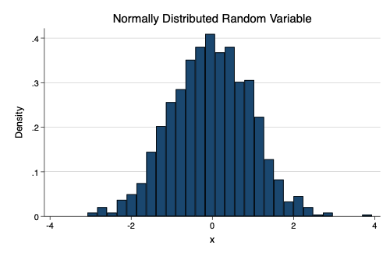

histogram of random normal variable

## Poisson Distribution

A Poisson with large lambda looks very similar to a normal distribution.

. generate w = rpoisson(.5)

. histogram w, title("Poisson Distributed Random Variable") scheme(michigan)  
(bin=29, start=0, width=.13793103)

. graph export myhistogram2.png, width(500) replace  
file /Users/agrogan/Desktop/GitHub/newstuff/categorical/count-regression/myhistogram2.png saved  
 as PNG format

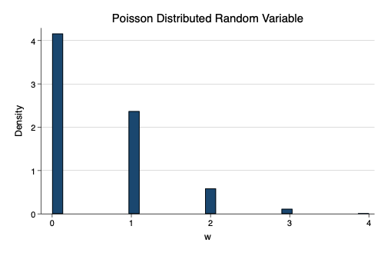

histogram of random Poisson variable

## Poisson is the Natural Form for Observations Distributed in Time or Space 🏛️🏛️🏛️ ⏳⏳⏳

is both mean and variance.

. clear all

. set obs 20  
Number of observations (_N) was 0, now 20.

. generate field = _n // field number

. generate mycount = rpoisson(1)

. expand mycount // create individual observations  
(11 zero counts ignored; observations not deleted)  
(10 observations created)

. generate x = runiform(1,10) // random x coordinate

. generate y =runiform(1,10) // random y coordinate

. generate mylabel = "🦆"

. twoway scatter y x, ///  
> by(field, title("Randomly Located Ducks")) ///  
> mlab(mylabel) mlabsize(vlarge) ///  
> msymbol(none) ///  
> legend(order(1 "🦆 Duck")) ///  
> scheme(michigan) plotr(fcolor(olive_teal))

. graph export ducks.png, width(1000) replace  
file /Users/agrogan/Desktop/GitHub/newstuff/categorical/count-regression/ducks.png saved as PNG  
 format

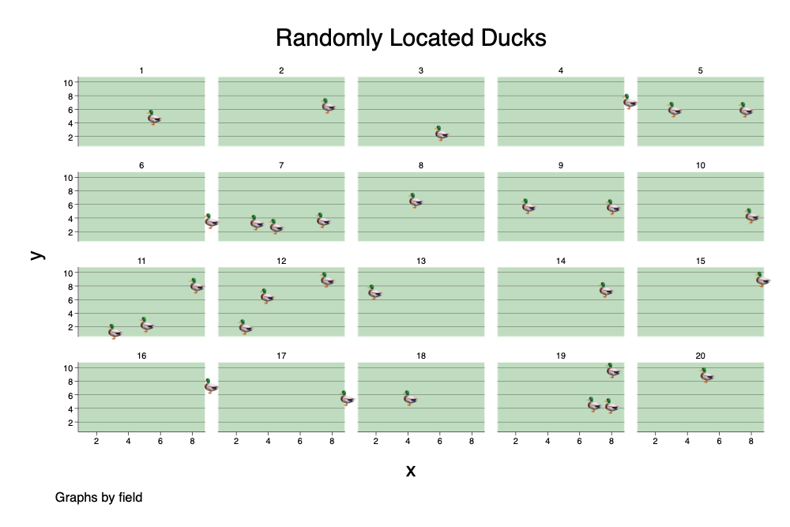

Randomly Located Ducks

. generate t = runiform(1,10) // random time coordinate

. generate y2 = runiform(1,2) // random y coordinate

. generate mylabel2 = "🔥"

. generate timeperiod = field

. twoway scatter y2 t, ///  
> by(timeperiod, title("Forest Fires At Random Times", size(vhuge)) cols(10)) ///  
> ytitle("", size(zero)) ylabel(none) xtitle("", size(zero)) xlabel(none) ///  
> subtitle(, size(vhuge)) ///  
> mlab(mylabel2) mlabsize(vhuge) ///  
> msymbol(none) ///  
> legend(order(1 "🔥 Forest Fire")) ///  
> scheme(michigan) plotr(fcolor(gs14)) ///  
> xsize(5) ysize(1)

. graph export fires.png, width(1000) replace  
file /Users/agrogan/Desktop/GitHub/newstuff/categorical/count-regression/fires.png saved as PNG  
 format

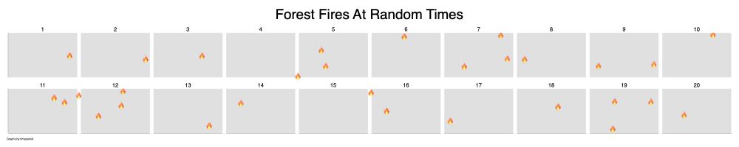

Forest Fires At Random Times

# Poisson Regression

## National Survey of Children’s Health (2018)

The data are an extract of the *National Survey of Children’s Health, 2018*. The data contain information on children’s exposure to various *Adverse Childhood Experiences* (ACEs) and their demographic characteristics.

. clear all

. use "../predict-and-margins-substantive-example/NSCH_ACES.dta", clear

. describe  
  
Contains data from ../predict-and-margins-substantive-example/NSCH_ACES.dta  
 Observations: 30,530   
 Variables: 23 20 Oct 2020 14:50  
───────────────────────────────────────────────────────────────────────────────────────────────────  
Variable Storage Display Value  
 name type format label Variable label  
───────────────────────────────────────────────────────────────────────────────────────────────────  
sc_sex byte %30.0g sc_sex_lab  
 Sex of Selected Child  
ace3 byte %30.0g ace3_lab Child Experienced - Parent or Guardian Divorced  
ace4 byte %30.0g ace4_lab Child Experienced - Parent or Guardian Died  
ace5 byte %30.0g ace5_lab Child Experienced - Parent or Guardian Time in Jail  
ace6 byte %30.0g ace6_lab Child Experienced - Adults Slap, Hit, Kick, Punch  
 Others  
ace7 byte %30.0g ace7_lab Child Experienced - Victim of Violence  
ace8 byte %30.0g ace8_lab Child Experienced - Lived with Mentally Ill  
ace9 byte %30.0g ace9_lab Child Experienced - Lived with Person with  
 Alcohol/Drug Problem  
ace10 byte %30.0g ace10_lab  
 Child Experienced - Treated Unfairly Because of Race  
ace1 byte %30.0g ace1_lab Hard to Cover Basics Like Food or Housing  
sc_race_r byte %48.0g sc_race_r_lab  
 Race of Selected Child, Detailed  
sc_racer byte %31.0g sc_racer_lab  
 Race of Selected Child, Recode  
higrade byte %61.0g higrade_lab  
 Highest Level of Education among Reported Adults  
depress byte %9.0g RECODE of k2q32b (Depression Currently)  
ace1R byte %9.0g RECODE of ace1 (Hard to Cover Basics Like Food or  
 Housing)  
ace3R byte %9.0g RECODE of ace3 (Child Experienced - Parent or  
 Guardian Divorced)  
ace4R byte %9.0g RECODE of ace4 (Child Experienced - Parent or  
 Guardian Died)  
ace5R byte %9.0g RECODE of ace5 (Child Experienced - Parent or  
 Guardian Time in Jail)  
ace6R byte %9.0g RECODE of ace6 (Child Experienced - Adults Slap, Hit,  
 Kick, Punch Others)  
ace7R byte %9.0g RECODE of ace7 (Child Experienced - Victim of  
 Violence)  
ace8R byte %9.0g RECODE of ace8 (Child Experienced - Lived with  
 Mentally Ill)  
ace9R byte %9.0g RECODE of ace9 (Child Experienced - Lived with Person  
 with Alcohol/Drug Problem)  
ace10R byte %9.0g RECODE of ace10 (Child Experienced - Treated Unfairly  
 Because of Race)  
───────────────────────────────────────────────────────────────────────────────────────────────────  
Sorted by:

## Generate Count of Aces

. egen acecount = anycount(ace*R), values(1) // generate count of ACES

. histogram acecount, discrete scheme(michigan)  
(start=0, width=1)

. graph export myhistogram3.png, width(1000) replace  
file /Users/agrogan/Desktop/GitHub/newstuff/categorical/count-regression/myhistogram3.png saved  
 as PNG format

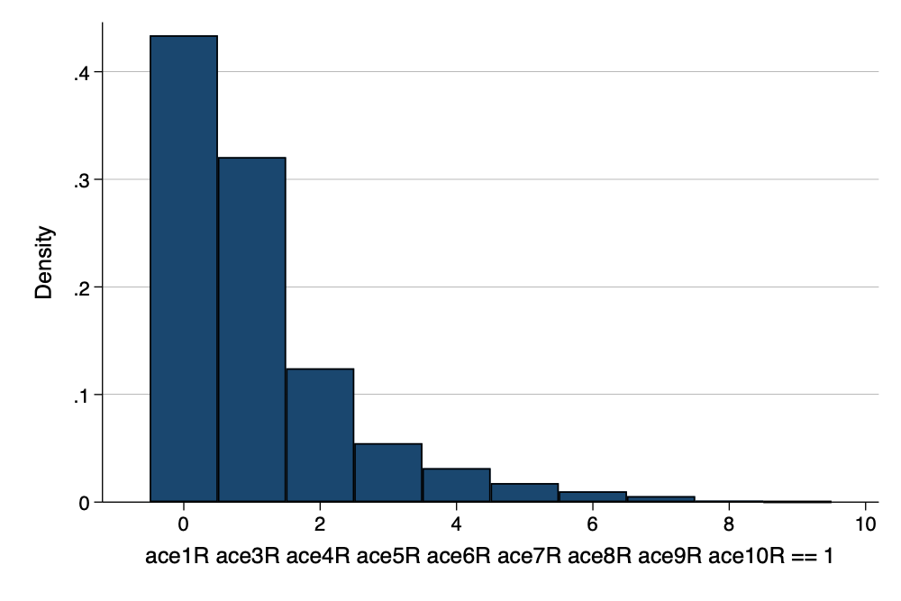

Count of ACEs

## Poisson Regression

. poisson acecount sc_sex i.sc_race_r i.higrade  
  
Iteration 0: log likelihood = -44759.253   
Iteration 1: log likelihood = -44758.999   
Iteration 2: log likelihood = -44758.999   
  
Poisson regression Number of obs = 30,530  
 LR chi2(9) = 2054.20  
 Prob > chi2 = 0.0000  
Log likelihood = -44758.999 Pseudo R2 = 0.0224  
  
─────────────────────────────────┬────────────────────────────────────────────────────────────────  
 acecount │ Coefficient Std. err. z P>|z| [95% conf. interval]  
─────────────────────────────────┼────────────────────────────────────────────────────────────────  
 sc_sex │ -.012823 .0111291 -1.15 0.249 -.0346357 .0089897  
 │  
 sc_race_r │  
Black or African American alone │ .2662761 .0196921 13.52 0.000 .2276802 .3048719  
American Indian or Alaska Nat.. │ .5971063 .0447201 13.35 0.000 .5094566 .684756  
 Asian alone │ -.6243821 .0358521 -17.42 0.000 -.6946509 -.5541134  
Native Hawaiian and Other Pac.. │ .2067409 .0969415 2.13 0.033 .0167392 .3967427  
 Some Other Race alone │ .0675521 .0324881 2.08 0.038 .0038765 .1312277  
 Two or More Races │ .2818125 .0190548 14.79 0.000 .2444658 .3191593  
 │  
 higrade │  
High school (including vocat..) │ .0632486 .0322397 1.96 0.050 .00006 .1264372  
 More than high school │ -.3786108 .030587 -12.38 0.000 -.4385602 -.3186615  
 │  
 _cons │ .3399425 .0345283 9.85 0.000 .2722683 .4076166  
─────────────────────────────────┴────────────────────────────────────────────────────────────────

## Incidence Rate Ratios

. poisson, irr  
  
Poisson regression Number of obs = 30,530  
 LR chi2(9) = 2054.20  
 Prob > chi2 = 0.0000  
Log likelihood = -44758.999 Pseudo R2 = 0.0224  
  
─────────────────────────────────┬────────────────────────────────────────────────────────────────  
 acecount │ IRR Std. err. z P>|z| [95% conf. interval]  
─────────────────────────────────┼────────────────────────────────────────────────────────────────  
 sc_sex │ .9872589 .0109873 -1.15 0.249 .9659573 1.00903  
 │  
 sc_race_r │  
Black or African American alone │ 1.305095 .0257001 13.52 0.000 1.255684 1.356451  
American Indian or Alaska Nat.. │ 1.816854 .0812498 13.35 0.000 1.664386 1.983288  
 Asian alone │ .5355922 .0192021 -17.42 0.000 .4992487 .5745815  
Native Hawaiian and Other Pac.. │ 1.229664 .1192054 2.13 0.033 1.01688 1.486973  
 Some Other Race alone │ 1.069886 .0347586 2.08 0.038 1.003884 1.140227  
 Two or More Races │ 1.32553 .0252577 14.79 0.000 1.276939 1.37597  
 │  
 higrade │  
High school (including vocat..) │ 1.065292 .0343446 1.96 0.050 1.00006 1.134778  
 More than high school │ .6848121 .0209463 -12.38 0.000 .6449644 .7271216  
 │  
 _cons │ 1.404867 .0485076 9.85 0.000 1.312939 1.503231  
─────────────────────────────────┴────────────────────────────────────────────────────────────────  
Note: _cons estimates baseline incidence rate.

# Negative Binomial Distribution

## Over-Dispersion

Due to population heterogeneity (diversity, variation), variance may be mean. This is often empirically the case.

## Negative Binomial Regression

. nbreg acecount sc_sex i.sc_race_r i.higrade, irr  
  
Fitting Poisson model:  
  
Iteration 0: log likelihood = -44759.253   
Iteration 1: log likelihood = -44758.999   
Iteration 2: log likelihood = -44758.999   
  
Fitting constant-only model:  
  
Iteration 0: log likelihood = -43591.3   
Iteration 1: log likelihood = -43392.427   
Iteration 2: log likelihood = -43391.748   
Iteration 3: log likelihood = -43391.748   
  
Fitting full model:  
  
Iteration 0: log likelihood = -42801.127   
Iteration 1: log likelihood = -42775.936   
Iteration 2: log likelihood = -42775.864   
Iteration 3: log likelihood = -42775.864   
  
Negative binomial regression Number of obs = 30,530  
 LR chi2(9) = 1231.77  
Dispersion: mean Prob > chi2 = 0.0000  
Log likelihood = -42775.864 Pseudo R2 = 0.0142  
  
─────────────────────────────────┬────────────────────────────────────────────────────────────────  
 acecount │ IRR Std. err. z P>|z| [95% conf. interval]  
─────────────────────────────────┼────────────────────────────────────────────────────────────────  
 sc_sex │ .9873253 .0140708 -0.90 0.371 .9601287 1.015292  
 │  
 sc_race_r │  
Black or African American alone │ 1.326253 .0350126 10.70 0.000 1.259374 1.396682  
American Indian or Alaska Nat.. │ 1.864104 .1222717 9.49 0.000 1.639221 2.119839  
 Asian alone │ .5378757 .0222161 -15.01 0.000 .4960489 .5832294  
Native Hawaiian and Other Pac.. │ 1.244574 .1624972 1.68 0.094 .9635716 1.607524  
 Some Other Race alone │ 1.083969 .0459946 1.90 0.057 .9974679 1.177971  
 Two or More Races │ 1.325755 .0336113 11.12 0.000 1.261488 1.393296  
 │  
 higrade │  
High school (including vocat..) │ 1.06806 .0468996 1.50 0.134 .979983 1.164053  
 More than high school │ .6831897 .0282212 -9.22 0.000 .6300572 .740803  
 │  
 _cons │ 1.403757 .0647737 7.35 0.000 1.282374 1.536629  
─────────────────────────────────┼────────────────────────────────────────────────────────────────  
 /lnalpha │ -.5443067 .0239625 -.5912723 -.4973411  
─────────────────────────────────┼────────────────────────────────────────────────────────────────  
 alpha │ .5802439 .0139041 .5536224 .6081455  
─────────────────────────────────┴────────────────────────────────────────────────────────────────  
Note: Estimates are transformed only in the first equation to incidence-rate ratios.  
Note: _cons estimates baseline incidence rate.  
LR test of alpha=0: chibar2(01) = 3966.27 Prob >= chibar2 = 0.000

## Predicted Values

. predict yhat  
(option n assumed; predicted number of events)

. histogram yhat, scheme(michigan)   
(bin=44, start=.50284678, width=.05128577)

. graph export myyhats.png, width(1000) replace  
file /Users/agrogan/Desktop/GitHub/newstuff/categorical/count-regression/myyhats.png saved as PNG  
 format

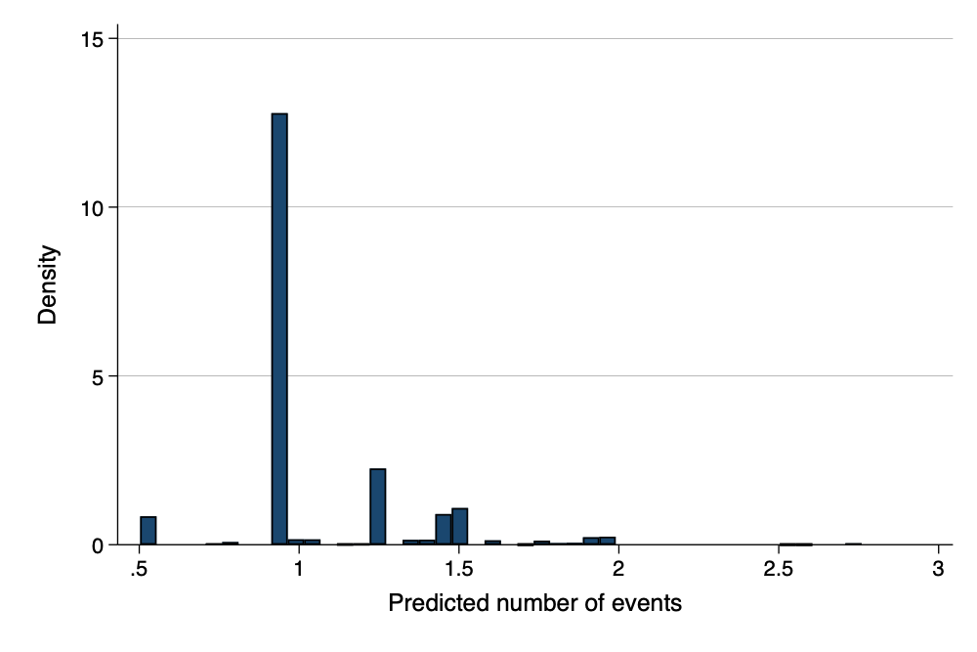

Predicted Count of ACEs

## Exposure

In some data sets, we will have a *years exposed* or *time exposed* variable. It is important to control for this variable.