Event History Analysis With Roman Emperor’s Data

Andy Grogan-Kaylor

8 Dec 2021

# Introduction

This example uses data on the ages of death of Roman Emperors. Sources for this data are unclear, but it appears that the original source is <http://www.roman-emperors.org/>.

# Get Data

. clear all

. import delimited "https://raw.githubusercontent.com/agrogan1/newstuff/master/categorical/survival  
> -analysis-and-event-history/emperors/emperors.csv"  
(16 vars, 68 obs)

# Data Wrangling

Remember that Stata works with dates by converting them to the *number of days since January 1, 1960*.

. * we can't use the date() function   
. * because it does not work  
. * with dates prior to 100AD

. * generate birthdate = date(birth, "YMD")

. * generate deathdate = date(death, "YMD")

. generate birthyear = real(substr(birth, 1, 4)) // convert first 4 characters to real number  
(5 missing values generated)

. generate deathyear = real(substr(death, 1, 4)) // convert first 4 characters to real number

. * browse name name_full birth birthyear death deathyear

. generate age = deathyear - birthyear  
(5 missing values generated)

. * need to recalculate age for those born in BCE

. encode cause, generate(causeNUMERIC) // numeric version of cause of death

. codebook causeNUMERIC if age != . // show values of causeNUMERIC for non missing ages  
  
───────────────────────────────────────────────────────────────────────────────────────────────────  
causeNUMERIC (unlabeled)  
───────────────────────────────────────────────────────────────────────────────────────────────────  
  
 Type: Numeric (long)  
 Label: causeNUMERIC  
  
 Range: [1,7] Units: 1  
 Unique values: 7 Missing .: 0/63  
  
 Tabulation: Freq. Numeric Label  
 23 1 Assassination  
 1 2 Captivity  
 4 3 Died in Battle  
 8 4 Execution  
 21 5 Natural Causes  
 5 6 Suicide  
 1 7 Unknown

. encode rise, generate(riseNUMERIC) // numeric version of cause of death

. codebook riseNUMERIC  
  
───────────────────────────────────────────────────────────────────────────────────────────────────  
riseNUMERIC (unlabeled)  
───────────────────────────────────────────────────────────────────────────────────────────────────  
  
 Type: Numeric (long)  
 Label: riseNUMERIC  
  
 Range: [1,8] Units: 1  
 Unique values: 8 Missing .: 0/68  
  
 Tabulation: Freq. Numeric Label  
 7 1 Appointment by Army  
 4 2 Appointment by Emperor  
 3 3 Appointment by Praetorian Guard  
 7 4 Appointment by Senate  
 35 5 Birthright  
 1 6 Election  
 1 7 Purchase  
 10 8 Seized Power

# stset The Data

We need to stset the data so that Stata knows that this is survival data with special characteristics relevant to survival analysis. For those of you have used other commands that attach special characteristics to the data, this is similar to using svyset for complex survey data, xtset for panel data, or even to the mi suite of commands for multiple imputation.

The most commonly used syntax is something like stset timevar, failure(failvar) id(id) [1]

There are many ways to specify failvar, we outline the most straightforward. Consult Stata help for your exact situation.

. stset age // stset the data  
  
Survival-time data settings  
  
 Failure event: (assumed to fail at time=age)  
Observed time interval: (0, age]  
 Exit on or before: failure  
  
──────────────────────────────────────────────────────────────────────────  
 68 total observations  
 5 event time missing (age>=.) PROBABLE ERROR  
 2 observations end on or before enter()  
──────────────────────────────────────────────────────────────────────────  
 61 observations remaining, representing  
 61 failures in single-record/single-failure data  
 2,984 total analysis time at risk and under observation  
 At risk from t = 0  
 Earliest observed entry t = 0  
 Last observed exit t = 79

# Kaplan-Meier Survivor Function (per Gabriela Ortiz, Stata)

## Overall Survival Function

. sts graph, scheme(michigan)  
  
 Failure _d: 1 (meaning all fail)  
 Analysis time _t: age

. graph export mysurvival0.png, width(1000) replace  
file  
 /Users/agrogan/Desktop/GitHub/newstuff/categorical/survival-analysis-and-event-history/empero  
 > rs/mysurvival0.png saved as PNG format

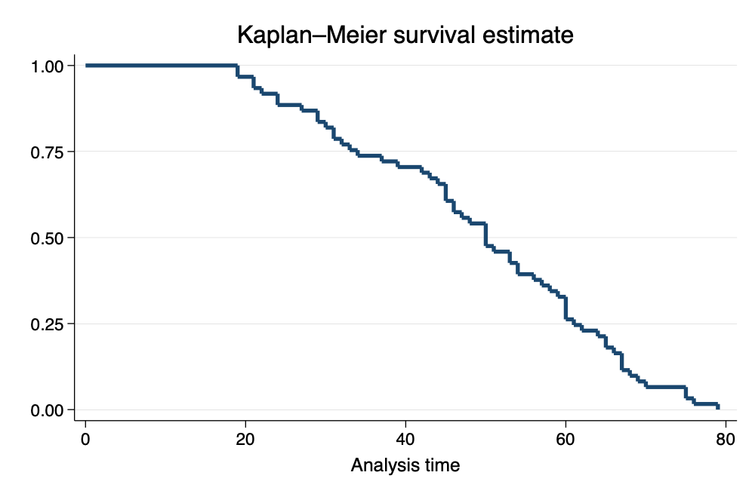

Survival Curve

## Survival Function by Cause of Death

. sts graph, by(causeNUMERIC) scheme(michigan) // survival curve by cause of death  
  
 Failure _d: 1 (meaning all fail)  
 Analysis time _t: age

. graph export mysurvival1.png, width(1000) replace  
file  
 /Users/agrogan/Desktop/GitHub/newstuff/categorical/survival-analysis-and-event-history/empero  
 > rs/mysurvival1.png saved as PNG format

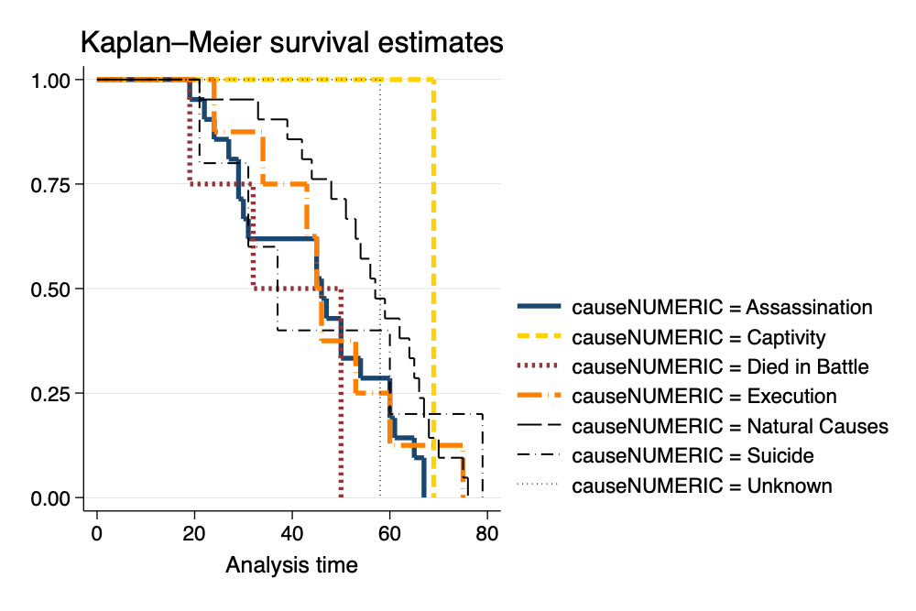

Survival Curve by Cause of Death

As an opportunity to take a closer look at the graph, we take a look at *cause of death* by age for those who *died in battle*.

. tabulate age causeNUMERIC if causeNUMERIC == 3  
  
 │ causeNUMER  
 │ IC  
 age │ Died in B │ Total  
───────────┼───────────┼──────────  
 19 │ 1 │ 1   
 32 │ 1 │ 1   
 50 │ 2 │ 2   
───────────┼───────────┼──────────  
 Total │ 4 │ 4

We can then work to make the legend more informative.

. sts graph, by(causeNUMERIC) scheme(michigan) ///  
> legend(pos(6) col(2) order(1 "Assasination" 2 "Captivity" 3 "Died in Battle" ///   
> 4 "Execution" 5 "Natural Causes" 6 "Suicide" 7 "Unknown")) // survival curve w better legend  
  
 Failure _d: 1 (meaning all fail)  
 Analysis time _t: age

. graph export mysurvival2.png, width(1000) replace  
file  
 /Users/agrogan/Desktop/GitHub/newstuff/categorical/survival-analysis-and-event-history/empero  
 > rs/mysurvival2.png saved as PNG format

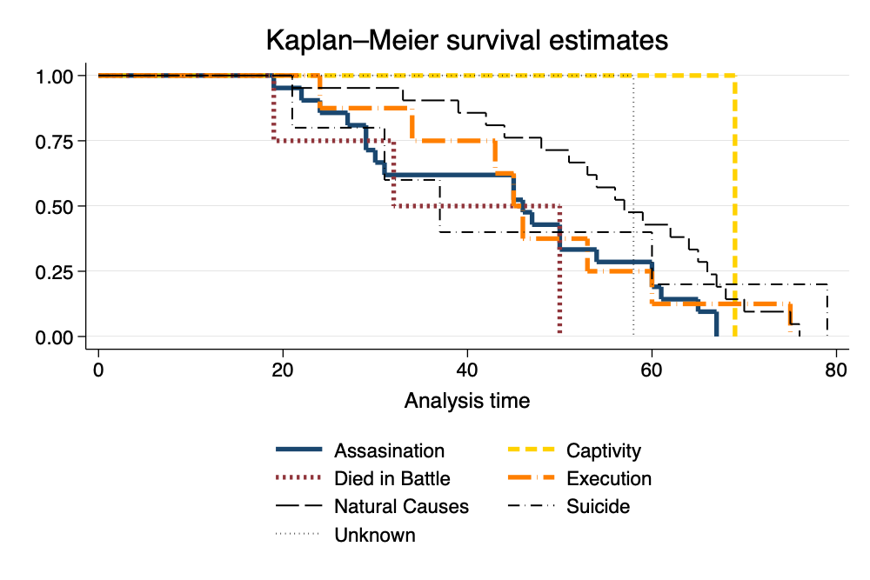

Survival Curve With Better Legend

# Cox Proportional Hazards Model

## Formula for the Hazard

the rate of occurrence.

This definition per Johnson & Shih (2007).

We don’t directly estimate the hazard, but estimate the effect of covariates on the hazard.

## Estimate the Cox Proportional Hazards Model

. stcox ib5.causeNUMERIC ib5.riseNUMERIC // Cox model  
  
 Failure _d: 1 (meaning all fail)  
 Analysis time _t: age  
  
Iteration 0: log likelihood = -194.21354  
Iteration 1: log likelihood = -183.48964  
Iteration 2: log likelihood = -183.01318  
Iteration 3: log likelihood = -183.00966  
Iteration 4: log likelihood = -183.00966  
Refining estimates:  
Iteration 0: log likelihood = -183.00966  
  
Cox regression with Breslow method for ties  
  
No. of subjects = 61 Number of obs = 61  
No. of failures = 61  
Time at risk = 2,984  
 LR chi2(13) = 22.41  
Log likelihood = -183.00966 Prob > chi2 = 0.0494  
  
─────────────────────────────────┬────────────────────────────────────────────────────────────────  
 _t │ Haz. ratio Std. err. z P>|z| [95% conf. interval]  
─────────────────────────────────┼────────────────────────────────────────────────────────────────  
 causeNUMERIC │  
 Assassination │ 2.903395 1.087888 2.84 0.004 1.393044 6.051281  
 Captivity │ .6157704 .7019255 -0.43 0.671 .0659359 5.750634  
 Died in Battle │ 3.190409 1.898109 1.95 0.051 .9941017 10.2391  
 Execution │ 1.262384 .5780177 0.51 0.611 .5145707 3.096976  
 Suicide │ 1.420734 .9364432 0.53 0.594 .3903581 5.170852  
 Unknown │ .9040191 .9428808 -0.10 0.923 .1170536 6.981847  
 │  
 riseNUMERIC │  
 Appointment by Army │ .5067648 .252628 -1.36 0.173 .1907536 1.346295  
 Appointment by Emperor │ .7952664 .5753412 -0.32 0.752 .1926215 3.283375  
Appointment by Praetorian Guard │ .2160533 .1461524 -2.27 0.024 .057379 .8135208  
 Appointment by Senate │ .2247029 .1196918 -2.80 0.005 .0791046 .6382865  
 Election │ 1.07545 1.123459 0.07 0.944 .1388001 8.332792  
 Purchase │ .5483916 .596986 -0.55 0.581 .0649325 4.631477  
 Seized Power │ .4053515 .1654931 -2.21 0.027 .1821005 .9023027  
─────────────────────────────────┴────────────────────────────────────────────────────────────────

. stcurve, survival at(causeNUMERIC=(1(1)7)) ///  
> scheme(michigan) // basic survival curve by causeNUMERIC

. graph export mycox1.png, width(1000) replace  
file  
 /Users/agrogan/Desktop/GitHub/newstuff/categorical/survival-analysis-and-event-history/empero  
 > rs/mycox1.png saved as PNG format

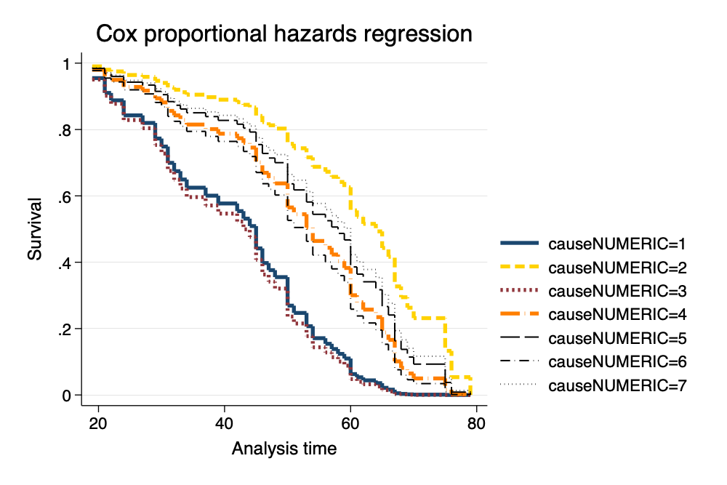

Survival Curve From Cox Model

. stcurve, survival ///  
> at(causeNUMERIC=(1(1)7)) ///  
> caption("Roman Emperors Data") ///  
> legend(order(1 "Assasination" 2 "Captivity" 3 "Died in Battle" ///   
> 4 "Execution" 5 "Natural Causes" 6 "Suicide" 7 "Unknown")) ///  
> scheme(michigan) // more nicely formatted survival curve

. graph export mycox2.png, width(1000) replace  
file  
 /Users/agrogan/Desktop/GitHub/newstuff/categorical/survival-analysis-and-event-history/empero  
 > rs/mycox2.png saved as PNG format

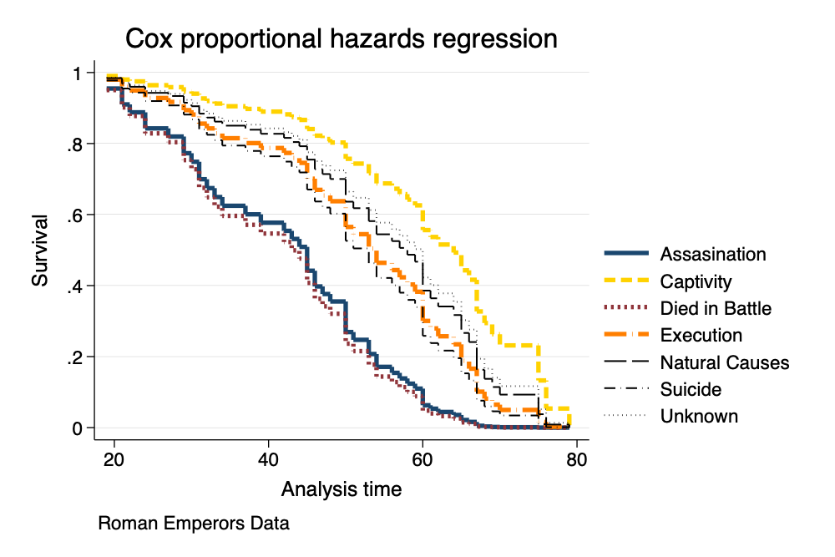

Survival Curve From Cox Model

## Proportional Hazards Assumption

. estat phtest, detail // formal test of PH assumption  
  
Test of proportional-hazards assumption  
  
Time function: Analysis time  
─────────────┬──────────────────────────────────────────  
 │ rho chi2 df Prob>chi2  
─────────────┼──────────────────────────────────────────  
1.causeNUM~C │ -0.04848 0.17 1 0.6819  
2.causeNUM~C │ 0.00996 0.01 1 0.9397  
3.causeNUM~C │ 0.01796 0.02 1 0.8869  
4.causeNUM~C │ -0.15154 1.62 1 0.2032  
5b.causeNU~C │ . . 1 .  
6.causeNUM~C │ -0.31746 10.60 1 0.0011  
7.causeNUM~C │ 0.13799 1.11 1 0.2912  
1.riseNUME~C │ 0.18269 2.18 1 0.1399  
2.riseNUME~C │ 0.30901 8.28 1 0.0040  
3.riseNUME~C │ 0.10627 0.77 1 0.3790  
4.riseNUME~C │ 0.10649 0.95 1 0.3304  
5b.riseNUM~C │ . . 1 .  
6.riseNUME~C │ 0.12455 0.91 1 0.3402  
7.riseNUME~C │ 0.18581 2.10 1 0.1477  
8.riseNUME~C │ 0.23405 3.44 1 0.0638  
─────────────┼──────────────────────────────────────────  
 Global test │ 21.90 13 0.0569  
─────────────┴──────────────────────────────────────────

. stphplot, by(causeNUMERIC) scheme(michigan) // graphical test of PH assumption  
  
 Failure _d: 1 (meaning all fail)  
 Analysis time _t: age

. graph export ph.png, width(1000) replace  
file  
 /Users/agrogan/Desktop/GitHub/newstuff/categorical/survival-analysis-and-event-history/empero  
 > rs/ph.png saved as PNG format

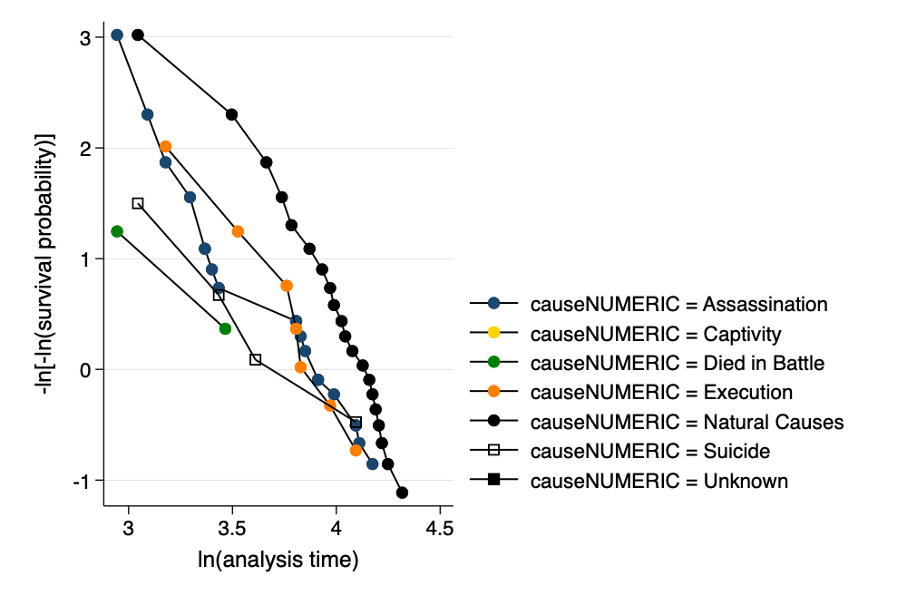

Graphical Assessment of Proportional Hazards Assumptions

## Correcting For Violations of the Proportional Hazards Assumption

Had the proportional hazards assumption been violated, we could correct for this violation in one of two ways:

1. Estimating an interaction of the time variable (in this case age) with the variable violating the assumption.

e.g. stcox ib5.causeNUMERIC age#ib5.riseNUMERIC.

Note: In this relatively small sample this command fails to converge, perhaps because of sample size; or perhaps because there is no underlying violation of the proportional hazards assumption.

1. Using the , strata(varname) option to *stratify* on the variable violating the assumption.

Note that the command below provides results, but does not provide parameter estimates for the variable on which we are stratifying, riseNUMERIC.

. stcox ib5.causeNUMERIC, strata(riseNUMERIC)  
  
 Failure _d: 1 (meaning all fail)  
 Analysis time _t: age  
  
Iteration 0: log likelihood = -110.21173  
Iteration 1: log likelihood = -106.78694  
Iteration 2: log likelihood = -106.44767  
Iteration 3: log likelihood = -106.33876  
Iteration 4: log likelihood = -106.30024  
Iteration 5: log likelihood = -106.28627  
Iteration 6: log likelihood = -106.28115  
Iteration 7: log likelihood = -106.27928  
Iteration 8: log likelihood = -106.27859  
Iteration 9: log likelihood = -106.27833  
Iteration 10: log likelihood = -106.27824  
Iteration 11: log likelihood = -106.27821  
Iteration 12: log likelihood = -106.27819  
Iteration 13: log likelihood = -106.27819  
Iteration 14: log likelihood = -106.27819  
Iteration 15: log likelihood = -106.27819  
Iteration 16: log likelihood = -106.27819  
Iteration 17: log likelihood = -106.27819  
Iteration 18: log likelihood = -106.27819  
Iteration 19: log likelihood = -106.27819  
Refining estimates:  
Iteration 0: log likelihood = -106.27819  
Iteration 1: log likelihood = -106.27819  
Iteration 2: log likelihood = -106.27819  
Iteration 3: log likelihood = -106.27819  
Iteration 4: log likelihood = -106.27819  
Iteration 5: log likelihood = -106.27819  
Iteration 6: log likelihood = -106.27819  
Iteration 7: log likelihood = -106.27819  
Iteration 8: log likelihood = -106.27819  
Iteration 9: log likelihood = -106.27819  
Iteration 10: log likelihood = -106.27819  
Iteration 11: log likelihood = -106.27819  
Iteration 12: log likelihood = -106.27819  
Iteration 13: log likelihood = -106.27819  
Iteration 14: log likelihood = -106.27819  
  
Stratified Cox regression with Breslow method for ties  
Strata variable: riseNUMERIC  
  
No. of subjects = 61 Number of obs = 61  
No. of failures = 61  
Time at risk = 2,984  
 LR chi2(6) = 7.87  
Log likelihood = -106.27819 Prob > chi2 = 0.2480  
  
────────────────┬────────────────────────────────────────────────────────────────  
 _t │ Haz. ratio Std. err. z P>|z| [95% conf. interval]  
────────────────┼────────────────────────────────────────────────────────────────  
 causeNUMERIC │  
 Assassination │ 2.055452 .7768999 1.91 0.057 .9798928 4.311578  
 Captivity │ 2.30e-15 4.51e-08 -0.00 1.000 0 .  
Died in Battle │ 1.888973 1.130025 1.06 0.288 .5848147 6.101451  
 Execution │ 1.581336 .7416243 0.98 0.328 .6307 3.96484  
 Suicide │ 1.130873 .808074 0.17 0.863 .2787286 4.588243  
 Unknown │ .8796497 .9202359 -0.12 0.902 .1131969 6.835731  
────────────────┴────────────────────────────────────────────────────────────────

# References

Johnson, L. L., & Shih, J. H. (2007). CHAPTER 20 - An Introduction to Survival Analysis (J. I. Gallin & F. P. Ognibene, eds.). https://doi.org/https://doi.org/10.1016/B978-012369440-9/50024-4

1. failvair is often something like died.