Visualizing Categorical Data With French Skiiers Data

Andy Grogan-Kaylor

12 Jul 2021 12:31:24

# Background

Visualizing categorical data presents its own unique challenges. Creating graphs may be easy, but creating graphs that effectively tell a story, or impart a message, may require additional effort.

There are multiple commands that may be useful, spineplot, graph bar, and graph pie.

The general useage of these commands is hopefully fairly simple, and is as follows:

* spineplot y x
* graph bar, over(y) by(x)
* graph pie, over(y) by (x)

Our graphing task is made a little bit more complicated because we have *weighted* data where every row of data represents multiple observations, so we need to include [fweight = Count] in order to let Stata know that we have weighted data.

We also add options to various graphs to make them more informative.

# Data

We use the *French Skiiers* data.

. use "FrenchSkiiers.dta", clear

# 2 X 2 Table

A 2 X 2 Table may be helpful

. tabulate Outcome Tx [fweight=Count], row col  
  
┌───────────────────┐  
│ Key │  
├───────────────────┤  
│ frequency │  
│ row percentage │  
│ column percentage │  
└───────────────────┘  
  
 │ Tx  
 Outcome │ Placebo Ascorbic │ Total  
───────────┼──────────────────────┼──────────  
 No Cold │ 109 122 │ 231   
 │ 47.19 52.81 │ 100.00   
 │ 77.86 87.77 │ 82.80   
───────────┼──────────────────────┼──────────  
 Cold │ 31 17 │ 48   
 │ 64.58 35.42 │ 100.00   
 │ 22.14 12.23 │ 17.20   
───────────┼──────────────────────┼──────────  
 Total │ 140 139 │ 279   
 │ 50.18 49.82 │ 100.00   
 │ 100.00 100.00 │ 100.00

We note from the column percentages that allocation to the placebo or treament (ascorbic acid) was roughly 50% in each group (1 subject dropped out of the study). We further note from the within column percentages that 22.14% of those receiving the placebo got colds while only 12.23% of those receiving ascorbic acid got colds.

# Spineplot (MosaicPlot)

A basic *spineplot* is illusrative of the *spineplot* idea, but perhaps not as informative as it might be.

. spineplot Outcome Tx [fweight=Count]  
  
.   
. graph export myspineplot1.png, width(1000) replace  
file myspineplot1.png saved as PNG format

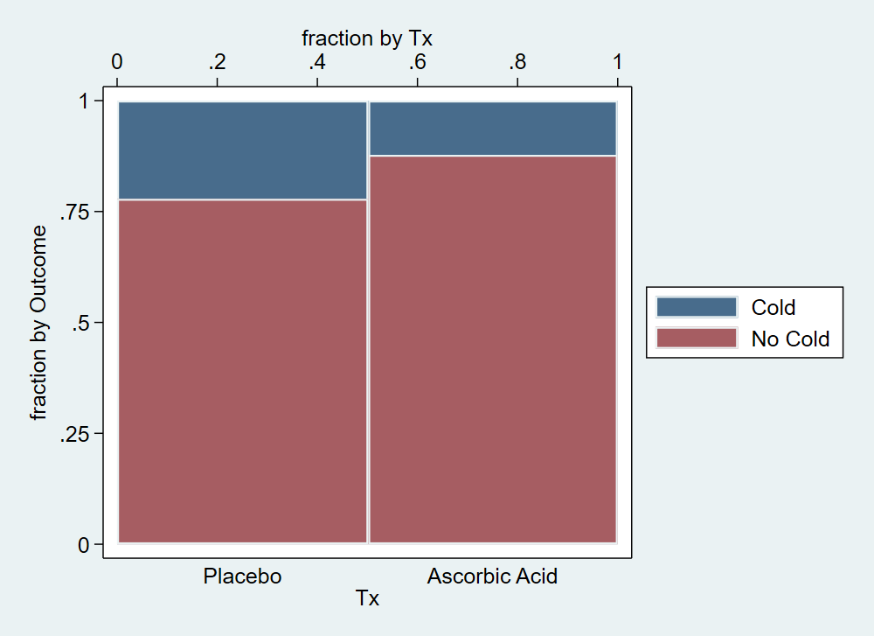{width=50%}

We add options to clarify the spineplot, which have the unfortunate effect of making the syntax more complicated and less intuitive. Hopefully, however we still see the core syntax of spineplot Outcome Tx is still there, and everything after the , is just options.

Observe especially that we have added note()'s to the graph to clarify the meaning of the spineplot.

. spineplot Outcome Tx [fweight=Count], ///  
> bar2(fintensity(%100)) /// set intensity for bar 2  
> title("Fewer Colds Among Those Recieving Ascorbic Acid") /// title  
> note("Allocation to Treament vs. Placebo is Roughly Equal" ///  
> "Fewer Colds Among Those Recieving Treatment") /// note  
> xtitle("Treatment Allocation", axis(2)) /// xtitle on axis(2)  
> xtitle(" ", axis(1)) /// blank x title on axis(1)  
> ytitle("Outcome", axis(2)) /// ytitle on axis(2)  
> text(Count, mlabcolor(black)) /// add Count variable to boxes  
> scheme(michigan) // Michigan graph scheme  
(note: named style % 100 not found in class intensity, default attributes used)  
  
.   
. graph export myspineplot2.png, width(1000) replace  
file myspineplot2.png saved as PNG format

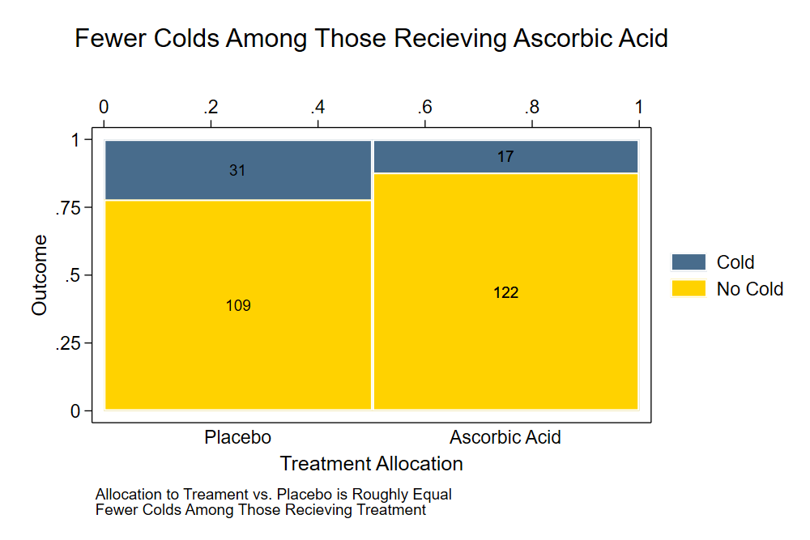{width=50%}

The spineplot makes clear that the allocation to the treatment vs. placebo was roughly 50/50. Note, that if the allocation had not been 50/50 the spineplot would have made this clear as well.

With enough annotations, the spineplot *may* make it clear that the treatment appears to result in a lower rate of colds than the placebo.

# Bar Graph

We try a bar graph.

. graph bar [fweight = Count], over(Outcome) ///   
> asyvars /// different colors for bars  
> blabel(bar, format(%9.4g) size(medium)) /// bars labelled with bar height  
> yscale(range(0 100)) /// y scale from 0 to 100  
> by(Tx, title("Fewer Colds Among Those Recieving Ascorbic Acid")) /// title (inside by command)  
> scheme(michigan) // Michigan graph scheme  
  
.   
. graph export mybargraph1.png, width(1000) replace  
file mybargraph1.png saved as PNG format

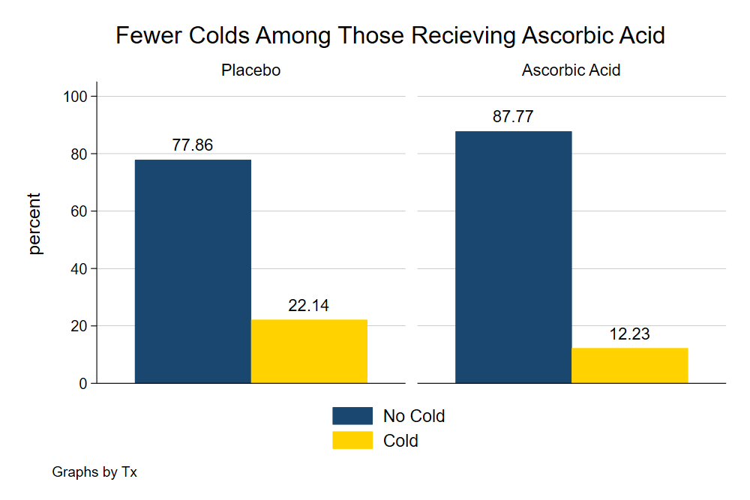{width=50%}

The bar graph tells a *very* clear story about *outcomes*. However, this version of a bar graph *does not* make clear what percentage was allocated to treatment and what percentage was allocated to control, which might be an important part of our story.

# Pie Chart

. graph pie [fweight = Count], over(Outcome) ///  
> by(Tx, title("Fewer Colds Among Those Recieving Ascorbic Acid")) /// title (inside by command)  
> plabel(1 percent, place(0) color(white)) /// label with percentages; placed in center of slice  
> plabel(2 percent, place(0)) /// label with percentages; placed in center of slice  
> scheme(michigan) // Michigan graph scheme  
  
.   
. graph export mypie2.png, width(1000) replace  
file mypie2.png saved as PNG format

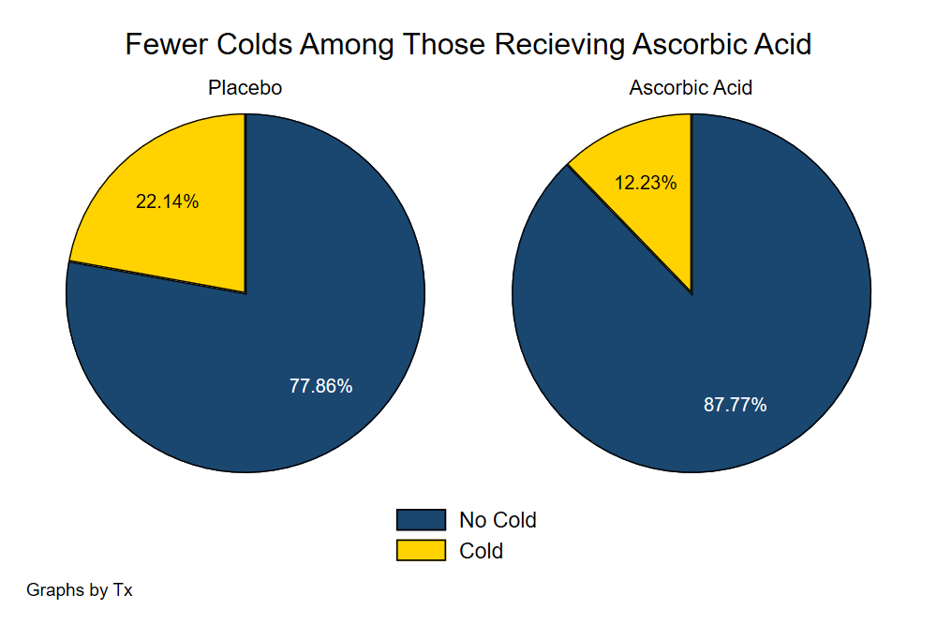{width=50%}

The pie chart also tells a *very* clear story about *outcomes*. Similar to the bar plot, however, the pie chart *does not* make clear what percentage was allocated to treatment and what percentage was allocated to control, which might be an important part of our story.

# Waffle Chart

Lastly, we try a waffle chart, which requires the use of R and the waffle library. The R script used to generate the figure below is [here](./mywaffle.R).

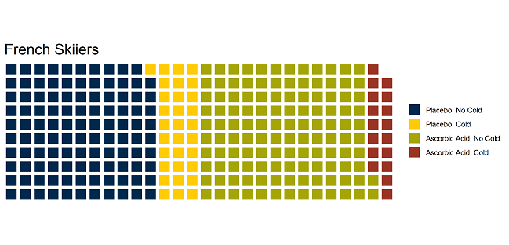{width=50%}