Interesting and Noteworthy Findings From MICS Analyses

Implications For The Cross Cultural Study Of Parenting And Child Development

2022-07-20

# Data

The findings below are drawn from studies using the *Multiple Indicator Cluster Surveys* (MICS) conducted by UNICEF. Data include more than 200,000 families from a diverse sample of approximately 60 Low and Middle Income (LMICS) around the world.

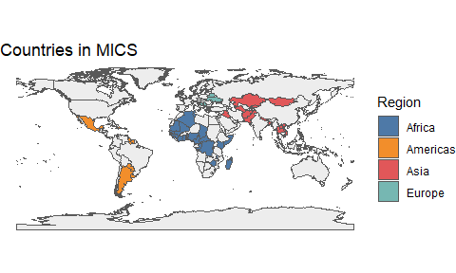

Figure 1: Countries in MICS

# No Spanking

Spanking is associated with decreases in child socio-emotional development & with increases in child aggression.

# No Insults

Name-calling & psychological aggression may have effects that are as harmful as those of physical punishment.

# No Physical Or Psychological Punishments

Though common, these parenting behaviors are consistently associated with decreases in child socio-emotional development & with increases in child aggression.

# Child Physical Abuse

Simulations with MICS data suggest that eliminating the use of physical punishment would be met with a large reduction in the amount of physical child abuse.

# Positive Discipline

Positive discipline–in the form of verbal reasoning–is generally associated with improvements in child well-being across countries, and should therefore be recommended.

# References

Grogan-Kaylor, Andrew, Berenice Castillo, Garrett T Pace, Kaitlin P Ward, Julie Ma, Shawna J Lee, and Heather Knauer. 2021. “Global perspectives on physical and nonphysical discipline: A Bayesian multilevel analysis.” *International Journal of Behavioral Development*, January. <https://doi.org/10.1177/0165025420981642>.

Ma, Julie, Andrew C. Grogan-Kaylor, Garrett T. Pace, Kaitlin P. Ward, and Shawna J. Lee. 2022. “The association between spanking and physical abuse of young children in 56 low- and middle-income countries.” *Child Abuse & Neglect* 129 (July): 105662. <https://doi.org/10.1016/j.chiabu.2022.105662>.

Pace, Garrett T., Shawna J. Lee, and Andrew Grogan-Kaylor. 2019. “Spanking and young children’s socioemotional development in low- and middle-income countries.” *Child Abuse and Neglect* 88: 84–95. <https://doi.org/10.1016/j.chiabu.2018.11.003>.

Ward, Kaitlin P., Andrew C. Grogan-Kaylor, Garrett T. Pace, Jorge Cuartas, and Shawna J. Lee. 2021a. “A Multilevel Ecological Analysis of the Predictors of Spanking Across 65 Countries.” *BMJ Open* 11 (e046075). <https://doi.org/10.1136/bmjopen-2020-046075>.

Ward, Kaitlin P, Andrew Grogan-Kaylor, Julie Ma, Garrett T Pace, and Shawna J Lee. 2021b. “Associations Between 11 Parental Discipline Behaviors and Child Outcomes Across 60 Countries.” PsyArXiv. <https://doi.org/10.31234/osf.io/f5t8x>.

Ward, Kaitlin P., Shawna J. Lee, Andrew C. Grogan-Kaylor, Julie Ma, and Garrett T. Pace. 2022. “Patterns of Caregiver Aggressive and Nonaggressive Discipline Toward Young Children in Low- and Middle-Income Countries: A Latent Class Approach.” *Child Abuse & Neglect* 128. https://doi.org/<https://doi.org/10.1016/j.chiabu.2022.105606>.