Interesting and Noteworthy Findings From MICS Analyses

Andy Grogan-Kaylor

2020-12-26

Table of Contents

# Data

The findings below are drawn from studies using the *Multiple Indicator Cluster Surveys* (MICS) conducted by UNICEF. Data include more than 200,000 families from a diverse sample of approximately 60 Low and Middle Income (LMICS) around the world.

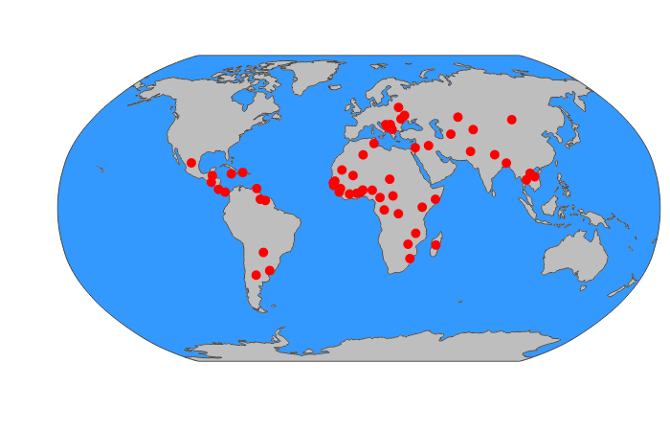

Countries in MICS

# Analysis

The statistical methods employed in this work consist of various forms of multilevel models which are able to synthesize results across samples from multiple sources. Thus these findings are applicable to a diverse variety of cultures and contexts from around the globe.

# Findings

When studied in global context, across a diverse group of Low and Middle Income Countries (LMICs):

* There are differences in parenting *behaviors* across countries.
* Physical punishment (spanking) is associated with decreases in child socio-emotional development, and particularly with increases in child aggression.
* There is some variation in the effects of parental discipline (including spanking), on child well-being, but across multiple diverse countries, the *effects* of parental discipline (including spanking) are remarkably consistent and nearly universal.
* Country level norms seem to have an association with child outcomes. In countries where spanking is more normative, child aggression is higher.
* Positive discipline–in the form of verbal reasoning–is generally associated with improvements in child well-being across countries, and should therefore be recommended.
* The association of other forms of nonviolent discipline with child outcomes is less clear. It may be that the long term investments that parents make in children, such as spending time with children, letting children know that they love them, and listening to children have more positive effects than nonviolent discipline, but this has yet to be thoroughly researched in global context.

# References

Grogan-Kaylor, Andrew C., Berenice Castillo, Garrett T. Pace, Kaitlin P. Ward, Julie Ma, Shawna J. Lee, and Heather Knauer. 2020. “Global Perspectives on Positive and Negative Parenting: A Bayesian Multilevel Analysis.” *International Journal of Behavioral Development*.

Pace, Garrett T., Shawna J. Lee, and Andrew Grogan-Kaylor. 2019. “Spanking and young children’s socioemotional development in low- and middle-income countries.” *Child Abuse and Neglect* 88: 84–95. <https://doi.org/10.1016/j.chiabu.2018.11.003>.

Ward, Kaitlin P., Andrew C. Grogan-Kaylor, Shawna J. Lee, Julie Ma, and Garrett T. Pace. n.d. “Associations Between 11 Forms of Discipline and Child Outcomes Across 60 Low- and Middle-Income Countries.”

Ward, Kaitlin P., Andrew C. Grogan-Kaylor, Garrett T. Pace, Jorge Cuartas, and Shawna J. Lee. n.d. “A Multilevel Ecological Analysis of the Predictors of Spanking Across 65 Countries.”