Survival Analysis of Corporal Punishment Bans

Andy Grogan-Kaylor

15 Jun 2021 09:52:47

# Introduction

Corporal punishment is associated with a number of deleterious outcomes for children, including increases in behavior problems and mental health problems.

A number of countries have instituted country wide bans upon the use of corporal punishment with children.

Below, we employ a variety of empirical strategies to explore the institution of these bans.

# Get The Data

. use "../CPBans_w_AllCountries.dta", clear // data with ALL Countries; not just bans

NB It is important to have data with the *correct risk set* which includes *all countries*, not just *countries that eventually ban corporal punishment*.

In web versions of this tutorial, click the tabs below to access different sections of the tutorial.

Setup

Parametric Survival Models

Cox Model

Life Table

Discrete Time Survival Analysis

Cox Model 2

Compare Estimates

# Setup

## stset The Data

. generate current_year = year(today()) // variable with current year

. replace year_of_prohibition = current_year if year_of_prohibition == . // replace missing w/ current year  
(186 real changes made)

. generate f = type == "CP Ban" // "failure" variable

. stset year_of_prohibition, failure(f = 1) // stset the data with time and failure variables  
  
Survival-time data settings  
  
 Failure event: f==1  
Observed time interval: (0, year_of_prohibition]  
 Exit on or before: failure  
  
──────────────────────────────────────────────────────────────────────────  
 248 total observations  
 0 exclusions  
──────────────────────────────────────────────────────────────────────────  
 248 observations remaining, representing  
 62 failures in single-record/single-failure data  
 500,452 total analysis time at risk and under observation  
 At risk from t = 0  
 Earliest observed entry t = 0  
 Last observed exit t = 2,021

## Data Wrangling

. encode continent, generate(continent_NUMERIC) // numeric version of continent

## Graphs

### Survival Function

. sts graph, scheme(michigan) tmin(1970) // Kaplan-Meier Survivor Function  
  
 Failure _d: f==1  
 Analysis time _t: year_of_prohibition

. graph export mysurvival.png, width(500) replace  
file mysurvival.png saved as PNG format

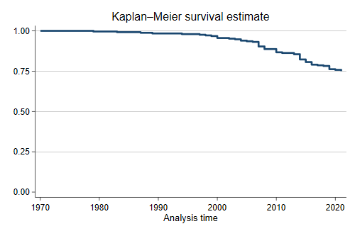

Kaplan-Meier Survivor Function

### Failure Function

. sts graph, failure scheme(michigan) tmin(1970) // Kaplan-Meier Failure Function  
  
 Failure _d: f==1  
 Analysis time _t: year_of_prohibition

. graph export myfailure.png, width(500) replace  
file myfailure.png saved as PNG format

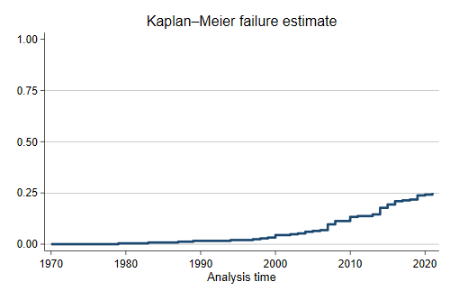

Kaplan-Meier Failure Function

# Parametric Survival Models

Unlike other regression commands in Stata, survival analysis commands seem to require covariates. Since Europe is where these bans started, we will use Europe (category 4) as the reference category.

## Weibull

. streg ib4.continent_NUMERIC, distribution(weibull) // Weibull distribution  
  
 Failure _d: f==1  
 Analysis time _t: year_of_prohibition  
  
Fitting constant-only model:  
Iteration 0: log likelihood = -148.2325  
Iteration 1: log likelihood = -86.999055  
Iteration 2: log likelihood = -27.073844  
Iteration 3: log likelihood = 29.365489  
Iteration 4: log likelihood = 77.015953  
Iteration 5: log likelihood = 106.62899  
Iteration 6: log likelihood = 115.32234  
Iteration 7: log likelihood = 115.88805  
Iteration 8: log likelihood = 115.89021  
Iteration 9: log likelihood = 115.89021  
  
Fitting full model:  
Iteration 0: log likelihood = 115.89021   
Iteration 1: log likelihood = 139.32561   
Iteration 2: log likelihood = 142.87372   
Iteration 3: log likelihood = 143.05492   
Iteration 4: log likelihood = 143.05732   
Iteration 5: log likelihood = 143.05732   
  
Weibull PH regression  
  
No. of subjects = 248 Number of obs = 248  
No. of failures = 62  
Time at risk = 500,452  
 LR chi2(5) = 54.33  
Log likelihood = 143.05732 Prob > chi2 = 0.0000  
  
──────────────────┬────────────────────────────────────────────────────────────────  
 _t │ Haz. ratio Std. err. z P>|z| [95% conf. interval]  
──────────────────┼────────────────────────────────────────────────────────────────  
continent_NUMERIC │  
 Africa │ .1684617 .0612563 -4.90 0.000 .0826011 .3435709  
 Americas │ .1938708 .0704541 -4.51 0.000 .0950997 .395226  
 Asia │ .1520997 .0603348 -4.75 0.000 .0698995 .3309653  
 NA │ .0916735 .0931508 -2.35 0.019 .0125119 .6716806  
 Oceania │ .0356574 .0362323 -3.28 0.001 .0048666 .2612621  
 │  
 _cons │ 0 0 -8.57 0.000 0 0  
──────────────────┼────────────────────────────────────────────────────────────────  
 /ln_p │ 5.278967 .1166492 45.26 0.000 5.050339 5.507596  
──────────────────┼────────────────────────────────────────────────────────────────  
 p │ 196.1672 22.88274 156.0754 246.5576  
 1/p │ .0050977 .0005946 .0040558 .0064072  
──────────────────┴────────────────────────────────────────────────────────────────  
Note: _cons estimates baseline hazard.

. est store Weibull

## Exponential

. streg ib4.continent_NUMERIC, distribution(exponential) // Exponential distribution  
  
 Failure _d: f==1  
 Analysis time _t: year_of_prohibition  
  
Iteration 0: log likelihood = -148.2325   
Iteration 1: log likelihood = -139.40941   
Iteration 2: log likelihood = -131.58499   
Iteration 3: log likelihood = -131.55897   
Iteration 4: log likelihood = -131.55892   
Iteration 5: log likelihood = -131.55892   
  
Exponential PH regression  
  
No. of subjects = 248 Number of obs = 248  
No. of failures = 62  
Time at risk = 500,452  
 LR chi2(5) = 33.35  
Log likelihood = -131.55892 Prob > chi2 = 0.0000  
  
──────────────────┬────────────────────────────────────────────────────────────────  
 _t │ Haz. ratio Std. err. z P>|z| [95% conf. interval]  
──────────────────┼────────────────────────────────────────────────────────────────  
continent_NUMERIC │  
 Africa │ .2736219 .099129 -3.58 0.000 .134516 .5565804  
 Americas │ .3052592 .1105907 -3.28 0.001 .1500692 .6209345  
 Asia │ .2489781 .0984172 -3.52 0.000 .1147345 .5402914  
 NA │ .1586176 .1610769 -1.81 0.070 .0216746 1.160782  
 Oceania │ .061017 .061963 -2.75 0.006 .0083378 .4465293  
 │  
 _cons │ .000312 .0000552 -45.67 0.000 .0002206 .0004412  
──────────────────┴────────────────────────────────────────────────────────────────  
Note: _cons estimates baseline hazard.

. est store Exponential

# Cox Proportional Hazards Model

. stcox ib4.continent_NUMERIC // Cox Proportional Hazards Model  
  
 Failure _d: f==1  
 Analysis time _t: year_of_prohibition  
  
Iteration 0: log likelihood = -333.92184  
Iteration 1: log likelihood = -317.94407  
Iteration 2: log likelihood = -308.96171  
Iteration 3: log likelihood = -308.00801  
Iteration 4: log likelihood = -308.00737  
Refining estimates:  
Iteration 0: log likelihood = -308.00737  
  
Cox regression with Breslow method for ties  
  
No. of subjects = 248 Number of obs = 248  
No. of failures = 62  
Time at risk = 500,452  
 LR chi2(5) = 51.83  
Log likelihood = -308.00737 Prob > chi2 = 0.0000  
  
──────────────────┬────────────────────────────────────────────────────────────────  
 _t │ Haz. ratio Std. err. z P>|z| [95% conf. interval]  
──────────────────┼────────────────────────────────────────────────────────────────  
continent_NUMERIC │  
 Africa │ .1769827 .0643396 -4.76 0.000 .0867938 .3608887  
 Americas │ .2023186 .0735008 -4.40 0.000 .0992661 .4123544  
 Asia │ .1610376 .0638871 -4.60 0.000 .0740009 .3504428  
 NA │ .0969297 .0984941 -2.30 0.022 .0132287 .7102257  
 Oceania │ .0380401 .038653 -3.22 0.001 .0051919 .2787139  
──────────────────┴────────────────────────────────────────────────────────────────

. est store Cox

## Survival Curves

. stcurve, survival scheme(michigan) // survival curve

. graph export survival1A.png, width(500) replace  
file survival1A.png saved as PNG format

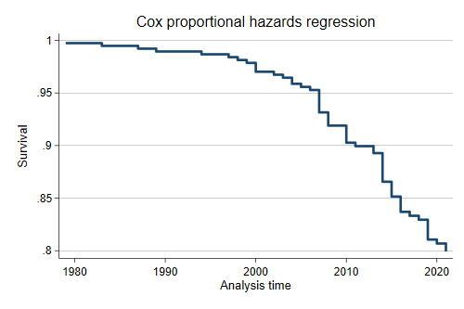

Survival Curve

. stcurve, failure scheme(michigan) // failure curve

. graph export survival1B.png, width(500) replace  
file survival1B.png saved as PNG format

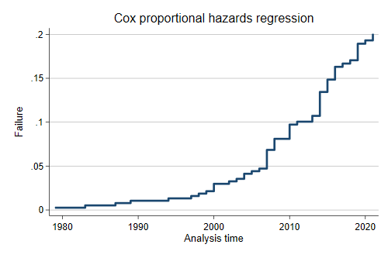

Failure Curve

. stcurve, failure at(continent_NUMERIC= (1 2 3 4 5 6)) ///  
> legend(order(1 "Africa" 2 "Americas" 3 "Asia" ///  
> 4 "Europe" 5 "NA" 6 "Oceania")) ///  
> scheme(michigan) // survival curve by continent

. graph export survival2.png, width(500) replace  
file survival2.png saved as PNG format

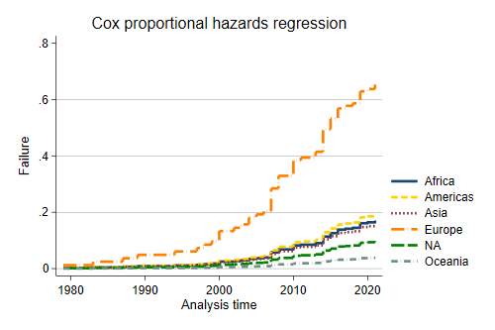

Failure Curve By Continent

## Proportional Hazards Assumption

. estat phtest // formal test of PH assumption  
  
Test of proportional-hazards assumption  
  
Time function: Analysis time  
─────────────┬──────────────────────────────────  
 │ chi2 df Prob>chi2  
─────────────┼──────────────────────────────────  
 Global test │ 6.20 5 0.2870  
─────────────┴──────────────────────────────────

. stphplot, by(continent_NUMERIC) scheme(michigan) // graphical test of PH assumption  
  
 Failure _d: f==1  
 Analysis time _t: year_of_prohibition

. graph export ph.png, width(500) replace  
file ph.png saved as PNG format

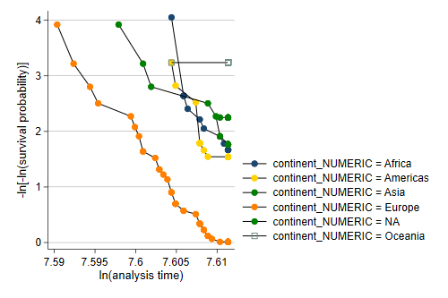

Graphical Test of Proportional Hazards Assumption

# Life Table

. ltable year_of_prohibition f, graph failure scheme(michigan) // lifetable  
  
 Beg. Cum. Std.  
 Interval Total Deaths Lost Failure Error [95% Conf. Int.]  
───────────────────────────────────────────────────────────────────────────────  
 1979 1980 248 1 0 0.0040 0.0040 0.0006 0.0283  
 1983 1984 247 1 0 0.0081 0.0057 0.0020 0.0319  
 1987 1988 246 1 0 0.0121 0.0069 0.0039 0.0370  
 1989 1990 245 1 0 0.0161 0.0080 0.0061 0.0424  
 1994 1995 244 1 0 0.0202 0.0089 0.0084 0.0478  
 1997 1998 243 1 0 0.0242 0.0098 0.0109 0.0531  
 1998 1999 242 1 0 0.0282 0.0105 0.0136 0.0583  
 1999 2000 241 1 0 0.0323 0.0112 0.0163 0.0635  
 2000 2001 240 3 0 0.0444 0.0131 0.0248 0.0787  
 2002 2003 237 1 0 0.0484 0.0136 0.0278 0.0836  
 2003 2004 236 1 0 0.0524 0.0142 0.0308 0.0886  
 2004 2005 235 2 0 0.0605 0.0151 0.0369 0.0983  
 2005 2006 233 1 0 0.0645 0.0156 0.0400 0.1032  
 2006 2007 232 1 0 0.0685 0.0160 0.0432 0.1080  
 2007 2008 231 7 0 0.0968 0.0188 0.0659 0.1409  
 2008 2009 224 4 0 0.1129 0.0201 0.0794 0.1593  
 2010 2011 220 5 0 0.1331 0.0216 0.0965 0.1820  
 2011 2012 215 1 0 0.1371 0.0218 0.1000 0.1865  
 2013 2014 214 2 0 0.1452 0.0224 0.1069 0.1955  
 2014 2015 212 8 0 0.1774 0.0243 0.1352 0.2309  
 2015 2016 204 4 0 0.1935 0.0251 0.1496 0.2484  
 2016 2017 200 4 0 0.2097 0.0258 0.1641 0.2658  
 2017 2018 196 1 0 0.2137 0.0260 0.1677 0.2701  
 2018 2019 195 1 0 0.2177 0.0262 0.1713 0.2745  
 2019 2020 194 5 0 0.2379 0.0270 0.1897 0.2960  
 2020 2021 189 1 0 0.2419 0.0272 0.1934 0.3002  
 2021 2022 188 2 186 0.2579 0.0289 0.2062 0.3196  
───────────────────────────────────────────────────────────────────────────────

. graph export myltable.png, width(500) replace  
file myltable.png saved as PNG format

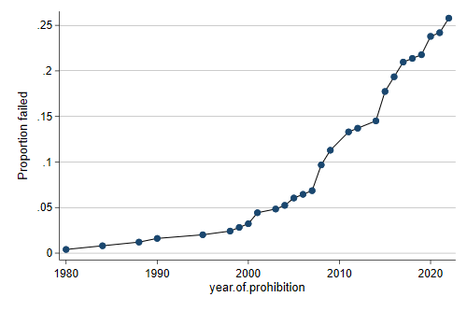

Graph Of Life Table

# Discrete Time Survival Analysis

Discrete time survival analysis is placed at the end because it requires us to restructure the data into a long format, where every row is a *country-year*.

## Restructuring the Data

We first need to generate a variable for the years during which a country was "at risk" of enacting a ban. Countries that have never enacted a ban are at risk up until the current year. Countries that enacted a ban leave the risk set once they have enacted a ban, and are thus at risk for a shorter time period.

. generate years_at_risk = year_of_prohibition - 1978 + 1 // years "at risk" of enacting a ban

We *expand* the data to generate one row of data for every year that each country is at risk.

. expand years_at_risk // "expand" the data; 1 row for every year at risk  
(9,908 observations created)

We create a year variable.

. bysort country_code: generate year = _n + 1977 // generate a year variable for each row

Lastly, we generate an indicator of the event, a 0/1' variable, which takes the value 1 for rows in which a ban was enacted, and 0 otherwise.

. generate event = type == "CP Ban" & year_of_prohibition == year // generate an event indicator

We list out a sample of the data to make sure that the data conform to our expectations. We focus on Norway, a country that *has* enacted a ban, and Great Britain, a country that *has not* enacted a ban.

. list country_code year_of_prohibition event continent years_at_risk year ///  
> if country_code == "NOR" | country_code == "GBR" , ab(20) // list out a sample of the data  
  
 ┌───────────────────────────────────────────────────────────────────────────────┐  
 │ country_code year_of_prohibition event continent years_at_risk year │  
 ├───────────────────────────────────────────────────────────────────────────────┤  
 3172. │ GBR 2021 0 Europe 44 1978 │  
 3173. │ GBR 2021 0 Europe 44 1979 │  
 3174. │ GBR 2021 0 Europe 44 1980 │  
 3175. │ GBR 2021 0 Europe 44 1981 │  
 3176. │ GBR 2021 0 Europe 44 1982 │  
 ├───────────────────────────────────────────────────────────────────────────────┤  
 3177. │ GBR 2021 0 Europe 44 1983 │  
 3178. │ GBR 2021 0 Europe 44 1984 │  
 3179. │ GBR 2021 0 Europe 44 1985 │  
 3180. │ GBR 2021 0 Europe 44 1986 │  
 3181. │ GBR 2021 0 Europe 44 1987 │  
 ├───────────────────────────────────────────────────────────────────────────────┤  
 3182. │ GBR 2021 0 Europe 44 1988 │  
 3183. │ GBR 2021 0 Europe 44 1989 │  
 3184. │ GBR 2021 0 Europe 44 1990 │  
 3185. │ GBR 2021 0 Europe 44 1991 │  
 3186. │ GBR 2021 0 Europe 44 1992 │  
 ├───────────────────────────────────────────────────────────────────────────────┤  
 3187. │ GBR 2021 0 Europe 44 1993 │  
 3188. │ GBR 2021 0 Europe 44 1994 │  
 3189. │ GBR 2021 0 Europe 44 1995 │  
 3190. │ GBR 2021 0 Europe 44 1996 │  
 3191. │ GBR 2021 0 Europe 44 1997 │  
 ├───────────────────────────────────────────────────────────────────────────────┤  
 3192. │ GBR 2021 0 Europe 44 1998 │  
 3193. │ GBR 2021 0 Europe 44 1999 │  
 3194. │ GBR 2021 0 Europe 44 2000 │  
 3195. │ GBR 2021 0 Europe 44 2001 │  
 3196. │ GBR 2021 0 Europe 44 2002 │  
 ├───────────────────────────────────────────────────────────────────────────────┤  
 3197. │ GBR 2021 0 Europe 44 2003 │  
 3198. │ GBR 2021 0 Europe 44 2004 │  
 3199. │ GBR 2021 0 Europe 44 2005 │  
 3200. │ GBR 2021 0 Europe 44 2006 │  
 3201. │ GBR 2021 0 Europe 44 2007 │  
 ├───────────────────────────────────────────────────────────────────────────────┤  
 3202. │ GBR 2021 0 Europe 44 2008 │  
 3203. │ GBR 2021 0 Europe 44 2009 │  
 3204. │ GBR 2021 0 Europe 44 2010 │  
 3205. │ GBR 2021 0 Europe 44 2011 │  
 3206. │ GBR 2021 0 Europe 44 2012 │  
 ├───────────────────────────────────────────────────────────────────────────────┤  
 3207. │ GBR 2021 0 Europe 44 2013 │  
 3208. │ GBR 2021 0 Europe 44 2014 │  
 3209. │ GBR 2021 0 Europe 44 2015 │  
 3210. │ GBR 2021 0 Europe 44 2016 │  
 3211. │ GBR 2021 0 Europe 44 2017 │  
 ├───────────────────────────────────────────────────────────────────────────────┤  
 3212. │ GBR 2021 0 Europe 44 2018 │  
 3213. │ GBR 2021 0 Europe 44 2019 │  
 3214. │ GBR 2021 0 Europe 44 2020 │  
 3215. │ GBR 2021 0 Europe 44 2021 │  
 6811. │ NOR 1987 0 Europe 10 1978 │  
 ├───────────────────────────────────────────────────────────────────────────────┤  
 6812. │ NOR 1987 0 Europe 10 1979 │  
 6813. │ NOR 1987 0 Europe 10 1980 │  
 6814. │ NOR 1987 0 Europe 10 1981 │  
 6815. │ NOR 1987 0 Europe 10 1982 │  
 6816. │ NOR 1987 0 Europe 10 1983 │  
 ├───────────────────────────────────────────────────────────────────────────────┤  
 6817. │ NOR 1987 0 Europe 10 1984 │  
 6818. │ NOR 1987 0 Europe 10 1985 │  
 6819. │ NOR 1987 0 Europe 10 1986 │  
 6820. │ NOR 1987 1 Europe 10 1987 │  
 └───────────────────────────────────────────────────────────────────────────────┘

## Analysis

Lastly, we analyze the data using a straightforward logistic regression model. While there is some discussion on this point, we choose not to cluster the standard errors on country, because of the argument from Singer and Willett (2003) that the rows of data are *conditionally* independent.

We ask for *odds ratios* so that our results are roughly comparable to those from the continuous time survival models.

. logit event ib4.continent_NUMERIC year, or  
  
Iteration 0: log likelihood = -377.92887   
Iteration 1: log likelihood = -372.7393   
Iteration 2: log likelihood = -330.01528   
Iteration 3: log likelihood = -328.96762   
Iteration 4: log likelihood = -328.96528   
Iteration 5: log likelihood = -328.96528   
  
Logistic regression Number of obs = 10,156  
 LR chi2(6) = 97.93  
 Prob > chi2 = 0.0000  
Log likelihood = -328.96528 Pseudo R2 = 0.1296  
  
──────────────────┬────────────────────────────────────────────────────────────────  
 event │ Odds ratio Std. err. z P>|z| [95% conf. interval]  
──────────────────┼────────────────────────────────────────────────────────────────  
continent_NUMERIC │  
 Africa │ .1666907 .0611921 -4.88 0.000 .0811775 .3422843  
 Americas │ .1916195 .0703136 -4.50 0.000 .0933462 .3933534  
 Asia │ .1507161 .0603004 -4.73 0.000 .0688019 .3301562  
 NA │ .0906814 .092426 -2.36 0.019 .012301 .6684916  
 Oceania │ .0351902 .0358209 -3.29 0.001 .0047859 .2587488  
 │  
 year │ 1.088786 .013881 6.67 0.000 1.061917 1.116335  
 _cons │ 2.05e-76 5.25e-75 -6.81 0.000 3.38e-98 1.24e-54  
──────────────────┴────────────────────────────────────────────────────────────────  
Note: _cons estimates baseline odds.

. est store Discrete

# Cox Model With Multiple Records Per Observation and Time Varying Covariates

We make use of the fact that the data are structured with multiple records per individual to include the effect of year, which is a *time varying covariate*. We need to newly stset the data to account for the multiple records per individual.

**I am not sure how to use the tvc option to program this when there is only one record per *individual*.**

// bysort country_y: egen maxyear = max(year) //  
// bysort country_y: generate f2 = (f ==1) & (year ==maxyear) // // stset year, failure(f2 = 1) id(country_y) origin(time 1978) // stset the data with time, failure & id variables // // stcox ib4.continent_NUMERIC year //  
// est store CoxTVC2

# Compare Estimates

Note the difference in the effect of *year* in the two models where this is included.

. estimates table Weibull Exponential Cox Discrete, ///  
> b(%9.3f) star stats(N r2_a) equations(1) // nice table of estimates  
  
─────────────┬────────────────────────────────────────────────────────────  
 Variable │ Weibull Exponential Cox Discrete   
─────────────┼────────────────────────────────────────────────────────────  
#1 │  
continent_~C │  
 Africa │ -1.781*** -1.296*** -1.732*** -1.792***   
 Americas │ -1.641*** -1.187** -1.598*** -1.652***   
 Asia │ -1.883*** -1.390*** -1.826*** -1.892***   
 │  
continent_~C │  
 NA │ -2.390* -1.841 -2.334* -2.400*   
 Oceania │ -3.334** -2.797** -3.269** -3.347**   
 │  
 year │ 0.085***   
 _cons │ -1492.992*** -8.073*** -174.278***   
─────────────┼────────────────────────────────────────────────────────────  
ln_p │  
 _cons │ 5.279***   
─────────────┼────────────────────────────────────────────────────────────  
Statistics │   
 N │ 248 248 248 10156   
 r2_a │   
─────────────┴────────────────────────────────────────────────────────────  
 Legend: * p<0.05; ** p<0.01; *** p<0.001

# References

Allison, P. D. (1984). *Event History Analysis: Regression for Longitudinal Event Data*. SAGE Publications.

Singer, J. D., & Willett, J. B. (2003). *Applied longitudinal data analysis : modeling change and event occurrence*. Oxford ; New York : Oxford University Press.

StataCorp. 2021. *Stata 17 Survival Analysis Reference Manual*. College Station, TX: Stata Press