Evaluation Demo

Evaluation Team

Table of contents

# 1. Introduction

I am going to say a lot of stuff about the data.

# 2. Data

This is really important data. It is a survey of blah blah blah.

# 3. Graph

Here is my graph. This says blah blah blah.

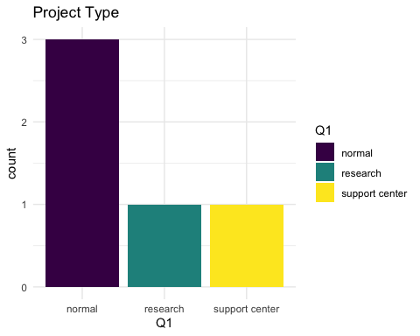

# 4. Analysis

Here are the proportions of various types of project.

normal research support center   
 0.6 0.2 0.2