Workflow

Andy Grogan-Kaylor

2024-02-12

Table of contents

# 1. Introduction

I have increasingly been thinking about the idea of *workflow* in data science / data analysis work.

So many workflows follow the same conceptual pattern.

# 2. Visually and Conceptually

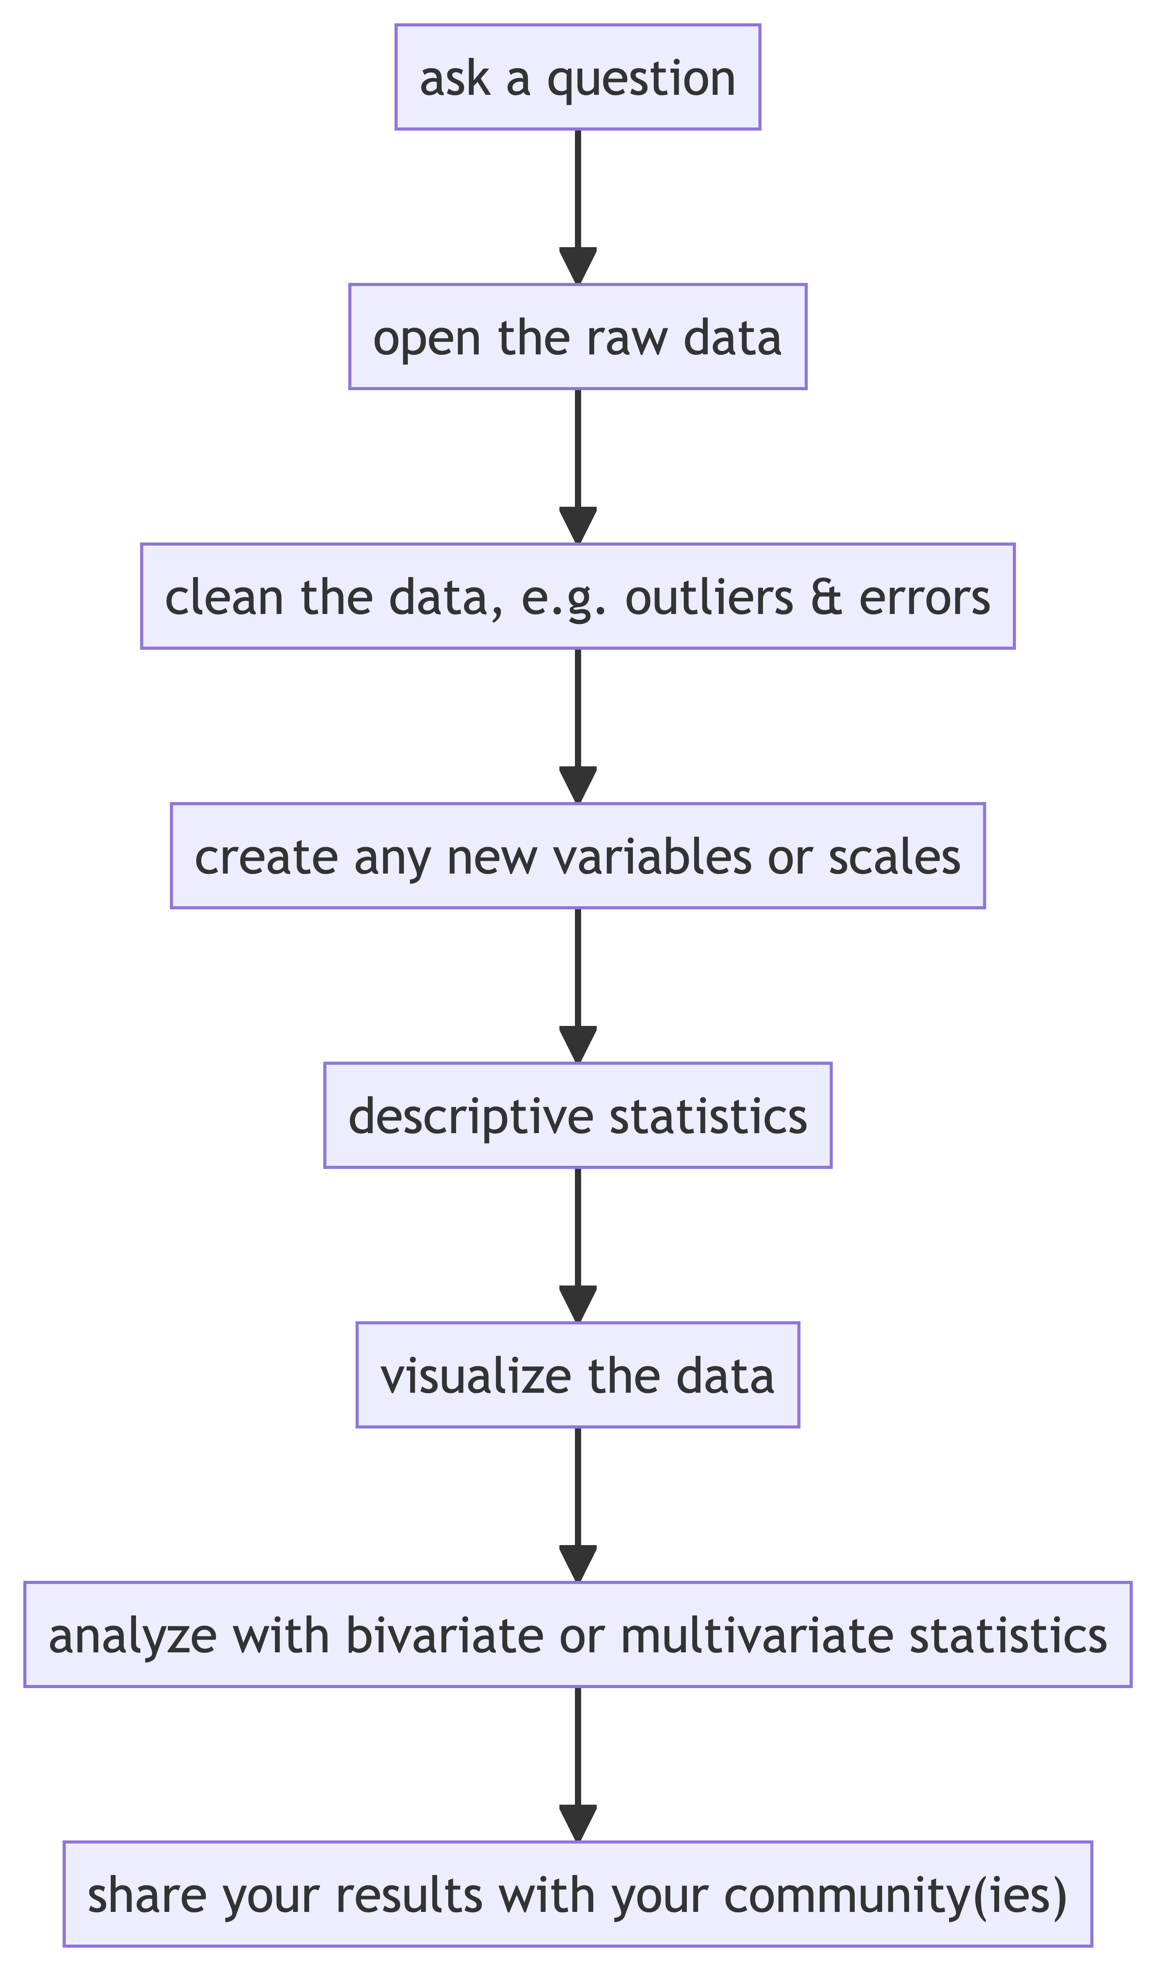

# 3. Characteristics of Good Workflows

Increasingly, we want to think about workflows that are

* **documentable**, **transparent**, and **auditable**: We have a record of what we did if we want to double check our work, clarify a result, or develop a new project with a similar process. We, or others, can find the inevitable errors in our work, **and correct them**.
* **replicable**: Others can replicate our findings with the same or new data.
* **scalable**: We are developing a process that can be as easily used with *thousands* or *millions* of rows of data as it can with *ten* rows of data. We are developing a process that can be easily repeated if we are *constantly getting new or updated data*, e.g. getting new data every week, or every month.

# 4. Complex Workflows

For **complex workflows**, we will often want to write a script.

The more graphs or calculations I have to make, the more complex the project, the more the desires of the client are likely to change, the more frequently the data is being updated, the more team members that are involved in the workflow, and/or the more mission critical the results (i.e. I need auditability, documentation, and error correction) the more likely I am to use a scripting tool like Stata or R.

Tools for Different Workflows

|  | Simple Process: Single Graph or Calculation | Complex Process: Multiple Graphs or Calculations. |
| --- | --- | --- |
| **Process Run** **Only Once** | Spreadsheet: Excel or Google | Scripting Tool: Stata or R |
| **Process** **Run**  **Multiple** **Times** **(Perhaps As** **Data Are** **Regularly** **Updated)** | Scripting Tool: Stata or R | Scripting Tool: Stata or R |

Always (or usually) beginning with the raw data, and then writing and running a script that generates our results allows us to develop a process that is **documentable**, **auditable**, **replicable** and **scalable**.

Related to this issue is the idea that it is usually best to store quantitative data in a statistical format such as SPSS or Stata. [Spreadsheets are likely to be a bad tool for storing quantitative data](https://agrogan1.github.io/posts/why-Excel-is-a-bad-format-for-storing-data/).

# 5. Example

Below is an example that uses the [Palmer Penguins](https://allisonhorst.github.io/palmerpenguins/) data set.

The example below is in Stata, due to Stata’s ease of readability, but could as easily be written in any other language that has scripting, such as SPSS, SAS, R, or Julia.

* Learning About Penguins  
  
* Ask A Question  
  
* What can I learn about penguins?

* Open The Raw Data  
  
use "https://github.com/agrogan1/Stata/raw/main/do-files/penguins.dta", clear   
  
* Clean and Wrangle Data  
  
generate big_penguin = body_mass_g > 4000 // create a big penguin variable

* Descriptive Statistics  
  
use "https://github.com/agrogan1/Stata/raw/main/do-files/penguins.dta", clear  
  
summarize culmen_length_mm culmen_depth_mm flipper_length_mm body_mass_g  
  
tabulate species

Variable | Obs Mean Std. dev. Min Max  
-------------+---------------------------------------------------------  
culmen_len~m | 342 43.92193 5.459584 32.1 59.6  
culmen_dep~m | 342 17.15117 1.974793 13.1 21.5  
flipper_le~m | 342 200.9152 14.06171 172 231  
 body_mass_g | 342 4201.754 801.9545 2700 6300  
  
 species | Freq. Percent Cum.  
------------+-----------------------------------  
 Adelie | 152 44.19 44.19  
 Chinstrap | 68 19.77 63.95  
 Gentoo | 124 36.05 100.00  
------------+-----------------------------------  
 Total | 344 100.00

* Visualize The Data  
  
use "https://github.com/agrogan1/Stata/raw/main/do-files/penguins.dta", clear  
  
graph bar body_mass_g, over(species) scheme(s1color) // bar graph  
  
quietly graph export "mybargraph.png", replace  
  
twoway scatter culmen_length_mm body_mass_g, scheme(s1color) // scatterplot  
  
quietly graph export "myscatterplot.png", replace

|  |  |
| --- | --- |
| Bar Graph of Penguin Species  Bar Graph of Penguin Species | Scatterplot of Culmen Length by Body Mass  Scatterplot of Culmen Length by Body Mass |

* Analyze  
  
use "https://github.com/agrogan1/Stata/raw/main/do-files/penguins.dta", clear  
  
regress culmen_length_mm body_mass_g // regress culmen length on body mass

Source | SS df MS Number of obs = 342  
-------------+---------------------------------- F(1, 340) = 186.44  
 Model | 3599.71136 1 3599.71136 Prob > F = 0.0000  
 Residual | 6564.49417 340 19.3073358 R-squared = 0.3542  
-------------+---------------------------------- Adj R-squared = 0.3523  
 Total | 10164.2055 341 29.8070543 Root MSE = 4.394  
  
------------------------------------------------------------------------------  
culmen_len~m | Coefficient Std. err. t P>|t| [95% conf. interval]  
-------------+----------------------------------------------------------------  
 body_mass_g | .0040514 .0002967 13.65 0.000 .0034678 .004635  
 _cons | 26.89887 1.269148 21.19 0.000 24.4025 29.39524  
------------------------------------------------------------------------------

# 6. Multiple Person Workflows

When workflows involve multiple people, all of the above considerations apply, but the situation often becomes more complex. Two hypothetical multiple person workflows are illustrated below.

In the diagram below, the workflow on the left is *uncoordinated*. Each person’s work is not available to the others, which may cause difficulties if people’s work is supposed to build on the work of others. If one team member makes updates or corrects errors, the results of these efforts are not automatically available to the others.

In contrast, in the diagram below, the workflow on the right is *coordinated*. Each person’s work is available to the others so that updates and corrections to errors are propagated through the workflow, and into final analyses and visualizations.

It is often the case that a *coordinated* workflow requires more *coordination*, *time* and *energy* to implement than an *uncoordinated* workflow, but a *coordinated* workflow is likely to pay benefits in terms of all of the advantages of good workflows listed above.

