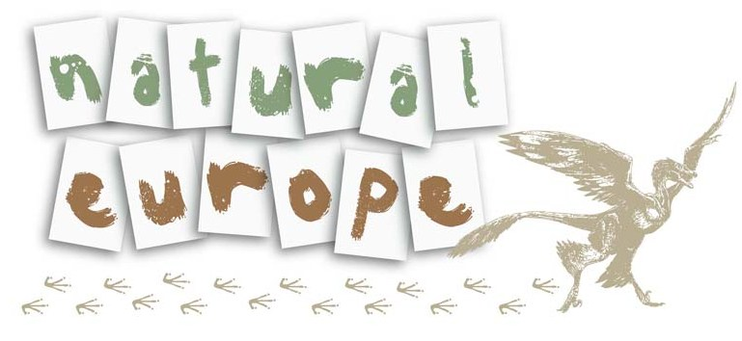 | 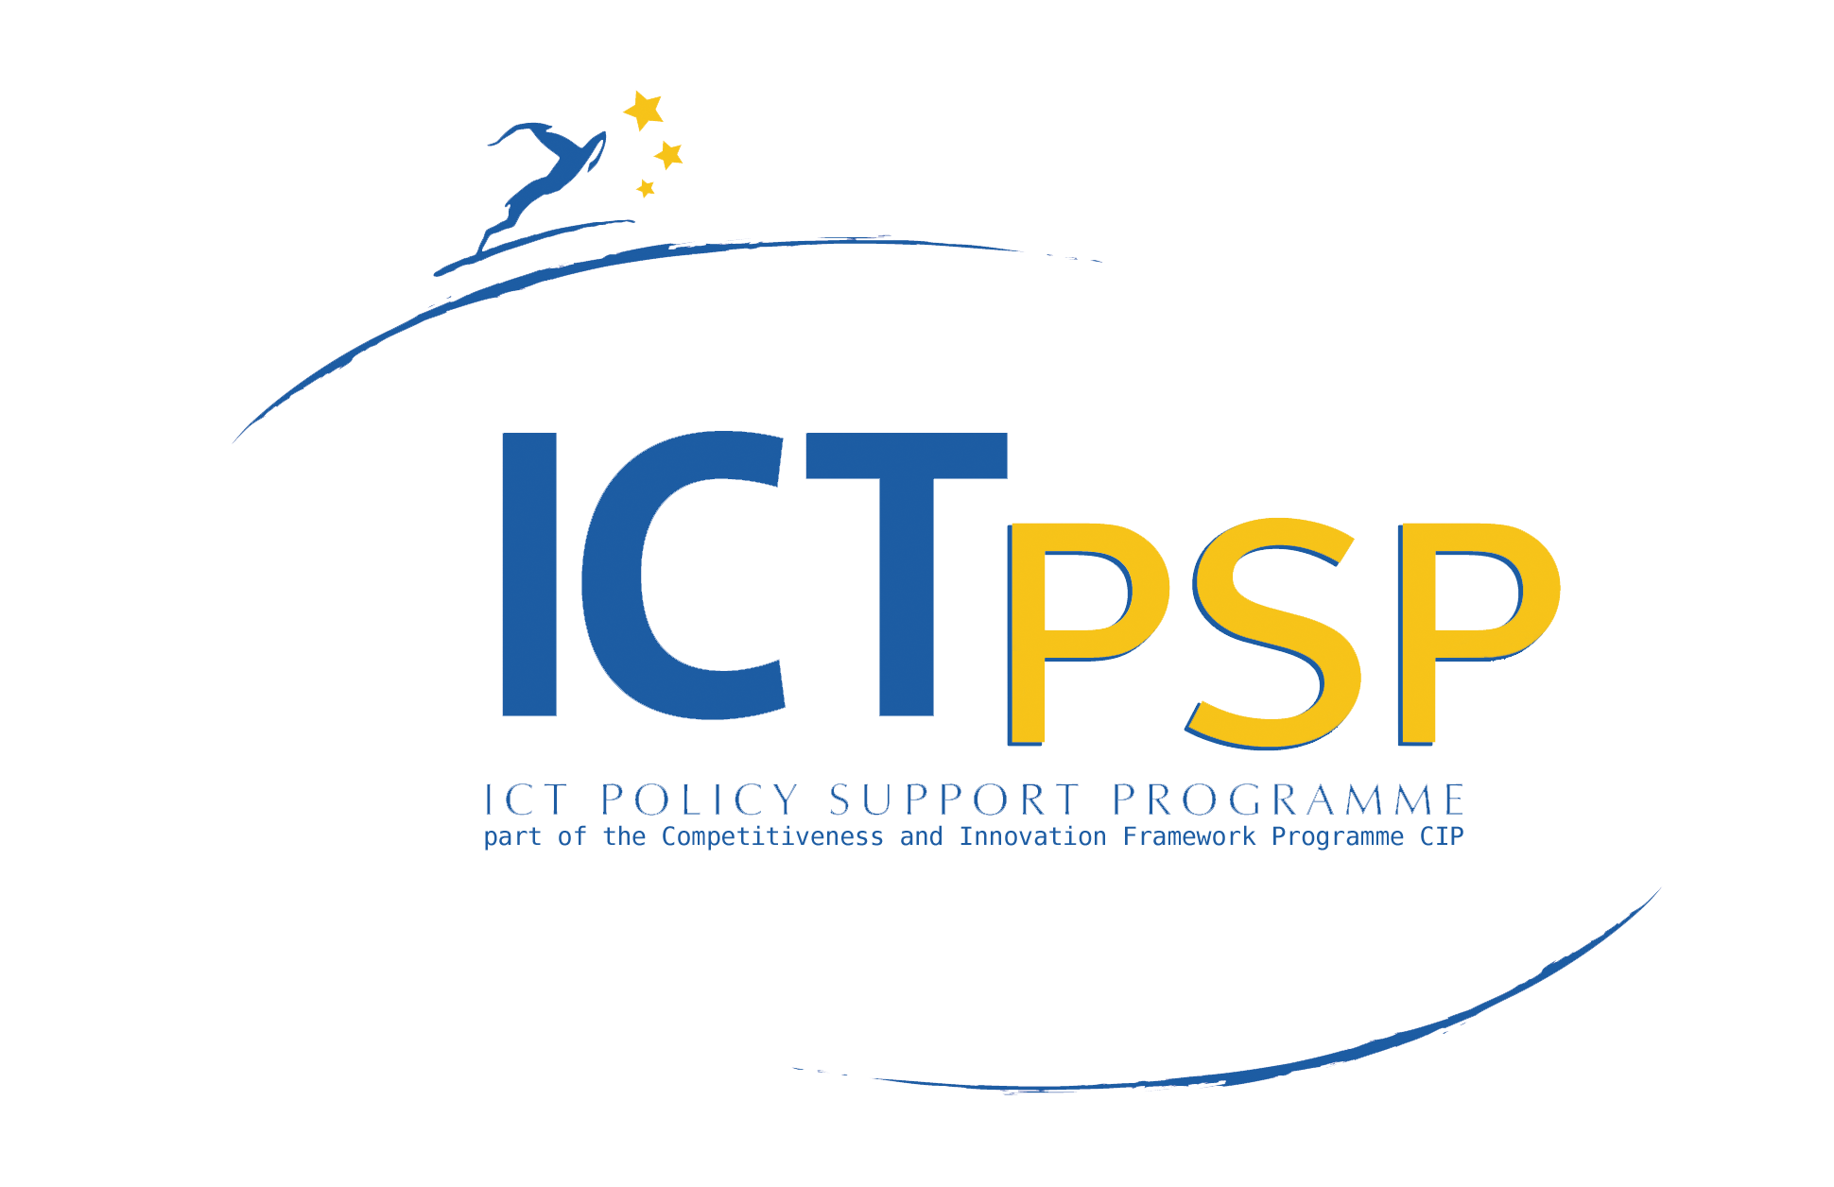

5th Meeting Minutes

Project Acronym: | Natural Europe
Grant Agreement number: | 250579
Project Title: | Natural Europe: Natural History & Environmental Cultural Heritage in European Digital Libraries for Education

5th Meeting Minutes
26-28, September 2012, Budapest, Hungary

Revision: final

Authors:
Effie Tsiflidou (GRNET)
Nikos Marianos (GRNET)
Nikos Manouselis (GRNET)

Project co-funded by the European Commission within the ICT Policy Support Programme
Dissemination Level
P | Public
C | Confidential, only for members of the consortium and the Commission Services | X

Meeting overview
The 5th Natural Europe project meeting was held...

Discussions overview
...
2nd Meeting Day
...
After a coffee break, the TUC team gave a presentation of the final version (7th release) of the MMAT, focusing on the changes that have been made based on the comments provided by all partners and the next steps.
GRNET reported the current status... (TO BE COMPLETED BY GRNET)
The next session was held by MW and BARCO, where... (TO BE COMPLETED BY MW/BARCO).
The day continued with two parallel sessions addressed respectively the content partners (pathway session) and the technical partners (technical session).
......... (pathway session is presented here).....

In the meantime in the technical session GRNET and TUC gave a presentation on the final version of the overall architecture of the project (Cultural and Educational) focusing on the components that would be discussed in this technical session. Afterwards, GRNET, MW and TUC discussed about the representation format needed to show educational pathways on Interactive Installations and the specific requirements needed for CHOs. Then, TUC presented its approach for the connection of the NE Cultural federated nodes to the BioCASE network. TUC will develop a web service implementing the BioCASE protocol (customized wrapper) that will be placed on top of the Multimedia Authoring Tool cultural repositories. Towards this end, TUC has performed a draft mapping of the Natural Europe Application Profile to the ABCD Schema, covering all mandatory and most of the highly recommended and commonly used elements (based on the BioCASE practices). These mappings should be evaluated by domain experts and revised if needed. Thereafter, TUC presented its framework for the proof of concept semantic infrastructure which will be developing until the end of the project that will allow for viewing of the NE cultural content from a more sophisticated (Semantic Web) perspective. Then FIT gave a presentation about the search widgets that are/will be supported, in specific, the Europeana Search widget, the Natural Europe Search widget, ROLE widgets (a version of the widgets for the ROLE environment), and iFrame widgets. Moreover, FIT presented some possible future directions for Natural Europe that were discussed with the technical partners: Educational games (TOTEM framework, Tidy City), Educational games for mobile devices, and mobile pathway authoring. Afterwards, FIT gave a presentation on how the technical validation of Natural Europe tools and services will be performed; using a test server with Jenkins for unit testing that can be linked to issue-tracker and SVN. Finally, FIT presented the testing schedule for the CHO repositories, the MMAT, the Educational Pathway repositories, the Pathway Authoring Tool and the Europeana Bridge.

Workplan issues, planning and main responsibilities
The following paragraphs briefly describe the ongoing work on each work package, focusing on the specific tasks and deliverables that have to be completed, also providing some tentative deadlines. The tasks and corresponding deadlines were commonly decided during the project meeting and can be changed due to project-related reasons.

WP4: Platform Design & Integration

Technical Architecture of Natural Europe
Technical partners had a separate meeting in parallel to the pathway meeting of the rest of the consortium. The details of this meeting were already presented in the corresponding section of the 2nd day description.
TUC will develop a web service implementing the BioCASE protocol (customized wrapper) that will be placed on top of the Multimedia Authoring Tool cultural repositories. Towards this end, TUC has performed a draft mapping of the Natural Europe Application Profile to the ABCD Schema, covering all mandatory and most of the highly recommended and commonly used elements (based on the BioCASE practices) that will be evaluated by NHMs domain experts and revised if needed. Moreover, TUC will continue to work on the proof of concept semantic infrastructure which will be developing until the end of the project that will allow for viewing of the NE cultural content from a more sophisticated (Semantic Web) perspective.
GRNET will…
FIT will…

Activities/Deadlines:
- NHMs biodiversity domain experts: Provide feedback on NE AP to ABCD mappings performed by TUC (17/10/2012)
- TUC: Development of the web service implementing the BioCASE protocol (10/11/2012)
- @GRNET and FIT: Add related activities and deadlines in this section or, if it is more appropriate, in the corresponding sections of your tasks

NHM Multimedia Annotation Tool
TUC presented the final version of the MMAT Tool which incorporated partners' comments made during the last months. Compared to the tool version presented in the 4th project meeting, several improvements have been made based on the comments received after the meeting (last round of comments received from NHMs on 30/03/2012). As far as metadata are concerned, each Natural Europe metadata record is divided into Species information, (b) CHO information, and (c) Digital Object information. The common names were added to the Species category, while various other changes on metadata elements, element semantics and obligations were performed. The final version of the tool offers an advanced search functionality, in order to enable users to locate records based on descriptive metadata, administrative metadata, or both and a help page providing basic help on the tool’s functionality (like importing, exporting, or executing batch record updates). Finally, after a request from the Hungarian Natural History Museum, TUC prepared an installation guide, providing instructions on how to install and configure MMAT on an Ubuntu/Fedora Web Server. The installation guide and packages are available at: http://natural-europe.tuc.gr/dev/wiki/NECulturalInstall

Activities/Deadlines:
- TUC: Add 3D-Object option to the “Content Type of the Digital Resource” – supported by ESE 3.4 (24/10/2012)
- TUC: Fix problems with some Unicode characters (e.g., German diphthongs) in the headers of the content boxes (24/10/2012)
- NHMC, MNHNL, JME, TNHM, HNHM: Give feedback to TUC to update translations reflecting the MMAT last changes (31/10/2012)
- AC: Provide Finnish translation for MMAT (31/10/2012)
- TUC: Update Greek, Portuguese, Magyar, German and Estonian translations (1/11/2012)
- TUC: Add Finnish translation (1/11/2012)
- TUC: Develop a web service implementing the BioCASE protocol (customized wrapper) that will be placed on top of the Multimedia Authoring Tool cultural repositories (10/11/2012)

Pathway Authoring Tool
TO BE COMPLETED BY GRNET

Activities/Deadlines:
- GRNET: Educational Pathway Template import functionality (??)

Educational Pathway Template Authoring Tool
TO BE COMPLETED BY TUC
During the project meeting a discussion between TUC and GRNET took place regarding the communication interface between the Educational Pathway Template Authoring Tool and the Pathway Authoring Tool.

Activities/Deadlines:
- TUC: Explore the import of pathways/pathways templates that have been developed in other related projects (e.g. OSR, COSMOS) to the Educational Pathway Template Authoring Tool in order to be able to use and adapt them for the needs of Natural Europe. These pathway templates can be thereafter imported and used in the Pathway Authoring Tool to guide the development of pathways.
- ...

Museum Digital Libraries Federation
TO BE COMPLETED BY GRNET

Activities/Deadlines:
- GRNET: ...

Federation with Europeana
TO BE COMPLETED BY GRNET

Activities/Deadlines:
- GRNET: ...

Enhancing Interfaces of NHM Web Sites
TO BE COMPLETED BY GRNET and FIT
During the project meeting, GRNET...
FIT gave a presentation about the search widgets that are/will be supported, in specific, the Europeana Search widget, the Natural Europe Search widget, ROLE widgets (a version of the widgets for the ROLE environment), and iFrame widgets.
…
Activities/Deadlines:
- ...

Interactive Installations
TO BE COMPLETED BY MW/BARCO and GRNET
Add description here
Activities/Deadlines:
- MW/BARCO: Deliver D4.6 “Specifications/Requirements for interactive installations (2/10/12)
- TUC: Support CHO specific requirements for interactive installations (24/10/2012)
- MW/BARCO, GRNET: Integration with NE cultural federal node. Specific set within NHMC MMAT with relevant content will be supported (??)
- MW/BARCO, GRNET: Integration with search APIs of NE & Europeana (??)
- MW/BARCO, GRNET: Integration with Pathway Player (NHMC PAT/ Collection, Enriched Pathways without instructions for educators) (??)
- MW/BARCO: Deliver D4.7 “Deployment of interactive installations” (??)
- Other?

