# 2019 Rx Monitoring Program Annual Report

3/31/2020

### Overview of objectives

* 1. Pull from statement of work
     1. Changes going forward

### Site locations

* 1. Map of sites (Two below, AG has a bunch – need to get my hard drive from campus today or tomorrow…)
  2. Number of plots

|  |  |  |
| --- | --- | --- |
| **Location** | **Pre-fire survey** | **Post-fire survey** |
| Bear Mtn (Stanislaus NF) | 27 | 27 |
| French Meadows (TNC) | 36 | Did not burn |
| Bliss State Park | 15 | Did not burn |
| Burton State Park | 24 | 5 (19 did not burn) |
| Sly Park (SPI/EID) | 22 | 11 (11 did not burn) |
| Springs Fire (USFS) | 35 | 24 |
| Total Sampling Effort | 159 | 67 |

* 1. Site complexity - treatment array
     1. French meadows least complex: will be first entry
     2. Springs fire and lakes district most complex (multiple TSLF)
  2. Where do we want to go forward??
     1. Different sites or treatment complexity? Similar sites?

### Methods

* 1. Intro: Initial surveys were completed as a part of the long-term prescribed fire monitoring program in California, with broad goals of measuring prescribed fire effectiveness and effects in the field. **159** common stand exams were distributed across six areas: Bear Mountain (Stanislaus NF), French Meadows (TNC), Bliss and Burton State Park (CA State Parks), Sly Park (EID and SPI), and Inyo NF (Springs Fire, USFS). Of these permanent initial plot locations, only four areas completed burning: Bear Mountain, Springs Fire, Sly Park (partial), and Burton SP (partial). 67 of these burned plots were surveyed within two weeks of burning to get initial measures of burn severity and fuel consumption.
  2. Common stand exam:
     1. 159 400-square meter permanent plots created and stratified across treatment type (if applicable). Plots were surveyed before prescribed fire, within two weeks (if logistically feasible), and will be surveyed again in spring 2020 and potentially for the following 3 years to examine change in species composition, mortality, and overall structure.
  3. Types of data collected
     1. *Reductions in fuel load/continuity:* Fuels collected before and within two weeks post-burn.
        1. Collaboration with Air and Resources on Springs Fire
     2. *Tree mortality:* Initial tree measurements collected before burn, mortality measurements to be collected in spring 2020.
     3. *Change in species composition:* Understory and shrub composition and cover collected before burn (including botanical survey of every plant species present). Spring 2020 surveys to examine year 1 composition change.
     4. *Soil surface conditions:* Ground cover collected before and within two weeks post burn.
     5. *Fire behavior:* Developed on-site monitoring protocol.
        1. Weather metrics and fire characteristics.
     6. *Incident checklist:* With the help of Springs Fire IC, developed standard protocol for RX monitoring crew responsibilities upon arrival of fire and during incident.

### Year-One Data Collected and Project Progress

* 1. Initial analyses:
     1. What can we show with what we have?
  2. On site collaboration
     1. Air and resources program on springs fire: fuels data provided to air and resources during managed wildfire to help with next day burn plans.
        1. Might want to get in touch with Lee with this part.
     2. Working with multiple jurisdictions, agencies, etc.
  3. Beginning to expand network
     1. Description or schematic of our current network
     2. Sketch of additional contacts or types of contacts we want to bring in (one possibility is diagram for i and ii where existing contacts are inner circle in gray and target additional contacts are outside in red, for example
     3. Brief description of why an expanded, better-connected network will lead to a well-oiled machine in which multiple entities look for us to conduct monitoring and make use of data we provide (do we know what the products people want are?)

### Discussion

* 1. **LESSONS LEARNED**
     1. Communication
        1. Communication protocol developed with IC
        2. Identified points of contact for permission and approval
        3. Communication between CALFIRE and UCD
     2. Safety issues while working on fire:
        1. created incident checklist while on Springs Fire to prevent any discrepancies going forward.
     3. Other possibilities: procurement of equipment, technology, personnel

### Going Forward

* 1. What do we wish to accomplish this year?
     1. Spring/ Summer 2020: Hire crew; initial data analysis complete (fuels, initial structure and composition); annual report submitted April 2020; follow up surveys for burned plots (Sly Park, Springs Fire, Burton State Park, Bear Mountain): tree mortality, species composition, cover; field site determination for summer/fall.
     2. Fall 2020: On site prescribed fire monitoring; Year one analysis conducted; year two data submitted.
  2. What about the long term?
     1. AG interested in mortality: take an ecophysiology approach and assess water potential across varying treatments. How do mortality patterns change across different treatment arrays
        1. Little empirical evidence of water stress due to variation in stand structure.
        2. Drought stress can be measured as decreased plant water potential (stomatal closure progressively restricts transpiration and carbon assimilation)
        3. Methods: Pressure chamber equipped with flow regulator, which measures the hydrostatic tension in the xylem of a tree.
  3. Implications
     1. What can we change going forward?
     2. Future research and growth

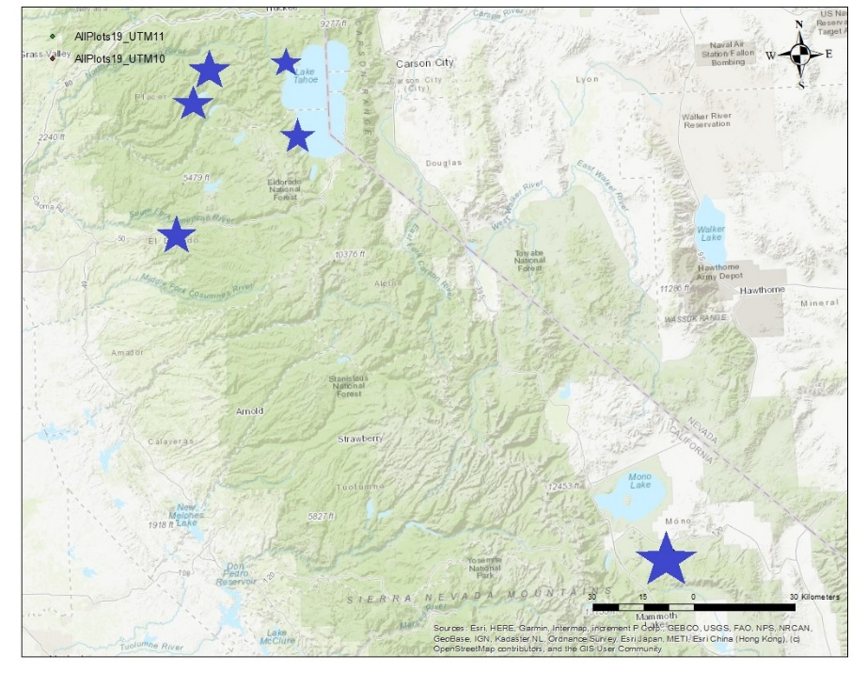

Fig 1: all plot locations

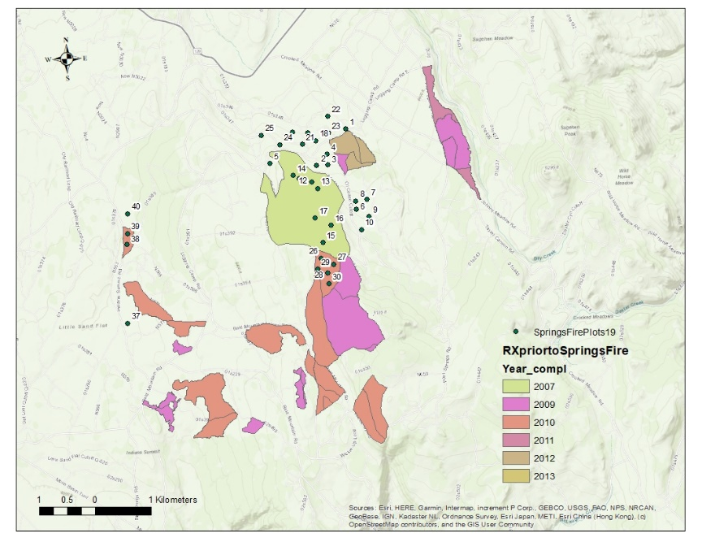

Fig 2: Springs fire treatment array