**INEQUALITIES IN MORBIMORTALITY DUE TO COVID-19 IN THE AUTONOMOUS CITY OF BUENOS AIRES**

Adrián Santoro

**PRESENTATION**

The first confirmed cases of SARS-CoV-2 infection in Argentina were in the Autonomous City of Buenos Aires (CABA) in early March 2020. They were tourists returning from European cities that were registering high levels of COVID-19 incidence. The virus quickly began to circulate in the community and spread to other jurisdictions. However, until early September 2020, the CABA and the 40 districts of the Province of Buenos Aires that surround it (the geographic aggregate known as the Buenos Aires Metropolitan Area) accounted for nearly 95% of the country's incident cases and deaths.

The main characteristic of the policies adopted by the Argentine government at the beginning of the epidemic was the early adoption of restrictive procedures. With 128 confirmed cases and 3 deaths throughout the country, on 20 March 2020 the "Preventive and Mandatory Social Isolation" was decreed. It was determined, among other measures, the closure of schools, the closing of borders, the limitation of intra- and inter-jurisdictional circulation, the work activities at home for non-essential workers, the limitation of public transportation and the prohibition of social events and activities that generate agglomeration of people (bars, restaurants, movie theaters, etc.) and the protocolization of physical distancing measures (1). The main purpose of the regulation was to delay the epidemic's maturation, giving time for the health system's preparation, and to strengthen a structure capable of responding to the demands of the new situation, given the high virus reproduction capacity and the great demand for resources for the attention it would potentially demand.

The CABA is the federal district of Argentine and adopted the regulations established by the national government. The implementation of these regulations had a high degree of compliance in the early days. According to Google's mobility index (2), after 10 days of isolation, mobility in workplaces had been reduced by more than 80% compared to the reference value of "normal". The same happened with mobility in parks and in vehicle traffic.

Although it is possible to establish the impact of the pandemic on CABA in comparison to the rest of the jurisdictions, it should be noted that the federal district of Argentina is a markedly unequal area, where 3075646 people live (3). The inequity of the distribution of resources in CABA has been demonstrated in numerous studies (4–7). All of these agree in identifying the southern zone of the city as the one with the worst living conditions. In particular, the study conducted by Santoro (8) evaluated the inequalities in relation to health-related dimensions of the population and found significant differences in the structure of mortality by cause, life expectancy and fertility between areas of the city.

There are studies that described the differential impact of the pandemic in different metropolises of the world, agreeing that its passage through socially vulnerable sectors of the population is more harmful. Van Dorm, Cooney y Sabin (9) argued that in cities such as New York, so-called "essential workers" constitute a population made up mostly of vulnerable people, mainly African Americans and Hispanics, so these communities' exposure to the virus is greater. Also in the United States, an ecological study on the distribution of mortality related to COVID-19 in the city of Chicago (10) showed how mortality was mainly concentrated in areas where African-American communities predominated. They proposed, based on the results, the higher prevalence of chronic diseases and persistent social inequities as possible explanatory factors for this phenomenon. In the same direction, the study by Blundell et al (11) in the United Kingdom showed that mortality from COVID-19 in the top 10% of deprived areas was double that of the top 10%. Moreover, for mortality from COVID-19 the inequality between these two extremes was even greater for overall mortality.

In Barcelona, a study by districts showed a high association between socio-demographic variables and incidence of COVID-19. In particular, it should be noted that the Baena-Díez study (12) showed a high correlation between average community income and incidence rates (Spearman's Rho = 0.83).

Although no empirical studies that quantify the unequal impact of morbidity and mortality due to COVID-19 in Latin American cities were observed, the potential differential impact of the pandemic on different dimensions of social life in large Latin American cities that previously presented high degrees of inequity was noted in the literature. Diez-Roux et al. (13) argued that there are phenomena whose consequences exceed the impact of COVID-19 infections, overlapping with pre-existing conditions of inequity. Thus, in addition to the impact on the health of infected people, there are socioeconomic consequences of unemployment, loss of income, delays in the care of other health conditions, etc. In the same direction, Patel and others (14) associated the phrase "the virus does not discriminate", occasionally repeated by political leaders, public health experts and journalists to a kind of "myth" that makes invisible the different degrees of vulnerability of the populations.

Another relevant reference represents the study by Campbell and Campbell (15) where the phenomenon of urbanization was problematized and features of large urban agglomerates were noted as factors of negative influence on the health of populations prior to the pandemic. High population density, overcrowding in unsafe settlements, poverty and aging, among others, would constitute factors of vulnerability for populations to the emergence and re-emergence of infectious diseases.

The inequality in the availability of information between countries and subnational areas should also be highlighted because it determines different levels of coverage, completeness and specificity of the statistics. Per-capita indicators are commonly disseminated as a measure of epidemiological phenomena, particularly mortality. In this aspect, the study by Heuveline and Tzen (16) represents a fundamental contribution in methodological terms, since it highlights the relevance of adjust factors of confusion (demographic structure and time elapsed since the beginning of the epidemic) for the assessment of the impact of the pandemic on different populations. The younger demographic structures are generally associated with populations having high levels of deprivation and masks, because of the confounding effect of the age distribution on the population, the level of harm from mortality, determining low crude death rates, for example.

The objective of this study was to describe the morbidity and mortality due to COVID-19 in the CABA and to quantify the level of inequality observed among the wards that compose it. The assumption that guided the description was based on the fact that the unequal distribution of morbidity and mortality indicators represents a greater negative impact in the southern zone of the city, which integrates the lowest income wards and is identified in the bibliography as the most neglected area of the city.

**METHODS**

The research was an observational study, of descriptive scope, from population aggregates. The temporal approach was transversal. The analysis units were represented by each ward of CABA. The population study was made up of the 15 wards into which the CABA is divided. The results were described by wards and zones. The division of the city into wards responds to an inter-jurisdictional and political-administrative division of the territory. The zones represent groupings of wards according to the homogeneity observed in different indicators of life conditions. Thus, the southern zone is considered to be made up of wards 4, 8, 9 and 10; the central zone is made up of wards 1, 3, 4, 5, 6, 7, 11, 12 and 15; and the northern zone is made up of wards 2, 13 and 14.

The average total family income of each commune registered in the Annual Household Survey 2019 (17) was used as socio-demographic gradient for the description of inequalities. In order to avoid the use of outdated monetary values, an index based on ratio between the average family income of each ward and the total of the CABA was calculated, so that wards with values below one represented communes with average income below the average of the city and vice versa. It was called "standardized income index" (SII).

The information used was reported up to ##/##/#### on the website of the Government of the City of Buenos Aires (18), a portal that offers microdata of the official epidemiological information of the Government of the City of Buenos Aires that comes from the National Health Surveillance System of Argentina. Cases that did not have information on age or commune of residence were excluded from the analysis. Thus, 11079 of the 339652 total cases were rejected (3.3%). Among the confirmed cases, the records discarded represented 2.7%.

The populations used to calculate the indicators were those elaborated by the General Directorate of Statistics and Census (3) and correspond to 2020.

For the whole of CABA and for each ward, the accumulated incidence rate per 1000 people, the mortality rate per 1000 people, the fatality rate and the positivity percentage were calculated. To measure mortality levels by ward, eliminating the confounding factor of different demographic structures, the standardized mortality ratio (SMR) was calculated according to the methodology proposed by the Pan American Health Organization (19), taking the specific mortality rates by age groups of the CABA as standard.

To evaluate the levels of inequality and concentration, rate ratios and differences were calculated. The 95% confidence intervals (CI95%) were calculated for the analyzed indicators. For the cumulative incidence rate per 1000 people, the mortality rate per 1000 people, the fatality rate and the percentage of positivity the IC95% was estimated by means of the normal approximation. For SMRs, the Chi2 methodology was used (20) and for rate ratios the one proposed by Fay (21).

Data processing, statistical analysis and figures were performed with the statistical software R (22).

The programming codes and data used to calculate the indicators of this study are available in the public repository XXX. The repository offers the possibility of updating the calculations automatically to the most up-to-date information available on-line.

**RESULTS**

By 11 November 2020, 215 days had passed since the first confirmed case of COVID-19. During this period, 328573 suspected cases were entered into the epidemiological surveillance system, of which 125652 were confirmed, resulting in a cumulative incidence rate of 40.8 cases per 1000 people (CI95% 40.6 - 41.1).

The analysis of the incidence showed that it was not distributed homogeneously, since it oscillated between 25.8 per 1000 people (CI95% 25.2 - 26.5) in ward 12 (central zone) and 62.2 per 1000 people (CI95% 61.3 - 63.2) in ward 4 (southern zone). This last ward, the one with the lowest average family income, presented an accumulated incidence rate 76.2% higher than the ward with the best socioeconomic situation - ward 14, in the northern zone - (rate ratio (RR) = 0.76, IC95% 1.72 - 1.81).

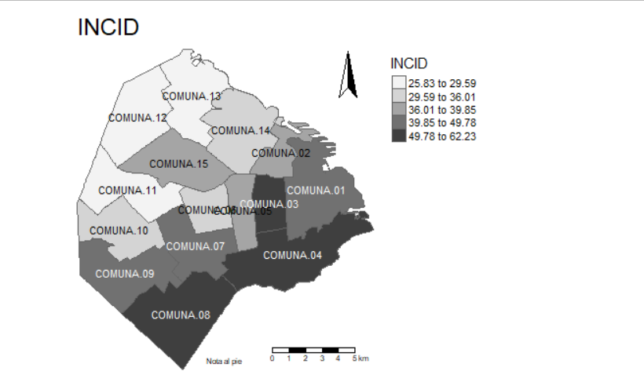

When observing the differences in incidence by age groups, the inequalities also acquire high magnitudes, with the greatest differences concentrated mainly among young adults. Figure 1 shows the different levels of incidence between the best and worst-off communes in relation to average family income according to different ages. The two most unequal age groups are the 20 to 24 year olds, where the incidence of the most disadvantaged commune represents 2.7 times that of the best situation (RR = 2.7, CI95% 2.4 - 3.0) and the 25 to 29 year old group, where the first represents 2.3 times the second (RR = 2.3, CI95% 2.1 - 2.5).

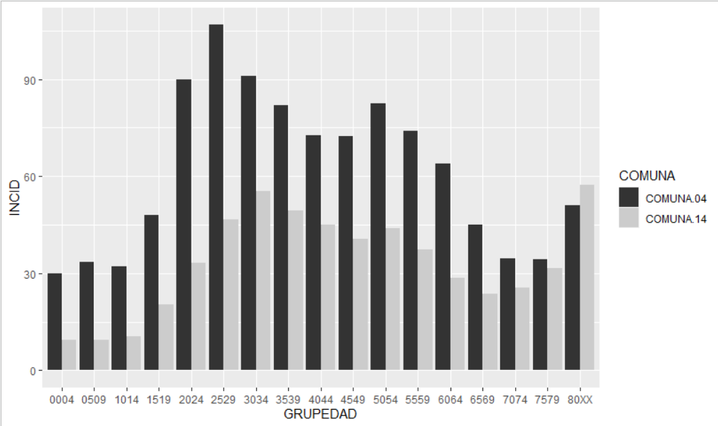

The percentage of positivity was also evaluated as a measure of the intensity of epidemiological surveillance. This indicator was more homogeneously distributed among the CABA ward in comparison with the accumulated incidence rate, but significant differences were evident. For the city as a whole, the percentage of positivity stood at 38.0% (CI95% 37.8 - 38.2), rising to 41.4% (CI95% 40.9 - 41.9) in the area of worst average income. The most favored ward presented a level of positivity of 32.6% (CI95% 32.0 - 33.2), almost 10 percentage points below the most economically disadvantaged and 5 below the value of the CABA. It is important to note that the highest value of positivity was presented by ward 3 with 44.6% of the cases, an area that does not present the lowest level of average income and is located in the center of the city. In any case, when observing the set of positivity values, a tendency towards concentration in the center of the city can be observed. Figure 2 describes the different levels of positivity observed by ward.

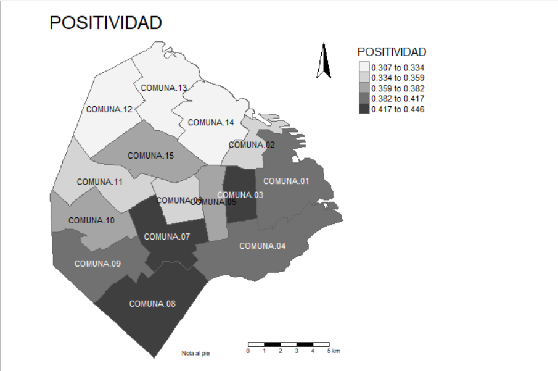

In relation to mortality, the percentage varied between 1.7% (CI 95% 1.5 - 1.9) in ward 8 (southern zone) and 3.6% (CI95% 3.1 - 4.1) in ward 12 (northern zone). The case fatality rate presented the lowest value in a ward of the southern zone, which would mean that, in general terms, the worst prognosis for those infected was found in one of the most disadvantaged areas, especially taking into account that among the five wards with the highest case fatality percentages (wards 12, 11, 2, 10 and 13) no one was found in the southern zone. In addition, three of them (2, 12 and 13) are among the five with the best average family income. This would evidence an inverse association between income level and fatality or, in other words, a worse prognosis for those infected cases living in the higher income zones. This apparent association becomes blurred observing the age groups, as shown in Figure X. In analyzing the age groups over 60, it was found that the concentration in the most disadvantaged communes is stronger. In any case, the width of some confidence intervals does not allow making assertions free of a high degree of uncertainty.

**AGREGAR INDEX**

|  |  |  |  |  |  |  |  |  |  |  |  |  |
| --- | --- | --- | --- | --- | --- | --- | --- | --- | --- | --- | --- | --- |
|  | **Total** | | | **60 a 69 años** | | | **70 a 79 años** | | | **80 a 89 años** | | |
| **Comuna** | **Porcentaje** | **Límite inferior** | **Límite Superior** | **Porcentaje** | **Límite inferior** | **Límite Superior** | **Porcentaje** | **Límite inferior** | **Límite Superior** | **Porcentaje** | **Límite inferior** | **Límite Superior** |
|  |  |  |  |  |  |  |  |  |  |  |  |  |
| Total | 2.8 | 2.7 | 2.9 | 5.5 | 5.1 | 6.0 | 13.5 | 12.6 | 14.4 | 22.4 | 21.4 | 23.3 |
|  |  |  |  |  |  |  |  |  |  |  |  |  |
| 1 | 2.4 | 2.1 | 2.6 | 4.4 | 3.1 | 5.8 | 12.8 | 9.9 | 15.8 | 26.1 | 22.3 | 29.9 |
| 2 | 3.5 | 3.0 | 4.0 | 2.6 | 1.2 | 3.9 | 12.9 | 9.4 | 16.4 | 23.1 | 19.5 | 26.7 |
| 3 | 2.8 | 2.4 | 3.1 | 6.0 | 4.4 | 7.6 | 16.0 | 12.8 | 19.2 | 21.3 | 17.9 | 24.7 |
| 4 | 2.3 | 2.0 | 2.5 | 7.4 | 5.8 | 9.0 | 16.2 | 12.9 | 19.5 | 26.4 | 22.2 | 30.6 |
| 5 | 3.2 | 2.8 | 3.6 | 6.3 | 4.4 | 8.2 | 12.8 | 9.5 | 16.1 | 20.5 | 17.2 | 23.8 |
| 6 | 2.9 | 2.5 | 3.4 | 3.3 | 1.7 | 4.8 | 12.6 | 9.0 | 16.2 | 19.9 | 16.3 | 23.5 |
| 7 | 3.0 | 2.7 | 3.3 | 6.0 | 4.3 | 7.6 | 16.4 | 13.2 | 19.6 | 20.6 | 17.6 | 23.6 |
| 8 | 1.7 | 1.5 | 1.9 | 8.6 | 6.5 | 10.7 | 17.3 | 12.9 | 21.7 | 27.2 | 21.1 | 33.3 |
| 9 | 2.9 | 2.5 | 3.2 | 7.5 | 5.3 | 9.8 | 13.3 | 9.7 | 17.0 | 23.4 | 19.2 | 27.6 |
| 10 | 3.4 | 2.9 | 3.9 | 6.2 | 4.0 | 8.5 | 12.9 | 9.1 | 16.8 | 22.1 | 18.3 | 25.9 |
| 11 | 3.6 | 3.1 | 4.1 | 5.1 | 3.1 | 7.2 | 13.0 | 9.4 | 16.6 | 20.5 | 17.3 | 23.8 |
| 12 | 3.6 | 3.1 | 4.1 | 5.3 | 3.3 | 7.3 | 17.5 | 13.2 | 21.9 | 23.0 | 19.2 | 26.8 |
| 13 | 3.3 | 2.8 | 3.7 | 3.3 | 1.9 | 4.7 | 7.1 | 4.7 | 9.6 | 22.2 | 19.0 | 25.4 |
| 14 | 3.1 | 2.7 | 3.4 | 4.4 | 2.8 | 6.0 | 9.7 | 7.1 | 12.3 | 21.6 | 18.6 | 24.7 |
| 15 | 2.9 | 2.5 | 3.2 | 4.3 | 2.6 | 6.0 | 12.9 | 9.4 | 16.4 | 22.6 | 18.9 | 26.3 |

Heterogeneity was observed in the distribution of mortality within CABA. SMRs ranged from 66.5 (CI95% 55.6 - 77.6) to 158.3 (CI95% 141.9 - 176.0). The ward with the worst mortality situation was number 4 in the southern zone, and the one with the worst situation in relation to the average family income. At the other extreme, ward 6, in the central zone, was sixth in the average income ranking. All of the wards in the southern zone presented SMRs above 100, which means that their situation was worse than the reference for the jurisdiction. The opposite occurred with all of those in the northern zone, located above the same reference. Measured by the SII, the exploration of the relationship between average family income and mortality, at the ward level, seems to present a correlation (Figure X)

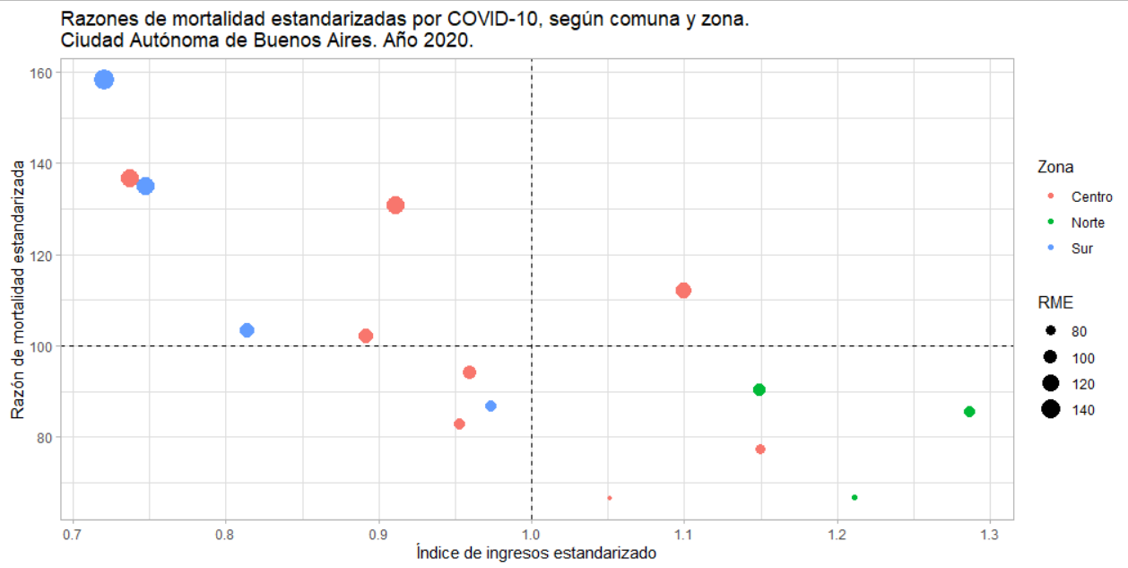

Based on the data on expected deaths according to the specific mortality rates of the CABA, the median age of the expected deaths in each ward was approximated, grouping the expected deaths into five-year age groups and identifying the one that accumulated 50% of the deaths. Wards 4 and 8, both in the southern zone, were the only ones that observed a lower median age than expected since they accumulated 50% of the deaths in the age groups 70-74 and 65-69 respectively, while this accumulation was expected in the age group 75-59. For other wards, the median value was in the same age group for both observed and expected deaths, except for wards 10 (southern zone), 12 (central zone), 14 (northern zone) and 15 (central zone), which observed the median age in the age group 80 years and older, when this value was expected between 75 and 79 years.

**DISCUSSION**

The findings of the present study highlight the disadvantageous situation of the wards of the so-called "southern zone" of CABA. It could be described how the accumulated incidence of COVID-19 at xxx days of the epidemic development is higher in the communes that conform that zone. Inequality increases among young adults, reaching great magnitude as the specific rates of these groups double in the most deprived commune compared to the one with the best income in the city. Levels of positivity higher than those of the jurisdiction were also observed in all the communes of the southern zone, although this phenomenon could also be detected in communes of the central zone. In relation to the fatality, a lower level of heterogeneity was observed, finding non-significant differences between most of the wards. In any case, differences were observed between the columns of extreme values, although in the opposite direction to that observed in the phenomena described above. In this case the best position was occupied by a ward in the southern zone which, in turn, was located in the third worst place in relation to the average income of the families living there. In any case, observing the phenomenon by age groups, higher levels of mortality were found among the older population of the most disadvantaged communes.

The results observed are congruent with previous studies that described the southern zone of CABA as a segregated geographical area with comparatively disadvantageous conditions in terms of the aspects involved in determining the health of populations and their living conditions (4–8). Adicionalmente, los hallazgos son congruentes con lo que mostró la encuesta de seroprovalencia realizada por el gobierno de la CABA, donde se constató que la proporción de población seroprevalente detectada en la zona sur fue 168,3% más alta que la detectada en la zona norte.

Additionally, the findings are congruent with what was shown by the seroprovalence survey carried out by the CABA government, which found that the proportion of the seroprevalent population detected in the southern zone was 168.3% higher than that detected in the northern zone (CITA).

It is possible that this context is the result of a structuring element such as the material conditions of existence which, as seen in this study, were shown to be associated with the differential impact of the epidemic, its measurement having been approximated by the average family income in each commune. A similar situation had been observed for morbidity in Barcelona (12) and mortality in the United Kingdom (11).

A notable finding is the higher incidence of COVID-19 among young adults in the southern communes of CABA. While the design of this research does not allow for individual-level associations, it could be hypothesized that, as described to Chicago's Hispanic population in Kim's study (10), there are higher levels of exposure among workers in vulnerable areas due to the greater insertion (in relative terms) in sectors linked to the informal economy (with less compliance with protocols) and to essential tasks (security, cleaning, nursing). Another element is comorbidity: unfavorable living conditions are associated with less detection and higher prevalence of chronic non-communicable diseases that act as comorbidities of COVID-19, worsening the prognosis in the evolution of the disease (23).

The results of this study call into question some of the underlying logics of government and media discourses about the cross-cutting impact of the epidemic across all levels of social vulnerability. As previously argued, the idea that the epidemic impacts equally (14) is difficult to support empirically in the case of CABA. The main advantage of this study, then, lies in the possibility of making inequalities visible and orienting the weighting of the impact of the pandemic on the CABA towards the complexity of its determination, directing it towards the social conditions of existence, made invisible by the discourses based on the humanization of the virus, fear and war metaphors, for example. On the other hand, the description of mortality through indicators adjusted by age, made it possible to overcome the approach based on indicators per capita, vulnerable to the demographic structures as factors of confusion, as warned by Heuveline and Tzen (16).

The fundamental weakness of this study lies in the limitations of its methodology. Aggregate studies allow the establishment of correlational hypotheses, but do not measure risk factors or causalities at the individual level. Then, results are of a descriptive scope, which is a limitation when designing interventions. In this sense, it is necessary to highlight a general limitation anchored in the characteristics of health information systems: quantitative approaches to the evolution of the epidemic are based on epidemiological surveillance systems that in many cases present coverage and integrity problems. On the other hand, it must be taken into account that throughout the pandemic, the national states have been modifying the definitions of "probable case" and "confirmed case", which impacts the detection capacity of the surveillance systems. Nor can it be ignored that the purpose of generating data states is not investigative, but rather surveillance, so that often there are procedures that are not sufficiently refined, such as those for determining the basic cause of death or the existence of comorbidities.

After XX days from the beginning of the epidemic in CABA, the description of morbi-mortality by COVID-19 validates the idea of drastically reinforcing public policies aimed at guaranteeing access to health services, deepening detection, testing, assistance and isolation in populations with deficient living conditions.