Facial Key-point Detection

Update Report

Sarthak Agarwal

Cognitive Computing and AI

# **Problem statement:**

The objective is to train a model that can predict the key-point positions on face images. Facial key-points are centers and corners of the eyes, eyebrows, nose and mouth, among other facial features.

The work done so far can be found at the following Github link:

<https://github.com/agsarthak/Cognitive-Computing-and-AI/tree/master/Midterm_Project>

# **Summary of what I have done and have not done.**

# **Things that I have successfully accomplished:**

1. **Data pre-processing and transformation**

* Handle missing values.
* Flatten, scale and stack the images in an array.
* Convert the test image to greyscale, resize it, reshape it and store it in a 2d array.

1. **Setup environment on AWS EC2 instance with GPU2xlarge.**

* Connected Jupyter notebook to AWS instance.
* Connected FileZilla to AWS instance for file transferring.

1. **Built a baseline neural network model.**

* Built a model with one hidden layer and 100 nodes.
* Ran it for 100 epochs on a CPU. Took 5mins to run.
* Tried different momentum, learning rate and optimizers and compare the learning curve by plotting the graph on training and validation data.

1. **Built a Convolutional Neural Network.**

* Built a neural network with 3 CNN layers and 3 dense layers.
* Ran it on GPU at AWS for 500 epochs that took 40mins to run.
* Observed significant decrease in loss when compared to baseline model.
* Saved the model and weights for future prediction.

1. **Researched and implemented data augmentation technique.**
   * Flip the images and map the key-points to the flipped image in training dataset. This is considered new data by the algorithm.
   * Ran the CNN on the updated set of data and observed decrease in loss.
   * Ran it on GPU at AWS for 500 epochs. It took 50mins.
2. **Prediction**
   * Wrote a script that takes a real-life image – resizes it, converts it into 2d greyscale image and stores it in an array.
   * Predicted the facial key-points on the real image.

# **Outstanding items / Future Work:**

1. Build a statistical model and compare the performance with Neural Networks.
2. Run the above CNN models for more epochs.
3. Build a deeper convolutional neural network like DenseNet and ResNet.

# **Results:**

|  |  |  |  |  |  |
| --- | --- | --- | --- | --- | --- |
| Model | Model Description | Epoch | Time | Train Loss | Val Loss |
| Model 1 | NN with 1 hidden layer, 100 nodes | 100 | 3mins CPU | 0.0024 | 0.0037 |
| Model 2 | Model 1 + momentum=0, decay=0, nesterov=False | 100 | 3mins CPU | 0.0070 | 0.0080 |
| Model 3 | CNN | 500 | 40mins GPU | 0.0012 | 0.0020 |
| Model 4 | CNN – Flipped images | Yet to run |  |  |  |

**Model 1 Prediction:**

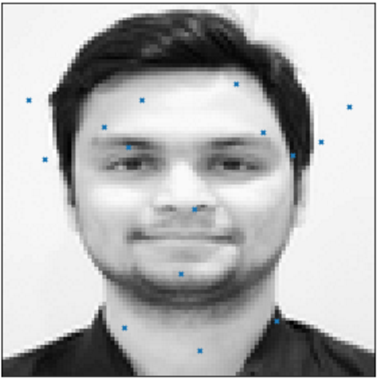

**Model 2 Prediction:**

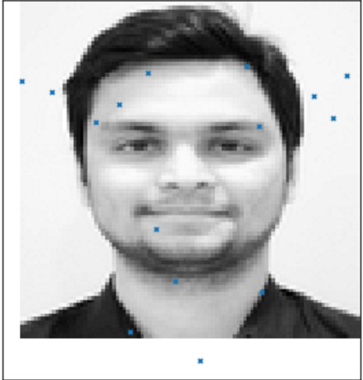

**Model 3 Prediction:**

