A Survey Paper on Goal-oriented-Dialogue-Systems
- Roopa Prasad , Sarthak Agarwal

Abstract— During the past decade, several areas of speech and language understanding have witnessed substantial breakthroughs from the use of data-driven models. In the area of dialogue systems, the trend is less obvious, and most practical systems are still built through significant engineering and expert knowledge. Nevertheless, several recent results suggest that data-driven approaches are feasible and quite promising. To facilitate research in this area, we have carried out a wide survey of publicly available datasets suitable for data-driven learning of dialogue systems. We discuss important characteristics of these datasets, how they can be used to learn diverse dialogue strategies, and their other potential uses. We also examine methods for transfer learning between datasets and the use of external knowledge. Finally, we discuss appropriate choice of evaluation metrics for the learning objective.

Introduction
Dialogue systems, also known as interactive conversational agents, virtual agents or sometimes chatterbots, are useful in a wide range of applications ranging from technical support services to language learning tools and entertainment. Large scale data-driven methods, which use recorded data to automatically infer knowledge and strategies, are becoming increasingly important in speech and language understanding and generation. A wide range of data driven methods have shown to be effective for tasks involved in dialog systems. We hypothesize that, in general, much of the recent progress is due to the availability of large public datasets, increased computing power, and new machine learning models, such as neural network architectures. To facilitate further research on building data-driven dialogue systems, this paper presents a broad survey of the goal oriented dialog systems that has been implemented.
The goal of this project is to understand the structure and the architecture of the goal oriented dialog system and compare the datasets used for two different goal oriented dialog system.
Overview of Goal Oriented Dialogue Systems:

In the past decade, goal-oriented dialogue systems have been the most prominent component in today’s virtual personal assistants, which allow users to speak naturally in order to finish tasks more efficiently. Practical dialogue systems consists of several components.
NLU Module:
Maps free texts to structured semantic frames of utterances . The module is trained to predict the intent of the user utterances. Training this model requires examples of pairs of user utterances and intentions. The dataset used are written dialogues between humans who have carried out a task and annotated each utterance with its intention label.
NLG Module:
Maps the structured representations back into a natural-language form. Given the user’s dialogue actions, the NLG module generates natural language texts. To control the quality of user simulation given limited labeled data, a hybrid approach including a template-based NLG and a model-based NLG is employed, where the model-based NLG is trained on the labeled dataset with a sequence-to-sequence model. It takes dialogue acts as input, and generates sentence sketch with slot placeholders via an LSTM decoder. Then a post-processing scan is performed to replace the slot placeholders with their actual values (Wen et al., 2015). In the LSTM decoder, we apply beam search, which iteratively considers the top k best sub-sentences when generating the next token.
Language Understanding:
The Language Understanding module consists of LSTM that performs LSTM and also fills the slot simultaneously. For example, for a question” find all the action movies available this weekend”.The find_movie goes into the request slot.
Dialog Manager:
DM keeps monitoring the belief distribution over all possible user states underlying current user behaviors, and predicts responsive system actions. For example, given a user utterance “any action movies recommended this weekend?”, LU predicts intent request movie and slots genre and date; thereafter, DM predicts system action request location. The state tracker will be updated based on the available result from the database and the latest user dialogue action. The DM includes Dialog state tracking where the state of the dialog is represented and policy learning. Policy Learning represents the next available system action based on the value of the state tracker.

Discussion:
Next, we will discuss about the recent research papers that have been carried out on goal oriented dialog systems
End-to-End Task-Completion Neural Dialogue Systems – Microsoft
Summary:
The objective of this project is to explore neural network architectures for question answering and goal oriented dialog systems. This paper presents a task oriented dialogue system which leverages supervised and reinforcement learning with various deep-learning models. We consider a dialogue system for helping users to book movie tickets or to look up the movies they want, by interacting with them in natural language. In this paper. The system interacts with the database and interacts with the users for helping them access information about movies and performing a task such as booking a movie ticket. The environment then assesses a binary outcome (success or failure) at the end of the conversation, based on (1) whether a movie is booked, and (2) whether the movie satisfies the user’s constraints.
Dataset : Movie knowledge base dataset which has the details of all the available movies, show timing and all the theaters nearby.
Architecture:
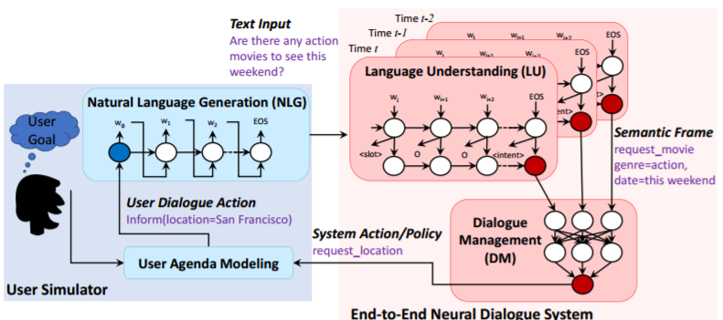

User Simulator: In the task oriented dialog system, the first step is to simulate a user goal where the agent knows nothing about the goal but the objective is to help the user accomplish the goal. The mechanism is to extract all the slots and aggregate them into one user goal. We dump these goals into a file as the user goal database for the simulator. The user simulator converts the movie database into a user goal template with structured conversations. There are three stages for a dialogue: no_outcome_yet, success and failure. The stage is no_outcome_yet if the agent has not issued the inform(taskcomplete) action and if the number of turns of the conversation has not exceeded the maximum value; otherwise, the dialogue is finished with either a success or a failure outcome. To be a success dialogue, the agent must answer all the questions (a.k.a. requestable slots of the user) and book the right movie tickets finally, within the maximum number of turns. All other cases are failure dialogues. For example, the whole dialogue exceeds the limit of max turns, or the agent books the wrong movie tickets for the user.
NLU Component: The natural language understanding (NLU) component is a recurrent neural network model with long-short term memory (LSTM) cells. The NLU component takes the dialogue act as the input and performs intent prediction and slot filling simultaneously. The LU component is implemented with a single LSTM
Dialogue Manager: The output from the LU module is passed to the dialogue manager which includes dialogue state tracking and policy learning. Given the LU symbolic output, a query is formed to interact with the database to retrieve the available result. The state tracker will be updated based on the available result from the database and the latest user dialogue action. Then the tracker prepares a state representation. Conditioned on the state input from the state tracker, policy learning is to generate the next available system action π(a|s).
End to End Reinforcement Learning: : Reinforcement Learning comes in place where we define the optimal action by learning the dialog policy. Reinforcement Learning is applied to the dialog manager where it is trained using the deep Q network. The Deep Q network takes the input as the state tracker and gives the Q value for all the possible actions available. The epsilon greedy exploration policy is used . Q values will be updated and In the training process, at every simulation epoch, we estimate the success rate of the current DQN agent.
Experiments and Discussions:
A task completion dialogue system for helping users book movie tickets. Over the course of conversation, the dialogue system gathers information about the customer’s desires and ultimately books the movie tickets. The environment then assesses a binary outcome (success or failure) at the end of the conversation, based on (1) whether a movie is booked, and (2) whether the movie satisfies the users constraints. Experiments were conducted in Dialogue Manager training.
The screenshot of the result of the conversation between an agent and the user is provided below:

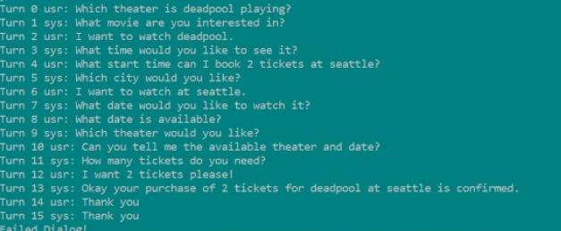
Figure 1: Output window
Limitations:
The model given is only compatible with the python 2.7 version. There is no other framework such as tensorflow or keras that was used. It is trained on a small dataset and the model is very specific to the dataset available.
The next paper that we will be discussing is about an end to end task oriented dialog system using the facebook bAbI dataset.
LEARNING END-TO-END GOAL-ORIENTED DIALOG:
This paper proposes a goal oriented dialog system for booking a restaurant using the facebook bAbI dataset. Set in the context of restaurant reservation, our tasks require manipulating sentences and symbols in order to properly conduct conversations, issue API calls and use the outputs of such calls. We show that an end-to-end dialog system based on Memory Networks can reach promising, yet imperfect, performance and learn to perform non-trivial operations. This is a restaurant booking dialog system that has been trained on bAbI tasks dataset available . The dataset consists of each task with 1000 questions for training and 1000 for testing . This model is trained based on 6 tasks in the restaurant domain . These dialog systems also keep a track of the state of the dialog and perform slot filling simulataneously similar to the Dialog Manager. However, the final stage is to issue an api call which calls the respective task and fetches information from the knowledge base database.
Dataset:
The dataset used in this paper is downloaded from facebook bAbI . It is a set of 6 tasks for testing end-to-end dialog systems in the restaurant domain. Each task tests a unique aspect of dialog. For each task, there are 1000 dialogs for training, 1000 for development and 1000 for testing.

TASK DEFINITIONS:
We now detail each task. Tasks 1 and 2 test dialog management to see if end-to-end systems can learn to implicitly track dialog state (never given explicitly), whereas Task 3 and 4 check if they can learn to use KB facts in a dialog setting. Task 3 also requires to learn to sort. Task 5 combines all tasks.
Task 1: Issuing API calls A user request implicitly defines a query that can contain from 0 to 4 of the required fields (sampled uniformly; in Figure 1, it contains 3). The bot must ask questions for filling the missing fields and eventually generate the correct corresponding API call. The bot asks for information in a deterministic order, making prediction possible.
Task 2: Updating API calls Starting by issuing an API call as in Task 1, users then ask to update their requests between 1 and 4 times (sampled uniformly). The order in which fields are updated is random. The bot must ask users if they are done with their updates and issue the updated API call.

Task 3: Displaying options Given a user request, we query the KB using the corresponding API call and add the facts resulting from the call to the dialog history. The bot must propose options to users by listing the restaurant names sorted by their corresponding rating (from higher to lower) until users accept. For each option, users have a 25% chance of accepting. If they do, the bot must stop displaying options, otherwise propose the next one. Users always accept the option if this is the last remaining one. We only keep examples with API calls retrieving at least 3 options.
Task 4: Providing extra information Given a user request, we sample a restaurant and start the dialog as if users had agreed to book a table there. We add all KB facts corresponding to it to the dialog. Users then ask for the phone number of the restaurant, its address or both, with proportions 25%, 25% and 50% respectively. The bot must learn to use the KB facts correctly to answer.
Task 5: Conducting full dialogs We combine Tasks 1-4 to generate full dialogs .Unlike in Task 3, we keep examples if API calls return at least 1 option instead of 3. The input to the back propagation network is the percent change of stocks for 5 consecutive days as shown in the above figure. Each neuron in the input and the hidden layer also has a bias of weight 1. This bias is trainable and its weight can be adjusted as the other neuron weights. The output of the back propagation is the predicted stock value. This value is computed using the weights associated with each neuron in the input and hidden layer and their respective inputs.

CONCLUSION:

This paper introduced an open dataset and task set for evaluating end-to-end goal-oriented dialog learning methods in a systematic and controlled way. This will help foster progress of end-toend conversational agents because (i) existing measures of performance either prevent reproducibility (different Mechanical Turk jobs) or do not correlate well with human judgements (Liu et al., 2016); (ii) the breakdown in tasks will help focus research and development to improve the learning methods; and (iii) goal-oriented dialog has clear utility in real applications. This paper also illustrated how to use the testbed using a variant of end-to-end Memory Networks, which prove an effective model on these tasks relative to other baselines, but are still lacking in some key areas.

Frames Dataset:
Now we are going to discuss another important dataset that is being used for research purposes. This is called the frames dataset which was created by a Microsoft company(Maluuba). Frames is precisely meant to encourage research towards conversational agents which can support decision-making in complex settings, in this case - booking a vacation including flights and a hotel. More than just searching a database, we believe the next generation of conversational agents will need to help users explore a database, compare items, and reach a decision. layers. The dialogues in Frames were collected in a Wizard-of-Oz fashion. Two humans talked to each other via a chat interface. One was playing the role of the user and the other one was playing the role of the conversational agent. We call the latter a wizard as a reference to the Wizard of Oz, the man behind the curtain. The wizards had access to a database of 250+ packages, each composed of a hotel and round-trip flights. We gave users a few constraints for each dialogue and we asked them to find the best deal. This resulted in complex dialogues where a user would often consider different options, compare packages, and progressively build the description of her ideal trip
.
Experiment:
We implemented a keras RNN architecture using the frames dataset

Conclusion:
Both the papers about the goal oriented dialog system were built to accomplish a particular task such as restaurant booking and movie booking. We inferred from the results that, the more the number of training episodes, the better the ressults. The end-to-end dialogue system architectures based on neural networks have shown promising results on several dialogue tasks. There is a vast amount of data available documenting human communication. Much of this data could be used — perhaps after some pre-processing — to train a dialogue system. However, covering all such sources of data would be infeasible. Thus, we restrict the scope of this survey to datasets that have already been used to study dialogue or build dialogue systems, and to very large corpora of interactions—that may or may not be strictly considered dialogue datasets—which could be leveraged in the near future to build more sophisticated data-driven dialogue models. We conclude by discussing a the general issues related to the development and evaluation of
data-driven dialogue systems. We also discussed the various challenges available with the huge datasets . There is strong evidence that over the next few years, dialogue research will quickly move towards large-scale data-driven model approaches. In particular, as is the case for other language-related applications such as speech recognition, machine translation and information retrieval, these approaches will likely come in the form of end-to-end trainable systems. This paper provides an extensive survey of currently available datasets suitable for research, development, and evaluation of such data-driven dialogue systems. In addition to presenting the datasets, we provide a detailed discussion of several of the issues related to the use of datasets in dialogue system research. Several potential directions are highlighted, such as transfer learning and incorporation of external knowledge, which may lead to scalable solutions for end-to-end training of conversational agents.

References:
https://arxiv.org/pdf/1606.02560v2.pdf

https://arxiv.org/pdf/1703.01008v2.pdf

https://research.fb.com/downloads/babi/

https://fbpublic.app.box.com/s/chnq60iivzv5uckpvj2n2vijlyepze6w
https://datasets.maluuba.com/Frames

