**LENDING CLUB DATA ANALYSIS**

**(Assignment-2 Report)**

**Advance in Data Sciences and Architecture**

**INFO 7390 - SPRING 2017**

PROFESSOR:

**SRIKANTH KRISHNAMURTHY**

TEAM MEMBERS (Team 9):

**AASHRI TANDON**

**PRAGATI SHAW**

**SARTHAK AGARWAL**

Table of Contents

Flow of the project: 3

Classification 4

Clustering 8

Manual Clustering 8

Based on Clustering Algorithm(k-means) 9

Prediction 11

Prediction for manual clusters 12

Prediction for algo-based clusters 15

Prediction for all data cluster 17

Deployment 18

Contribution 21

# **Flow of the project:**

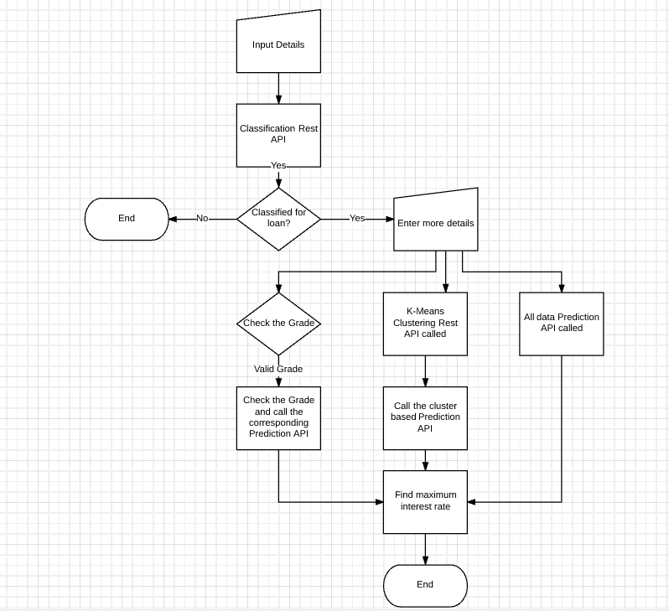

# **Classification**

The task was to classify a new record whether loan will be approved or not. We have created a combined csv file for both accepted loan data and declined loan data with the following columns:

DTI ratio

Fico score Low (or Risk Score): Note- vantage score is assumed to be fico score

State

Zip Code

Loan Amount

Policy Code

Employment Length

Accepted Status (New Column generated for both files)

We have trained all our models on Microsoft Azure Machine Learning Studio.

Columns excluded: State and Zip Code

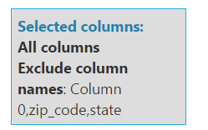

Metadata Editor: Converted Employment Length, Policy Code, Accepted Status to categorical fields

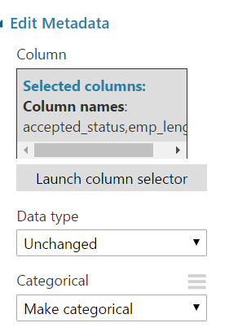

Training was done on ‘Accepted Status’ column.

Below is the screenshot of all the algorithms that were used to train the model. ROC curve value was used to determine the best model out of four (Two class support vector machine, Logistic Regression, Two class decision forest, Two class Neural Network)

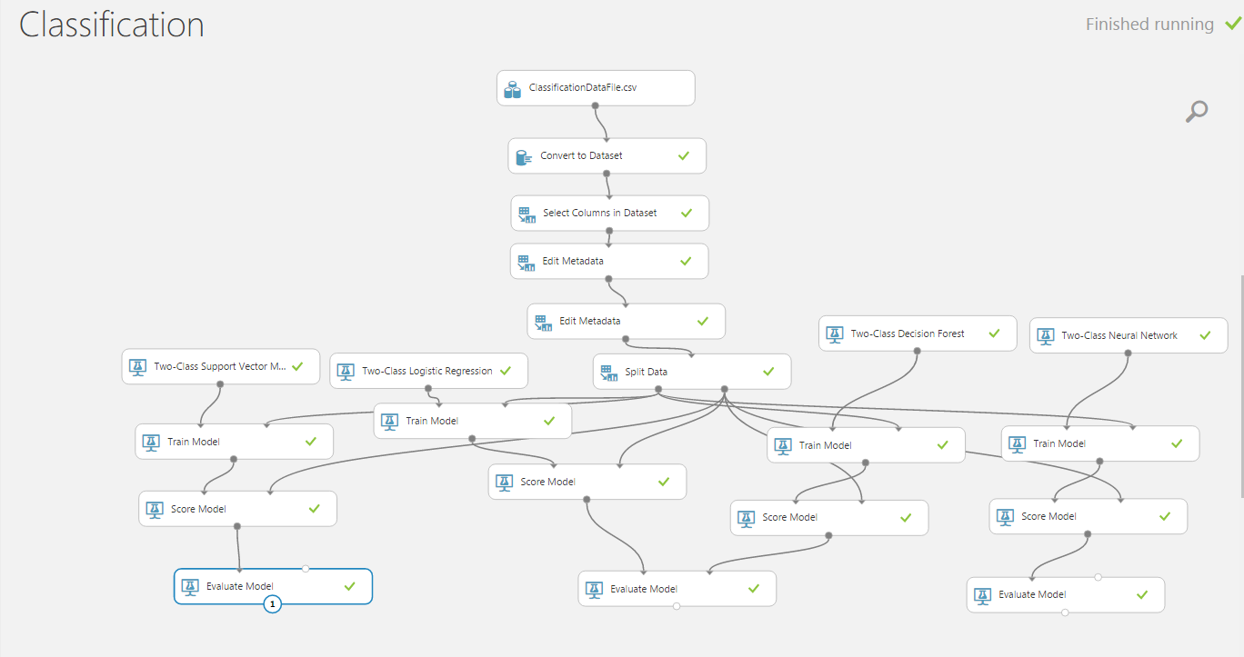

Evaluation Results of various classification algorithms:

**Two class Logistic Regression**

* ROC Curve

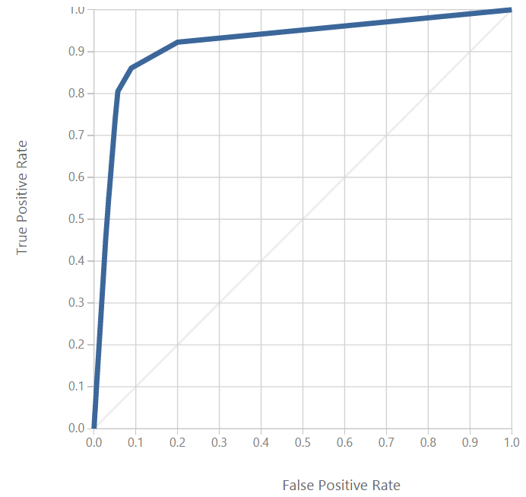

* Confusion Matrix

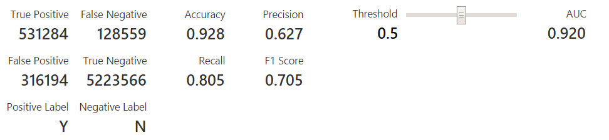

**Two class decision forest**

* ROC Curve

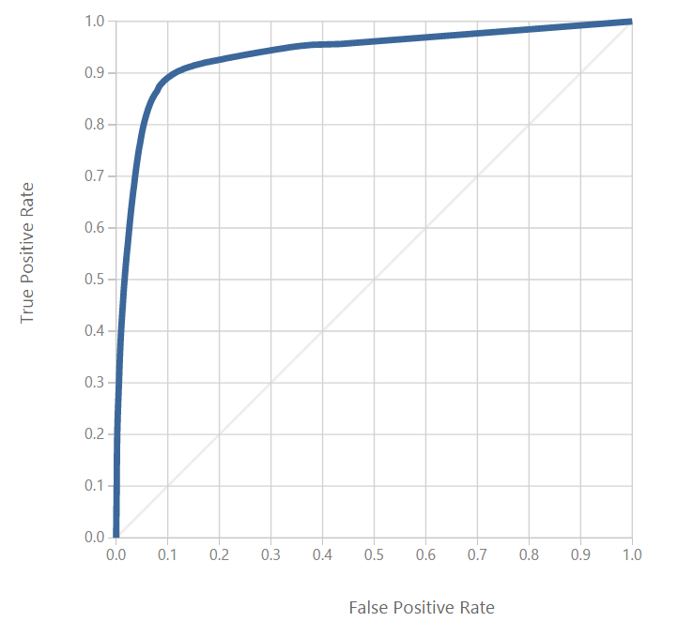

* Confusion Matrix

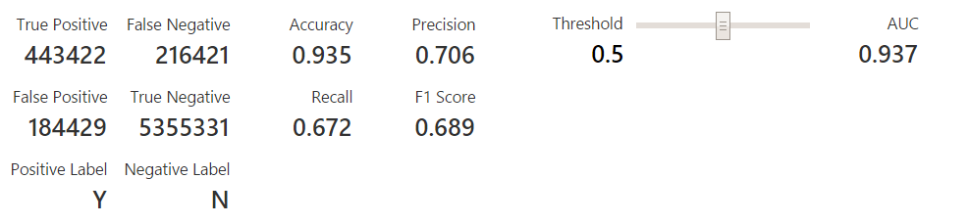

**Two class Neural Network**

* ROC Curve

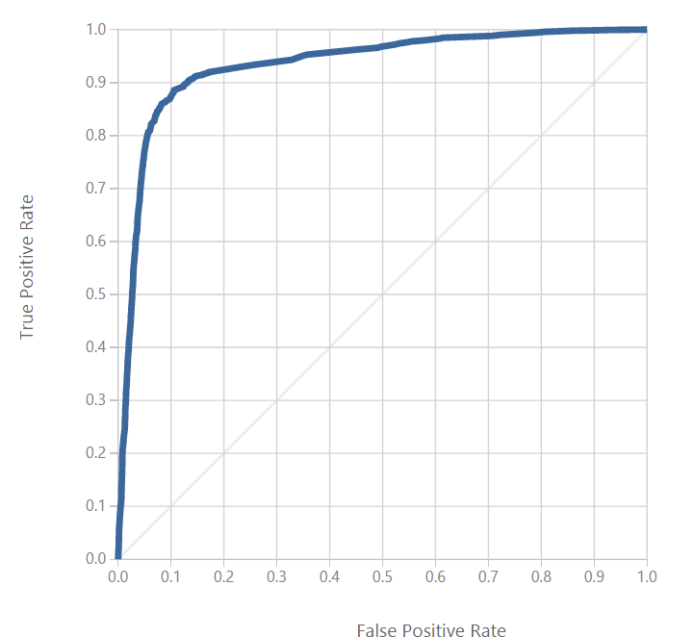

* Confusion Matrix

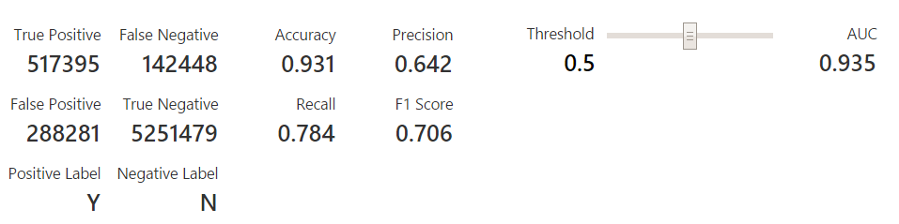

**Two class support vector machine**

* ROC Curve

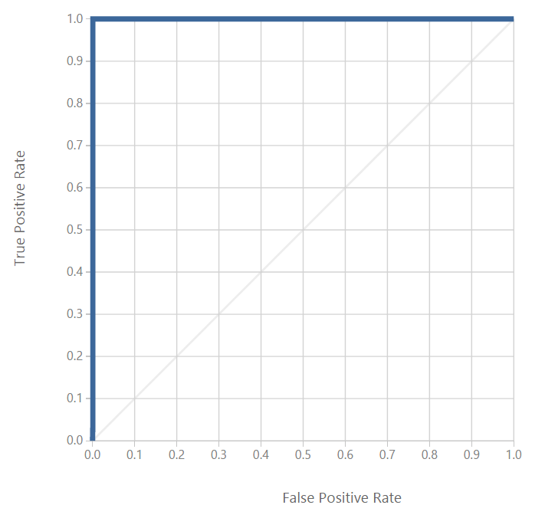

* Confusion Matrix

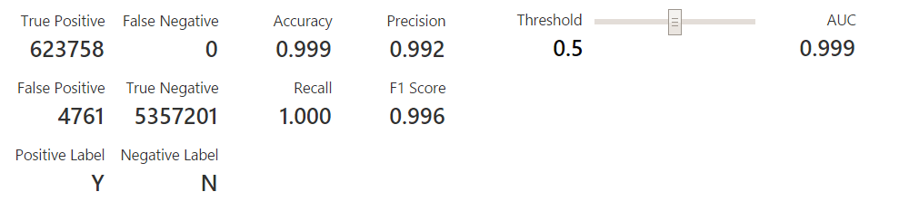

Chosen Model: Two class SVM as AUC is 0.999

# **Clustering**

## **Manual Clustering**

Based on each loan application and credit report, every loan is assigned a grade ranging from A to G with a corresponding interest rate. We have considered ‘grades’ of every loan record to cluster the entire dataset.

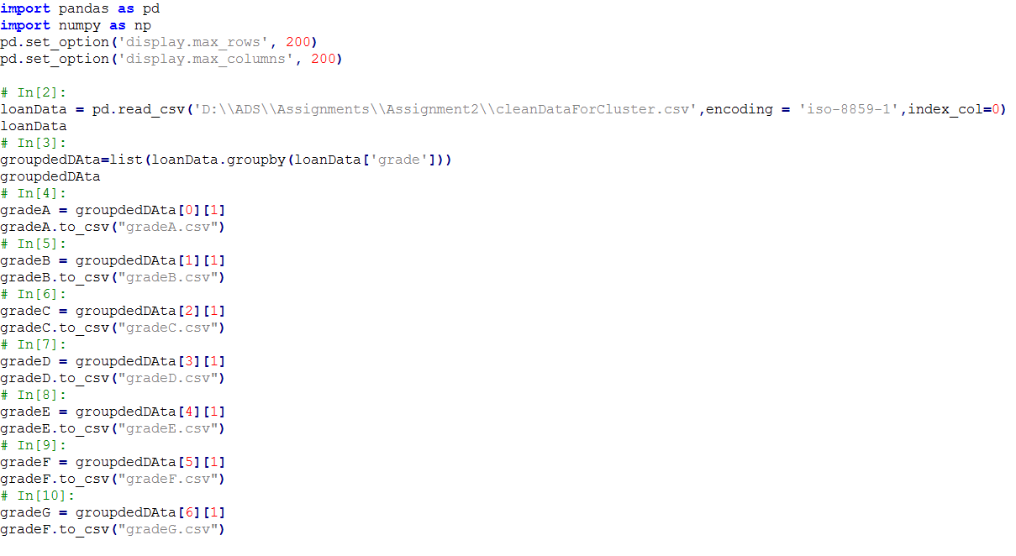

## **Based on Clustering Algorithm(k-means)**

**k**-**means clustering** aims to partition dataset into **k clusters** in which record belongs to the **cluster** with the nearest **mean**, serving as a prototype of the **cluster**.

This algorithm is an iterative process.

We have made 3 clusters (No of centroids = 3)

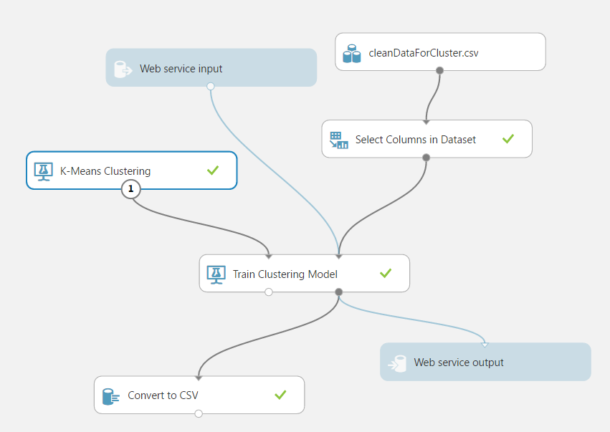

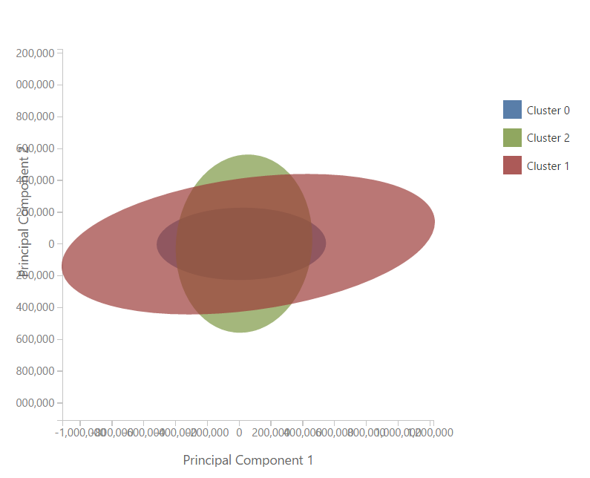

# **Prediction**

**Variable Selection**

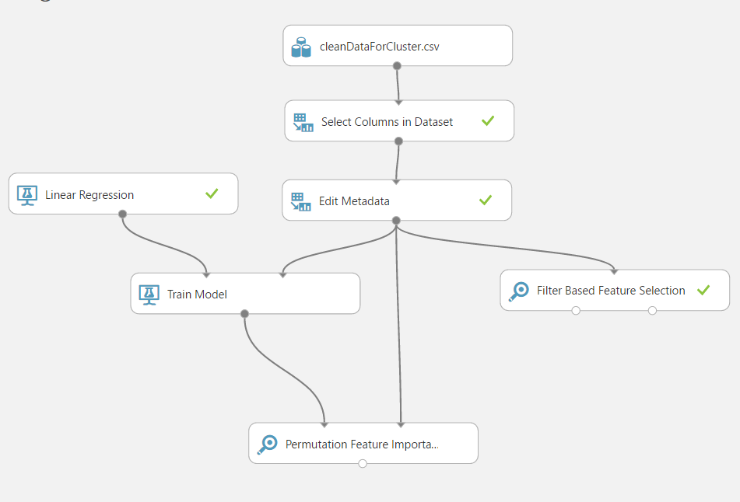

Selected 17 variables out of 90:

|  |
| --- |
| int_rate, |
| sub_grade, |
| grade, |
| dti, |
| fico_range_low, |
| fico_range_high, |
| term, |
| bc_util, |
| total_pymnt, |
| loan_amnt, |
| funded_amnt, |
| total_pymnt_inv, |
| home_ownership, |
| loan_status,purpose, |
| application_type, |
| emp_length, |
| policy_code |

## **Prediction for manual clusters**

- term, grade, sub_grade, home_ownership, loan_status, purpose, application_type, emp_length is converted to categorical

- Training was done on ‘int_rate’ column.

- Below is the screenshot of all the algorithms that were used to train the model.

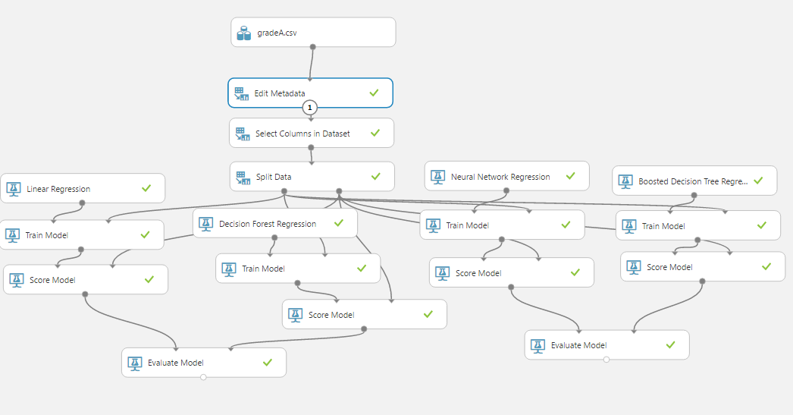

The following metrics are reported for evaluating regression models. All metrics are reported but the models are ranked by the metric you select for evaluation.

* **Mean absolute error (MAE)** measures how close the predictions are to the actual outcomes; thus, a lower score is better.
* **Root mean squared error (RMSE)** creates a single value that summarizes the error in the model. By squaring the difference, the metric disregards the difference between over-prediction and under-prediction.
* **Relative absolute error (RAE)** is the relative absolute difference between expected and actual values; relative because the mean difference is divided by the arithmetic mean.
* **Relative squared error (RSE)** similarly normalizes the total squared error of the predicted values by dividing by the total squared error of the actual values.
* **Mean Zero One Error (MZOE)** indicates whether the prediction was correct or not. In other words: ZeroOneLoss(x,y) = 1 when x!=y; otherwise 0
* **Coefficient of determination**, often referred to as R2, represents the predictive power of the model as a value between 0 and 1. Zero means the model is random (explains nothing); 1 means there is a perfect fit. However, caution should be used in interpreting R2 values, as low values can be entirely normal and high values can be suspect.

- Coefficient of Determination was used to determine the best model

|  |  |  |  |  |  |
| --- | --- | --- | --- | --- | --- |
| **Grade A** | **Mean Absolute Error** | **Root Mean Squared Error** | **Relative Absolute Error** | **Relative Squared Error** | **Coefficient of Determination** |
| Linear Regression | 0.255555 | 0.324468 | 0.303447 | 0.102186 | 0.897814 |
| Decision Forest | 0.135789 | 0.242014 | 0.161236 | 0.05685 | 0.94315 |
| Neural Network Regression | 0.176836 | 0.256185 | 0.209977 | 0.063702 | 0.936298 |
| Boosted Decision Tree Regression | 0.169064 | 0.246523 | 0.200747 | 0.058988 | 0.941012 |

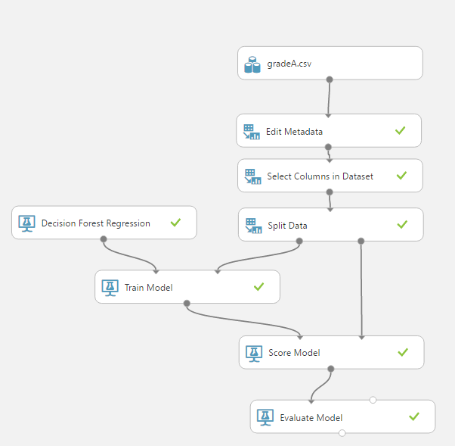

-The same steps were repeated for all the grades from A – G

|  |  |  |  |  |  |
| --- | --- | --- | --- | --- | --- |
| Grade B | Mean Absolute Error | Root Mean Squared Error | Relative Absolute Error | Relative Squared Error | Coefficient of Determination |
| Linear Regression | 0.502831 | 0.644016 | 0.44532 | 0.222228 | 0.777772 |
| Decision Forest | 0.272973 | 0.48012 | 0.241752 | 0.12351 | 0.87649 |
| Neural Network Regression | 0.322249 | 0.472912 | 0.285393 | 0.11983 | 0.88017 |

|  |  |  |  |  |  |
| --- | --- | --- | --- | --- | --- |
| Grade C | Mean Absolute Error | Root Mean Squared Error | Relative Absolute Error | Relative Squared Error | Coefficient of Determination |
| Linear Regression | 0.559709 | 0.695042 | 0.577957 | 0.33929 | 0.66071 |
| Decision Forest | 0.289796 | 0.527047 | 0.299244 | 0.195096 | 0.804904 |
| Neural Network Regression | 0.380037 | 0.545436 | 0.392427 | 0.208947 | 0.791053 |

|  |  |  |  |  |  |
| --- | --- | --- | --- | --- | --- |
| Grade D | Mean Absolute Error | Root Mean Squared Error | Relative Absolute Error | Relative Squared Error | Coefficient of Determination |
| Linear Regression | 0.816289 | 0.977778 | 0.731532 | 0.473531 | 0.526469 |
| Decision Forest | 0.408611 | 0.675745 | 0.366184 | 0.226169 | 0.773831 |
| Neural Network Regression | 0.497176 | 0.718605 | 0.445553 | 0.25577 | 0.74423 |

|  |  |  |  |  |  |
| --- | --- | --- | --- | --- | --- |
| Grade E | Mean Absolute Error | Root Mean Squared Error | Relative Absolute Error | Relative Squared Error | Coefficient of Determination |
| Linear Regression | 1.284342 | 1.601835 | 0.81075 | 0.639658 | 0.360342 |
| Decision Forest | 0.597067 | 0.972431 | 0.376903 | 0.235739 | 0.764261 |
| Neural Network Regression | 0.731612 | 1.050325 | 0.461835 | 0.275017 | 0.724983 |

|  |  |  |  |  |  |
| --- | --- | --- | --- | --- | --- |
| Grade F | Mean Absolute Error | Root Mean Squared Error | Relative Absolute Error | Relative Squared Error | Coefficient of Determination |
| Linear Regression | 0.967413 | 1.437962 | 0.697032 | 0.528946 | 0.471054 |
| Decision Forest | 0.546625 | 0.946123 | 0.39385 | 0.228988 | 0.771012 |
| Neural Network Regression | 0.704689 | 1.078992 | 0.507737 | 0.29782 | 0.70218 |

|  |  |  |  |  |  |
| --- | --- | --- | --- | --- | --- |
| Grade G | Mean Absolute Error | Root Mean Squared Error | Relative Absolute Error | Relative Squared Error | Coefficient of Determination |
| Linear Regression | 0.967413 | 1.437962 | 0.697032 | 0.528946 | 0.471054 |
| Decision Forest | 0.546625 | 0.946123 | 0.39385 | 0.228988 | 0.771012 |
| Neural Network Regression | 0.687735 | 1.067815 | 0.495521 | 0.291681 | 0.708319 |

## **Prediction for algo-based clusters**

- term, grade, sub_grade, home_ownership, loan_status, purpose, application_type, emp_length is converted to categorical

- Training was done on ‘int_rate’ column.

- Below is the screenshot of all the algorithms that were used to train the model.

- Coefficient of Determination was used to determine the best model

- The steps were repeated for all the 3 clusters

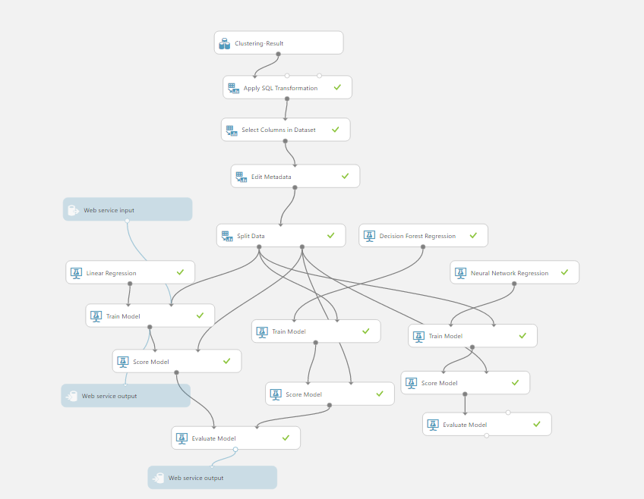

|  |  |  |  |  |  |
| --- | --- | --- | --- | --- | --- |
| Cluster 0 | Mean Absolute Error | Root Mean Squared Error | Relative Absolute Error | Relative Squared Error | Coefficient of Determination |
| Linear Regression | 0.630395 | 0.928021 | 0.170642 | 0.039107 | 0.960893 |
| Decision Forest | 0.290409 | 0.560009 | 0.078611 | 0.014241 | 0.985759 |
| Neural Network Regression | 0.371853 | 0.594041 | 0.100657 | 0.016024 | 0.983976 |

|  |  |  |  |  |  |
| --- | --- | --- | --- | --- | --- |
| Cluster 1 | Mean Absolute Error | Root Mean Squared Error | Relative Absolute Error | Relative Squared Error | Coefficient of Determination |
| Decision Forest | 10.319968 | 12.61246 | 0.953268 | 0.883275 | 0.116725 |
| Neural Network Regression | 0.456668 | 0.791767 | 0.042183 | 0.003481 | 0.996519 |

|  |  |  |  |  |  |
| --- | --- | --- | --- | --- | --- |
| Cluster 2 | Mean Absolute Error | Root Mean Squared Error | Relative Absolute Error | Relative Squared Error | Coefficient of Determination |
| Linear Regression | 0.535601 | 0.683568 | 0.152743 | 0.02443 | 0.97557 |
| Decision Forest | 0.364592 | 0.57985 | 0.103975 | 0.017579 | 0.982421 |
| Neural Network Regression | 0.363844 | 0.533762 | 0.103761 | 0.014895 | 0.985105 |

## **Prediction for all data cluster**

term, grade, sub_grade, home_ownership, loan_status, purpose, application_type, emp_length is converted to categorical

- Training was done on ‘int_rate’ column.

- Below is the screenshot of all the algorithms that were used to train the model.

- Coefficient of Determination was used to determine the best model

|  |  |  |  |  |  |
| --- | --- | --- | --- | --- | --- |
| Cluster 0 | Mean Absolute Error | Root Mean Squared Error | Relative Absolute Error | Relative Squared Error | Coefficient of Determination |
| Decision Forest | 0.312521 | 0.570922 | 0.086188 | 0.015582 | 0.984418 |
| Neural Network Regression | 0.366483 | 0.586578 | 0.10107 | 0.016448 | 0.983552 |
| Boosted Decision Tree Regression | 0.446942 | 0.633206 | 0.12326 | 0.019167 | 0.980833 |

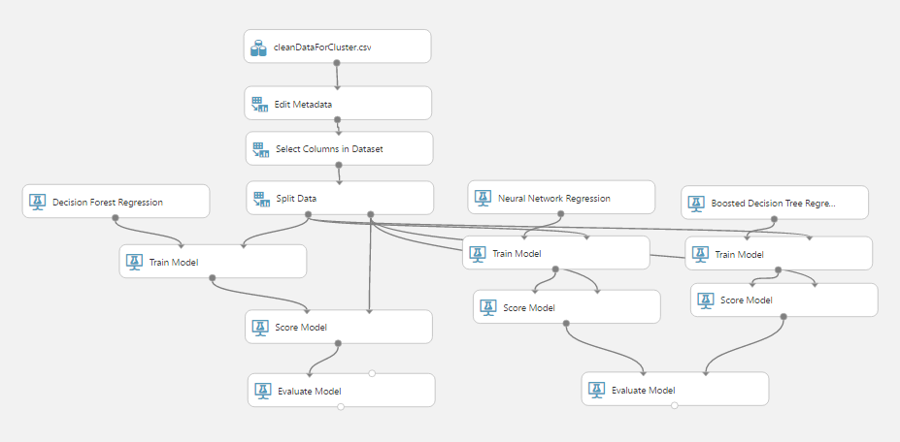

# **Deployment**

We have created a Spring MVC application that ask the user to input details and calls the Classification/Clustering/Prediction Rest APIs to provide the predicted interest rate. Following steps define the workflow of the application.

1. Input the dti, fico_score, employment_length, policy_code, loan_amount

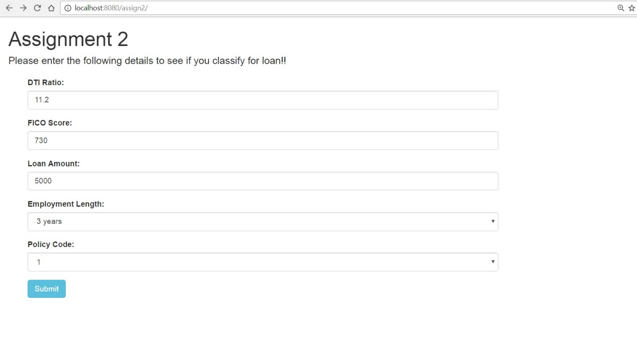

1. Call the classification API and score the result in acceptedStatus variable
2. If acceptedStatus variable is ‘N’, there is no flow further, else we ask the user to enter more details for clustering

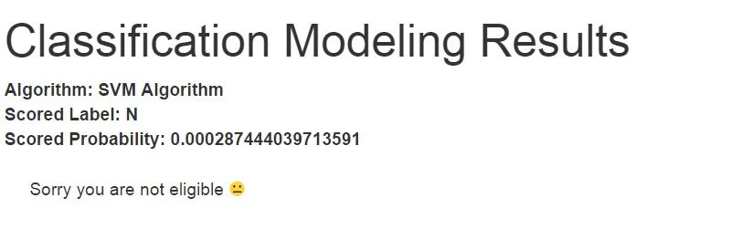

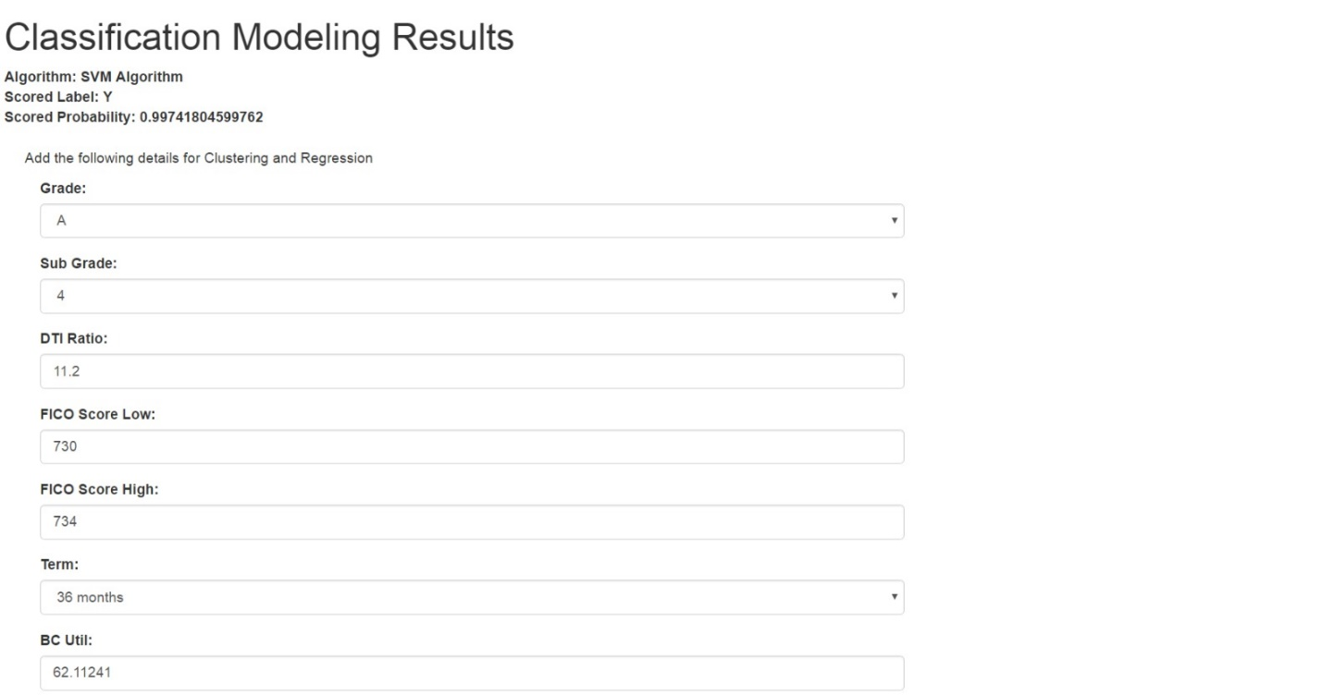

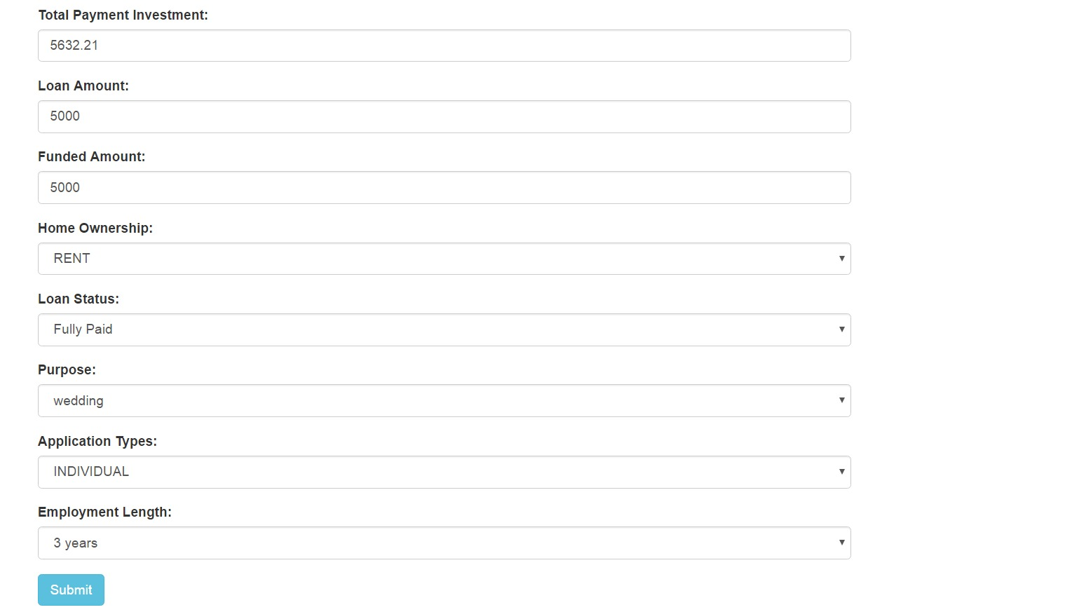

4. We check the grade, and call the grade based Prediction API

5. We call the clustering API, that returns us the cluster value. Then based on cluster value, we call the Prediction API

6. We call the prediction API where no clustering was done.

7. Lastly, we display all the results from all the algorithms and the maximum of all.

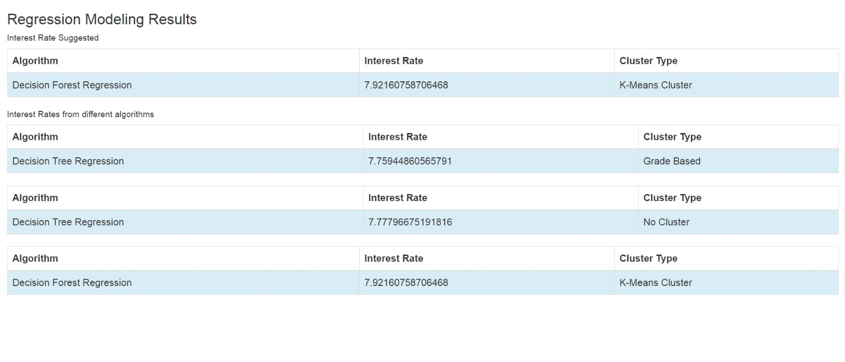

# **Contribution**

