Notes + new results Leipzig, 4-5-2017

Notes:

‘Final’ Sample (HC): N=29

Proberror matched & day_order balanced, excluded 2 who had button box or mirror flipped. Below chance and non-fitters are still included.

14 A  
15 B

Repeated measures ANOVA in this N=29 sample, condition*phase (within):

Main effect phase  
No main effect condition (p>0.2)  
No interaction phase*condition

Adding day_order as between-subjects factor does not give additional significant results

Of this final sample (N=29), 7 are non-fitters based on SU1a1b, binomial test on predictive probability (binomial against 0.5: exp(-LL)/ntrials)

When excluding these 7 non-fitters (6A, 1B), all is left is: 8A & 14B, and they are not proberror matched..

Repeated measures ANOVA in this N=22 sample, condition*phase (within): same as 29

Next steps + new results:

1. *HC sample: Raw data analysis: p_correct, rt, switching, perseveration*
   1. *In N=29*

**p_correct:**

Main effect of phase p<0.001  
No main effect of condition p=0.239  
No condition*phase interaction p=0.972. (Also visible in Figure 1, left panel)

**Reaction times:**

No main effect of phase pgg=0.130  
No main effect of condition pgg=0.924  
Condition*phase interaction pgg=0.045. (See Figure 2, left panel)

**Switching:**

A trendwise main effect of phase pgg=0.062  
No main effect of condition pgg=0.802  
No condition*phase interaction pgg=0.106. (See Figure 3, left panel)

**Perseveration in face of loss:**paired-samples t-test  
  
control (M=0.114; SD=0.074) versus stress (M=0.092; SD=0.066): t(28)=1.722, p=0.096   
The two variables correlate highly: r(29)=0.494, p=0.006

* 1. *In N=22 (so excluding non-fitters)*

**p_correct:**

highly comparable to N=29. The mean p_correct in the last phase is slightly higher in control than in stress (whereas in N=29 this is the other way around), showing that in control HC’s ‘recover’ better after the middle phase. But this does not have any statistical consequences.

**Reaction times:**

Main effect of phase pgg=0.024  
No main effect of condition p=0.824  
Condition*phase interaction p=0.022. Plot looks comparable to N=29

**Switching:**

Main effect of phase pgg=0.001  
No main effect of condition pgg=0.255  
No condition*phase interaction pgg=0.762.

**Perseveration in face of loss:**paired-samples t-test  
  
Comparable to N=29: t(28)=1.445, p=0.163

**In conclusion when it comes to HC:**We see no clear effects (except for phase) on p_correct, switching or perseveration in the full or reduced HC sample. We do however see condition * phase interactions on reaction times.   
Post-hoc tests on this:

* Paired samples t-test on every phase, comparing conditions: no significant differences
* Paired samples t-test on delta rt (c-s), comparing phases: middle & end phase differ significantly (t(28)=-3.161; p=0.004 in N=29; in N=22 very comparable results). This is reflected in the figure (see Figure 2, left panel).

1. *AD sample (N=27, 13 fMRI, 14 behav)*
   1. *do same sample cleanup in AD as in HC*
      1. *Proberror matching 🡪* All N=27 are matched!
      2. *Other really necessary exclusion criteria? 🡪* Does not seem like it! There are again a few ‘below chance’ in the AD sample: 2x <0.5 (both stress & control condition); 2x between 0.5 and 0.6; The rest is above 0.6
   2. *perform AD-HC group comparisons on task data & demographics*

HC: N=29  
AD: N=27

**Demographics & Neuropsych**

2-sample t-test

Table 1

|  |  |  |  |
| --- | --- | --- | --- |
| **Demographics:** | **HC (N=29)** | **AD (N=27)** | **p** |
| Age | 26.930 | 37.330 | 0.000 |
| Education (0-3) | 1.590 | 0.630 | 0.001 |
| Gewicht | 77.930 | 81.390 | 0.287 |
|  |  |  |  |
| **Neuropsych:** | **HC (N=29)** | **AD (N=27)** | **p** |
| IQ | 104.180 | 97.810 | 0.023 |
| Num Forward | 10.240 | 8.810 | 0.014 |
| Num Backward | 7.590 | 6.330 | 0.042 |
| TMTA | 29.180 | 27.276 | 0.481 |
| TMTB | 62.813 | 72.540 | 0.188 |
| DSST | 80.720 | 65.560 | 0.000 |

**p_correct:**

rmANOVA

No main effect of condition  
Main effect of phase (as usual; won’t report afterwards)

Main effect of group p=0.021

Condition*Phase*Group: p(greenhouse geisser)=0.082, F(2,108)=2.694. See figure below (it’s the graph output of rmANOVA, so note the lack of errorbars and zoomed-in scale):

Figure 1

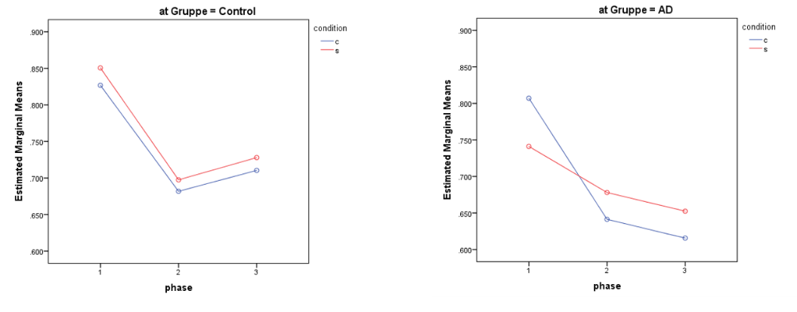

Considering the (trendwise) interaction with Gruppe I post-hoc performed the rmANOVA in the two groups separately. There it shows that the condition*phase interaction is non-significant in HC (p=0.972; see also the analyses under point 1), but it is significant for AD (pgg=0.034), reflecting the graph figure. No main effect of condition is visible in either groups.

Paired samples t-test in matched group:  
AD c vs s: start (0.032) & middle (0.042) differ; end (0.301) does not. In fitters only start c vs s (0.007), not middle (0.069) or end 0.341)

Short conclusion on p_correct:

- we replicate our previous HC-operant studies in that HC get better again in the end phase (independent of condition).

- we replicate the AD-operant study in that AD patients do the task overall worse

- we see a phase-dependent effect of stress in the AD. Specifically, it seems that they start worse under stress than under control (effect in first stable phase), but do not decline as much in the middle phase. However still they do not recover in the last stable phase (same as in control). The phase-dependent effect is driven mainly by start phase, and partly by middle phase (depending on fitted or overall sample).

The double dissociation effect of stress vs control between start and middle phase in AD might indicate a different strategy, e.g. more switch-like, as it does good for p_correct in the middle phase, but bad in the start phase 🡪 follow up this effect with modeling 😊

NB1: Excluding the worst below-chancers does not change the direction of effects

NB2: As the two groups differ on age and Schulabschluss (apart from the neuropsy differences), I additionally included these as covariates in two separate rmANOVAs

**Age** 🡪 no main effect of age, and age does not interact with the existing effects. The group*condition*phase interaction is gone, however, but that was to be expected, and is very hard to interpret, as you remove virtually all group-based variance by including age. The fact that age does not at all interact with condition or phase, nor with condition*phase, tells me that the actual effect of age here is limited.

**Schulabschluss** (defined as 0 = kein, 1 = Volks-/Hauptschule, 2 = Mittlere Reife, 3 = Abitur) 🡪 No main effect of education, nor an interaction with any of the other variables. Condition*Phase*Gruppe is still trendwise significant: pgg=0.091.

**Reaction times:**

rmANOVA

Interestingly, the effect we see in p_correct seems reflected in the reaction times too, although there is no main effect of group, and the condition*phase*group interaction is not significant (pgg=0.197). But the image it creates is striking (but again do note the lack of errorbars and zoomed in scale..!):

Figure 2

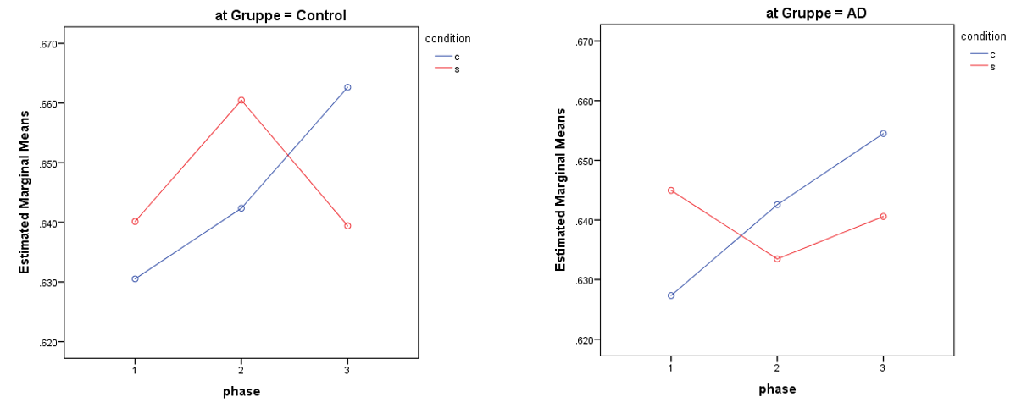

The AD group shows an opposite effect of stress: they become faster in the middle phase, instead of slower!? Did they become more impulsive?  
NB. As you can see, the phase * condition effect (independent of group) is significant (pgg=0.022), as in the control condition people ‘simply become slower’ towards the end, but the stress condition has a very different effect on each phase.

**Stay after win:**

rmANOVA

No Main effect of group (p=0.286)

Trendwise main effect of phase (pgg=0.065)

Condition*phase*group interaction (pgg=0.022)

Splitting up the groups by performing two separate condition*phase rmANOVA on win-stay behavior actually gives no significant condition*phase effects: HC pgg=0.106; AD pgg=0.113 (non-greenhouse-geisser p-values of both groups are resp 0.071& 0.079, but the sphericity is highly violated, so we can’t report those)

Figure 3

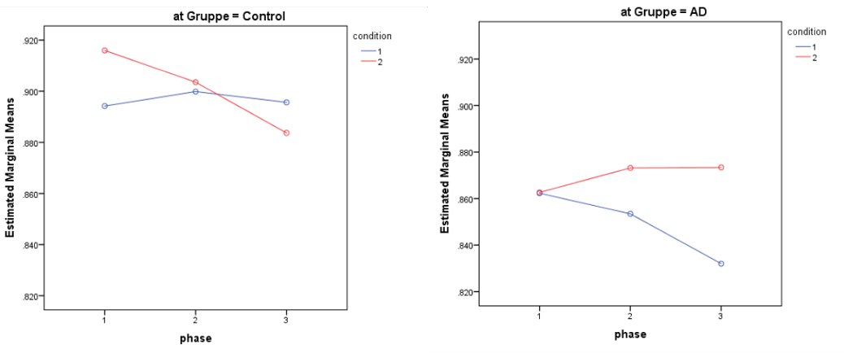

…This seems quite random, though; can you make a logical interpretation out of it? (blue = control, red = stress). Moreover, I find it strange that there is no main effect of group here.. must be a very big variance then..!

**Stay, independent of feedback:**

rmANOVA

No Main effect of group (p=0.286)

Trendwise main effect of phase (pgg=0.065)

Condition*phase*group interaction (pgg=0.022)

**Perseveration in face of loss:**

2-sample t-test

No group differences   
stress perseveration: p=0.230  
control perseveration: p=0.957  
delta (c-s) perseveration: p=0.283

**TO DO:**

1. *Perform analyses (start with HC) on intraindividual differences:*
   1. *Chronic stress 🡪* get the data in the SPSS file – Limesurvey!!  
      *(e.g. regression delta-p_correct with chronic stress)*

rmANOVA: phase * condition, CTQ_total as covariate

Main effect of phase: p=0.012  
Main effect of CTQ_total: p=0.039

* 1. *Stress reactivation* 🡪 work out cortisol values + see for responders vs non-responders!?