SALAD rmANOVA and Mixed Effects Models

Lara Wieland

28 April, 2020

## 

## rmANOVA p_correct

# make a boxplot to take a look at distribution of p_correct group and phasewise  
ggplot(longdat.correct, aes(x=phase, y=p_correct)) + geom_boxplot()

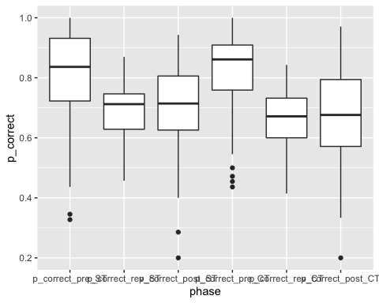

# extract string ST or CT from phase strings and turn it into logical, then numeric  
longdat.correct <- longdat.correct %>% mutate(cond = grepl("*CT",longdat.correct$phase))  
longdat.correct <- longdat.correct %>% mutate(cond2 = longdat.correct$cond*1) %>% rename(cond = longdat.correct$cond2)  
  
# now ezANOVA can be filled with dv = p_correct, within-variables = phase and cond, between-variable = group and type 3 sums of squares  
  
res.correct <- ezANOVA(longdat.correct, p_correct, id, within = .(volat,cond), between = group, detailed = TRUE, type =2)

## Warning: Converting "cond" to factor for ANOVA.

## Warning: "group" will be treated as numeric.

## Warning: Data is unbalanced (unequal N per group). Make sure you specified a  
## well-considered value for the type argument to ezANOVA().

res.correct

## $ANOVA  
## Effect DFn DFd SSn SSd F p  
## 1 (Intercept) 1 54 1.743189e+02 2.8961323 3250.2727475 6.262742e-50  
## 2 group 1 54 3.008109e-01 2.8961323 5.6087863 2.147964e-02  
## 3 volat 2 108 1.279715e+00 2.0109938 34.3634032 2.821965e-12  
## 5 cond 1 54 1.028596e-02 0.5206182 1.0668889 3.062532e-01  
## 4 group:volat 2 108 4.340665e-02 2.0109938 1.1655726 3.156342e-01  
## 6 group:cond 1 54 5.690762e-03 0.5206182 0.5902619 4.456648e-01  
## 7 volat:cond 2 108 3.919871e-02 1.1307778 1.8719240 1.587842e-01  
## 8 group:volat:cond 2 108 5.640453e-02 1.1307778 2.6935836 7.218250e-02  
## p<.05 ges  
## 1 * 0.9637405128  
## 2 * 0.0438542454  
## 3 * 0.1632656252  
## 5 0.0015658791  
## 4 0.0065748441  
## 6 0.0008669374  
## 7 0.0059412497  
## 8 0.0085268565  
##   
## $`Mauchly's Test for Sphericity`  
## Effect W p p<.05  
## 3 volat 0.7810793 0.001433575 *  
## 4 group:volat 0.7810793 0.001433575 *  
## 7 volat:cond 0.8054456 0.003235641 *  
## 8 group:volat:cond 0.8054456 0.003235641 *  
##   
## $`Sphericity Corrections`  
## Effect GGe p[GG] p[GG]<.05 HFe p[HF]  
## 3 volat 0.8203979 1.745007e-10 * 0.8426768 1.045507e-10  
## 4 group:volat 0.8203979 3.088041e-01 0.8426768 3.098201e-01  
## 7 volat:cond 0.8371323 1.659861e-01 0.8608054 1.649697e-01  
## 8 group:volat:cond 0.8371323 8.239331e-02 0.8608054 8.083508e-02  
## p[HF]<.05  
## 3 *  
## 4   
## 7   
## 8

ezPlot(  
 data = longdat.correct  
 , dv = .(p_correct)  
 , wid = .(id)  
 , within = .(volat,cond)  
 , between = .(group)  
 , x = .(volat)  
)

## Warning: Converting "cond" to factor for ANOVA.

## Warning: "group" will be treated as numeric.

## Warning: Data is unbalanced (unequal N per group). Make sure you specified a  
## well-considered value for the type argument to ezANOVA().

## Warning: Mixed within-and-between-Ss effect requested; FLSD is only appropriate  
## for within-Ss comparisons (see warning in ?ezStats or ?ezPlot).

## Warning in ezStats(data = data, dv = dv, wid = wid, within = within, within_full  
## = within_full, : Unbalanced groups. Mean N will be used in computation of FLSD

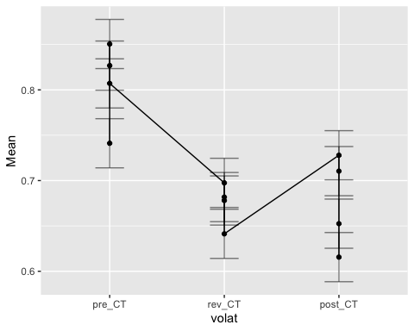

## rmANOVA p_winstay

# make a boxplot to take a look at distribution of p_correct group and phasewise  
ggplot(longdat.winstay, aes(x=phase, y=p_winstay)) + geom_boxplot()

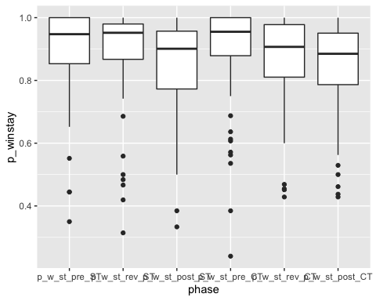

# extract string ST or CT from phase strings and turn it into logical, then numeric  
longdat.winstay <- longdat.winstay %>% mutate(cond = grepl("*CT",longdat.winstay$phase))  
longdat.winstay <- longdat.winstay %>% mutate(cond2 = longdat.winstay$cond*1) %>% rename(cond = longdat.winstay$cond2)  
  
# now ezANOVA can be filled with dv = p_correct, within-variables = phase and cond, between-variable = group and type 3 sums of squares  
  
res.winstay <- ezANOVA(longdat.winstay, p_winstay, id, within = .(volat,cond), between = group, detailed = TRUE, type = 2)

## Warning: Converting "cond" to factor for ANOVA.

## Warning: "group" will be treated as numeric.

## Warning: Data is unbalanced (unequal N per group). Make sure you specified a  
## well-considered value for the type argument to ezANOVA().

res.winstay

## $ANOVA  
## Effect DFn DFd SSn SSd F p  
## 1 (Intercept) 1 54 2.520135e+02 5.9673272 2.280540e+03 7.444340e-46  
## 2 group 1 54 1.375040e-01 5.9673272 1.244312e+00 2.695812e-01  
## 3 volat 2 108 1.271851e-01 0.8188221 8.387651e+00 4.110899e-04  
## 5 cond 1 54 1.079049e-02 0.6968840 8.361310e-01 3.645707e-01  
## 4 group:volat 2 108 1.090940e-02 0.8188221 7.194573e-01 4.893356e-01  
## 6 group:cond 1 54 8.688749e-04 0.6968840 6.732719e-02 7.962556e-01  
## 7 volat:cond 2 108 4.292300e-03 0.6121584 3.786343e-01 6.857014e-01  
## 8 group:volat:cond 2 108 3.719712e-02 0.6121584 3.281250e+00 4.136079e-02  
## p<.05 ges  
## 1 * 0.9688776584  
## 2 0.0167021901  
## 3 * 0.0154681640  
## 5 0.0013311758  
## 4 0.0013458256  
## 6 0.0001073207  
## 7 0.0005299473  
## 8 * 0.0045739479  
##   
## $`Mauchly's Test for Sphericity`  
## Effect W p p<.05  
## 3 volat 0.8879876 0.04293216 *  
## 4 group:volat 0.8879876 0.04293216 *  
## 7 volat:cond 0.9434452 0.21379232   
## 8 group:volat:cond 0.9434452 0.21379232   
##   
## $`Sphericity Corrections`  
## Effect GGe p[GG] p[GG]<.05 HFe p[HF]  
## 3 volat 0.8992705 0.00068928 * 0.9283242 0.0005937075  
## 4 group:volat 0.8992705 0.47568027 0.9283242 0.4797692927  
## 7 volat:cond 0.9464724 0.67422413 0.9798286 0.6814538966  
## 8 group:volat:cond 0.9464724 0.04417393 * 0.9798286 0.0423992770  
## p[HF]<.05  
## 3 *  
## 4   
## 7   
## 8 *

ezPlot(  
 data = longdat.winstay  
 , dv = .(p_winstay)  
 , wid = .(id)  
 , within = .(volat,cond)  
 , between = .(group)  
 , x = .(volat)  
)

## Warning: Converting "cond" to factor for ANOVA.

## Warning: "group" will be treated as numeric.

## Warning: Data is unbalanced (unequal N per group). Make sure you specified a  
## well-considered value for the type argument to ezANOVA().

## Warning: Mixed within-and-between-Ss effect requested; FLSD is only appropriate  
## for within-Ss comparisons (see warning in ?ezStats or ?ezPlot).

## Warning in ezStats(data = data, dv = dv, wid = wid, within = within, within_full  
## = within_full, : Unbalanced groups. Mean N will be used in computation of FLSD

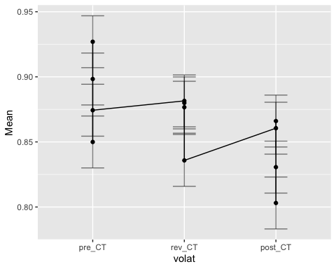

## rmANOVA p_RT

# make a boxplot to take a look at distribution of p_correct group and phasewise  
ggplot(longdat.RT, aes(x=phase, y=p_RT)) + geom_boxplot()

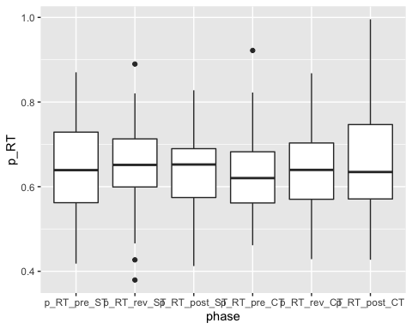

# extract string ST or CT from phase strings and turn it into logical, then numeric  
longdat.RT <- longdat.RT %>% mutate(cond = grepl("*CT",longdat.RT$phase))  
longdat.RT <- longdat.RT %>% mutate(cond2 = longdat.RT$cond*1) %>% rename(cond = longdat.RT$cond2)  
  
# now ezANOVA can be filled with dv = p_correct, within-variables = phase and cond, between-variable = group and type 3 sums of squares  
  
res.RT <- ezANOVA(longdat.RT, p_RT, id, within = .(volat,cond), between = group, detailed = TRUE, type =2)

## Warning: Converting "cond" to factor for ANOVA.

## Warning: "group" will be treated as numeric.

## Warning: Data is unbalanced (unequal N per group). Make sure you specified a  
## well-considered value for the type argument to ezANOVA().

res.RT

## $ANOVA  
## Effect DFn DFd SSn SSd F p  
## 1 (Intercept) 1 54 1.390672e+02 2.5491039 2.945989e+03 8.510148e-49  
## 2 group 1 54 2.404000e-03 2.5491039 5.092613e-02 8.223114e-01  
## 3 volat 2 108 1.083611e-02 0.2952648 1.981781e+00 1.428041e-01  
## 5 cond 1 54 5.795893e-07 0.6458352 4.846100e-05 9.944713e-01  
## 4 group:volat 2 108 2.976976e-03 0.2952648 5.444493e-01 5.817451e-01  
## 6 group:cond 1 54 2.280202e-04 0.6458352 1.906537e-02 8.906928e-01  
## 7 volat:cond 2 108 1.560543e-02 0.1939808 4.344210e+00 1.532441e-02  
## 8 group:volat:cond 2 108 6.002621e-03 0.1939808 1.670998e+00 1.928843e-01  
## p<.05 ges  
## 1 * 9.741916e-01  
## 2 6.520934e-04  
## 3 2.932625e-03  
## 5 1.573182e-07  
## 4 8.073896e-04  
## 6 6.188780e-05  
## 7 * 4.217924e-03  
## 8 1.626644e-03  
##   
## $`Mauchly's Test for Sphericity`  
## Effect W p p<.05  
## 3 volat 0.5851135 6.789902e-07 *  
## 4 group:volat 0.5851135 6.789902e-07 *  
## 7 volat:cond 0.8260936 6.328120e-03 *  
## 8 group:volat:cond 0.8260936 6.328120e-03 *  
##   
## $`Sphericity Corrections`  
## Effect GGe p[GG] p[GG]<.05 HFe p[HF]  
## 3 volat 0.7067705 0.15716267 0.7201926 0.15654922  
## 4 group:volat 0.7067705 0.52210836 0.7201926 0.52531380  
## 7 volat:cond 0.8518566 0.02065372 * 0.8767757 0.01964111  
## 8 group:volat:cond 0.8518566 0.19731612 0.8767757 0.19662665  
## p[HF]<.05  
## 3   
## 4   
## 7 *  
## 8

ezPlot(  
 data = longdat.correct  
 , dv = .(p_correct)  
 , wid = .(id)  
 , within = .(volat,cond)  
 , between = .(group)  
 , x = .(volat)  
)

## Warning: Converting "cond" to factor for ANOVA.

## Warning: "group" will be treated as numeric.

## Warning: Data is unbalanced (unequal N per group). Make sure you specified a  
## well-considered value for the type argument to ezANOVA().

## Warning: Mixed within-and-between-Ss effect requested; FLSD is only appropriate  
## for within-Ss comparisons (see warning in ?ezStats or ?ezPlot).

## Warning in ezStats(data = data, dv = dv, wid = wid, within = within, within_full  
## = within_full, : Unbalanced groups. Mean N will be used in computation of FLSD



## Mixed Effects Model p_correct

# predict p_correct only from intercept, 2 repeated measure factors (volat and cond2) are nested within participant (id)  
basmod <- lme(p_correct ~ 1,data = longdat.correct, random = ~1|id/volat/cond2, method = "ML")  
  
#   
mod <- lme(p_correct ~ volat, random = ~1|id/volat/cond2,data = longdat.correct, method = "ML")  
  
# main effects  
groupmod <- update(basmod, .~. + group)  
volatmod <- update(groupmod, .~. + volat)  
condmod <- update(volatmod, .~. + cond2)  
  
# 2-way interactions  
group_volat <- update(condmod, .~. + group:volat)  
group_cond <- update(group_volat, .~. + group:cond2)  
volat_cond <- update(group_cond, .~. + volat:cond2)  
  
# 3-way interactions  
group_volat_cond <- update(volat_cond, .~. + group:volat:cond2)  
  
# compare models with anova  
anova(basmod, mod, groupmod, volatmod, condmod, group_volat, group_cond, volat_cond, group_volat_cond)

## Model df AIC BIC logLik Test L.Ratio p-value  
## basmod 1 5 -355.9801 -336.8946 182.9901   
## mod 2 7 -406.2131 -379.4934 210.1066 1 vs 2 54.23300 <.0001  
## groupmod 3 6 -359.5140 -336.6113 185.7570 2 vs 3 48.69914 <.0001  
## volatmod 4 8 -409.7470 -379.2101 212.8735 3 vs 4 54.23300 <.0001  
## condmod 5 9 -408.7300 -374.3760 213.3650 4 vs 5 0.98305 0.3214  
## group_volat 6 11 -407.1218 -365.1336 214.5609 5 vs 6 2.39176 0.3024  
## group_cond 7 12 -405.6682 -359.8628 214.8341 6 vs 7 0.54636 0.4598  
## volat_cond 8 14 -405.4806 -352.0411 216.7403 7 vs 8 3.81247 0.1486  
## group_volat_cond 9 16 -407.1230 -346.0492 219.5615 8 vs 9 5.64233 0.0595

ggplot(longdat.correct, aes(x = volat,y = p_correct, col = group)) + stat_summary(fun = mean, geom = "point") + stat_summary(fun = mean, geom = "line", aes(group = group))

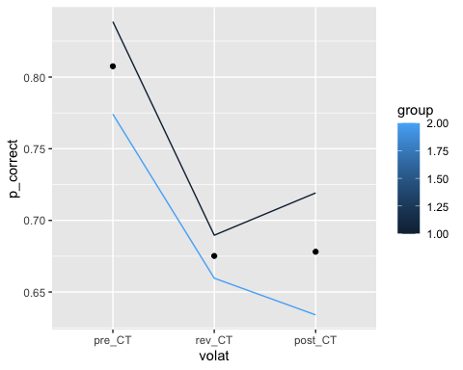

## Mixed Effects Model p_winstay

# predict p_winstay only from intercept, 2 repeated measure factors (volat and cond2) are nested within participant (id)  
basmod <- lme(p_winstay ~ 1,data = longdat.winstay, random = ~1|id/volat/cond2, method = "ML")  
  
#   
mod <- lme(p_winstay ~ volat, random = ~1|id/volat/cond2,data = longdat.winstay, method = "ML")  
  
# main effects  
groupmod <- update(basmod, .~. + group)  
volatmod <- update(groupmod, .~. + volat)  
condmod <- update(volatmod, .~. + cond2)  
  
# 2-way interactions  
group_volat <- update(condmod, .~. + group:volat)  
group_cond <- update(group_volat, .~. + group:cond2)  
volat_cond <- update(group_cond, .~. + volat:cond2)  
  
# 3-way interactions  
group_volat_cond <- update(volat_cond, .~. + group:volat:cond2)  
  
# compare models with anova  
anova(basmod, mod, groupmod, volatmod, condmod, group_volat, group_cond, volat_cond, group_volat_cond)

## Model df AIC BIC logLik Test L.Ratio p-value  
## basmod 1 5 -502.8868 -483.8012 256.4434   
## mod 2 7 -514.5874 -487.8677 264.2937 1 vs 2 15.700632 0.0004  
## groupmod 3 6 -502.1626 -479.2599 257.0813 2 vs 3 14.424876 0.0001  
## volatmod 4 8 -513.8632 -483.3263 264.9316 3 vs 4 15.700632 0.0004  
## condmod 5 9 -513.2450 -478.8910 265.6225 4 vs 5 1.381800 0.2398  
## group_volat 6 11 -510.6490 -468.6608 266.3245 5 vs 6 1.403994 0.4956  
## group_cond 7 12 -508.7611 -462.9558 266.3806 6 vs 7 0.112124 0.7377  
## volat_cond 8 14 -505.3157 -451.8761 266.6578 7 vs 8 0.554559 0.7578  
## group_volat_cond 9 16 -506.1680 -445.0943 269.0840 8 vs 9 4.852380 0.0884

ggplot(longdat.winstay, aes(x = volat,y = p_winstay, col = group)) + stat_summary(fun = mean, geom = "point") + stat_summary(fun = mean, geom = "line", aes(group = group))

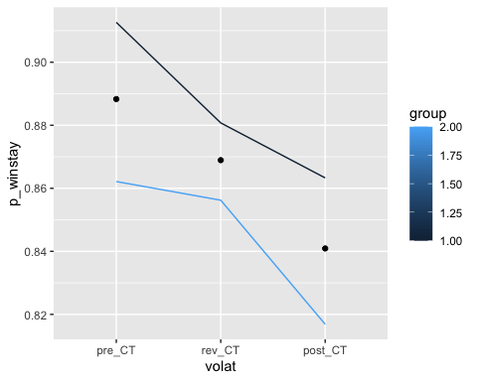

## Mixed Effects Model p_RT

# predict p_RT only from intercept, 2 repeated measure factors (volat and cond2) are nested within participant (id)  
basmod <- lme(p_RT ~ 1,data = longdat.RT, random = ~1|id/volat/cond2, method = "ML")  
  
#   
mod <- lme(p_RT ~ volat, random = ~1|id/volat/cond2,data = longdat.RT, method = "ML")  
  
# main effects  
groupmod <- update(basmod, .~. + group)  
volatmod <- update(groupmod, .~. + volat)  
condmod <- update(volatmod, .~. + cond2)  
  
# 2-way interactions  
group_volat <- update(condmod, .~. + group:volat)  
group_cond <- update(group_volat, .~. + group:cond2)  
volat_cond <- update(group_cond, .~. + volat:cond2)  
  
# 3-way interactions  
group_volat_cond <- update(volat_cond, .~. + group:volat:cond2)  
  
# compare models with anova  
anova(basmod, mod, groupmod, volatmod, condmod, group_volat, group_cond, volat_cond, group_volat_cond)

## Model df AIC BIC logLik Test L.Ratio p-value  
## basmod 1 5 -743.0439 -723.9584 376.5220   
## mod 2 7 -741.6476 -714.9279 377.8238 1 vs 2 2.603707 0.2720  
## groupmod 3 6 -741.0967 -718.1940 376.5484 2 vs 3 2.550920 0.1102  
## volatmod 4 8 -739.7004 -709.1635 377.8502 3 vs 4 2.603707 0.2720  
## condmod 5 9 -737.7006 -703.3466 377.8503 4 vs 5 0.000140 0.9906  
## group_volat 6 11 -734.4201 -692.4319 378.2101 5 vs 6 0.719570 0.6978  
## group_cond 7 12 -732.4753 -686.6700 378.2377 6 vs 7 0.055191 0.8143  
## volat_cond 8 14 -732.2786 -678.8391 380.1393 7 vs 8 3.803326 0.1493  
## group_volat_cond 9 16 -729.7555 -668.6817 380.8777 8 vs 9 1.476816 0.4779

ggplot(longdat.RT, aes(x = volat,y = p_RT, col = group)) + stat_summary(fun = mean, geom = "point") + stat_summary(fun = mean, geom = "line", aes(group = group))

