**Acute stress alters probabilistic reversal learning in healthy participants**

* Lara Wieland1, Claudia Ebrahimi1, Teresa Katthagen1, Martin Panitz2, Lennart Luettgau3, Andreas Heinz1, Zsuzsika Sjoerds4*, Florian Schlagenhauf1* (*shared last author ship)

Affiliations:

1Charité-Universitätsmedizin Berlin, Department of Psychiatry and Psychotherapy CCM, Berlin, Germany

2Max-Planck-Institute for Human Cognitive and Brain Sciences, Leipzig, Germany

3Max Planck University College London Centre for Computational Psychiatry  
and Ageing Research, London, UK

4Leiden University, Netherlands

Corresponding author:

Lara Wieland, M. Sc.

Department of Psychiatry and Psychotherapy

Charité–Universitätsmedizin Berlin, Campus Mitte

Charitéplatz 1, 10117 Berlin, Germany

E-mail: [lara.wieland@charite.de](mailto:lara.wieland@charite.de)

Keywords: Stress, fMRI, cognitive flexibility, reversal learning, decision-making

Text no. of words:

no. of references: 34

**Introduction** Stressful situations can improve or impair flexibility of reward learning. Reversal learning requires flexible adaptation to sudden changes in reward contingencies. Acute stress effects on reversal learning are highly relevant for psychiatric disorders but have rarely been investigated. Here, we employed functional MRI informed by computational modeling in a within-subject design with healthy participants to investigate the effect of acute social on flexible behavioral adaptation

**Methods** Healthy participants (n=28) underwent MRI during a reversal learning task, once after the Trier Social Stress Test (ST) and after a control condition (CT) in separate sessions. During the task participants chose between two stimuli with anti-correlated reward contingencies in order to obtain rewards in three phases with different levels of volatility. Effects of stress on choice behavior were investigated using generalized linear mixed-effects models and a set of computational models describing different learning processes that might have generated the data (hybrid Pearce-Hall and Rescorla-Wagner). Models were fitted using a hierarchical Bayesian approach (Piray, 2019) with reward prediction errors (RPE) as a parametric first-level regressor for fMRI.

**Results** Cortisol responses demonstrated that stress induction was successful. Stress significantly albeit subtly increased correct responses. Model comparison revealed that a Rescorla-Wagner model with individual scaling of the inverse decision temperature best explained the observed behavior under stress. On the neural level, RPE signals were coded in striatum and vmPFC, but we did not observe whole-brain correctable effects of stress on RPE representation.

**Discussion** Our study shows that acute social stress has an impact on reversal learning with high interindividual variability.

**Background** (1000-1500 words)

Decision-making under stress is an everyday-life situation, as for example choosing an efficient and cheap commute to work. Different choice options, such as taking the car, bike or train, are associated with relatively stable levels of cost and reward. In contrast, the weather forecast of the day, a congestion on the preferred route or a train delay, are more volatile factors. Both, stable and volatile factors interact, in that cycling to work may be rewarding on a sunny but not rainy day. Stress affects hormonal and neuronal and consequently their cognitive capacities for effective decision-making (Calvo & Gutiérrez-García, 2016).

**Psychiatric relevance**

While healthy individuals can adapt to a certain level of stress and even find it beneficial (Lighthall, Gorlick, Schoeke, Frank, & Mather, 2013), decision-making can go awry in psychiatric disorders (Cáceda, Nemeroff, & Harvey, 2014; Voon, Reiter, Sebold, & Groman, 2017). Stress is an important factor in causing and maintaining psychiatric illness (McEwen, 2004) and health-related behavior in general (Cohen, Gianaros, & Manuck, 2016). Understanding the impact of stress on decision-making is essential to develop a mechanistic understanding of psychiatric disorders and necessitates a model of how healthy individuals make decisions under stress. So far small sample sizes, heterogenous aspects of decision-making and methodological considerations with regard to the operationalization of stress(, stress-to-task latency and lifetime stress exposure) have complicated the picture (Porcelli & Delgado, 2017).

**Stress and learning (broader)**

Flexible decision-making requires several subordinate functions such as goal implementation, risk-taking, reward and loss sensitivity, task switching or learning from feedback. Across paradigms the effects of stress on these different types of learning are beneficial sometimes and detrimental other times (Goldfarb, Froböse, Cools, & Phelps, 2015; Plessow, Fischer, Kirschbaum, & Goschke, 2011; Plessow, Kiesel, & Kirschbaum, 2012). In a meta-analysis investigating the impact of acute stress on decision-making, paradigms were categorized on two dimensions: task type (decision-making under ambiguity vs. risk) and reward contingencies (risk taking/reward seeking is disadvantageous vs. not). Independent of task type, acute stress had a small negative impact on tasks in which reward seeking and risk taking/reward seeking was disadvantageous (*d* = .26 and *d* = .44), but no effect if this was not the case. Similarly, a meta-analysis investigating the effects of acute stress on cognitive flexibility in a smaller study set concluded that stress had an impairing effect (Shields, Sazma, & Yonelinas, 2016). This demonstrates how important it is to carefully consider which behavior constitutes optimal decision-making in different paradigms. Both meta-analyses predominantly focussed on paradigms such as the Wisconsin card sorting test or task-switching tests. While providing valuable insight into overall cognitive flexibility these paradigms mostly rely on averaged outcome measures. In contrast, novel tasks designed for computational modeling provide a more fine-grained measure of underlying processes, as will become clear in the next section. Another important factor is the type of standardized stressors, which are commonly used in behavioral experiments. They can be physiological as in the Cold Pressor Task, psychosocial as in the Trier Social Stress Test (TSST) or a mix of both as in the Socially Evaluated Cold Pressor Test (Starcke & Brand, 2016). The physiological paradigms lead to more immediate stress during learning, whereas the psychosocial paradigms release their full physiological effect 10-20 mins after stress induction.

**Stress and learning (computational)**

In the last decade cognitive neuroscience and computational approaches gained traction in clinical application (Huys, Maia, & Frank, 2016; Maia & Frank, 2011). A useful dichotomy in differentiating decision-making is habitual versus goal-directed behavior and its respective neural correlates (Balleine & O’Doherty, 2010). Both types of learning find their computational equivalent in reinforcement learning (RL) model. Generally, learning results from so-called reward prediction errors (RPE), signalling the difference between an observed and expected reward. RPE are used to update choice values of available choice options in order to maximise rewards. When behaving habitually or model-free, a learner is guided by model-free RPE in seeking rewards without taking the environmental structure into account. The respective neural signature is found in the ventral striatum. Goal-directed behavior on the other hand is also called model-based because a model of the environment is necessary. A model-based RPE incorporates knowledge about higher-order task structure, such as interdependent choice options. On the neural level, the medial prefrontal cortex (mPFC) is a key network for model-based learning. In general, learners presumably use a mixture of both types for learning depending on their cognitive resources (Dolan & Dayan, 2013). As stress is a key factor impacting cognitive resources, both processes should be prone to interruption by stress (Schwabe & Wolf, 2009, 2011). Experimental attempts to disentangle model-free and model-based learning show that stress affects both types of learning in different ways (Cremer, Kalbe, Gläscher, & Schwabe, 2021; Otto, Raio, Chiang, Phelps, & Daw, 2013).

A potential explanation for the inconsistent impact of acute stress on learning are moderating variables, such as chronic stress exposure, cognitive capacities or personality traits. For instance, a high working memory capacity seems to hold a protective function against the attenuation of model-based learning (Otto et al., 2013), while trait impulsivity interacts with different aspects of learning differentially, but particularly seems to increase perseveration (Raio, Hartley, Orederu, Li, & Phelps, 2017).

**Probabilistic reversal learning**

Probabilistic reversal learning is a central concept in the realm of reward-related decision-making because it operationalizes cognitive flexibility in a volatile environment. Successful performance in this task is subsumed under model-based learning. Paradigms tapping at this type of learning require participants to choose between two stimuli with anti-correlated reward contingencies. Contingencies are reversed several times throughout the task unannounced and therefore require flexible adaptation to a volatile environment. The main outcome variable of interest is the percentage of correct responses, win-stay and lose-switch behavior. With regard to the probabilistic reversal learning task, optimal learning necessitates that the anti-correlated task structure is understood and taken into consideration. In this case probabilistic losses should still lead to stay-behavior and probabilistic wins should lead to switch-behavior. Computationally informed cognitive modelling has helped to investigate neural correlates of this task and mainly implicate the ventral striatum and the ventromedial prefrontal cortex (vmPFC). (Cools, Clark, Owen, & Robbins, 2002; Hampton, Bossaerts, & Doherty, 2006).

**Limitations of previous studies**

However, it is less clear how stress affects the neural correlates of probabilistic reversal learning and previous studies rely on between-subject designs (Preprint von Carvalheiro zitieren?). The few studies using within-subject designs (Radenbach et al., 2015) to investigate learning, are either purely behavioral or employ electroencephalography without the possibility of precise localization (Cavanagh, Frank, & Allen, 2011). Additionally, few studies in the realm of cognitive flexibility use computational modeling to elucidate underlying cognitive mechanisms. Applying a state-of-the-art hierarchical Bayesian modeling approach (Piray, Dezfouli, Heskes, Frank, & Daw, 2019), allowed us to set up a set of computational models and the impact of stress. To our best of knowledge probabilistic reversal learning has not been investigated after a psychosocial stress intervention in a within-subject design before.

**Methods** (1500 words)

Study Design:

Employing a within-subject design, a probabilistic reversal learning task during fMRI in two separate sessions seven days apart was performed by participants. During the stress condition participants were exposed to a mock interview and calculus in front of a socially unresponsive committee in white lab coats, following the standard Trier Social Stress Test (TSST) protocol. During the control condition participants read a neutral text without presence of the committee. Session type (stress vs. control) was counter-balanced across participants. In order to prevent confounding effects of circadian rhythm on cortisol levels both experimental sessions were scheduled at exactly the same time of the day (Kudielka, Schommer, Hellhammer, & Kirschbaum, 2004). Acute stress response was assessed at physiological (cortisol and α-amylase) and subjective (self-report VAS scales) level at six timepoints throughout the session (see Figurex).

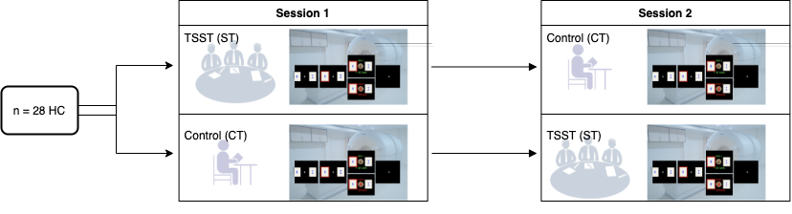

Figure 1 Study design

Physiological stress response:

We assessed physiological stress response via salivary cortisol and α-amylase, which were assessed six times throughout the experiment ﻿at the following time points: after 10 mins of rest (baseline, T1), directly after the termination of the TSST or control condition, respectively (t2), ∼20 min .... For collection and extraction of saliva we used Salivette saliva sampling tubes (SalivetteCortisol®, Sarstedt, Nuembrecht, Germany) (see Supplement). Individual cortisol reactivity was determined by calculating the area under the curve with respect to ground (AUCg-stress and AUCg-control, according to Pruessner et al., 2003) separately for both conditions and subtracting AUCg-control from AUCg-stress. The AUC was calculated based on individualized subjectwise time points, taking into account slight dispersion in the testing protocol. We further applied a criterion of 1.5nmol per liter (nmol/l, Miller et al., 2013) from post-stress (T3 through T6) above the pre-stress level (T1/2) during the stress condition (Goodman, Janson, & Wolf, 2017) to define stress-responders vs. non-responders. Using this method three participants were classified as non-responders. However, excluding these participants did not change our behavioral findings and therefore they remained in the final sample.

Subjective stress response:

Three different visual analogue scales (VAS) ranging from 0 to 100 were used to assess subjective arousal, valence and stress at all time points (T1-T6). Arousal was rated on the scale "Do you feel active or sleepy?" from 0 (sleepy) to 100 (active), valence on the scale "Do you feel happy or unhappy?" from 0 (unhappy) to 100 (happy) and stress on the scale "Do you feel stressed or not stressed?" from 0 (not stressed) to 100 (stressed).   
Participants filled in trait questionnaires at home in an online survey program (Limesurvey, www.limesurvey.org).

Task Design

Participants performed a probabilistic reversal learning task, which included 160 trials and comprised around 15 minutes. The task was programmed in Matlab (The MathWorks, Natick, MA) with Psychtoolbox. On every trial, participants had to decide between two cards, depicting a different geometric stimulus. The underlying reward structure was not explicitly instructed but could be inferred: reward probabilites associated with the two choice options were anticorrelated (i.e. whenever card A was rewarded, card B was a loss and vice versa). Furthermore, Participants were informed on the probabilistic nature of the task: the respective winning card was only rewarded in 80% of all trials. Right-side versus left-side location of the stimulus was randomized. After a fixed number of trials, contingencies reversed and these reversals repeated over the middle experimental phase (see Figure 2). Participants were instructed to win as much money as possible and paid out a monetary bonus at the end of the experiment.

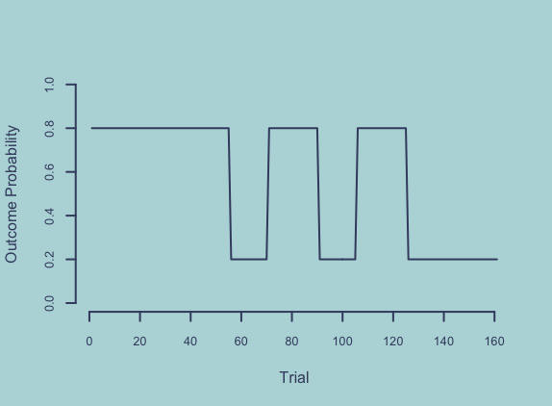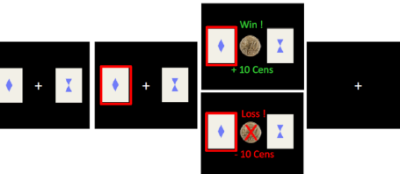

Figure 2 Task design

Analyses

*Stress response analyses*

Cortisol, α-amylase, and the three subjective VAS scales were asssessed using paired-samples *t*-tests.

*Behavioral data*

Single-trial mixed effects logistic regressions were conducted using the lme4 package (Bates, Mächler, Bolker, & Walker, 2015) in R (Version 3.1.X). Results were considered significant at p≤.05. We analyzed trial-by-trail correct responses, win-stay and lose-switch behavior with factors *stress condition* (CT vs. ST, effect coding as -0.5 and 0.5) and *experimental phase* (pre, reversal, post) as fixed effects, allowing for a random subject intercept. For the factor *experimental phase* we specified a custom centered contrast, testing the null hypothesis of performance differences between first stable vs. reversal and late stable vs. reversal phase using the hypr package (Rabe, Vasishth, Hohenstein, Kliegl, & Schad, 2020). Main effects of condition and phase, as well as an interaction effect were added incrementally in two steps. They were also compared to the null model, which predicted outcome variables with the random subject intercept only, using Aikaike information criterion (AIC) and Bayesian information criterion (BIC). For the winning model Odd's Ratio was computed to assess effect size. The same analysis was conducted with cortisol AUC instead of stress condition. Participants were excluded when their performance was below chance (correct responses < 50%). This was the case for one participant. Across all trials, participants missed a relatively low number of trials (0.71%).

*fMRI data*

Scans were acquired on a Siemens 3 T high-resolution PRISMA MR-System with a 20-channel head coil (Siemens, Erlangen, Germany) with the following parameters: T2*-weighted gradient-echo echo-planar imaging (EPI) (repetition time, 2000 ms; echo time, 30 ms; flip angle, 90°; field of view, matrix, 192×192 mm2 ; voxel size, 3 × 3 × 5 mm) . The scanning procedure (A) comprised a T1 MPRAGE recorded within seven days before the first test session, (B) after the task a field map was collected to account for individual homogeneity differences of the magnetic field, (C) an average total of 30 EPI volumes were recorded per subject. Functional imaging data analyses were performed using SPM12 in Matlab.

Reward prediction errors (RPE) and Q-values were included as a parametric first-level regressors.

*Computational models*

In order to describe different learning processes that might have generated the data under stress and control condition we followed a two-step procedure: First, we fit a set of Rescorla-Wagner and Pearce-Hall models to explain learning only in the control condition. Among the Rescorla-Wagner family are a single-update (SU), double-update (DU), and individual double update-learning (iDU) algorithm. Each of those was implemented with one or two learning rates for wins and losses in combination with two inverse temperature parameters (always separate for wins and losses). The use of two versions with different learning rates resulted in six models from the Rescorla-Wagner family. Furthermore, a Pearce-Hall model (PH) with a dynamic learning rate and a no-learning model with a bias towards one of the choice options were used. This resulted in a model space of eight models.

In the RL model family the expected value of of an action at trial is updated via the RPE , which is defined as the difference between received reward and previously expected reward value for the chosen stimulus :

How much the RPE is weighted for this update depends on the learning rate . In case of only the most recent RPE will be used.

First, in the SU model the anti-correlated task structure is not taken into account, which means that the unchosen stimulus is not updated:

The extent of an update might also differ on the last trial resulting in a win or a loss. To make this possible a model with different learning rates was implemented:

Second, the DU model updates chosen and unchosen value. This results from the anti-correlated task structure, where a win for one stimulus has to mean a loss for the other one. If a learner understood the task structure, they can use a win or less feedback to update the decision value of the chosen as well as the other card. In order to achieve this a different RPE is needed, comparing the possible outcome with the value of the unchosen option:

Comparable to the SU update model, different learning rates can be implemented for wins and losses (not shown as formula for reasons of brevity):

Third, the degree of how much a learner uses DU can vary interindividually. In order to incorporate this, the iDU introduces an additional weighting parameter for called , if set to resulting in the DU model and resulting in the SU model. can be added to both DU models and changes only the equation for the unchosen option:

For all models, decisions are transformed into choice probabilities by a softmax response model:

The free softmax temperature parameter reflects choice stochasticity with higher values equating more deterministic and lower values equating more stochastic choices. Similar to learning rates, choice stochasticity can be differentially sensitive to wins and losses with separate softmax temperature parameters for wins and losses.

In a second step to model learning under the stress condition we added a scaling factor for stress to the previously conceived winning model from the first step. Our model family included a model without the scaling factor, a model with stress scaling only affecting the learning parameters and , a model with stress scaling only affecting the temperature parameters and , and a model with stress scaling affecting all free parameters. We then fit data from each subject in both conditions together, while applying the stress scaling only to the stress condition data.

*Model fitting*

Parameters were estimated in the cbm toolbox in Matlab R2018a.

**Results** (1500 words)

Sample characteristics

Table or Text?

Insert table: age, BMI, education years, handednness, IQ (WST)

Physiological and subjective results

The stress intervention significantly increased subjective stress response (arousal, valence and subjective stress), as well as physiological response. For detailed statistics refer to the supplement and Figure 3.

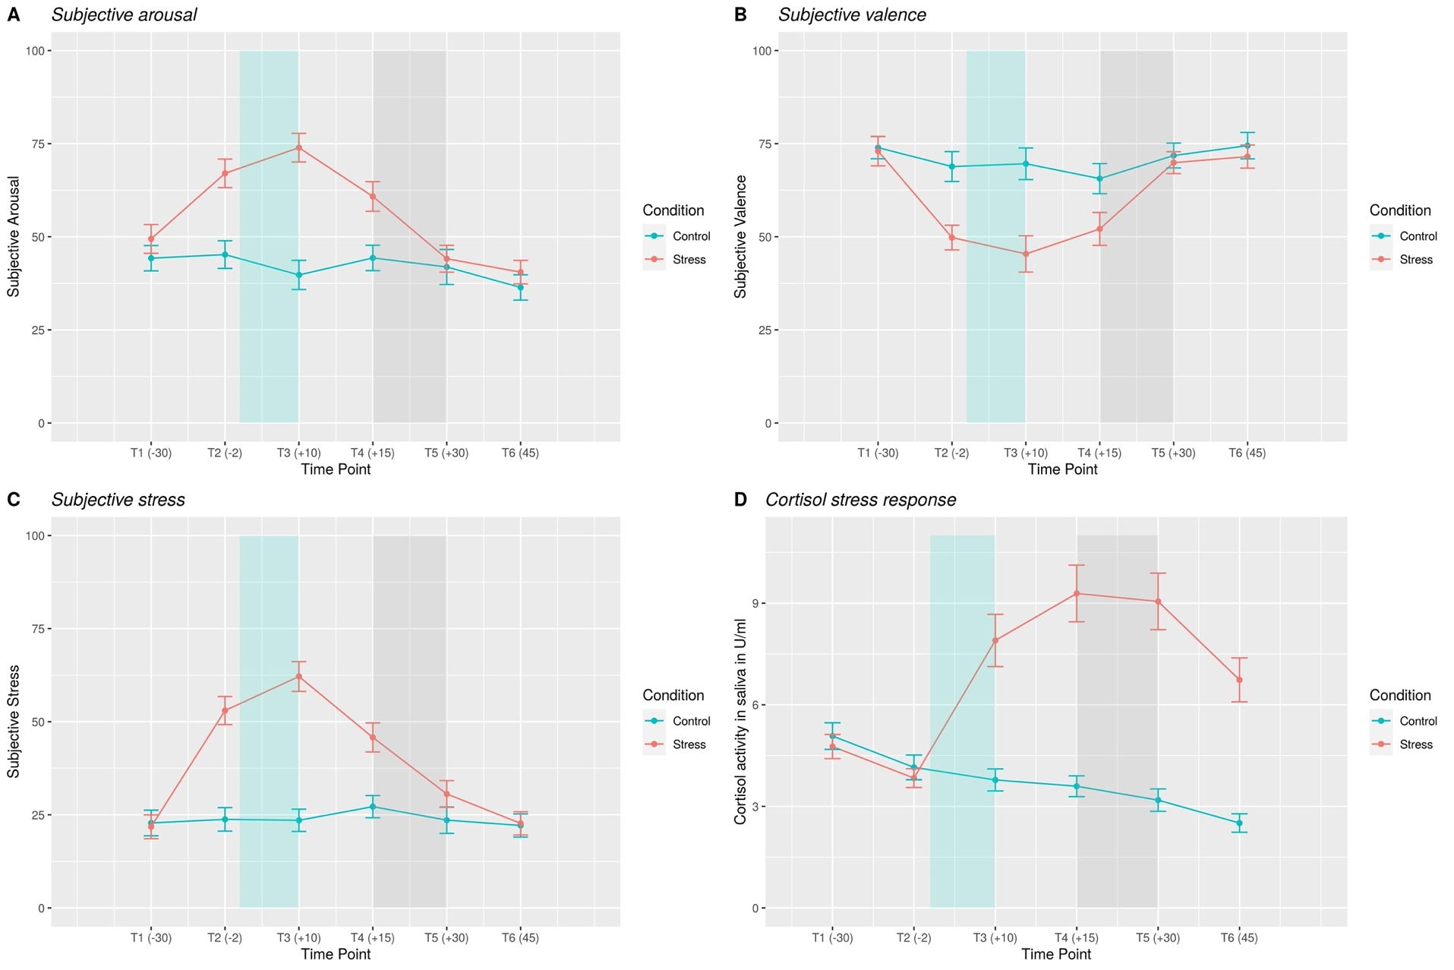

Figure 3 Subjective and physiological stress response over the course of experimental session

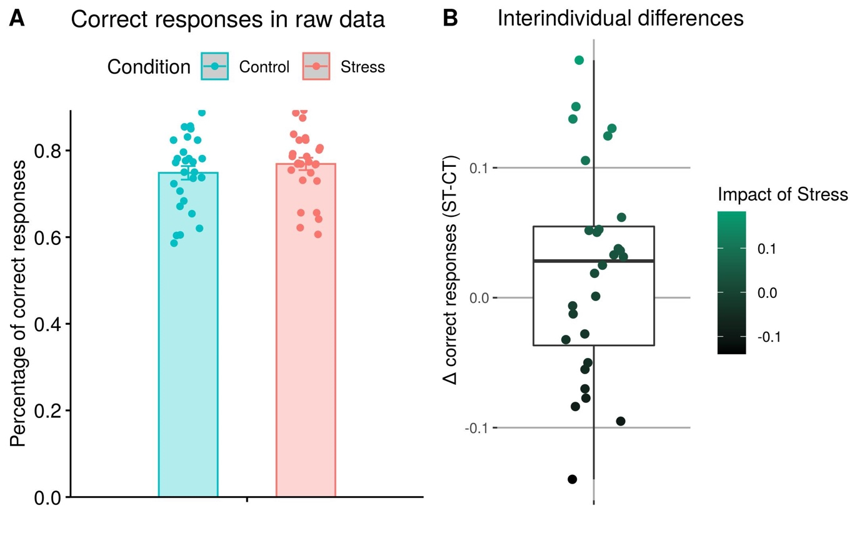

Figure 4 Behavioral results: correct responses

Behavioral results

Predicting correct responses on a single-trial basis with generalized mixed effects modeling indicated the expected task effect under reversal ﻿(*p* < 0.001) and in the second stable phase ﻿(*p* < 0.001). For both phases, correct responses decreased with respect to the first reference phase. Furthermore, there was a main effect of condition (*p* = 0.026), suggesting that participants' correct responses increased under stress with a subtle effect size (OR = 1.12). These results were supported by a significant main effect (*p* = 0.030) of stress when physiological stress level (AUC) was used as a continuous predictor instead of experimental condition (ST vs. CT). In this model task effects were again significant for the reversal phase ﻿(*p* < 0.001) as well as the stable phase ﻿(*p* < 0.001).

Regarding win-stay behavior, task effects of reversal phase ﻿(*p* < 0.001) and stable phase ﻿(*p* < 0.001) were significant, but not experimental condition (*p* = 0.39). Similarly, lose-switch behavior resulted in significant task effects of reversal phase (*p* < 0.001) and stable phase ﻿(*p* < 0.001), but not experimental condition (*p* = 0.76).

Computational modeling results

fMRI results

**Discussion** (1500 words)

The present study investigated the behavioral and neural effects of acute psychosocial stress on reversal learning. In healthy male participants we found that probabilistic reversal learning improves slightly under acute social stress. Win-stay, as well as lose-switch behavior was not affected.

The existing literature on decision-making is inconsistent with regard to the directional impact of stress on learning. While meta-analyses on older studies found that stress impairs learning (Shields, Sazma, et al., 2016; Starcke & Brand, 2016), more recent

**Reversal learning and psychiatric relevance**

As an operationalization of cognitive flexibility, reversal learning is a construct with high relevance for several psychiatric disorders. For instance, in patients with alcohol use disorder (Reiter et al., 2016) anorexia nervosa (Bernardoni et al., 2017), binge-eating disorder (Reiter, Heinze, Schlagenhauf, & Deserno, 2017), ADHD (Hauser et al., 2021) or schizophrenia (Katthagen, Kaminski, Heinz, Buchert, & Schlagenhauf, 2020) cognitive flexibility and its neural correlates are impaired. Our results suggest that it might be worthwhile to assess acute stress in at-risk populations in order to reveal how stress is involved in maladaptive decision-making.

**Limitations**

Considering the gender differences in decision-making (Shields, Trainor, Lam, & Yonelinas, 2016) which may be amplified by stress (Mather & Lighthall, 2012) and potential impact of cyclical changes in female individuals we decided to investigate an exclusively male sample. Furthermore, our sample was homogenously young and highly educated. Therefore, our findings cannot be generalized to the general population or patient samples.

**Future studies**

**References**

Balleine, B. W., & O’Doherty, J. P. (2010). Human and rodent homologies in action control: Corticostriatal determinants of goal-directed and habitual action. *Neuropsychopharmacology*, *35*(1), 48–69. https://doi.org/10.1038/npp.2009.131

Bates, D., Mächler, M., Bolker, B. M., & Walker, S. C. (2015). Fitting linear mixed-effects models using lme4. *Journal of Statistical Software*, *67*(1). https://doi.org/10.18637/jss.v067.i01

Bernardoni, F., Geisler, D., King, J. A., Ritschel, F., Murr, J., Reiter, A. M. F., … Ehrlich, S. (2017). Altered medial frontal feedback learning signals in anorexia nervosa. *Biological Psychiatry*. https://doi.org/10.1016/j.biopsych.2017.07.024

Cáceda, R., Nemeroff, C. B., & Harvey, P. D. (2014). Toward an understanding of decision making in severe mental illness. *Journal of Neuropsychiatry and Clinical Neurosciences*, *26*(3), 196–213. https://doi.org/10.1176/appi.neuropsych.12110268

Calvo, M. G., & Gutiérrez-García, A. (2016). *Chapter 16 - Cognition and Stress* (G. B. T.-S. C. Fink Cognition, Emotion, and Behavior, ed.). https://doi.org/https://doi.org/10.1016/B978-0-12-800951-2.00016-9

Cavanagh, J. F., Frank, M. J., & Allen, J. J. B. (2011). Social stress reactivity alters reward and punishment learning. *Social Cognitive and Affective Neuroscience*, *6*(3), 311–320. https://doi.org/10.1093/scan/nsq041

Cohen, S., Gianaros, P. J., & Manuck, S. B. (2016). A Stage Model of Stress and Disease. *Perspectives on Psychological Science*, *11*(4), 456–463. https://doi.org/10.1177/1745691616646305

Cools, R., Clark, L., Owen, A. M., & Robbins, T. W. (2002). *Defining the Neural Mechanisms of Probabilistic Reversal Learning Using Event-Related Functional Magnetic Resonance Imaging*. *22*(11), 4563–4567.

Cremer, A., Kalbe, F., Gläscher, J., & Schwabe, L. (2021). NeuroImage Stress reduces both model-based and model-free neural computations during flexible learning. *NeuroImage*, *229*(January), 117747. https://doi.org/10.1016/j.neuroimage.2021.117747

Dolan, R. J., & Dayan, P. (2013). Review Goals and Habits in the Brain. *Neuron*, *80*(2), 312–325. https://doi.org/10.1016/j.neuron.2013.09.007

Goldfarb, E. V, Froböse, M. I., Cools, R., & Phelps, E. A. (2015). *Stress and Cognitive Flexibility : Cortisol Increases Are Associated with Enhanced Updating but Impaired Switching*. 14–24. https://doi.org/10.1162/jocn

Goodman, W. K., Janson, J., & Wolf, J. M. (2017). Meta-analytical assessment of the effects of protocol variations on cortisol responses to the Trier Social Stress Test. *Psychoneuroendocrinology*, *80*, 26–35. https://doi.org/10.1016/j.psyneuen.2017.02.030

Hampton, A. N., Bossaerts, P., & Doherty, J. P. O. (2006). *The Role of the Ventromedial Prefrontal Cortex in Abstract State-Based Inference during Decision Making in Humans*. *26*(32), 8360–8367. https://doi.org/10.1523/JNEUROSCI.1010-06.2006

Hauser, T. U., Iannaccone, R., Ball, J., Mathys, C., Brandeis, D., Walitza, S., & Brem, S. (2021). *Role of the Medial Prefrontal Cortex in Impaired Decision Making in Juvenile Attention-Deficit/Hyperactivity Disorder*. *71*(10), 1165–1173. https://doi.org/10.1001/jamapsychiatry.2014.1093

Huys, Q. J. M., Maia, T. V., & Frank, M. J. (2016). Computational psychiatry as a bridge from neuroscience to clinical applications. *Nature Neuroscience*, *19*(3), 404–413. https://doi.org/10.1038/nn.4238

Katthagen, T., Kaminski, J., Heinz, A., Buchert, R., & Schlagenhauf, F. (2020). Striatal Dopamine and Reward Prediction Error Signaling in Unmedicated Schizophrenia Patients. *Schizophrenia Bulletin*, *46*(6), 1535–1546. https://doi.org/10.1093/schbul/sbaa055

Kudielka, B. M., Schommer, N. C., Hellhammer, D. H., & Kirschbaum, C. (2004). Acute HPA axis responses, heart rate, and mood changes to psychosocial stress (TSST) in humans at different times of day. *Psychoneuroendocrinology*, *29*(8), 983–992. https://doi.org/https://doi.org/10.1016/j.psyneuen.2003.08.009

Lighthall, N. R., Gorlick, M. A., Schoeke, A., Frank, M. J., & Mather, M. (2013). *Stress Modulates Reinforcement Learning in Younger and Older Adults*. *28*(1), 35–46. https://doi.org/10.1037/a0029823

Maia, T. V., & Frank, M. J. (2011). From reinforcement learning models to psychiatric and neurological disorders. *Nature Neuroscience*, *14*(2), 154–162. https://doi.org/10.1038/nn.2723

Mather, M., & Lighthall, N. R. (2012). Risk and reward are processed differently in decisions made under stress. *Current Directions in Psychological Science*, *21*(1), 36–41. https://doi.org/10.1177/0963721411429452

McEwen, B. S. (2004). Protection and damage from acute and chronic stress: Allostasis and allostatic overload and relevance to the pathophysiology of psychiatric disorders. *Annals of the New York Academy of Sciences*, *1032*, 1–7. https://doi.org/10.1196/annals.1314.001

Otto, A. R., Raio, C. M., Chiang, A., Phelps, E. A., & Daw, N. D. (2013). Working-memory capacity protects model-based learning from stress. *Proceedings of the National Academy of Sciences of the United States of America*, *110*(52), 20941–20946. https://doi.org/10.1073/pnas.1312011110

Piray, P., Dezfouli, A., Heskes, T., Frank, M. J., & Daw, N. D. (2019). Hierarchical Bayesian inference for concurrent model fitting and comparison for group studies. *PLoS Computational Biology*, *15*(6). https://doi.org/10.1371/journal.pcbi.1007043

Plessow, F., Fischer, R., Kirschbaum, C., & Goschke, T. (2011). Inflexibly Focused under Stress: Acute Psychosocial Stress Increases Shielding of Action Goals at the Expense of Reduced Cognitive Flexibility with Increasing Time Lag to the Stressor. *Journal of Cognitive Neuroscience*, *23*(11), 3218–3227. https://doi.org/10.1162/jocn_a_00024

Plessow, F., Kiesel, A., & Kirschbaum, C. (2012). The stressed prefrontal cortex and goal-directed behaviour: Acute psychosocial stress impairs the flexible implementation of task goals. *Experimental Brain Research*, *216*(3), 397–408. https://doi.org/10.1007/s00221-011-2943-1

Porcelli, A. J., & Delgado, M. R. (2017). Stress and Decision Making: Effects on Valuation, Learning, and Risk-taking. *Current Opinion in Behavioral Sciences*, *14*, 33–39. https://doi.org/10.1016/j.cobeha.2016.11.015

Rabe, M. M., Vasishth, S., Hohenstein, S., Kliegl, R., & Schad, D. J. (2020). hypr: An R package for hypothesis-driven contrast coding. *The Journal of Open Source Software*, *5*(48), 2134. https://doi.org/10.21105/joss.02134

Radenbach, C., Reiter, A. M. F., Engert, V., Sjoerds, Z., Villringer, A., Heinze, H. J., … Schlagenhauf, F. (2015). The interaction of acute and chronic stress impairs model-based behavioral control. *Psychoneuroendocrinology*, *53*, 268–280. https://doi.org/10.1016/j.psyneuen.2014.12.017

Raio, C. M., Hartley, C. A., Orederu, T. A., Li, J., & Phelps, E. A. (2017). Stress attenuates the flexible updating of aversive value. *Proceedings of the National Academy of Sciences of the United States of America*, *114*(42), 11241–11246. https://doi.org/10.1073/pnas.1702565114

Reiter, A. M. F., Deserno, L., Kallert, T., Heinze, H. J., Heinz, A., & Schlagenhauf, F. (2016). Behavioral and neural signatures of reduced updating of alternative options in alcohol-dependent patients during flexible decision-making. *Journal of Neuroscience*, *36*(43), 10935–10948. https://doi.org/10.1523/JNEUROSCI.4322-15.2016

Reiter, A. M. F., Heinze, H. J., Schlagenhauf, F., & Deserno, L. (2017). Impaired Flexible Reward-Based Decision-Making in Binge Eating Disorder: Evidence from Computational Modeling and Functional Neuroimaging. *Neuropsychopharmacology*, *42*(3), 628–637. https://doi.org/10.1038/npp.2016.95

Schwabe, L., & Wolf, O. T. (2009). Stress prompts habit behavior in humans. *Journal of Neuroscience*, *29*(22), 7191–7198. https://doi.org/10.1523/JNEUROSCI.0979-09.2009

Schwabe, L., & Wolf, O. T. (2011). Stress-induced modulation of instrumental behavior: From goal-directed to habitual control of action. *Behavioural Brain Research*, *219*(2), 321–328. https://doi.org/10.1016/j.bbr.2010.12.038

Shields, G. S., Sazma, M. A., & Yonelinas, A. P. (2016). The effects of acute stress on core executive functions: A meta-analysis and comparison with cortisol. *Neuroscience and Biobehavioral Reviews*, *68*, 651–668. https://doi.org/10.1016/j.neubiorev.2016.06.038

Shields, G. S., Trainor, B. C., Lam, J. C. W., & Yonelinas, A. P. (2016). Acute stress impairs cognitive flexibility in men, not women. *Stress (Amsterdam, Netherlands)*, *19*(5), 542–546. https://doi.org/10.1080/10253890.2016.1192603

Starcke, K., & Brand, M. (2016). Effects of stress on decisions under uncertainty: A meta-analysis. *Psychological Bulletin*, *142*(9), 909–933. https://doi.org/10.1037/bul0000060

Voon, V., Reiter, A., Sebold, M., & Groman, S. (2017). Model-Based Control in Dimensional Psychiatry. *Biological Psychiatry*, *82*(6), 391–400. https://doi.org/10.1016/j.biopsych.2017.04.006