Supplementary material

**Acute stress alters probabilistic reversal learning in healthy participants.**

Wieland et al.

Study Design: Within seven days prior to the first intervention participants performed a verbal intelligence assessment (Schmidt and Metzler, 1992) and a high-resolution structural MR scan, which was used for coregistration of fMRI data. After arrival on the intervention day participants rested for 10 minutes and practiced the reversal learning task outside of the MR scanner before the stress or control intervention. After the intervention, participants were led to the MR scanner. For further details see Luettgau et al. (2018).

Stress/control intervention: After arrival participants were able to accommodate to the environment by relaxing for about 10 minutes.During the anticipation period (5 mins) of the TSST stress condition participants were instructed to prepare for a job interview as the first part of the stress intervention. They were allowed to take notes in preparation but not use them afterwards in a free speech for 5 mins in front of a mock committee explaining why they would be suitable candidates. The committee acted in an emotionally and socially non-responsive manner and wore white laboratory coats to heighten stress response. The committee consisted of an actor and a trained psychologist student who were introduced as specializing in the analysis of non-verbal behavior. As a second part of the stress intervention participants were asked to perform a mental arithmetic task (5 minutes) in front of the committee. They had to perform a serial substraction of the number 17 starting at 2043 verbally as fast and accurately as possible. During both parts participants were supposedly video- and audiorecorded, which was enhanced by a microphone and a video camera (turned off unknown to the participants). In the debriefing after finishing the study participants were told about the purpose of the stress intervention by a psychologist. They were told that they had not been video- or audio-recorded and that the interview would not be relevant for the remaining parts of the study. During the anticipation period (5 mins) of the control condition participants were instructed that they would read a piece of text and could relax. Afterwards, they read a neutral non-fiction text about the Mesozoic era for 10 minutes.

Computational modeling:

*Pearce-Hall model*

We implemented a Pearce-Hall model, where denotes the absolute RPE, C is an arbitrary scaling coefficient and is a decay constant. The learning rate depends on the absolute RPE on previous trials, the learning rate on previous trials, and the decay constant (Diederen et al., 2016):

Stress response analyses:

Our analyses resulted in a significant difference between ST and CT condition with regard to subjective arousal (*t*(27) = -4.9, *p* < .001), subjective valence (*t*(27) = 4.2, *p* < .001), and subjective stress (*t*(27) = -6.7, *p* < .001). Furthermore, we found a significant difference between ST and CT for cortisol AUC-G (*t*(26) = -2.6, *p* = .02).

**Supplementary Figures**

Generalized mixed effects modeling: Odd's ratio

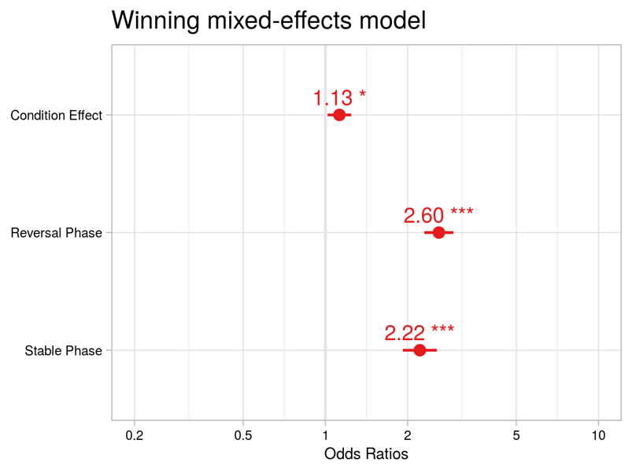

Figure S1. Odd's Ratio of condition (CI: 1.02-1.24), reversal phase (CI: 2.30-2.94) and stable phase (CI:1.92-2.56) contrasts from fixed-effects model.

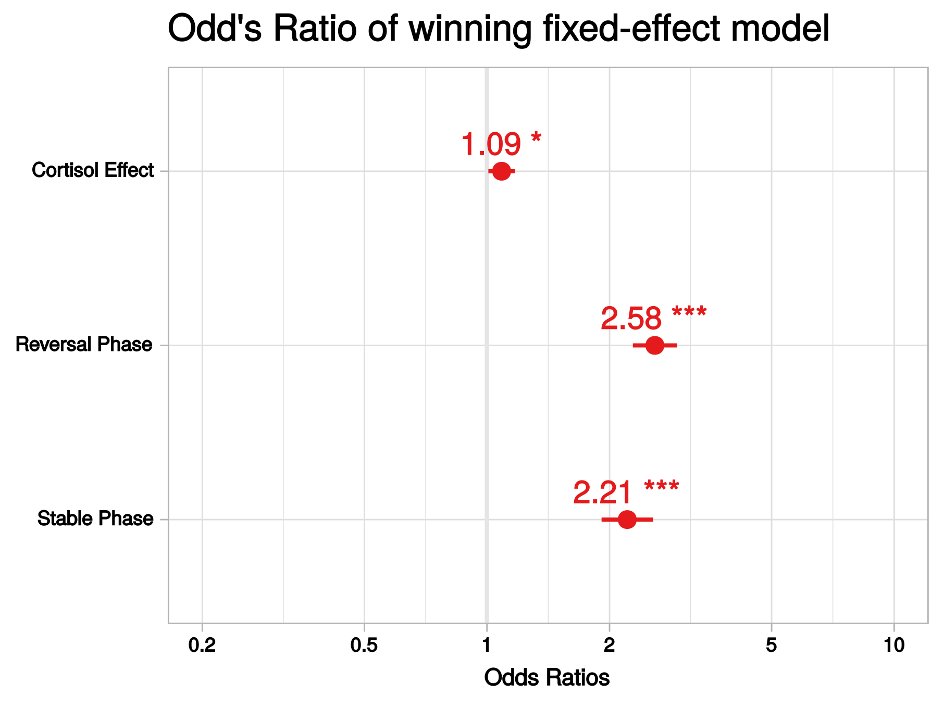

Figure S2. Odd's Ratio of cortisol (1.09, CI: 1.01-1.17), reversal phase (2.58 CI: 2.28-2.93) and stable phase (2.21, CI:1.91-2.56) contrasts from fixed-effects model.

Computational modeling: parameter distribution

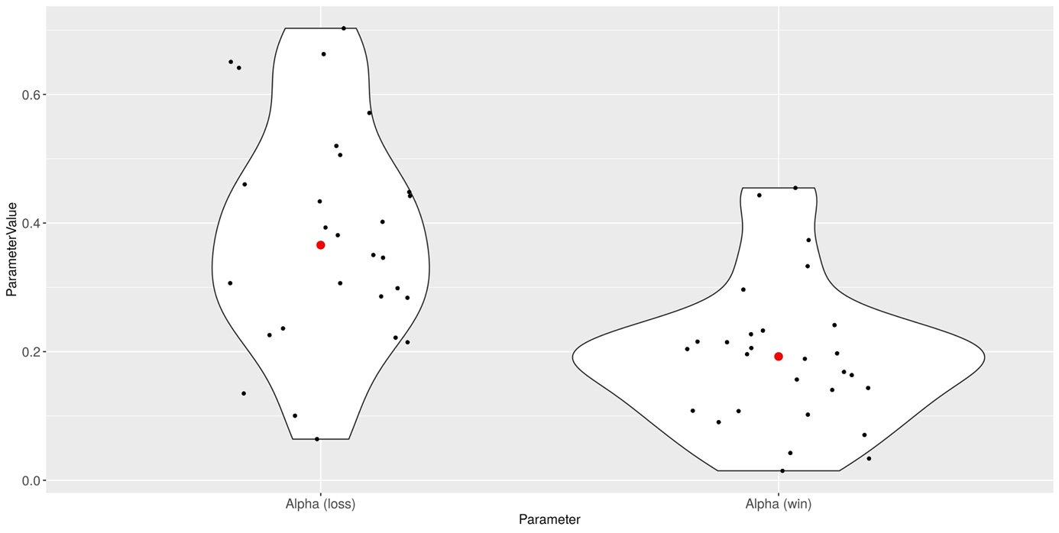

Figure S3. Learning parameter values across all participants (median in red).

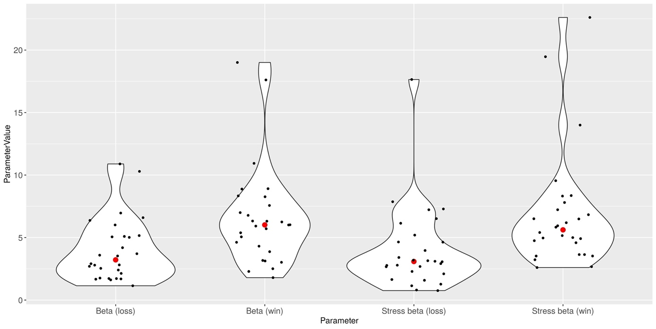

Figure S4. Choice stochasticity parameter values across all participants (median in red).

Computational modeling: choice stochasticity and behavioral results

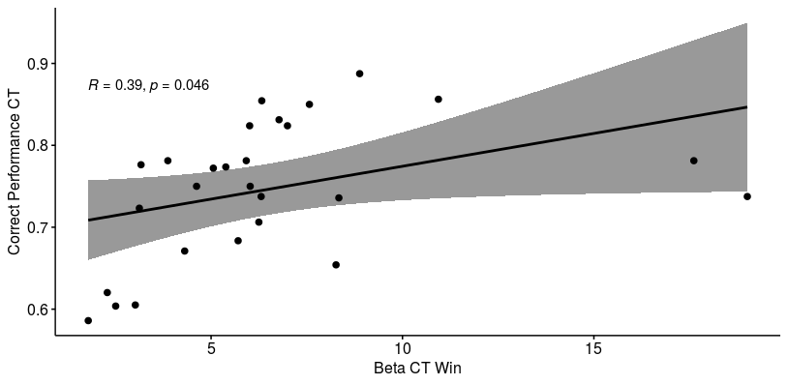

Figure S5. Correlation of and correct performance (%) in the control condition.

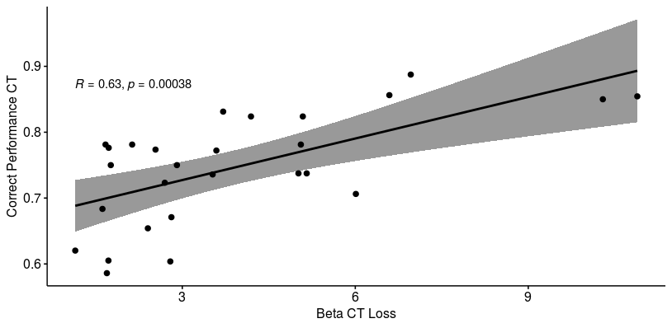

Figure S6. Correlation of and correct performance (%) in the control condition.

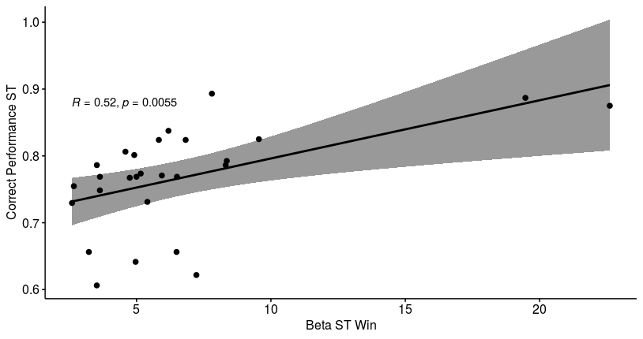

Figure S7. Correlation of and correct performance (%) in the stress condition.

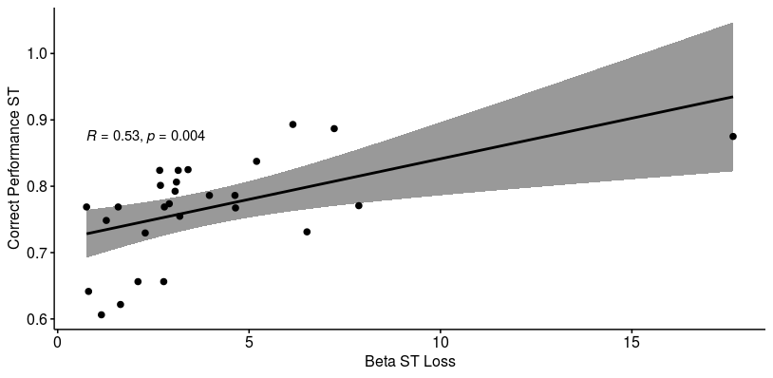

Figure S8. Correlation of and correct performance (%) in the stress condition.

Exploratory fMRI analyses



Figure S9. Differential effect of stress intervention in participants with better vs. worse performance under stress. A flexible factorial ANOVA design within-factor condition (ST vs. CT) and between-factor learning performance (delta correct response > 0 vs. delta correct response < 0) was used and the interaction between condition and performance group were tested in regions showing a significant main effect of RPE at *pFWE* 0.05, whole-brain-corrected (conjunction analysis). The vmPFC showed an interaction effect at an uncorrected threshold ([4, 34, -18], *t*(26)= 2.96 *puncorr* = .003). Figure displayed at *p*<0.05 uncorrected and beta estimates for the two performance groups at stress and control condition in the lower panel.

**Supplementary Tables**

Table S-A Multilevel linear modeling results predicting correct responses of the winning model: random-subject intercept, main effect of continuous cortisol response (AUC-G) and phase

|  |  |  |  |  |  |  |  |  |
| --- | --- | --- | --- | --- | --- | --- | --- | --- |
|  |  | | **Correct Responses** | | | | |  |
| **Predictors** | | *Estimate (SE)* | | *CI* | *Z* | *p* | *OR* |  |
| Intercept | | 1.22 (0.07) | | 1.07-1.37 | 16.54 | < 0.001 | 3.39 |  |
| Cortisol Level | | 0.08 (0.04) | | 0.01-0.16 | 2.16 | 0.030 | 1.09 |  |
| Reversal Phase | | 0.95 (0.06) | | 0.83-1.07 | 14.94 | < 0.001 | 2.58 |  |
| Stable Phase | | 0.79 (0.07) | | 0.65-0.94 | 10.70 | < 0.001 | 2.21 |  |
| ICC | | 0.04 | |  |  |  |  |  |
| N subject | | 27 | |  |  |  |  |  |
| Observations | | 8578 | |  |  |  |  |  |
| Marginal R2 / Conditional R2 | | 0.053/0.088 | |  |  |  |  |

*Note*. Sample of *n* = 27 due to a missing AUC-G value for one subject.

Table S-B Multilevel linear modeling results predicting win-stay behavior of the winning model: random-subject intercept, main effect of condition and phase

|  |  |  |  |  |  |  |  |  |
| --- | --- | --- | --- | --- | --- | --- | --- | --- |
|  |  | | **Win-stay behavior** | | | | |  |
| **Predictors** | | *Estimate (SE)* | | *CI* | *Z* | *p* | *OR* |  |
| Intercept | | 0.44 (0.07) | | 0.30 – 0.59 | 6.23 | < 0.001 | 1.56 |  |
| Condition | | 0.05 (0.04) | | -0.03 – 0.14 | 1.23 | 0.220 | 1.06 |  |
| Reversal Phase | | 0.47 (0.05) | | 0.37 – 0.57 | 9.14 | < 0.001 | 1.59 |  |
| Stable Phase | | 0.36 (0.06) | | 0.23 – 0.48 | 5.81 | < 0.001 | 1.43 |  |
| ICC | | 0.04 | |  |  |  |  |  |
| N subject | | 28 | |  |  |  |  |  |
| Observations | | 8837 | |  |  |  |  |  |
| Marginal R2 / Conditional R2 | | 0.013/0.050 | |  |  |  |  |

Table S-C Multilevel linear modeling results predicting lose-switch behavior of the winning model: (random-subject intercept, main effect of condition and phase)

|  |  |  |  |  |  |  |  |  |
| --- | --- | --- | --- | --- | --- | --- | --- | --- |
|  |  | | **Lose-switch behavior** | | | | |  |
| **Predictors** | | *Estimate (SE)* | | *CI* | *Z* | *p* | *OR* |  |
| Intercept | | -1.74 (0.1) | | -1.95 – -1.55 | -17.75 | < 0.001 | 0.17 |  |
| Condition | | -0.02 (0.06) | | -0.14 – 0.1 | -0.34 | 0.734 | 0.98 |  |
| Reversal Phase | | -0.45 (0.07) | | -0.58 – -0.31 | -6.45 | < 0.001 | 0.64 |  |
| Stable Phase | | -0.41 (0.08) | | -0.57 – -0.25 | -5.01 | < 0.001 | 0.66 |  |
| ICC | | 0.04 | |  |  |  |  |  |
| N subject | | 28 | |  |  |  |  |  |
| Observations | | 8837 | |  |  |  |  |  |
| Marginal R2 / Conditional R2 | | 0.012/0.079 | |  |  |  |  |

Table S-D Main effects of task on RPE representation across conditions

|  |  |  |  |  |  |  |  |  |
| --- | --- | --- | --- | --- | --- | --- | --- | --- |
| **Region** | **Cluster size** | **Side** | **P FWE corrected** | **t-value** | **P uncorrected** | **x** | **y** | **z** |
|  |  |  |  |  |  |  |  |  |
| Middle frontal gyrus | 401 | L | 0.000 | 9.48 | < .001 | 10 | 42 | -12 |
| Middle frontal gyrus |  | R | 0.001 | 8.12 | < .001 | 4 | 40 | -12 |
| ACC pregenual |  | L | 0.004 | 7.44 | < .001 | -2 | 48 | -4 |
| Posterior cingulate cortex | 222 | L | 0.000 | 9.05 | < .001 | -8 | -52 | 32 |
| Precuneus |  | L | 0.001 | 8.27 | < .001 | -2 | -56 | 26 |
| Precuneus |  | L | 0.001 | 8.04 | < .001 | 0 | -56 | 18 |
| Ventral striatum | 16 | R | 0.000 | 8.62 | < .001 | 10 | 2 | -12 |
| Ventral striatum |  | R | 0.005 | 7.29 | < .001 | 10 | 10 | -10 |
| Insula | 56 | L | 0.001 | 8.08 | < .001 | -36 | 2 | 12 |
| Insula |  | L | 0.009 | 7.05 | < .001 | -36 | -6 | 18 |
| IFG pars orbitalis | 39 | L | 0.001 | 8.05 | < .001 | -22 | 32 | -12 |
| Precentral gyrus |  | R | 0.002 | 7.69 | < .001 | 32 | -20 | 58 |
| Superior frontal gyrus |  | L | 0.003 | 7.59 | < .001 | -18 | 38 | 44 |
| Postcentral gyrus | 75 | R | 0.003 | 7.56 | < .001 | 38 | -26 | 46 |
| Postcentral gyrus |  | R | 0.007 | 7.19 | < .001 | 48 | -22 | 60 |
| Postcentral gyrus |  | R | 0.007 | 7.16 | < .001 | 42 | -26 | 54 |
| Rolandic operculum | 11 | R | 0.005 | 7.35 | < .001 | 46 | 2 | 10 |
| Middle cingulate | 11 | R | 0.007 | 7.17 | < .001 | 16 | -14 | 46 |
| Paracentral lobule | 12 | L | 0.010 | 7.00 | < .001 | -4 | -26 | 50 |
| Ventral striatum | 9 | L | 0.010 | 7.00 | < .001 | -10 | -6 | -10 |
| Putamen | 7 | L | 0.010 | 6.99 | < .001 | -32 | -12 | 2 |
| Rolandic operculum | 8 | R | 0.015 | 6.82 | < .001 | 54 | -18 | 20 |
| Postcentral gyrus | 21 | L | 0.015 | 6.81 | < .001 | -34 | -30 | 48 |
| Postcentral gyrus |  | L | 0.022 | 6.62 | < .001 | -44 | -24 | 58 |
| Superior frontal gyrus medial | 7 | L | 0.020 | 6.68 | < .001 | -10 | 60 | 28 |
| Insula | 2 | R | 0.024 | 6.59 | < .001 | 38 | 6 | 12 |
| Postcentral gyrus | 4 | L | 0.024 | 6.57 | < .001 | -46 | -24 | 40 |
| Anterior orbital gyrus | 6 | L | 0.025 | 6.57 | < .001 | -34 | 36 | -14 |
| Precentral gyrus | 9 | L | 0.027 | 6.53 | < .001 | -34 | -18 | 52 |
| SupraMarginal gyrus | 1 | L | 0.035 | 6.40 | < .001 | -60 | -26 | 24 |
| Middle temporal gyrus | 7 | L | 0.036 | 6.39 | < .001 | -58 | -50 | -6 |
| Putamen | 2 | L | 0.037 | 6.38 | < .001 | -30 | -14 | 10 |
| Precentral gyrus | 5 | L | 0.038 | 6.36 | < .001 | -42 | -16 | 56 |
| IFG pars orbitalis | 1 | L | 0.038 | 6.36 | < .001 | -42 | 40 | -12 |
| Postcentral gyrus | 2 | L | 0.046 | 6.27 | < .001 | -54 | -20 | 52 |
| Superior frontal gyrus, medial | 1 | R | 0.047 | 6.27 | < .001 | 4 | 58 | 10 |
| Precentral gyrus | 1 | R | 0.047 | 6.27 | < .001 | 48 | -14 | 54 |
| Posterior orbital gyrus | 1 | R | 0.047 | 6.27 | < .001 | 24 | 32 | -14 |

*Note*. Uncorrected as well as whole-brain corrected fMRI results from the main task effect across conditions in n = 28 participants are illustrated above. Abbreviations: ACC = Anterior cingulate cortex, fMRI = functional magnetic resonance imaging, FWE = family-wise error correction, IFG = inferior frontal gyrus, L = left, MNI = Montreal Neurological Institute, R = right.

References

Diederen, K.M.M.J., Spencer, T., Vestergaard, M.D.D., Fletcher, P.C.C., Schultz, W., 2016. Adaptive Prediction Error Coding in the Human Midbrain and Striatum Facilitates Behavioral Adaptation and Learning Efficiency. Neuron 90, 1127–1138. https://doi.org/10.1016/j.neuron.2016.04.019

Luettgau, L., Schlagenhauf, F., Sjoerds, Z., 2018. Acute and past subjective stress influence working memory and related neural substrates. Psychoneuroendocrinology 96, 25–34. https://doi.org/10.1016/j.psyneuen.2018.05.036

Schmidt, K.-H., Metzler, P., 1992. Wortschatztest : WST. Beltz, Weinheim.