Supplementary material

**Acute stress alters probabilistic reversal learning in healthy male adults**

Wieland et al.

Study design: Within seven days prior to the first intervention participants performed a verbal intelligence assessment (Schmidt and Metzler, 1992) and a high-resolution structural MR scan, which was used for coregistration of fMRI data. After arrival on the intervention day participants rested for 10 minutes and practiced the reversal learning task outside of the MR scanner before the stress or control intervention. After the intervention, participants were led to the MR scanner. For further details see Luettgau et al. (2018).

Stress/control intervention: After arrival, participants were able to accommodate to the environment by relaxing for about 10 minutes. During the anticipation period (5 mins) of the TSST stress condition participants were instructed to prepare for a job interview. They were allowed to take notes in preparation but not to use them afterwards in a free speech for 5 mins in front of a mock committee explaining why they would be suitable candidates. The committee acted in an emotionally and socially non-responsive manner and wore white laboratory coats to heighten stress response. The committee consisted of an actor and a trained psychologist student who were introduced as specializing in the analysis of non-verbal behavior. As a second part of the stress intervention participants were asked to perform a mental arithmetic task (5 minutes) in front of the committee. They had to perform a serial substraction of the number 17 starting at 2043 verbally as fast and accurately as possible. During both parts participants were supposedly video- and audiorecorded, which was enhanced by a microphone and a video camera (turned off unknown to the participants). In the debriefing after finishing the study participants were told about the purpose of the stress intervention by a psychologist. They were told that they had not been video- or audio-recorded and that the interview would not be relevant for the remaining parts of the study. In the anticipation phase of the control condition, participants were instructed that they would read a piece of text and could relax. Afterwards, they read a neutral non-fiction text about the Mesozoic era for 10 minutes.

Task design:

Right-side versus left-side location of the stimulus was randomized on each trial. Participants had to choose one card by button press within 1.5 s, whereafter the feedback (in case of monetary win a 10 Eurocent coin and in case of monetary loss a crossed 10 Eurocent coin) was displayed for 0.5 s. A fixation cross was shown during inter-trial interval with a variable duration (jittered and exponentially distributed, range 1-12.5 s, mean 3.5 s). This resulted in an average trial length of 4 s

fMRI:

Field maps were acquired after the task to account for individual homogeneity differences of the magnetic field (TR = 488 ms, TE = 4.92 ms, flip angle = 60°, matrix = 192 × 192 mm). The scanning procedure further comprised a three-dimensional T1-weighted images (TR: 0.5 s, TE: 2.03 ms, FoV = 256 × 240 × 176, voxel size: 1 × 1 × 1 mm) with a magnetization-prepared two rapid acquisition gradient echoes (MP2RAGE) and 32-channel head coil recorded within seven days before the first test session. fMRI data were preprocessed and analyzed using SPM8 (http://www.fil.ion.ucl.ac.uk/spm/) in Matlab. The first 5 volumes of each functional time series were discarded. Before preprocessing, the origins of the functional imaging series were reoriented to the anterior–posterior commissure plane in native space. Preprocessing included slicetiming, realignment, coregistration, and warping to Montreal Neurological Institute (MNI) space. The obtained normalization parameters were applied to the realigned images, which were resliced with a voxel size of 3 x 3 x 4 mm. All images were smoothed with a Gaussian kernel of 6 mm full width at half-maximum (FWHM).

Computational modeling:

*Pearce-Hall model*

We implemented a Pearce-Hall model, where $|δ|$ denotes the absolute RPE, C is an arbitrary scaling coefficient and $γ$ is a decay constant. The learning rate depends on the absolute RPE on previous trials, the learning rate on previous trials, and the decay constant $γ$ (Pearce-Hall, 1980).

$$α_{n}=γC\left|δ_{n-1}\right|+(1-γ)α_{n-1}$$

Stress response analyses:

Our analyses resulted in a significant difference between ST and CT condition with regard to subjective arousal (*t*(27) = -4.9, *p* < .001), subjective valence (*t*(27) = 4.2, *p* < .001), and subjective stress (*t*(27) = -6.7, *p* < .001). Furthermore, we found a significant difference between ST and CT for cortisol AUC-G (*t*(26) = -2.6, *p* = .02).

**Supplementary Figures**

Choice behavior in both conditions

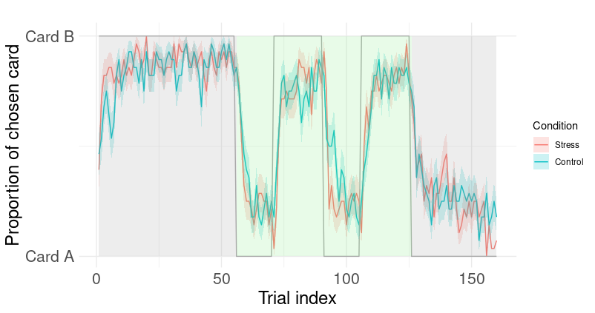

Figure S1. Empirical choice behavior in both conditions (lines showing the mean percentage of chosen card for stress (ST) in red and control (CT) in blue and shaded red and blue areas showing standard errors) with underlying task structure in grey line and shaded areas in grey for stable and light green for volatile phases.

Generalized mixed effects modeling: Odd's ratio

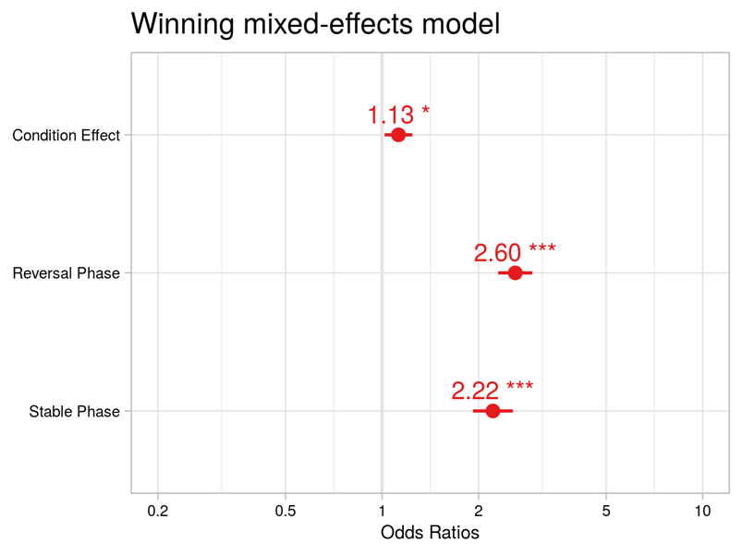

Figure S2a. Odd's Ratio of condition (1.13, CI: 1.02-1.24), reversal phase (2.60, CI: 2.30-2.94) and stable phase (2.22, CI: 1.92-2.56) contrasts from fixed-effects model.

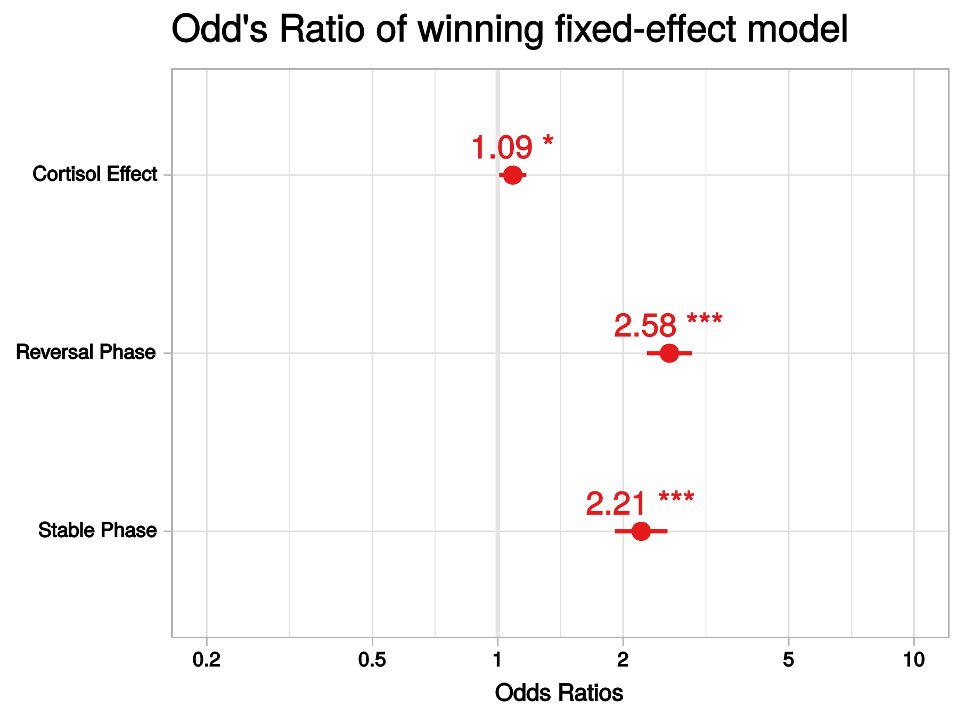

Figure S2b. Odd's Ratio of cortisol (1.09, CI: 1.01-1.17), reversal phase (2.58 CI: 2.28-2.93) and stable phase (2.21, CI: 1.91-2.56) contrasts from fixed-effects model.

Computational modeling: parameter distribution

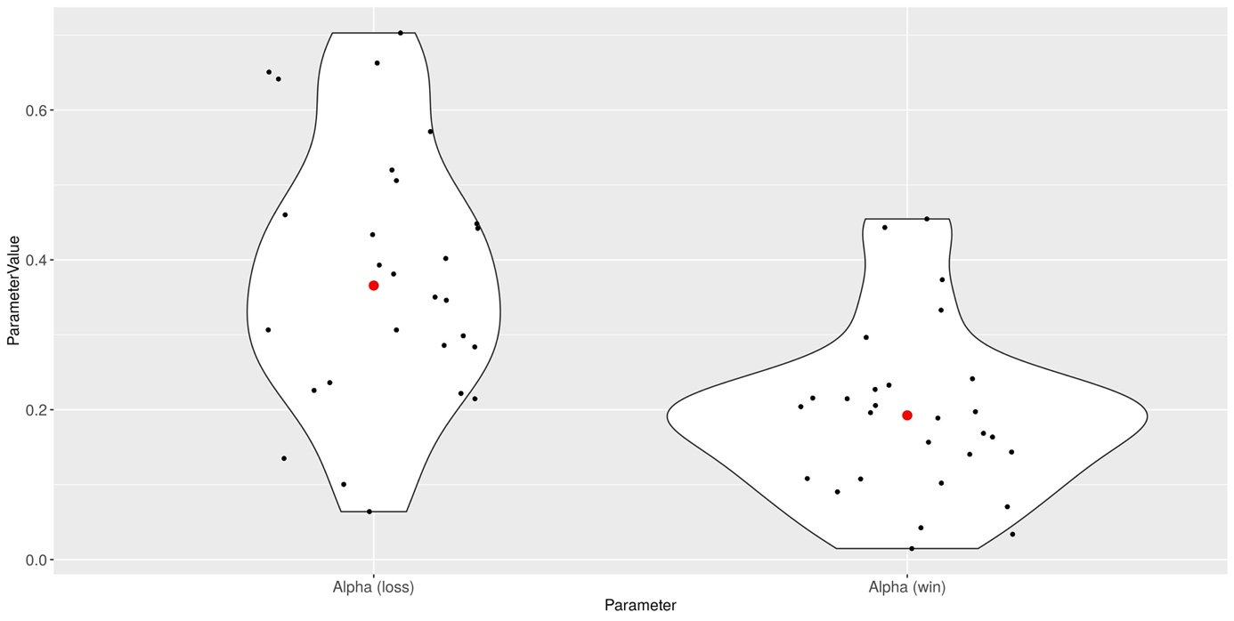

Figure S3. Learning parameter values across all participants (median in red).

Ein Bild, das Text, Karte, verschieden, mehrere enthält.

Figure S4. Choice stochasticity parameter values across all participants (median in red). Control beta refers to the inverse decision temperature resulting from the 'step 1' model space and stress beta refers to the inverse decision temperature resulting from the 'step 2' model space (control beta additive a scaling factor for stress).

Computational modeling: choice stochasticity and behavioral results

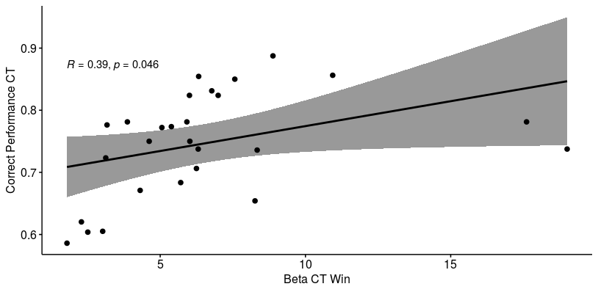

Figure S5. Correlation of $β_{control win}$ and correct performance (%) in the control condition.

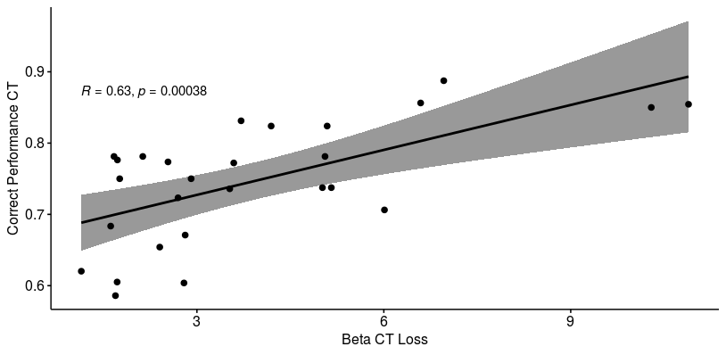

Figure S6. Correlation of $β_{control loss}$ and correct performance (%) in the control condition.

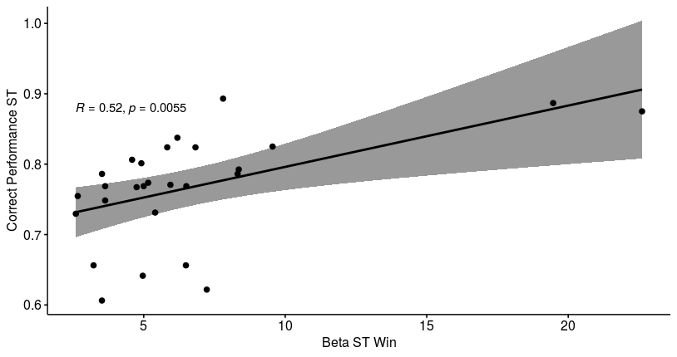

Figure S7. Correlation of $β_{stress win}$ and correct performance (%) in the stress condition.

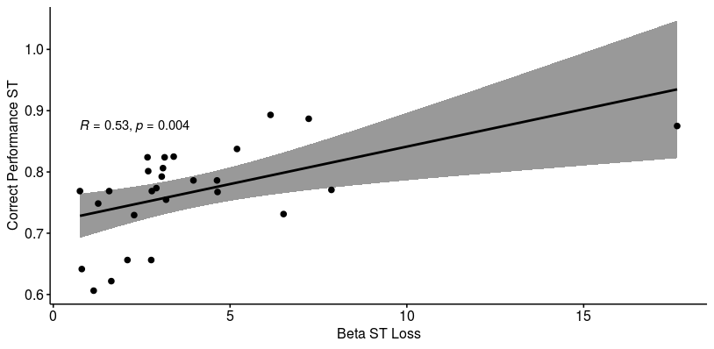

Figure S8. Correlation of $β_{stress loss}$ and correct performance (%) in the stress condition.

fMRI Analyses

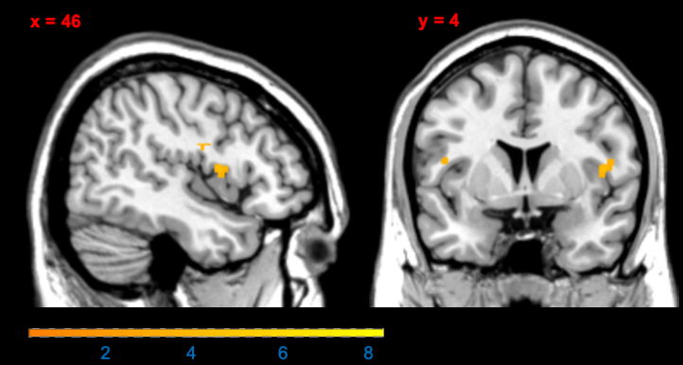

Figure S9: Stronger coding of RPE in right insula during stress compared to control condition (t=4.02, *pFWE SVC for task main effect* = 0.068; displayed at t>3 with cluster extent of 20 voxels for display purposes).

**Supplementary Tables**

Table S-A Multilevel linear modeling results predicting correct responses of the winning model: random-subject intercept, main effect of continuous cortisol response (AUC-G) and phase

|  |  |  |  |  |  |  |  |  |
| --- | --- | --- | --- | --- | --- | --- | --- | --- |
|  |  | | **Correct Responses** | | | | |  |
| **Predictors** | | *Estimate (SE)* | | *CI* | *Z* | *p* | *OR* |  |
| Intercept | | 1.22 (0.07) | | 1.07-1.37 | 16.54 | < 0.001 | 3.39 |  |
| Cortisol Level | | 0.08 (0.04) | | 0.01-0.16 | 2.16 | 0.030 | 1.09 |  |
| Reversal Phase | | 0.95 (0.06) | | 0.83-1.07 | 14.94 | < 0.001 | 2.58 |  |
| Last Stable Phase | | 0.79 (0.07) | | 0.65-0.94 | 10.70 | < 0.001 | 2.21 |  |
| ICC | | 0.04 | |  |  |  |  |  |
| N subject | | 27 | |  |  |  |  |  |
| Observations | | 8578 | |  |  |  |  |  |
| Marginal R2 / Conditional R2 | | 0.053/0.088 | |  |  |  |  |

*Note*. Sample of *n* = 27 due to a missing cortisol value for one subject.

Table S-B Multilevel linear modeling results predicting win-stay behavior of the winning model: random-subject intercept, main effect of condition and phase

|  |  |  |  |  |  |  |  |  |
| --- | --- | --- | --- | --- | --- | --- | --- | --- |
|  |  | | **Win-stay behavior** | | | | |  |
| **Predictors** | | *Estimate (SE)* | | *CI* | *Z* | *p* | *OR* |  |
| Intercept | | 0.44 (0.07) | | 0.30 – 0.59 | 6.23 | < 0.001 | 1.56 |  |
| Condition | | 0.05 (0.04) | | -0.03 – 0.14 | 1.23 | 0.220 | 1.06 |  |
| Reversal Phase | | 0.47 (0.05) | | 0.37 – 0.57 | 9.14 | < 0.001 | 1.59 |  |
| Last Stable Phase | | 0.36 (0.06) | | 0.23 – 0.48 | 5.81 | < 0.001 | 1.43 |  |
| ICC | | 0.04 | |  |  |  |  |  |
| N subject | | 28 | |  |  |  |  |  |
| Observations | | 8837 | |  |  |  |  |  |
| Marginal R2 / Conditional R2 | | 0.013/0.050 | |  |  |  |  |

Table S-C Multilevel linear modeling results predicting lose-switch behavior of the winning model: (random-subject intercept, main effect of condition and phase)

|  |  |  |  |  |  |  |  |  |
| --- | --- | --- | --- | --- | --- | --- | --- | --- |
|  |  | | **Lose-switch behavior** | | | | |  |
| **Predictors** | | *Estimate (SE)* | | *CI* | *Z* | *p* | *OR* |  |
| Intercept | | -1.74 (0.1) | | -1.95 – -1.55 | -17.75 | < 0.001 | 0.17 |  |
| Condition | | -0.02 (0.06) | | -0.14 – 0.1 | -0.34 | 0.734 | 0.98 |  |
| Reversal Phase | | -0.45 (0.07) | | -0.58 – -0.31 | -6.45 | < 0.001 | 0.64 |  |
| Last Stable Phase | | -0.41 (0.08) | | -0.57 – -0.25 | -5.01 | < 0.001 | 0.66 |  |
| ICC | | 0.04 | |  |  |  |  |  |
| N subject | | 28 | |  |  |  |  |  |
| Observations | | 8837 | |  |  |  |  |  |
| Marginal R2 / Conditional R2 | | 0.012/0.079 | |  |  |  |  |

Table S-D Parameter mean estimates of the winning model of ‘step 2 model space’.

|  |  |  |  |
| --- | --- | --- | --- |
| **Variable** | *Median* | *SD* |  |
| 𝛼win | 0.19 | 0.11 |  |
| 𝛼loss | 0.36 | 0.17 |  |
| 𝛽control-win | 6.01 | 3.99 |  |
| 𝛽control-loss | 3.21 | 2.52 |  |
| 𝛽stress−win | 5.61 | 4.68 |  |
| 𝛽stress−loss | 3.08 | 3.33 |  |

Table S-E Main effects of task on RPE representation across conditions

|  |  |  |  |  |  |  |  |  |
| --- | --- | --- | --- | --- | --- | --- | --- | --- |
| **Region** | **Cluster size** | **Side** | **P FWE corrected** | **t-value** | **P uncorrected** | **x** | **y** | **z** |
|  |  |  |  |  |  |  |  |  |
| Middle frontal gyrus | 401 | L | 0.000 | 9.48 | < .001 | 10 | 42 | -12 |
| Middle frontal gyrus |  | R | 0.001 | 8.12 | < .001 | 4 | 40 | -12 |
| ACC pregenual |  | L | 0.004 | 7.44 | < .001 | -2 | 48 | -4 |
| Posterior cingulate cortex | 222 | L | 0.000 | 9.05 | < .001 | -8 | -52 | 32 |
| Precuneus |  | L | 0.001 | 8.27 | < .001 | -2 | -56 | 26 |
| Precuneus |  | L | 0.001 | 8.04 | < .001 | 0 | -56 | 18 |
| Ventral striatum | 16 | R | 0.000 | 8.62 | < .001 | 10 | 2 | -12 |
| Ventral striatum |  | R | 0.005 | 7.29 | < .001 | 10 | 10 | -10 |
| Insula | 56 | L | 0.001 | 8.08 | < .001 | -36 | 2 | 12 |
| Insula |  | L | 0.009 | 7.05 | < .001 | -36 | -6 | 18 |
| IFG pars orbitalis | 39 | L | 0.001 | 8.05 | < .001 | -22 | 32 | -12 |
| Precentral gyrus |  | R | 0.002 | 7.69 | < .001 | 32 | -20 | 58 |
| Superior frontal gyrus |  | L | 0.003 | 7.59 | < .001 | -18 | 38 | 44 |
| Postcentral gyrus | 75 | R | 0.003 | 7.56 | < .001 | 38 | -26 | 46 |
| Postcentral gyrus |  | R | 0.007 | 7.19 | < .001 | 48 | -22 | 60 |
| Postcentral gyrus |  | R | 0.007 | 7.16 | < .001 | 42 | -26 | 54 |
| Rolandic operculum | 11 | R | 0.005 | 7.35 | < .001 | 46 | 2 | 10 |
| Middle cingulate | 11 | R | 0.007 | 7.17 | < .001 | 16 | -14 | 46 |
| Paracentral lobule | 12 | L | 0.010 | 7.00 | < .001 | -4 | -26 | 50 |
| Ventral striatum | 9 | L | 0.010 | 7.00 | < .001 | -10 | -6 | -10 |
| Putamen | 7 | L | 0.010 | 6.99 | < .001 | -32 | -12 | 2 |
| Rolandic operculum | 8 | R | 0.015 | 6.82 | < .001 | 54 | -18 | 20 |
| Postcentral gyrus | 21 | L | 0.015 | 6.81 | < .001 | -34 | -30 | 48 |
| Postcentral gyrus |  | L | 0.022 | 6.62 | < .001 | -44 | -24 | 58 |
| Superior frontal gyrus medial | 7 | L | 0.020 | 6.68 | < .001 | -10 | 60 | 28 |
| Insula | 2 | R | 0.024 | 6.59 | < .001 | 38 | 6 | 12 |
| Postcentral gyrus | 4 | L | 0.024 | 6.57 | < .001 | -46 | -24 | 40 |
| Anterior orbital gyrus | 6 | L | 0.025 | 6.57 | < .001 | -34 | 36 | -14 |
| Precentral gyrus | 9 | L | 0.027 | 6.53 | < .001 | -34 | -18 | 52 |
| SupraMarginal gyrus | 1 | L | 0.035 | 6.40 | < .001 | -60 | -26 | 24 |
| Middle temporal gyrus | 7 | L | 0.036 | 6.39 | < .001 | -58 | -50 | -6 |
| Putamen | 2 | L | 0.037 | 6.38 | < .001 | -30 | -14 | 10 |
| Precentral gyrus | 5 | L | 0.038 | 6.36 | < .001 | -42 | -16 | 56 |
| IFG pars orbitalis | 1 | L | 0.038 | 6.36 | < .001 | -42 | 40 | -12 |
| Postcentral gyrus | 2 | L | 0.046 | 6.27 | < .001 | -54 | -20 | 52 |
| Superior frontal gyrus, medial | 1 | R | 0.047 | 6.27 | < .001 | 4 | 58 | 10 |
| Precentral gyrus | 1 | R | 0.047 | 6.27 | < .001 | 48 | -14 | 54 |
| Posterior orbital gyrus | 1 | R | 0.047 | 6.27 | < .001 | 24 | 32 | -14 |

*Note*. Uncorrected as well as whole-brain corrected fMRI results from the main task effect across conditions in n = 28 participants are illustrated above. Abbreviations: ACC = Anterior cingulate cortex, fMRI = functional magnetic resonance imaging, FWE = family-wise error correction, IFG = inferior frontal gyrus, L = left, R = right.

References

Faul, F., Erdfelder, E., Lang, A.-G., Buchner, A., 2007. G*Power 3: A flexible statistical power analysis program for the social, behavioral, and biomedical sciences. Behav. Res. Methods 39, 175–191. https://doi.org/10.3758/BF03193146

Luettgau, L., Schlagenhauf, F., Sjoerds, Z., 2018. Acute and past subjective stress influence working memory and related neural substrates. Psychoneuroendocrinology 96, 25–34. https://doi.org/10.1016/j.psyneuen.2018.05.036

Schmidt, K.-H., Metzler, P., 1992. Wortschatztest : WST. Beltz, Weinheim.

Shields, G.S., Sazma, M.A., Yonelinas, A.P., 2016. The effects of acute stress on core executive functions: A meta-analysis and comparison with cortisol. Neurosci. Biobehav. Rev. 68, 651–668. https://doi.org/10.1016/j.neubiorev.2016.06.038