**Acute stress alters probabilistic reversal learning in healthy participants**

Lara Wieland1, Claudia Ebrahimi1, Teresa Katthagen1, Martin Panitz2, Lennart Luettgau3, Andreas Heinz1, Florian Schlagenhauf1*, Zsuzsika Sjoerds4* (*shared last author ship)

Affiliations:

1Charité-Universitätsmedizin Berlin, Department of Psychiatry and Neurosciences | CCM, Berlin, Germany

2Max-Planck-Institute for Human Cognitive and Brain Sciences, Leipzig, Germany

3Max Planck University College London Centre for Computational Psychiatry  
and Ageing Research, London, UK

4Cognitive Psychology Unit, Institute of Psychology & Leiden Institute for Brain and Cognition, Leiden University, Leiden, the Netherlands

Corresponding author:

Dr. Zsuzsika Sjoerds

Leiden University, Institute of Psychology

Cognitive Psychology Unit

Wassenaarseweg 52   
 2333 AK Leiden, The Netherlands  
E-mail: z.sjoerds@fsw.leidenuniv.nl

Keywords: Stress, fMRI, cognitive flexibility, reversal learning, decision-making, modeling

Text no. of words:

no. of references: 42

**Abstract** (318 words)

Behavioral adaptation is a fundamental cognitive ability, ensuring an organism’s survival by allowing for flexible adjustment to changing environmental conditions. These adaptive abilities can be measured using reversal learning paradigms requiring agents to adjust their reward learning to sudden changes in stimulus-action-outcome contingencies. Stressful situations have been found to alter flexibility of reward learning, but effects have been mixed, and it remains unclear what neurocomputational mechanisms play a role in this. Here, we employed functional MRI (fMRI) informed by computational modeling parameters in a within-subject design with healthy human volunteers to investigate the effect of acute psychosocial stress on flexible behavioral adaptation. Participants (n=28) underwent fMRI during a reversal learning task, once after the Trier Social Stress Test (TSST), a validated psychosocial stress induction method, and once after a control condition, in two separate sessions. During the task, participants chose between two stimuli with anti-correlated reward contingencies in order to obtain probabilistic rewards in three phases. Effects of stress on choice behavior were investigated using multilevel generalized linear models and a set of computational models describing different learning processes that might have generated the data. Computational models were fitted using a hierarchical Bayesian approach, and model-derived reward prediction errors (RPE) were used as regressors for fMRI analyses. We found that acute psychosocial stress significantly albeit subtly increased correct response rates in our participants. Behavioral responses were best captured by a model including a main effect of stress and experimental phase and allowing for interindividually different average learning performance. Model comparison revealed that a Rescorla-Wagner model with individual scaling of the inverse decision temperature parameter best explained the observed behavior under stress. On the neural level, RPE signals were coded in striatum and vmPFC. No whole-brain correctable effects of stress on RPE representations were found. Our study shows that acute psychosocial stress has an impact on reversal learning with high interindividual variability. Future studies could use more fine-grained measures to disentangle different types of learning and their neural counterparts.

**1. Background** (890 words)

Humans and other agents are routinely confronted with decision-making situations under stress, for example when choosing an efficient and cheap way of commuting to work, despite running late. Different choice options, such as taking the car, bike or train, are associated with relatively stable and predictable levels of cost and reward. In contrast, the weather forecast of the day, a congestion on the preferred route or a train delay, are more volatile, less predictable factors. Both, stable and volatile factors interact, in that cycling to work may be rewarding in sunny weather but not on a rainy day. Stress impacts individuals' emotions, mood, physiological responses and may affect their cognitive processing resources, influencing their decision-making strategies. This might especially be relevant in situations that afford high behavioral flexibility, for instance in constantly changing environments. Stress is also an important factor in causing and maintaining psychiatric conditions (McEwen, 2004) and health-related behavior in general (Cohen et al., 2016). Therefore, the development of a model of how stress affects choice behavior in healthy individuals is pivotal for a mechanistic understanding of maladaptive behavior from daily mistakes to psychiatric disorders. So far, small sample sizes, heterogenous subdomains in the operationalization of decision-making, and methodological considerations with regard to the type of stressor have complicated the picture of these underlying mechanisms (Porcelli and Delgado, 2017).

In operationalizing decision-making under stress, it is crucial to evaluate which behavior constitutes flexible decision-making in different paradigms. Flexible decision-making requires one to learn what is most rewarding in the current environment and adapt one's decision-making to that. Studies have found mixed results for the influence of stress on decision-making, ranging from beneficial to detrimental effects across paradigms (Goldfarb et al., 2015; Plessow et al., 2012, 2011). In a meta-analysis, acute stress showed small negative impact for tasks in which reward seeking and risk taking is disadvantageous (*d* = .26 and *d* = .44), but showed no effect if this was not the case (Starcke and Brand, 2016). Similarly, a meta-analysis investigating the effects of acute stress on cognitive flexibility in a smaller study concluded that stress had an impairing effect (*g*+= -.30) (Shields et al., 2016). Different learning processes are presumably differentially prone to interruption by stress (Schwabe and Wolf, 2011, 2009). Whereas habitual learning relies on simple stimulus-related associations, goal-directed learning associates actions with a motivational value and is therefore more flexible but also computationally more costly. It has been found that acute and chronic stress disrupt goal-directed learning, while habitual learning appears unaffected at the behavioral as well as neural level (Schwabe et al., 2013, 2008). One possible explanation for the variable findings are different types of standardized stressors, which are commonly used in behavioral experiments. They can be physiological as in the Cold Pressor Task, psychosocial as in the Trier Social Stress Test (TSST) or both as in the Socially Evaluated Cold Pressor Test (Starcke and Brand, 2016). The physiological paradigms lead to more immediate stress during learning, whereas the psychosocial paradigms release their full physiological effect 10-20 minutes after stress induction. Another explanation for the inconsistent meta-analytical findings could lie in how cognitive flexibility was measured. Both meta-analyses predominantly focused on classical paradigms such as the Wisconsin card sorting test or task-switching tests. While providing valuable insight into overall cognitive flexibility, these paradigms mostly rely on averaged outcome measures. In contrast, tasks designed for computational modeling may provide a more fine-grained measure of behavioral adaptation. In the last decade computational approaches were combined with cognitive neuroscience to study cognitive control and decision-making and gained traction in clinical application (Huys et al., 2016; Maia and Frank, 2011). Another understudied subject remains how the brain adapts to learning from rewards in an uncertain environment under stress. Probabilistic reversal learning requires participants to choose between stimuli with varying reward contingencies. In these paradigms contingencies are reversed several times throughout the task unannounced and therefore demand behavioral adaptation to a volatile environment. A computational mechanism underlying the putative learning process can be formalized by the reward prediction error (RPE), a computational quantity derived from the reinforcement learning (RL) framework. RPEs signal the difference between an observed and expected reward (Dolan and Dayan, 2013) and are used to update the value of a stimulus, a state, or an action. Due to the probabilistic nature of reversal learning tasks, an ideal observer would stay with an advantageous option, despite experiencing occasional negative RPEs. However, an ideal agent would switch choices away from disadvantageous options despite occasional wins and the resulting positive RPE. The neural signature of RPE during reversal learning is reliably found in the human ventral frontostriatal circuitry (Doherty et al., 2003).

Most previous studies on stress effects on decision-making have employed between-subject designs – but subjects vary drastically in both individual stress responses, choice behavior and how stress affects performance. In the previously used between-subjects studies it thus remains unclear, how much of stress-related changes to the neural correlates of probabilistic reversal learning can be attributed to the stressor and how much may be related to interindividual differences in stress reactivity. The few studies using within-subject designs (Radenbach et al., 2015a) to investigate learning, are either purely behavioral or employ electroencephalography, lacking the possibility of precise spatial signal localization (Cavanagh et al., 2011) and anatomical specificity with respect to the neural representation of RPE signals. Additionally, few studies in the realm of cognitive flexibility use computational modeling to elucidate underlying cognitive mechanisms. Applying a state-of-the-art hierarchical Bayesian modeling approach (Piray et al., 2019), allowed us to model the impact of stress on behavioral adaptation using a probabilistic reversal paradigm in a within-subjects design. A design that, to the best of our knowledge had not been used for investigation before.

**2. Methods** (1763 words)

2.1. Study Design:

Employing a within-subject design, 38 healthy adult participants (n=28 in the final analyzed sample) performed a probabilistic reversal learning task during fMRI in two separate sessions seven days apart. Procedures and materials are identical with data previously published using another paradigm (Luettgau et al., 2018). During the stress condition, participants were exposed to a mock interview and calculus in front of a socially unresponsive committee in white lab coats, following the standardized Trier Social Stress Test (TSST) protocol (Kirschbaum et al., 1993). During the control condition participants read a neutral text without presence of the committee. Session type (stress vs. control) was counter-balanced across participants. In order to prevent confounding effects of circadian rhythm on cortisol levels (Kudielka et al., 2004) both experimental sessions were scheduled at exactly the same time of the day. Acute stress response was assessed at physiological (cortisol) and subjective (self-report) level at six time points throughout the session (see Figure 3).

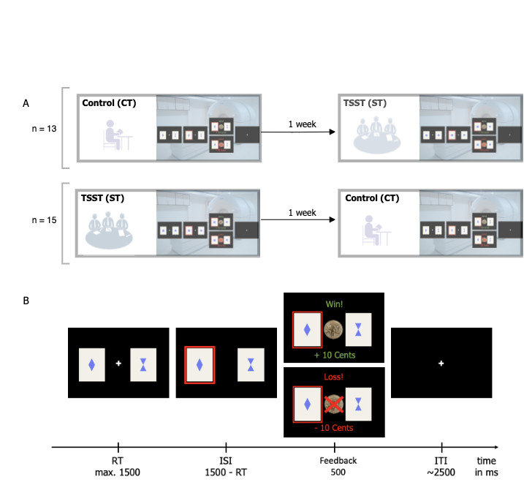

Figure 1 Study design (A) and task design (B)

2.2. Physiological stress response:

We assessed physiological stress response via salivary cortisol, which were assessed six times throughout the experiment at the following time points relative to the start of intervention (stress or control): t1: -30 minutes; t2: -2 minutes; t3: +10 minutes; t4: +15 minutes; t5: +30 minutes; t6: +45 minutes (Luettgau et al., 2018). For collection and extraction of saliva we used Salivette saliva sampling tubes (SalivetteCortisol®, Sarstedt, Nuembrecht, Germany) (see Supplement). Individual cortisol reactivity was determined by calculating the area under the curve with respect to ground (AUCg-stress and AUCg-control, according to Pruessner et al., 2003) separately for both conditions and subtracting AUCg-control from AUCg-stress. The AUC was calculated based on individualized subject wise time points, taking into account slight temporal dispersion in the testing protocol. For an additional analysis to confirm stress reactivity please refer to the supplement (subsection: physiological stress response).

2.3. Subjective stress response:

Three different visual analogue scales (VAS) ranging from 0 to 100 were used to assess subjective arousal, valence and stress at all time points (T1-T6). Participants were asked to rate how they felt, regarding arousal on a scale "Please rate your current state" from 0 (sleepy) to 100 (active), valence on a scale from 0 (unhappy) to 100 (happy) and stress on a scale from 0 (not stressed) to 100 (stressed). Analogue to cortisol values this was determined by calculating the area under the curve with respect to ground (AUCg-stress and AUCg-control, according to Pruessner et al., 2003) separately for both conditions and subtracting AUCg-control from AUCg-stress.

2.4. Task Design

Participants performed a probabilistic reversal learning task, which included 160 trials and comprised around 15 minutes. The task (Boehme et al., 2015; Andrea M.F. Reiter et al., 2016)was programmed in Matlab (The MathWorks, Natick, MA) with Psychtoolbox . On every trial, participants had to decide between two cards, depicting a different geometric figure. The underlying reward structure was not explicitly instructed but could be inferred: reward probabilities associated with the two choice options were anticorrelated (i.e. whenever card A was rewarded, card B was punished and vice versa). Furthermore, participants were informed on the probabilistic nature of the task: the respective winning card was only rewarded in 80% of all trials. Right-side versus left-side location of the stimulus was randomized on each trial. After a fixed number of 55 trials, contingencies reversed and these reversals repeated over the middle experimental phase (see Figure 2). Participants were instructed to win as much money as possible and received a monetary bonus at the end of the experiment. Participants in both groups were matched on differences in proportion of the number of informative and misleading events between the two sessions because feedback was drawn probabilistically.

Due to a technical error in the task script, 8 participants had to be excluded from the final sample. Additionally, one participant had to be excluded due to lack of MRI data. Furthermore, one participant had to be excluded because they performed the task below chance level, leaving a total of 28 participants for final analyses.

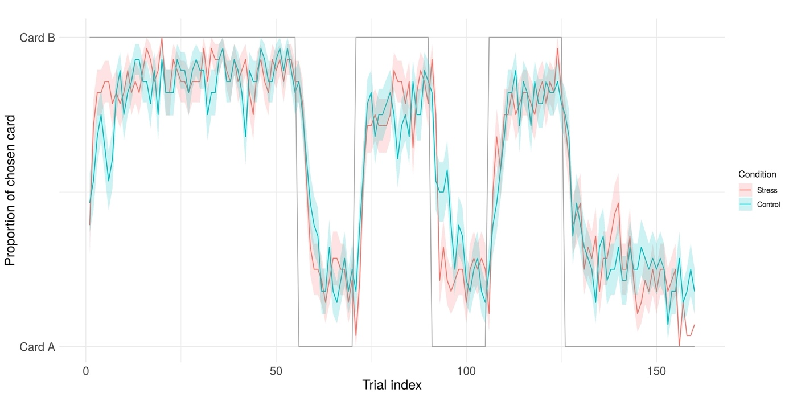

Figure 2 Empirical average choice behavior across trials for stress (COLOR) and control (COLOR) condition. The underlying task structure(i.e., xxx) is depicted in grey.

2.5. Analyses

*2.5.1. Stress response analyses*

Cortisol responses (AUC-g) and the three subjective VAS scales were compared across conditions (stress vs control) using one-tailed paired-sample *t*-tests at a significance level of p < .05.

*2.5.2. Behavioral data*

Single-trial multilevel linear model (logistic regressions) were conducted using the lme4 package (Bates et al., 2015) in R (Version 3.1.X). Parameter estimates were considered significant at p≤.05. We analyzed trial-by-trial correct responses (chose better option), win-stay (select same stimulus after win) and lose-switch (switch stimulus after loss) behavior with factors *stress condition* (CT vs. ST, effect coding as -0.5 and 0.5) and *experimental phase* (pre, reversal, post) as fixed effects, allowing for an individually varying intercept per subject. For the factor *experimental phase* we specified a custom centered contrast, testing the null hypothesis of performance differences between first stable vs. reversal and late stable vs. reversal phase using the hypr package (Rabe et al., 2020). Main effects of condition and phase, as well as an interaction effect were added incrementally in two steps. We used the Akaike information criterion (AIC) and Bayesian information criterion (BIC) to compare the models to a null model, which predicted outcome variables with the individually varying intercept per subject only. For the best-fitting model, the parameter estimates’ odd's ratio was computed to assess effect size. Additionally, we performed the same analysis using the cortisol AUC-g values instead of condition labels as predictor. Participants were excluded when their performance was below chance (correct responses < 50%). This was the case for one participant. Across all trials, participants missed a relatively low number of trials (0.71%).   
Furthermore, as an exploratory analysis we dichotomized the sample into improved vs. impaired performance (percentage of correct responses) and conduced an independent t-test with chronic stress exposure, as well as working memory performance between both groups.

*2.5.3 Computational models*

In order to describe different learning processes that might have generated the data under stress and control condition we followed a two-step procedure: First, we fit our model space to the behavioral data of the control condition. Then, the best fitting model from the control condition was used for modelling behavior under stress now with additional ‘stress weights’ on the free parameters. The model space comprised Rescorla-Wagner (RW), Pearce-Hall (PH; Diederen et al., 2016) models and a null model (no-learning). In the RW and PH models, the expected value of an action at trial is updated via the RPE (eq. 1), which is defined as the difference between received reward and previously expected reward value for the chosen stimulus (eq. 2):

In RW models, we accounted for learning about the unchosen option as indicated by the implicit anti-correlated task structure in different sub-models (eq. 3,for single update (SU), for full double update (DU) and freely fitted for individually weighted double update (iDU)). We further varied whether learning rates differed for wins and losses. The PH model encompasses eq. 1 and 2 with a dynamic learning rate depending on a decay over time as and the absolute prediction error (see Supplement or Diederen et al., 2016). In the no-learning model, a stable bias towards one of the stimuli was implemented (Supplement). For all learning models, trial-wise Q-action values are transformed into choice probabilities by a softmax response model with different inverse decision noise temperatures following wins and losses:

The free softmax temperature parameter reflects choice stochasticity with higher values equating more deterministic and lower values equating more stochastic choices. Taken together, the ‘step 1 model space’ consisted of 8 models for learning under the control condition: RW-SU-1al, RW-SU-2al, RW-DU-1al, RW-DU-2al, RW-iDU-1al, RW-iDU-1al, PH and no-learning. We applied Bayesian model comparison (Piray et al., 2020) to find out which of these models explained the data best (see protected exceedance probabilities (PXP) in Figure X).

To model learning under the stress condition, we added stress weights to the free parameters of the best-fitting model from the first step (RW-DU-2al). The ‘step 2 model space’ included the DU-2al model without stress effects (RW-DU-2al-NoStress), one with stress weights affecting only the learning parameters and (RW-DU-2al-StressLearning) one model with stress only affecting the temperature parameters and , (RW-DU-2al-StressBetas) and a full model with stress affecting all free parameter (RW-DU-2al-StressAll). This model space was fitted to combined data from both conditions: trials were concatenated across control and stress conditions within subjects, with the free stress parameters quantifying the additive effect on the respective parameters for the trials of the stress condition (see Supplement). As in step 1, model fits were then compared between models.

*2.5.4. Model fitting*

Models from both steps were fitted under the hierarchical Bayesian inference approach as implemented in the cbm toolbox (Piray et al., 2020) run in in Matlab R2018a. This procedure allowed for concurrent model comparison and parameter estimation. Thereby, the latter also follows a mixed effects approach: the group mean parameter affects individual parameter estimation and vice versa, but the relationship is scaled by how (relatively) well the model explains the individual subject’s behavior.

*2.5.5. fMRI data*

Scans were acquired on a Siemens 3 T high-resolution PRISMA MR-System with a 20-channel head coil (Siemens, Erlangen, Germany). Covering the whole brain, 40 slices were acquired in oblique orientation at 20° to the anterior commissure-posterior commissure line and in ascending order with the following parameters: T2*-weighted gradient-echo echo-planar imaging (EPI) (TR: 2.09 s; TE: 22 ms; flip angle: 90°; 3 × 3 mm2 in-plane voxel resolution, 0.5 mm gap between slices, voxel size, 3 × 3 × 5 mm). The scanning procedure further comprised a T1-weighted MPRAGE recorded within seven days before the first test session, and a field map to account for individual homogeneity differences of the magnetic field. Functional imaging data analyses were performed using SPM12 in Matlab.

On the first, individual subject level the feedback onsets were modeled with the reward prediction errors (RPE) included as parametric modulator. The six realignment parameters, the derivative of the translation parameters and a dummy regressor for scans with excessive motion were added as further nuisance regressors. The stress and control condition were modeled separately.

Contrast images were computed for the RPE for the control and stress condition and subsequently submitted to random-effects group statistics (second level). A paired t-test was used to compare activation between conditions (stress/control). To control for multiple comparisons, family-wise error correction (*pFWE*) was applied at the whole-brain level and for the condition effect using a mask of the RPE main effect over both conditions at pFWE<0.05.

The association of RPE BOLD signal with behavioral learning performance was tested as follows: A flexible factorial design was used with condition (stress/control) as within-subject factor and learning (median split on percentage of correct responses resulting in two groups: improved vs. impaired learners under stress) and subject as random effect (see Supplement: Exploratory fMRI analyses).

**3. Results**

3.1. Sample characteristics

The final sample consisted of n = 28 healthy male adult human participants with a mean age of 26.9 (*SD* = 5.7), a mean of 12.2 (*SD* = 1.2) educational years, and a mean verbal intelligence of 103.8 (*SD* = 10.1).

3.2. Physiological and subjective results

The stress intervention significantly increased subjective stress response (arousal, valence and subjective stress), as well as physiological response (cortisol levels). For detailed statistics refer to the supplement and Figure 3.

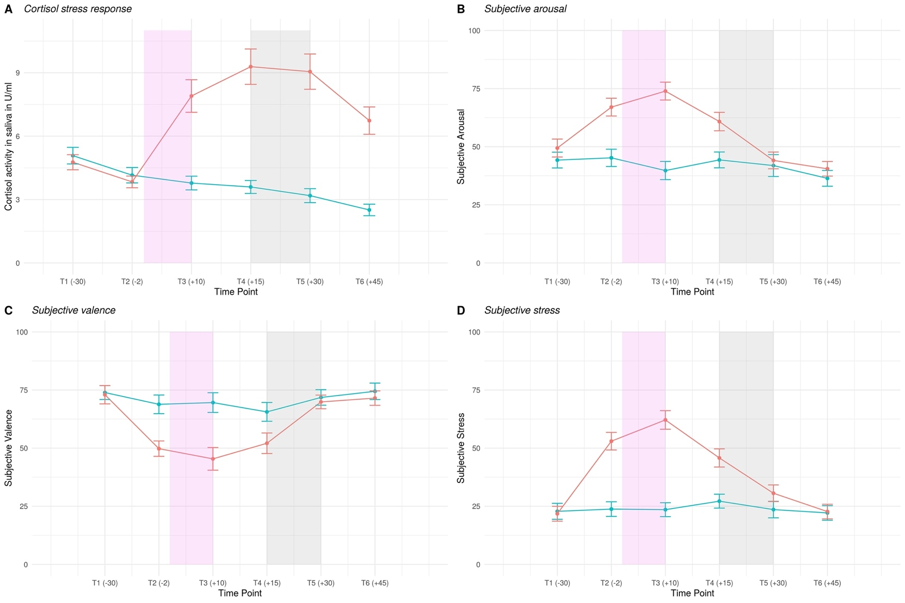

Figure 3 Physiological (cortisol) (A) and subjective stress response (B-D) over the course of the session. Violet shaded area: period of intervention (either stress induction (TSST) or control intervention), grey shaded area: reversal learning task was administered in the MR scanner.

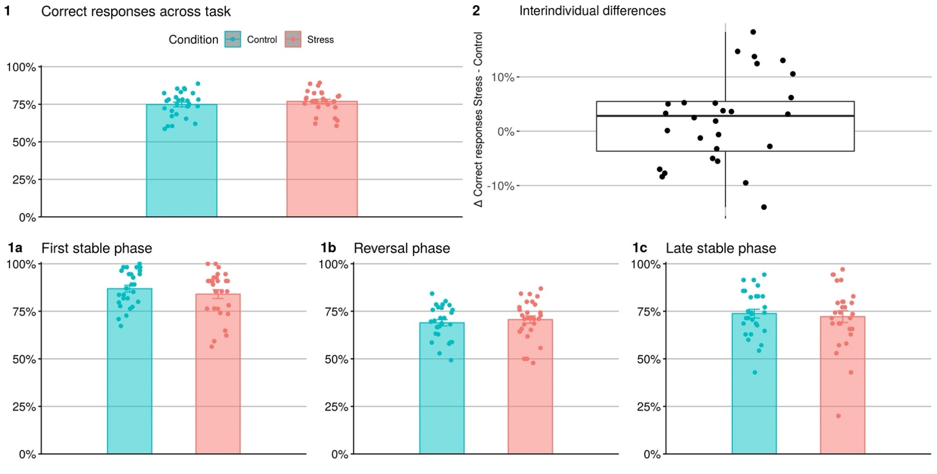

Figure 4 Correct responses across task (1), as well as phases (1a-c) and interindividual differences between conditions (2)

3.3. Behavioral results (690 words)

Best-fitting multilevel linear modeling included a random-subject intercept, as well as a main effect of condition and phase. Predicting correct responses on a single-trial basis with multilevel linear modeling indicated the expected task effect under reversal (*p* < 0.001) and in the second stable phase (*p* < 0.001). For both phases, correct responses decreased with respect to the first reference phase. Furthermore, there was a main effect of condition (*p* = 0.020), suggesting that participants' correct responses subtly increased with a 1.13 higher chance for correct responses under stress (see Table 1 and Supplement: Figure S1). As becomes apparent in Figure 4.2 the effects of stress on correct responses were quite heterogenous with high interindividual variability. These results were supported by a significant main effect (*p* = 0.030) of stress when physiological stress level (AUC) was used as a continuous predictor instead of experimental condition (see Supplementary Table S-A). In this model, task effects were again significant for the reversal phase (*p* < 0.001) as well as the stable phase (*p* < 0.001).   
Regarding win-stay behavior, best-fitting multilevel linear modeling included a random-subject intercept, as well as a main effect of condition and phase. Task effects of reversal phase (*p* < 0.001) and stable phase (*p* < 0.001) were significant, but not experimental condition (*p* = 0.22). Similarly, lose-switch behavior resulted in significant task effects of reversal phase (*p* < 0.001) and stable phase (*p* < 0.001), but not experimental condition (*p* = 0.73) (see Supplementary Tables S-B and S-C).

Table 1 Multilevel linear modeling results of the winning model predicting correct responses

|  |  |  |  |  |  |  |  |  |
| --- | --- | --- | --- | --- | --- | --- | --- | --- |
|  |  | | **Correct Responses** | | | | |  |
| **Predictors** | | *Estimate (SE)* | | *CI* | *Z* | *p* | *OR* |  |
| Intercept | | 1.23 (0.07) | | 1.08-1.38 | 17.13 | < 0.001 |  |  |
| Condition | | 0.12 (0.05) | | 0.01-0.22 | 2.32 | 0.020 | 1.13 |  |
| Reversal Phase | | 0.96 (0.06) | | 0.83-1.07 | 15.27 | < 0.001 | 2.6 |  |
| Stable Phase | | 0.8 (0.07) | | 0.65-0.94 | 10.89 | < 0.001 | 2.22 |  |
| ICC | | 0.04 | |  |  |  |  |  |
| N subject | | 28 | |  |  |  |  |  |
| Observations | | 8893 | |  |  |  |  |  |
| Marginal R2 / Conditional R2 | | 0.053/0.088 | |  |  |  |  |

3.4. Computational modeling results

Behavior in the control condition (‘step 1 model space’) was best explained by the RW-DU-2al model across all participants with a PXP = 0.62 (see Figure 6). This indicates that participants used the anticorrelated task structure and updated the chosen and the unchosen choice option to a similar extent (full double update model). Furthermore, the learning rate in win trials was lower than in loss trials (paired t-test on alpha win vs alpha loss: *t(*27) = -6.7, *p* < 0.001), resulting in stronger influence of RPEs in loss compared to win trials. In a next step, additional free parameters for potential stress effects were entered for this winning model (the ‘step 2 model space’). This resulted in a best fit for RW-DU-2al-StressBetas (PXP = 0.92), indicating that only the temperature parameter and were different between control and stress condition but not the learning rates (see Table 2 for parameter estimates and Figure S3 and S4 for violin plots of parameter distributions). Model selection resulted in protected exceedance probabilities (PXP) < 0.1 for all other models (see Figure 6). Choice temperature parameters were significantly higher after win trials compared to loss trials F(1,27)= 22.77, *p* < .001 and numerically higher during the control compared to the stress condition, although the latter effect was not significant F(1, 27) = 0.25, *p* = .623. We observed a large interindividual variance for the beta parameters.

Table 2 Parameter mean estimates of the winning model of ‘step 2 model space’.

|  |  |  |  |
| --- | --- | --- | --- |
| **Variable** | *M* | *SD* |  |
|  | 0.19 | 0.11 |  |
|  | 0.36 | 0.17 |  |
|  | 6.01 | 3.99 |  |
|  | 3.21 | 2.52 |  |
|  | 5.61 | 4.68 |  |
|  | 3.08 | 3.33 |  |



Figure 5 Protected exceedance probability - 'step 1' model space explaining behavior in the control condition (top) and 'step 2' model space with added free stress parameters to the best fitting model of the control condition in order to detect stress-related parameter differences between control and stress condition (bottom).

fMRI results

We found a main effect of RPE combined over both conditions in the vmPFC, bilateral striatum, posterior cingulate cortex (PCC) and bilateral insula (*pFWE* < .05 for the whole brain, see Figure 6 and Supplementary Table S-D). Comparing stress and control condition revealed a higher activation in right insula during stress compared to control condition, which was trendwise correctable for the task main effect ([46 4 10], *t* = 4.02, *pFWE* = .068, see Figure 7). The opposite contrast CT>ST did not result in significant activation.

Figure 6: Main task effect

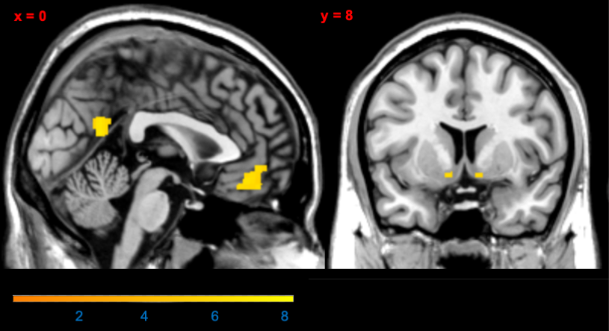

Figure 7: Insula



Exploratory analysis of moderator variables:

Regarding potential moderator variables such as chronic stress exposure as well as working memory performance there were no significant differences between the group of participants who improved their performance and the group of participants who was impaired under stress.

**Discussion** (820 words)

The present study investigated the behavioral and neural effects of acute psychosocial stress on reversal learning. In healthy male human participants, we found that probabilistic reversal learning improves slightly under acute psychosocial stress. Win-stay, as well as lose-switch behavior was not affected. Choice behavior under stress was best explained by a model with altered choice stochasticity but unchanged learning rate under stress. Neurally, a network of vmPFC, bilateral ventral striatum, posterior cingulate cortex and insula represented reward-based learning across conditions with no whole-brain correctable effect of stress.

The existing literature on decision-making is unclear regarding the directional impact of stress on learning. While meta-analyses on older studies found that stress slightly impairs learning (Shields et al., 2016; Starcke and Brand, 2016), other studies using cognitive computational modeling found a shift in the balance of model-free and model-based learning (Cremer et al., 2021; Otto et al., 2013; Raio et al., 2020). However, our probabilistic reversal learning paradigm may not be suited to disentangle both types of learning. This could be one reason for a lack of stronger effects in our study. In rodents acute stress improved reversal learning whereas chronic stress impaired reversal learning (Bryce et al., 2013; Hurtubise et al., 2017). Differential long-term stress exposure may have lead to the heterogenous effects of stress on reversal learning in our sample.

Our neural findings on activated regions in this task are in line with previous studies using the same paradigm (Katthagen et al., 2020; Andrea M.F. Reiter et al., 2016; Reiter et al., 2017). With regards to computational strategies in this task learners could either use simple RL to update values of their chosen stimulus or use more complex Markov models, which take the anti-correlated task structure into account. The latter would enable them to track the hidden state of the task, i.e. which stimulus is rewarding at the moment. They could then update the choice values of the unobserved stimulus after receiving feedback on the observed stimulus. Investigating probabilistic reversal learning in healthy participants showed that they were able to exploit the higher-order task structure and that the vmPFC was a key region for that (Hampton et al., 2006). This region was also differentially activated in our study, depending on improved or impaired task performance under stress. This indicates that future studies should always consider interindividual differences in the reactivity to stress. The fact that we did not find whole-brain correctable effect of stress may be related to the low effect size of the behavioral stress effects uncovered by multilevel linear modeling as well as computational modeling.

**Moderator variables**

A further potential explanation for the inconsistent impact of acute stress on learning are moderating variables, such as cognitive capacities, personality traits or chronic stress exposure. For instance, a high working memory capacity seems to hold a protective function against the attenuation of model-based learning (Otto et al., 2013), while trait impulsivity interacts with different aspects of learning differentially, but particularly seems to increase perseveration (Raio et al., 2017). Chronic stress increased the detrimental influence of acute stress on model-based learning (Radenbach et al., 2015b). As probabilistic reversal learning does not disentangle model-based and model-free learning these effects of moderators were difficult to replicate here. Exploratory analyses on working memory capacity and chronic stress exposure did not have an effect on stress in our sample.

**Limitations**

Considering the gender differences in decision-making (Shields et al., 2016) which may be amplified by stress (Mather and Lighthall, 2012) and potential impact of cyclical changes in female individuals we decided to investigate an exclusively male sample. Furthermore, our sample was homogenously young and highly educated. Therefore, our findings cannot be generalized to the general population or patient samples. Our task does not allow to temporally disentangle value and RPE representations in the brain. Dissociating these computations might be a promising avenue for future studies to determine the neurocomputational processes underlying reversal learning performance increases under acute stress.

While healthy individuals can adapt to a certain level of stress and even find it beneficial (Lighthall et al., 2013), decision-making frequently goes awry in psychiatric disorders (Cáceda et al., 2014; Voon et al., 2017).Our results suggest that it might be worthwhile assessing decision-making under acute stress in populations at risk of developing psychiatric conditions to reveal how stress is involved in maladaptive decision-making. Identification of altered choice behavior and relevant neural networks in healthy individuals make it possible to disentangle how stress affects healthy decision-making and what might be a maladaptive psychiatric alteration. As an operationalization of cognitive flexibility, reversal learning is a construct with high relevance for several psychiatric disorders. For instance, in patients with alcohol use disorder (Andrea M F Reiter et al., 2016), anorexia nervosa (Bernardoni et al., 2017), binge-eating disorder (Reiter et al., 2017), ADHD (Hauser et al., 2021) or schizophrenia (Katthagen et al., 2020) cognitive flexibility and its neural correlates are impaired.

**Conclusion**

Our study combines the advantages of a within-subject design and fine-grained computational measures to investigate the effect of acute psychosocial stress on healthy male adults. Several lines of analysis showed altered choice stochasticity and slightly improved performance under stress, with no whole-brain-correctable neural effects of stress.

**Funding**

This work was supported by the Rubicon award granted to ZS by the Netherlands Organization for Scientific Research (NWO, Rubicon 2014/05563/ALW), by the Einstein Center for Neurosciences (LW), and by the Heisenberg program from the German Research Foundation (grant number SCHL 1969/1-2/3-1/5-1), as well as the Max Planck Society and grants from the German Research Foundation awarded to FS (DFG SCHL 1969/2-2 as part of FOR1617 and SCHL1969/4-1). (FS),

**Acknowledgements**

We thank all the authors contacted who provided additional information. The authors would like to thank all volunteers who participated in this study. The authors would also like to thank C. Edwards, K. Hudl, L. Golz, M. Panitz, M. Jochemko, A. Kummer, N. Pampus, J. Lepsien, A. Pampel, T. Schlumm, S. Thiers, C. Backhauß, M. Falk, and L. Fisher for their valuable assistance in recruitment and data acquisition throughout the study.

**Disclosure Statement**

The authors have declared that there are no conflicts of interest in relation to the subject of this study.

**Data availability**

Data and analysis scripts are available via https://github.com/agschlagenhauf/SALAD

**Author Contributions**

ZS, FS; Conceptualization.   
LL, ZS; Data curation.  
LW, CE, TK, FS; Formal analysis.   
LW; Roles/Writing - original draft.  
CE, TK, ZS, FS, LL, MP, AH; Writing - review & editing.

**References**

Bates, D., Mächler, M., Bolker, B.M., Walker, S.C., 2015. Fitting linear mixed-effects models using lme4. J. Stat. Softw. 67. https://doi.org/10.18637/jss.v067.i01

Bernardoni, F., Geisler, D., King, J.A., Ritschel, F., Murr, J., Reiter, A.M.F., Smolka, M.N., Kiebel, S., Ehrlich, S., 2017. Altered medial frontal feedback learning signals in anorexia nervosa. Biol. Psychiatry. https://doi.org/10.1016/j.biopsych.2017.07.024

Boehme, R., Deserno, L., Gleich, T., Katthagen, T., Pankow, A., Behr, J., Buchert, R., Roiser, J.P., Heinz, A., Schlagenhauf, F., 2015. Aberrant salience is related to reduced reinforcement learning signals and elevated dopamine synthesis capacity in healthy adults. J. Neurosci. 35, 10103–10111. https://doi.org/10.1523/JNEUROSCI.0805-15.2015

Cáceda, R., Nemeroff, C.B., Harvey, P.D., 2014. Toward an understanding of decision making in severe mental illness. J. Neuropsychiatry Clin. Neurosci. 26, 196–213. https://doi.org/10.1176/appi.neuropsych.12110268

Cavanagh, J.F., Frank, M.J., Allen, J.J.B., 2011. Social stress reactivity alters reward and punishment learning. Soc. Cogn. Affect. Neurosci. 6, 311–320. https://doi.org/10.1093/scan/nsq041

Cohen, S., Gianaros, P.J., Manuck, S.B., 2016. A Stage Model of Stress and Disease. Perspect. Psychol. Sci. 11, 456–463. https://doi.org/10.1177/1745691616646305

Cremer, A., Kalbe, F., Gläscher, J., Schwabe, L., 2021. NeuroImage Stress reduces both model-based and model-free neural computations during flexible learning. Neuroimage 229, 117747. https://doi.org/10.1016/j.neuroimage.2021.117747

Doherty, J.P.O., Dayan, P., Friston, K., Critchley, H., Dolan, R.J., 2003. Temporal Difference Models and Reward-Related Learning in the Human Brain 28, 329–337.

Dolan, R.J., Dayan, P., 2013. Review Goals and Habits in the Brain. Neuron 80, 312–325. https://doi.org/10.1016/j.neuron.2013.09.007

Goldfarb, E. V, Froböse, M.I., Cools, R., Phelps, E.A., 2015. Stress and Cognitive Flexibility : Cortisol Increases Are Associated with Enhanced Updating but Impaired Switching 14–24. https://doi.org/10.1162/jocn

Hampton, A.N., Bossaerts, P., Doherty, J.P.O., 2006. The Role of the Ventromedial Prefrontal Cortex in Abstract State-Based Inference during Decision Making in Humans 26, 8360–8367. https://doi.org/10.1523/JNEUROSCI.1010-06.2006

Hauser, T.U., Iannaccone, R., Ball, J., Mathys, C., Brandeis, D., Walitza, S., Brem, S., 2021. Role of the Medial Prefrontal Cortex in Impaired Decision Making in Juvenile Attention-Deficit/Hyperactivity Disorder 71, 1165–1173. https://doi.org/10.1001/jamapsychiatry.2014.1093

Huys, Q.J.M., Maia, T. V., Frank, M.J., 2016. Computational psychiatry as a bridge from neuroscience to clinical applications. Nat. Neurosci. 19, 404–413. https://doi.org/10.1038/nn.4238

Katthagen, T., Kaminski, J., Heinz, A., Buchert, R., Schlagenhauf, F., 2020. Striatal Dopamine and Reward Prediction Error Signaling in Unmedicated Schizophrenia Patients. Schizophr. Bull. 46, 1535–1546. https://doi.org/10.1093/schbul/sbaa055

Kirschbaum, C., Pirke, K.-M., Hellhammer, D.H., 1993. The ‘Trier Social Stress Test’ – A Tool for Investigating Psychobiological Stress Responses in a Laboratory Setting. Neuropsychobiology 28, 76–81. https://doi.org/10.1159/000119004

Kudielka, B.M., Schommer, N.C., Hellhammer, D.H., Kirschbaum, C., 2004. Acute HPA axis responses, heart rate, and mood changes to psychosocial stress (TSST) in humans at different times of day. Psychoneuroendocrinology 29, 983–992. https://doi.org/https://doi.org/10.1016/j.psyneuen.2003.08.009

Lighthall, N.R., Gorlick, M.A., Schoeke, A., Frank, M.J., Mather, M., 2013. Stress Modulates Reinforcement Learning in Younger and Older Adults 28, 35–46. https://doi.org/10.1037/a0029823

Luettgau, L., Schlagenhauf, F., Sjoerds, Z., 2018. Psychoneuroendocrinology Acute and past subjective stress in fl uence working memory and related neural substrates. Psychoneuroendocrinology 96, 25–34. https://doi.org/10.1016/j.psyneuen.2018.05.036

Maia, T. V., Frank, M.J., 2011. From reinforcement learning models to psychiatric and neurological disorders. Nat. Neurosci. 14, 154–162. https://doi.org/10.1038/nn.2723

Mather, M., Lighthall, N.R., 2012. Risk and reward are processed differently in decisions made under stress. Curr. Dir. Psychol. Sci. 21, 36–41. https://doi.org/10.1177/0963721411429452

McEwen, B.S., 2004. Protection and damage from acute and chronic stress: Allostasis and allostatic overload and relevance to the pathophysiology of psychiatric disorders. Ann. N. Y. Acad. Sci. 1032, 1–7. https://doi.org/10.1196/annals.1314.001

Otto, A.R., Raio, C.M., Chiang, A., Phelps, E.A., Daw, N.D., 2013. Working-memory capacity protects model-based learning from stress. Proc. Natl. Acad. Sci. U. S. A. 110, 20941–20946. https://doi.org/10.1073/pnas.1312011110

Piray, P., Dezfouli, A., Heskes, T., Frank, M.J., Daw, N.D., 2019. Hierarchical Bayesian inference for concurrent model fitting and comparison for group studies. PLoS Comput. Biol. 15. https://doi.org/10.1371/journal.pcbi.1007043

Plessow, F., Fischer, R., Kirschbaum, C., Goschke, T., 2011. Inflexibly Focused under Stress: Acute Psychosocial Stress Increases Shielding of Action Goals at the Expense of Reduced Cognitive Flexibility with Increasing Time Lag to the Stressor. J. Cogn. Neurosci. 23, 3218–3227. https://doi.org/10.1162/jocn_a_00024

Plessow, F., Kiesel, A., Kirschbaum, C., 2012. The stressed prefrontal cortex and goal-directed behaviour: Acute psychosocial stress impairs the flexible implementation of task goals. Exp. Brain Res. 216, 397–408. https://doi.org/10.1007/s00221-011-2943-1

Porcelli, A.J., Delgado, M.R., 2017. Stress and Decision Making: Effects on Valuation, Learning, and Risk-taking. Curr. Opin. Behav. Sci. 14, 33–39. https://doi.org/10.1016/j.cobeha.2016.11.015

Rabe, M.M., Vasishth, S., Hohenstein, S., Kliegl, R., Schad, D.J., 2020. hypr: An R package for hypothesis-driven contrast coding. J. Open Source Softw. 5, 2134. https://doi.org/10.21105/joss.02134

Radenbach, C., Reiter, A.M.F., Engert, V., Sjoerds, Z., Villringer, A., Heinze, H.J., Deserno, L., Schlagenhauf, F., 2015a. The interaction of acute and chronic stress impairs model-based behavioral control. Psychoneuroendocrinology 53, 268–280. https://doi.org/10.1016/j.psyneuen.2014.12.017

Radenbach, C., Reiter, A.M.F., Engert, V., Sjoerds, Z., Villringer, A., Heinze, H.J., Deserno, L., Schlagenhauf, F., 2015b. The interaction of acute and chronic stress impairs model-based behavioral control. Psychoneuroendocrinology 53, 268–280. https://doi.org/10.1016/j.psyneuen.2014.12.017

Raio, C.M., Hartley, C.A., Orederu, T.A., Li, J., Phelps, E.A., 2017. Stress attenuates the flexible updating of aversive value. Proc. Natl. Acad. Sci. U. S. A. 114, 11241–11246. https://doi.org/10.1073/pnas.1702565114

Raio, C.M., Konova, A.B., Otto, A.R., 2020. Trait impulsivity and acute stress interact to influence choice and decision speed during multi-stage decision-making. Sci. Rep. 10. https://doi.org/10.1038/s41598-020-64540-0

Reiter, Andrea M.F., Deserno, L., Kallert, T., Heinze, H.J., Heinz, A., Schlagenhauf, F., 2016. Behavioral and neural signatures of reduced updating of alternative options in alcohol-dependent patients during flexible decision-making. J. Neurosci. 36, 10935–10948. https://doi.org/10.1523/JNEUROSCI.4322-15.2016

Reiter, Andrea M F, Deserno, L., Kallert, T., Heinze, H.J., Heinz, A., Schlagenhauf, F., 2016. Behavioral and neural signatures of reduced updating of alternative options in alcohol-dependent patients during flexible decision-making. J. Neurosci. 36, 10935–10948. https://doi.org/10.1523/JNEUROSCI.4322-15.2016

Reiter, A.M.F., Heinze, H.J., Schlagenhauf, F., Deserno, L., 2017. Impaired Flexible Reward-Based Decision-Making in Binge Eating Disorder: Evidence from Computational Modeling and Functional Neuroimaging. Neuropsychopharmacology 42, 628–637. https://doi.org/10.1038/npp.2016.95

Schwabe, L., Dalm, S., Schächinger, H., Oitzl, M.S., 2008. Neurobiology of Learning and Memory Chronic stress modulates the use of spatial and stimulus-response learning strategies in mice and man 90, 495–503. https://doi.org/10.1016/j.nlm.2008.07.015

Schwabe, L., Tegenthoff, M., Höffken, O., Wolf, O.T., 2013. Mineralocorticoid Receptor Blockade Prevents Stress-Induced Modulation of Multiple Memory Systems in the Human Brain. Biol. Psychiatry 74, 801–808. https://doi.org/10.1016/j.biopsych.2013.06.001

Schwabe, L., Wolf, O.T., 2011. Stress-induced modulation of instrumental behavior: From goal-directed to habitual control of action. Behav. Brain Res. 219, 321–328. https://doi.org/10.1016/j.bbr.2010.12.038

Schwabe, L., Wolf, O.T., 2009. Stress prompts habit behavior in humans. J. Neurosci. 29, 7191–7198. https://doi.org/10.1523/JNEUROSCI.0979-09.2009

Shields, Grant S., Sazma, M.A., Yonelinas, A.P., 2016. The effects of acute stress on core executive functions: A meta-analysis and comparison with cortisol. Neurosci. Biobehav. Rev. 68, 651–668. https://doi.org/10.1016/j.neubiorev.2016.06.038

Shields, Grant S, Trainor, B.C., Lam, J.C.W., Yonelinas, A.P., 2016. Acute stress impairs cognitive flexibility in men, not women. Stress 19, 542–546. https://doi.org/10.1080/10253890.2016.1192603

Starcke, K., Brand, M., 2016. Effects of stress on decisions under uncertainty: A meta-analysis. Psychol. Bull. 142, 909–933. https://doi.org/10.1037/bul0000060

Voon, V., Reiter, A., Sebold, M., Groman, S., 2017. Model-Based Control in Dimensional Psychiatry. Biol. Psychiatry 82, 391–400. https://doi.org/10.1016/j.biopsych.2017.04.006