# Test 1

* What is the color of the sky?
  + red
  + green
  + blue
  + yellow
* Which ones are programmer's text editor?
  + sublime text
  + vim
  + atom
  + microsoft word

# Test 2

* 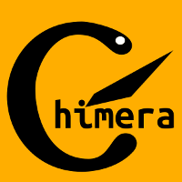 What is this?
  + Chimera framework logo
  + National flag of Wakanda
* How do you spell
$$α+β$$

* ?
  + a plus b
  + alpha plus beta
  + a fish and a funny flag