Patient Transfer Grading Support Tool – Installation and Setup
This document provides installation and setup instructions for the Patient Transfer Grading Support Tool application.

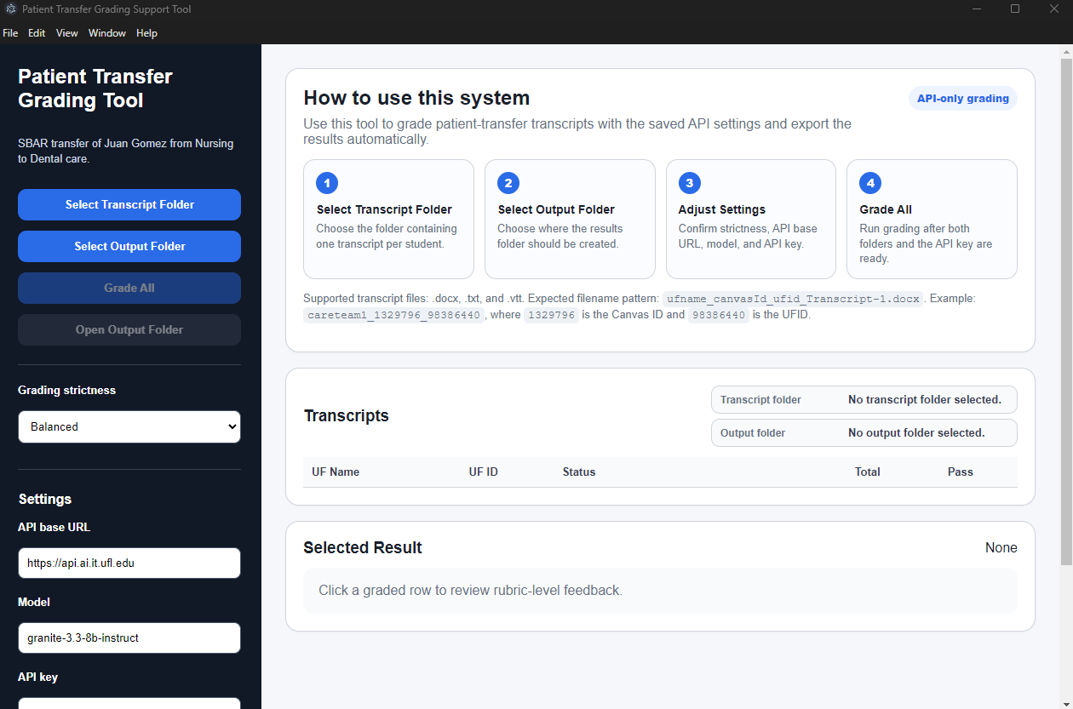

1. Download the Application
Download the installer that matches your computer from the official GitHub Releases page:
https://github.com/agsiqueira/patient-transfer-grading-support-tool/releases

Installer Selection
- Windows computers: Patient Transfer Grading Support Tool Setup.exe
- Mac computers with Apple Silicon processors (M1, M2, M3, etc.): arm64.dmg installer
- Mac computers with Intel processors: regular .dmg installer
If you are unsure which Mac processor you have, open Apple Menu → About This Mac.
If the computer shows “Chip: Apple M...”, use the arm64 installer.
If the computer shows “Processor: Intel...”, use the regular .dmg installer.

2. Install the Application
- Windows: Run the .exe installer.
- Mac: Open the .dmg file and drag the application into Applications.

Important Windows Security Notice
Because this application is distributed independently for educational use and is not digitally code-signed by a commercial certificate authority, Windows SmartScreen may display a warning such as “Windows protected your PC.”
This warning is common for newly distributed academic or independent software and does not indicate malware.
If this happens:
- Click “More info”.
- Click “Run anyway”.

3. Obtain a UF NaviGator API Key
Go to the UF NaviGator portal:
https://api.ai.it.ufl.edu/ui
- Log in with your UF credentials.
- Click “Create New Key” in the upper-left area near the sidebar.
- Fill out the form as follows:
- Owned By: You
- Team: navigator-toolkit
- Key Name: Choose a descriptive name such as patient-transfer-grading
- Models: granite-3.3-8b-instruct
- Key Type: AI APIs

Important API Key Security Information
Save your API key in a safe location. You may not be able to view the full key again after leaving the page.
Never share your API key with anyone.

4. Use the Application
- Open the Patient Transfer Grading Support Tool application.
- Paste your API key into the “API Key” field and click “Save Settings.”
- Choose the desired Grading Strictness level.

- Select the Input and output folders.
- Select the Transcript Folder: This is the folder containing students’ transcripts
- Select the Output Folder: Define the location of the generated grading files
- Click “Grade All” to begin processing submissions.
- Review the generated Excel output file, Word reports, and execution log CSV file.

Transcript Processing Notes
- If multiple transcript files are detected for the same student, only the first transcript is processed.
- Duplicate transcripts are skipped and recorded in the execution log CSV file.
- The Transcripts interface displays the following columns: UF Name, UF ID, Status, Total, and Pass.

Accessibility Notes
This document uses structured headings, lists, and readable formatting to support screen readers and assistive technologies.

