Healthcare Patient Experience and Operational Efficiency Analysis

1. Data Collection and Preprocessing
For this analysis, I utilized a healthcare patient dataset containing demographic information, admission details, referral departments, patient wait times, and satisfaction scores. The objective was to understand patient experience, operational efficiency, and demographic patterns within the healthcare system.
During the initial data cleaning phase, I examined the dataset structure, descriptive statistics, missing values, and duplicate records. Missing values in the Department Referral column were replaced with "Not Listed" to preserve referral information. Additionally, missing values in the Patient Satisfaction Score column were imputed using the median satisfaction score, ensuring a complete dataset for further analysis. Duplicate records were identified and removed where necessary to maintain data quality.

2. Feature Engineering
To extract deeper insights beyond the raw dataset, several new features were engineered:
- Age Group: Patients were categorized into four meaningful groups: Pediatric (0–18), Young Adult (19–35), Adult (36–60), and Senior (60+).
- Admission Timestamp: Admission date and admission time were combined into a single datetime feature to facilitate temporal analysis.
- Hour of Admission: Extracted from the admission timestamp to study hourly patient flow and waiting trends.
- Day of Admission: Derived from the timestamp to identify weekly operational patterns and patient visitation behavior.
These engineered features enabled more comprehensive segmentation and visualization of patient experiences.

3. Exploratory Data Analysis & Visualizations

A. Patient Satisfaction Analysis
The distribution of patient satisfaction scores was visualized using histograms before and after handling missing values. The results revealed the overall satisfaction patterns of patients while confirming that median imputation preserved the original score distribution without introducing significant bias.
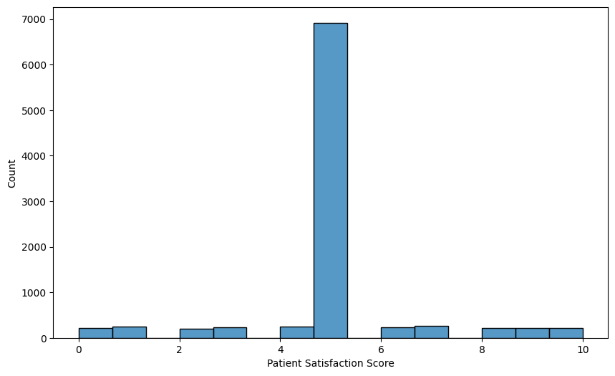
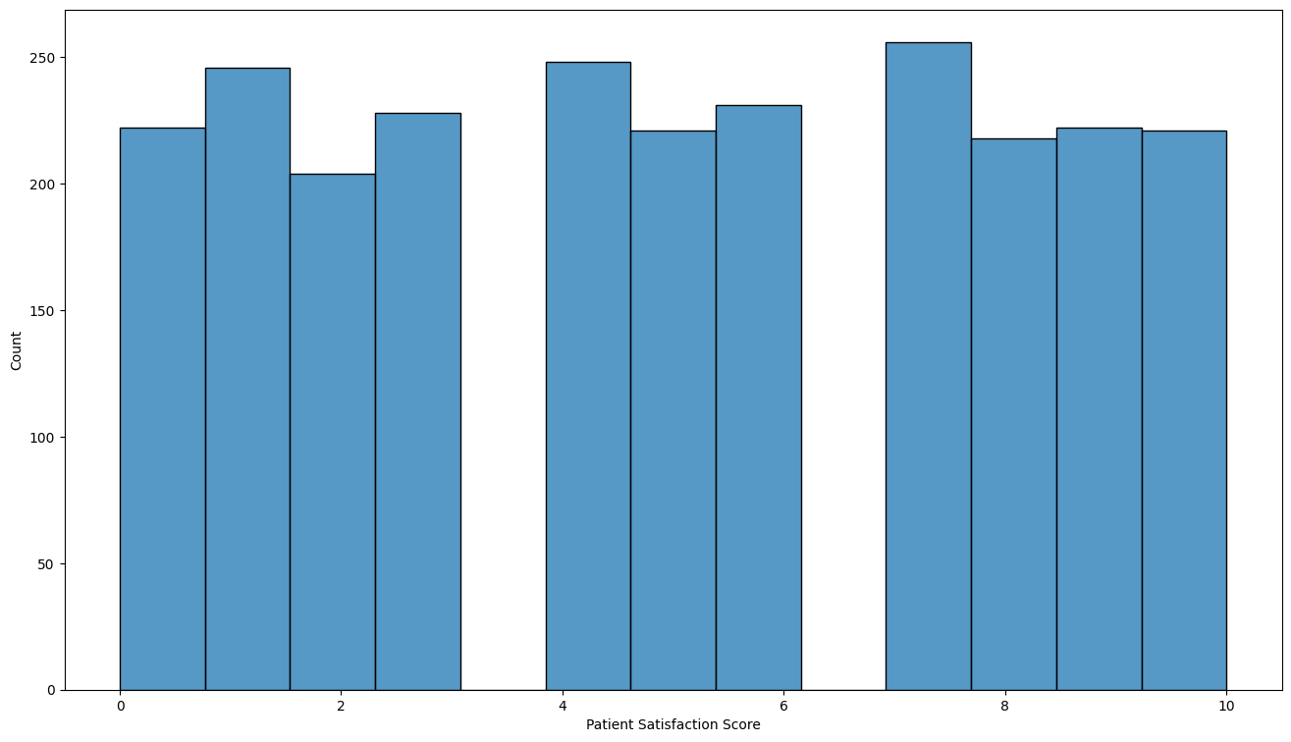

B. Demographic Distribution
Patient demographics were explored through age distribution histograms and race-based count plots. The age distribution provided insight into the most common patient age groups, while race distribution visualizations highlighted the diversity of the patient population served by the healthcare facility.
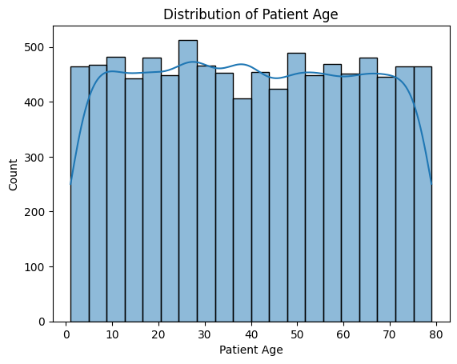
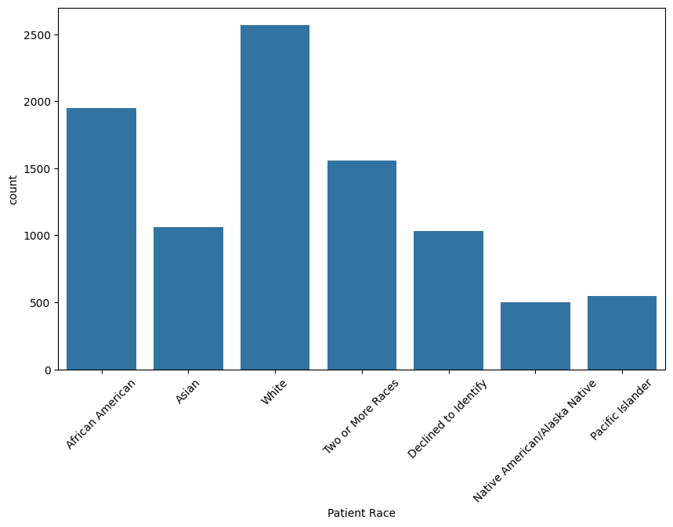

C. Wait-Time Analysis
Several visualizations were developed to understand waiting behavior:
- Boxplots of patient wait times across different age groups.
- Line plots comparing average wait times among racial groups.
- Gender-based wait-time comparisons within each age group.
The analysis demonstrated that patient waiting time varies considerably across demographic segments and may significantly influence satisfaction levels.
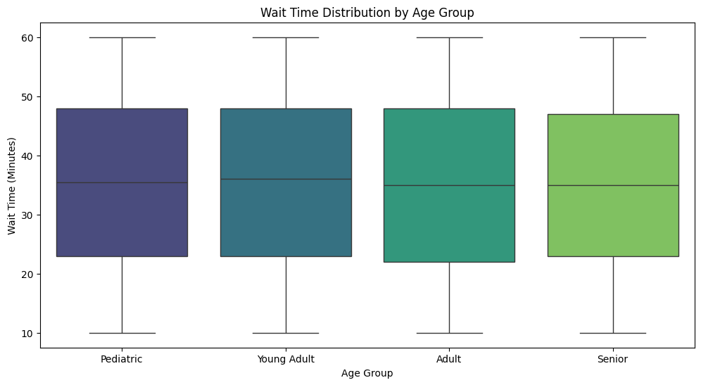
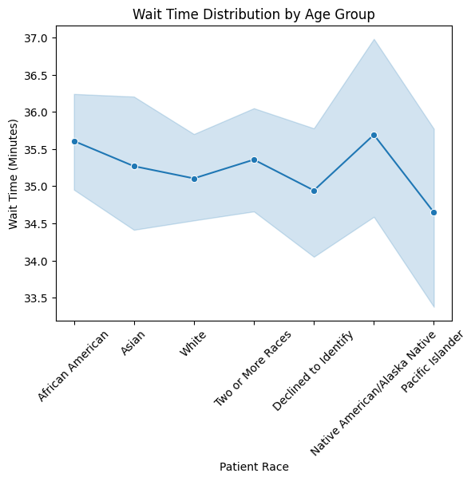
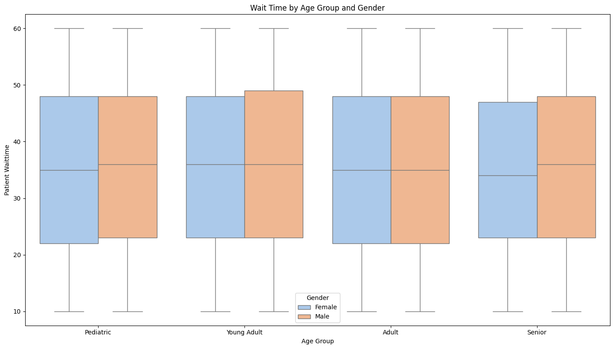

D. Operational Time Trends
Average patient wait times were analyzed across admission hours throughout the day. The hourly trend visualization identified peak periods where waiting times increased, highlighting potential bottlenecks in resource allocation and patient flow management.
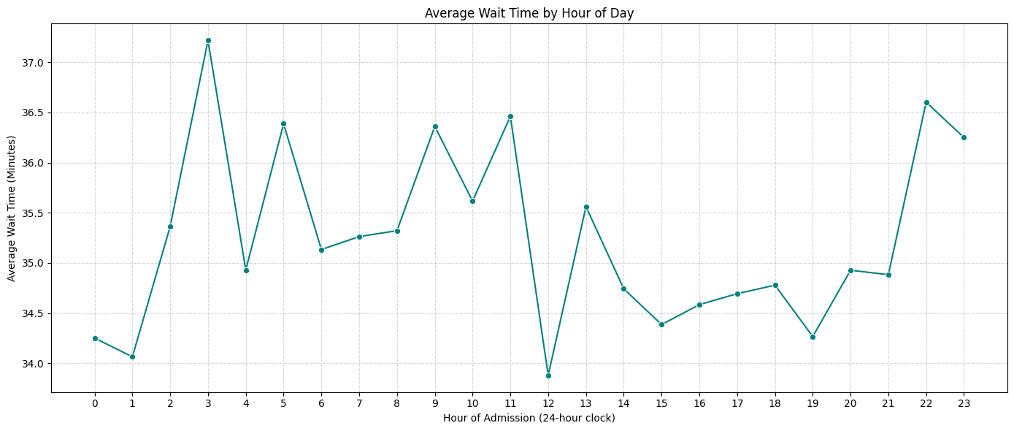

4. Advanced Machine Learning Preparation
To ensure the dataset was fully optimized for future predictive modeling and machine learning applications, several preprocessing techniques were applied.
Categorical variables including Patient Gender, Department Referral, and Day of Admission were transformed using One-Hot Encoding, allowing machine learning algorithms to process non-numeric information effectively.
The engineered Age Group feature was converted into numerical form using Ordinal Encoding, preserving the natural hierarchy between age categories. Furthermore, continuous variables such as Patient Age and Admission Hour were standardized using StandardScaler to eliminate scale-related bias and improve model performance.
The final processed dataset was exported as Hospital_Data_Cleaned_Swapnil.csv, making it fully prepared for predictive analytics and machine learning workflows.

5. Final Conclusions
The analysis provides valuable insights into patient demographics, satisfaction levels, and healthcare operational performance. Results suggest that waiting time is a critical factor affecting patient experience and satisfaction. Additionally, temporal patterns reveal periods of increased congestion that may require improved staffing or resource allocation strategies.
Through comprehensive data preprocessing, feature engineering, exploratory analysis, and machine learning preparation, the dataset was successfully transformed into a high-quality analytical resource. Future work may focus on predicting patient wait times, forecasting satisfaction scores, and optimizing healthcare operations through data-driven decision-making.

