*Stellarium* is a computer program that shows what you can see in the night sky, from any place, at any date and time in the past, present or future.

Open *Stellarium*.

Check the information bar at the bottom of the screen. It gives the location and time.

Screen Shot 2015-08-25 at 2

In this example we’re on Earth, in Perth, 71 m above sea level. It’s just after half past two in the afternoon, on 25 August 2015.

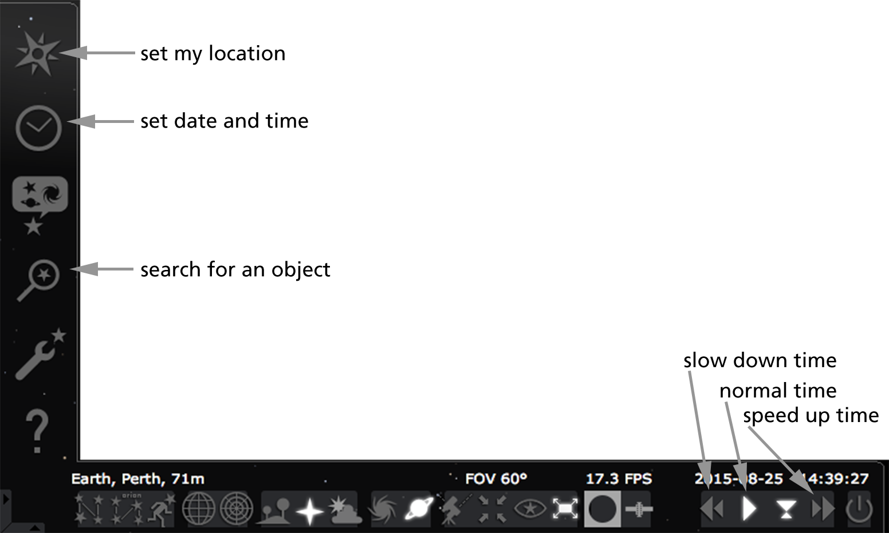

Your teacher may have already set up *Stellarium* for your location. If not you will have to do it yourself. Move the mouse into the bottom left corner of the screen to display two tool bars. Some important tools are shown in the diagram below. Use the ‘set my location’ window to choose a nearby city.

Experiment with *Stellarium* for a while so you are familiar with the main keyboard commands, listed below, as well as moving around with the mouse.

If you get stuck in space anytime just quit the program and start again.

|  |  |
| --- | --- |
| **KEY** | **COMMAND** |
| **J** | slow down time |
| **K** | normal time |
| **L** | speed up time |
| **-** | go back 1 day |
| **8** | go to present time |
| **=** | go forward 1 day |
| **A** | turn atmosphere on/off |
| **G** | turn ground on/off |
| **B C R V** | display constellation boundaries / lines / artwork / names |
| **E** | show a grid in the sky |
| <**page up**>/<**page down**> | zoom in/out |
| <**space bar**> | move selected object to screen centre (click an object to select it) |
| **/** or **\** | zoom in or out of selected object |

When you start *Stellarium* will probably be looking south over a pleasant green field. *Stellarium* knows a lot about stars and other objects in the sky, but generally uses this same view for every location on Earth!

Use the mouse to drag the view around until you are looking west (the letter **W** is visible on the horizon) and the screen shows half sky and half ground. Not much seems to be happening, but if you check the information bar at the bottom of the screen you will see time is passing by, at its usual rate.

# Looking at the night sky

1. Speed up time by pressing the **L** key four times and then wait for the Sun to set. Describe how the Sun and stars move in the sky when you are looking west.

1. Some of the objects moving in the sky are labelled. Do you recognise any of these names? Write down three objects that you see moving and what you think they are.

1.

2.

3.

1. Use the mouse to change your view so you are looking north, then east, and finally south. Describe the direction stars move in the night sky.

When I look north the stars move:

When I look east the stars move:

When I look south the stars move:

1. Keep facing south, but use the mouse to drag the view so you are looking higher in the sky. The sky should just about fill the screen, with only a small amount of ground at the bottom. Describe how the stars move in the night sky. (Turning the grid on, **E**, might help).

1. Imagine stars are painted on your classroom ceiling. You are sitting in a swivel chair, looking up at them, and someone spins your chair around. What would you see?

1. Why do you think stars move in the night sky? Are they really moving?

# Looking at planets

Reset time to the present (**8**) and normal rate (**K**).

Now you will use *Stellarium* to look at the planet Venus. This is one of the inner planets (the planets closest to the Sun). There are several ways to choose objects in *Stellarium*: an easy way is to open the search window and choose Venus from the list of Solar System objects. Double-click to select it.

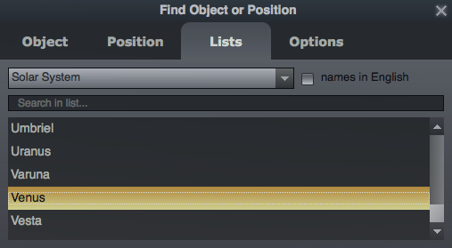 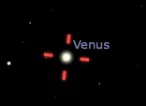

The view will change so Venus is in the middle of the screen, marked by four red lines, but you may not be able to see the planet at first.

1. Why might Venus be hidden from view at first?

1. Speed up time by typing **L** four times. Describe how Venus moves through the sky over 24 hours.

1. Venus is often known as the morning star or the evening star (although it is a planet, not a star). Why do you think it has these names?

1. 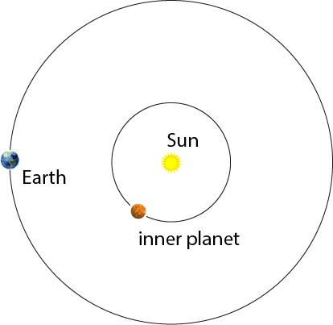Use this diagram to explain why inner planets like Venus are sometimes only visible in the night sky for a short time.

Use a *Stellarium* trick to make it easier to see Venus.  
Type **A** to turn off the atmosphere: now you can see stars and planets, including Venus, even when its day. Wait until Venus is clearly visible above the horizon, then set normal time (type **K**).

1. Type the equals sign (**=**) to jump forward one day. Keep advancing one day at a time to see how Venus moves in the sky. Turning on constellation display (**B** and **C**) may help. Describe how Venus moves in the night sky, compared with the stars.