Look closely at the picture on your postcard and read the message on the back.

# Observe

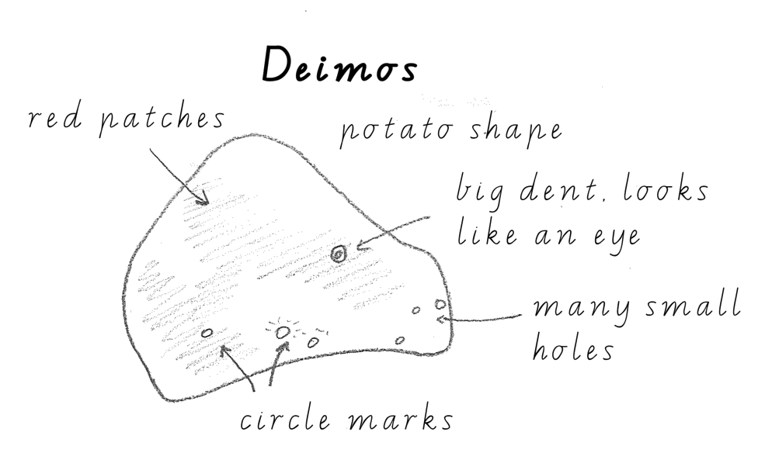Draw and label a diagram of the space object on your postcard.  
Look for patterns, shapes, colours and shades.

Example:

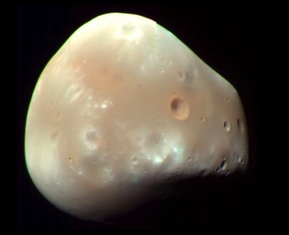

# Compare

How do features on your postcard compare to things that you are familiar with, such as mountains and oceans on Earth?

This space object

looks like

# Deduce or infer

What do you think about this space object, and why? For example, I think this space body has rivers because it has patterns like rivers on Earth.

I think this space object

because

# Questions

What questions do you have about your postcard? For example, how was this picture taken? Why is there a shape like a bear on it?

How

?

Why

?

Where

?

What

?