GOVERNMENT ARTS AND SCIENCE COLLEGE, TRICHY–22
NAAN MUDHALVAN
PROJECT REPORT
IMPORT DATA USING TRANSFORM MAPS
(SPREADSHEET)
Team Leader
Mari Sidharthan.D
Team Members
Vinayaga Moorthi.R
Kavikumar.R
Manikandan.C
Karthick.S
Academic Project
2026

1. INTRODUCTION
This project demonstrates how spreadsheet data can be imported into a ServiceNow application using Import Sets and Transform Maps. Instead of entering every record manually, the spreadsheet is first loaded into a staging area and then transformed into records in the required target table.
The project focuses on preparing source data, loading the spreadsheet, creating a Transform Map, mapping source fields to target fields, using matching logic where required, running the transformation, checking the results and presenting the imported information through reports or dashboards.

Project Workflow
Spreadsheet → Import Set → Import Set Table → Transform Map → Field Mapping → Transform → Target Table → Reports / Dashboard

Project Team
Role | Name
Team Leader | Mari Sidharthan.D
Team Member | Vinayaga Moorthi.R
Team Member | Kavikumar.R
Team Member | Manikandan.C
Team Member | Karthick.S

2. OBJECTIVES
- To understand spreadsheet-based data import in ServiceNow.
- To prepare structured source data for import.
- To load spreadsheet records into an Import Set.
- To create and configure a Transform Map.
- To map source fields with corresponding target fields.
- To understand matching/coalesce logic for existing records.
- To execute the transformation and verify the result.
- To create useful reports or dashboard views from imported records.
- To reduce manual data entry and improve consistency.

3. TECHNOLOGIES AND TOOLS USED
Tool / Technology | Purpose
ServiceNow | Platform used for importing, transforming and viewing data.
Import Sets | Stages incoming spreadsheet data before transformation.
Transform Maps | Defines how source records are transferred to the target table.
Excel / CSV | Source spreadsheet containing structured records.
Web Browser | Accesses the ServiceNow instance.
Reports / Dashboards | Presents imported data visually for analysis.

4. SYSTEM REQUIREMENTS
- Laptop or desktop computer.
- Stable internet connection.
- Modern web browser.
- Excel/CSV-compatible spreadsheet application.
- ServiceNow instance with required import and configuration permissions.
- Prepared spreadsheet containing clean column headers and records.

5. SOURCE DATA PREPARATION
Before importing, the spreadsheet should be checked for correct column names, duplicate values, blank required fields and inconsistent data formats. A clean source file makes the transformation process easier to validate.
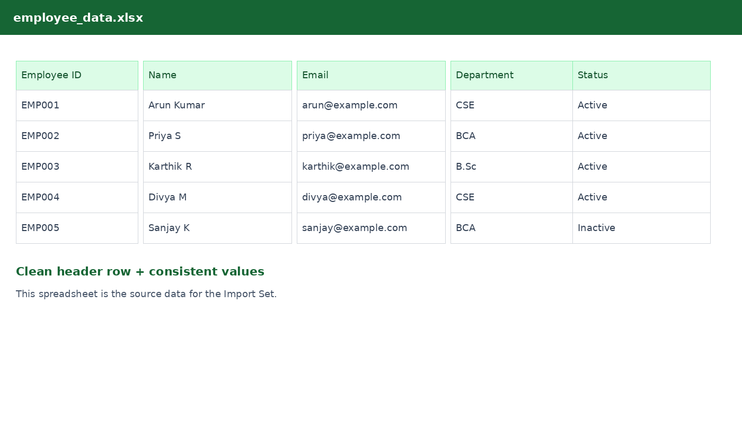
Figure 5.1 — Illustrative spreadsheet prepared as the source file.

- Use the first row for clear column headers.
- Keep one record per row.
- Avoid unnecessary blank rows or merged cells.
- Use consistent formats for identifiers, email addresses and status values.
- Where updates are required, include a stable unique identifier.

6. LOADING THE SPREADSHEET INTO SERVICENOW
- Open the ServiceNow instance and navigate to the spreadsheet/data import function.
- Select the prepared Excel or CSV file.
- Choose the appropriate import-set table option.
- Review the detected columns and sample records.
- Submit the file for loading.
- Verify that the source records appear in the Import Set.
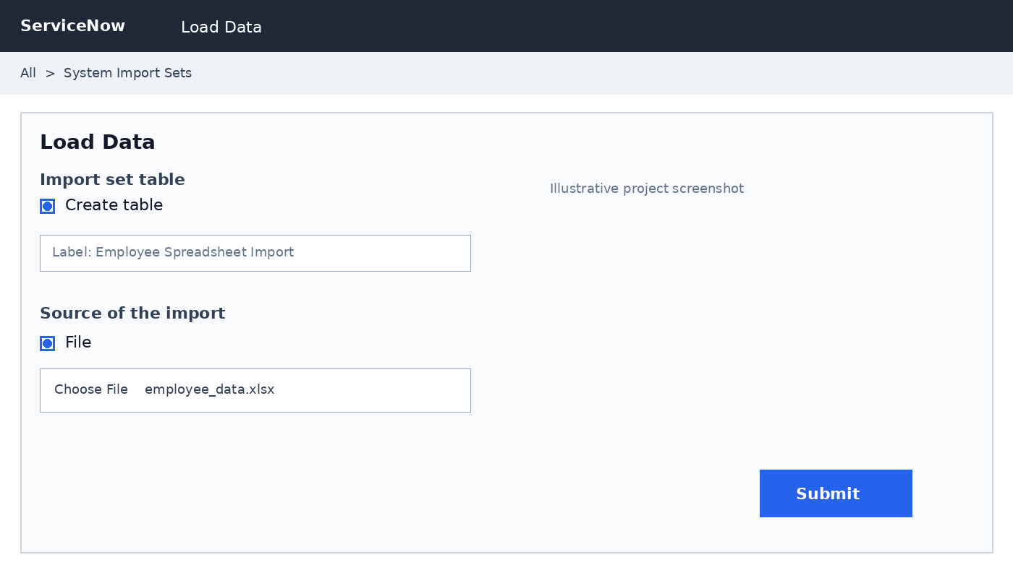
Figure 6.1 — Illustrative ServiceNow Load Data screen.

The Import Set acts as a temporary staging area. This allows the incoming data to be checked before it is transformed into the final target table.

7. CREATING THE TRANSFORM MAP
A Transform Map contains the rules used to move data from the Import Set table into the selected target table. It is the main configuration used to control the transformation process.
- Open Transform Maps in ServiceNow.
- Create a new Transform Map.
- Give the map a meaningful name.
- Select the source/import-set table.
- Select the target table.
- Save the Transform Map.
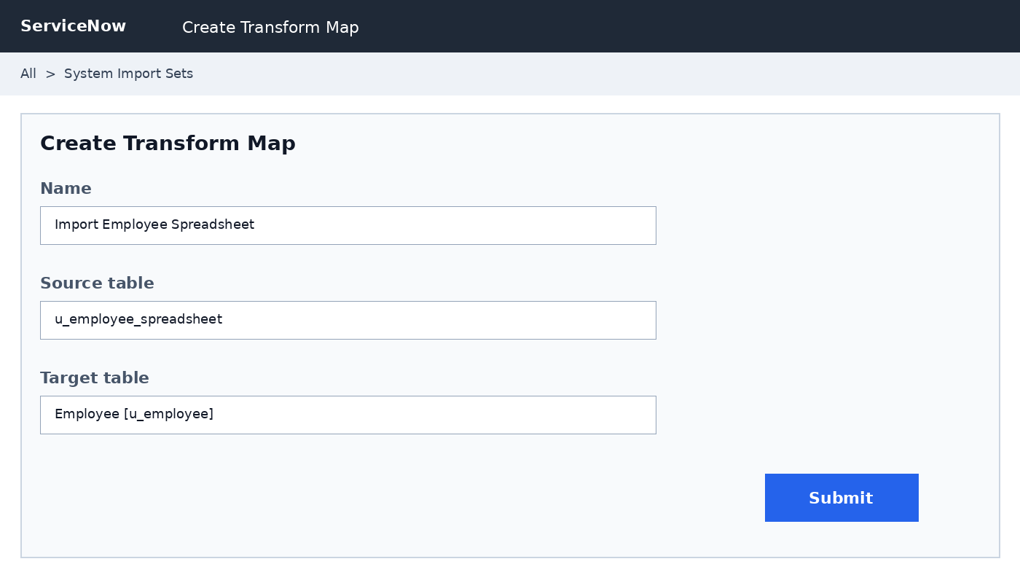
Figure 7.1 — Illustrative Transform Map configuration.

Important Configuration
Setting | Purpose
Name | Identifies the Transform Map.
Source table | Contains the staged spreadsheet records.
Target table | Stores the final transformed records.
Active | Controls whether the Transform Map is available for use.
Run business rules / scripts | Used according to the requirements of the target process.

8. FIELD MAPPING AND COALESCE
Field mapping connects a source column to the corresponding target-table field. Correct mapping is essential because it determines where each value is stored after transformation.
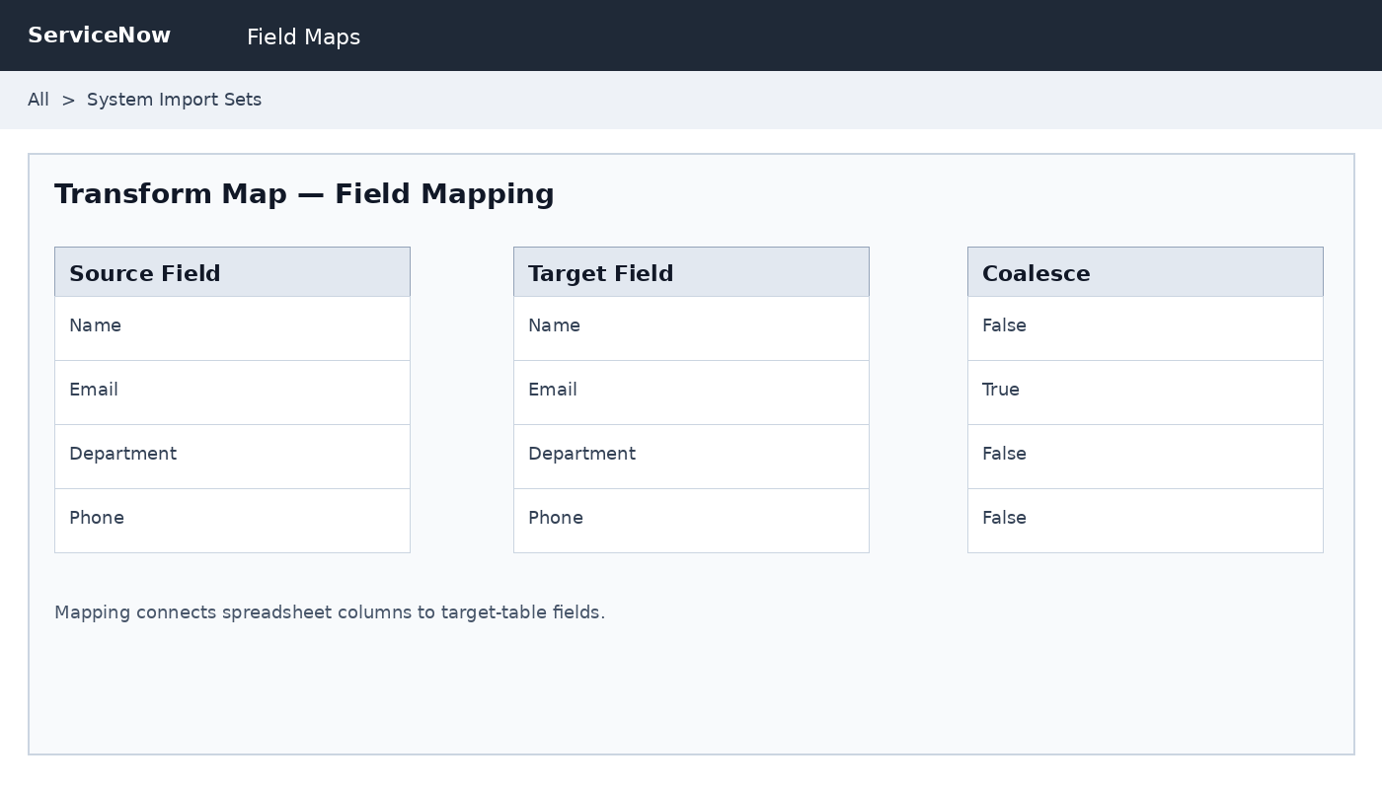
Figure 8.1 — Illustrative source-to-target field mapping.

Source Column | Target Field | Purpose
Employee ID | Employee ID | Unique record identifier.
Name | Name | Stores employee name.
Email | Email | Stores email address.
Department | Department | Stores department/category.
Status | Status | Stores active/inactive state.

Coalesce / Matching
When the project needs to update existing records rather than create duplicates, a suitable unique field can be configured as a matching or coalesce field. A stable identifier such as Employee ID is more appropriate than a value that can occur in multiple records.

9. RUNNING THE TRANSFORMATION
- Open the configured Transform Map.
- Confirm the source and target tables.
- Review the field mappings.
- Check the matching/coalesce setting if it is being used.
- Run the transform.
- Review the transformation result and any errors.
- Open the target table and verify the final records.
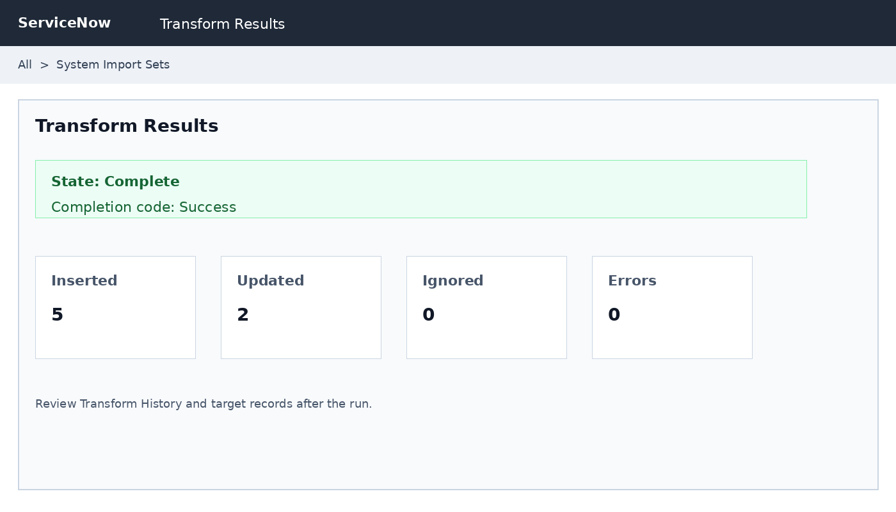
Figure 9.1 — Illustrative transformation result and validation screen.

Validation
- Check that expected records were inserted.
- Check whether existing records were updated when matching is configured.
- Review skipped, ignored or failed rows.
- Verify important values in the target table.
- Correct source or mapping errors and repeat the test if necessary.

10. REPORTS AND DASHBOARD
After the data has been successfully transformed into the target table, reports can be created to present the imported records in a useful form. A dashboard can combine multiple report components so that users can quickly understand the data.
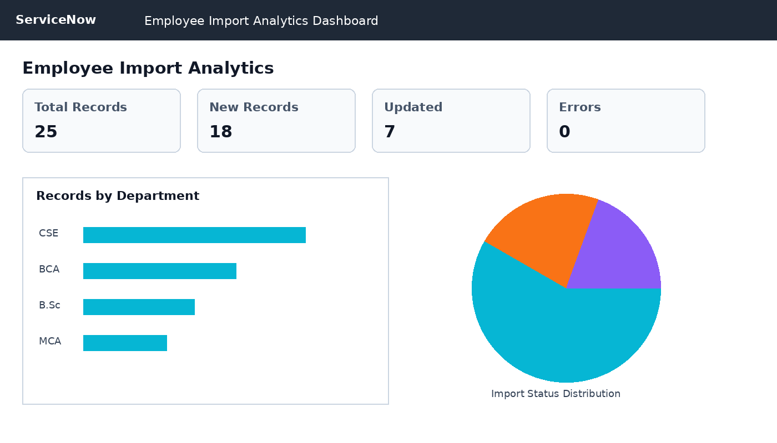
Figure 10.1 — Illustrative employee import analytics dashboard.

- Total employee records.
- Newly added records.
- Updated employee records.
- Department-wise distribution.
- Import success and error counts.
These visualizations can help administrators monitor imported data, identify patterns and review the outcome of repeated import operations.

11. TESTING
Test Case | Expected Result
Valid spreadsheet | Records are loaded into the Import Set.
Correct field mapping | Values appear in the correct target fields.
Matching existing ID | Existing record is handled according to the Transform Map configuration.
Invalid required value | Record is flagged or fails according to configuration.
Successful transformation | Final record is visible in the target table.
Report generation | Imported records appear in the selected report/dashboard.

12. ADVANTAGES
- Reduces manual data entry.
- Provides a repeatable import workflow.
- Separates source staging from the final target table.
- Makes source-to-target mapping explicit.
- Supports insert and update scenarios when matching logic is configured.
- Makes import results easier to validate.
- Allows imported data to be represented through reports and dashboards.

13. LIMITATIONS
- Incorrect source data can produce incorrect target records.
- Incorrect field mapping can place values in the wrong fields.
- Complex data may require additional transformation logic.
- The process requires suitable ServiceNow permissions.
- Large imports should be tested and monitored carefully.

14. CONCLUSION
This project successfully demonstrates spreadsheet data import using ServiceNow Import Sets and Transform Maps. The process begins with a structured spreadsheet and continues through staging, field mapping, matching logic, transformation and validation.
The project provides practical knowledge of data migration and shows how Transform Maps can reduce repetitive manual entry while providing controlled source-to-target mapping. Reports and dashboard views can further improve visibility into imported records and import outcomes.
The concepts demonstrated in this project can be extended to larger datasets and more advanced ServiceNow data-integration scenarios.

15. REFERENCES
- ServiceNow Developer Documentation – Import Sets and Transform Maps.
- ServiceNow platform documentation and in-instance help.
- Naan Mudhalvan learning and project resources.
- Excel/CSV documentation for spreadsheet preparation.
--- END OF PROJECT REPORT ---

