|  |  |  |
| --- | --- | --- |
| Image | |  |
| INVENTORY MANAGEMENT SYSTEM FOR INTEGRADEV DEMO PROJECT | | |
| Aung Thet Paing30 June 2020 |  | |

# System Vision

### Project Description

DayNight is a local grocer in one of the Melbourne suburbs which was adapted to various manual bookkeeping with either excel files or different account ledgers. This has soon become a hassle as it was getting hard to centralize their business as more and more products get imported and there is often a shortage of stocks.

They have then reached out to implement a new system which centralizes the stock levels helping them to run the business run more efficiently.

# System Capabilities

The system will be able to perform the following functionalities:

* Log in securely to the system
* Record customer details
* Record supplier details
* View product details and stock levels
* Log sales transactions
* Log purchase transactions

### Log in securely to the system

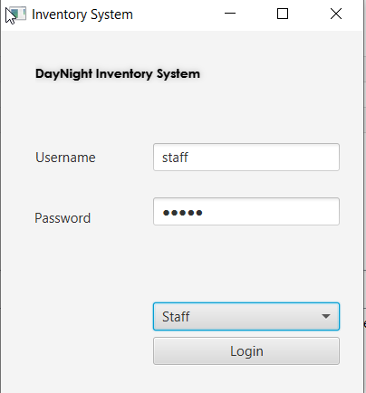

There will be a log in for each user in the system with different roles based on their responsibilities of the business.

### Record Customer Details

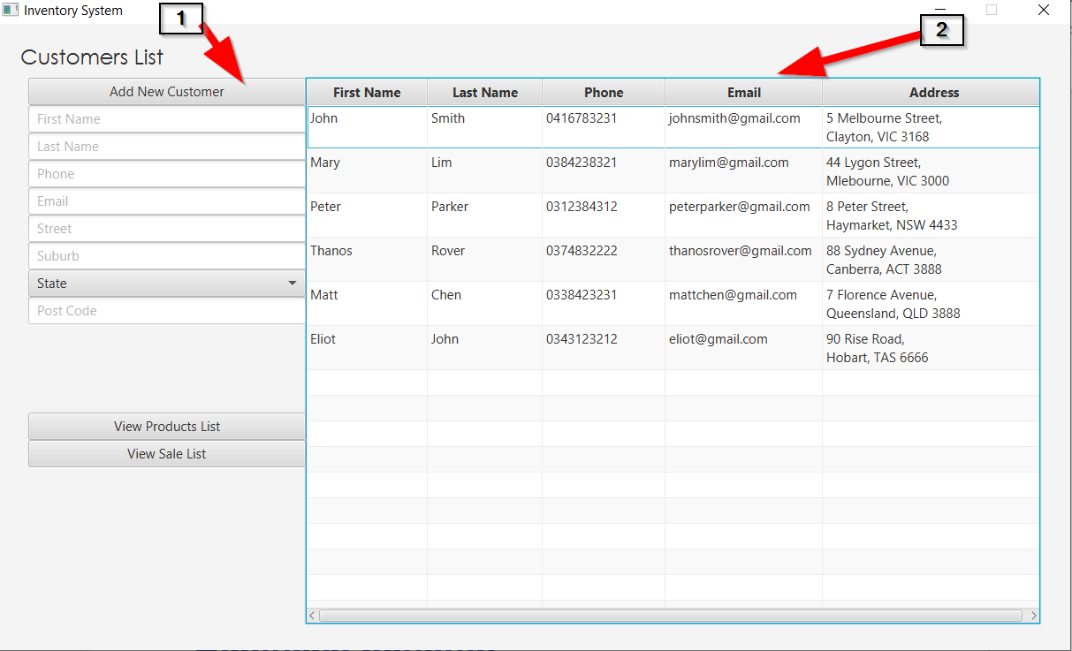

1. The system will allow the users to add new customer details for future references.
2. It will then be refreshed on the table real-time.

### View product details and stock levels

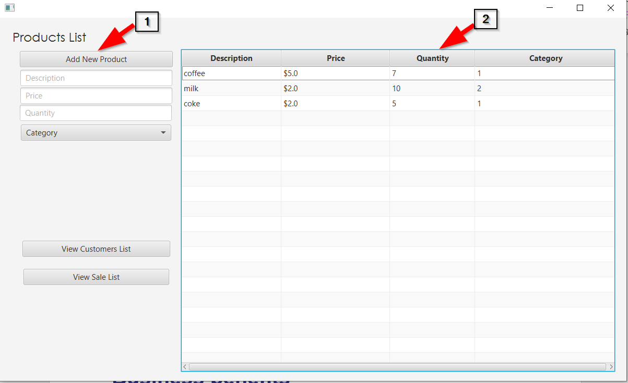

1. The system will allow the business to add any new products incoming
2. The system will allow the viewing of the details of each product and the current stock level.

### Log sales transactions

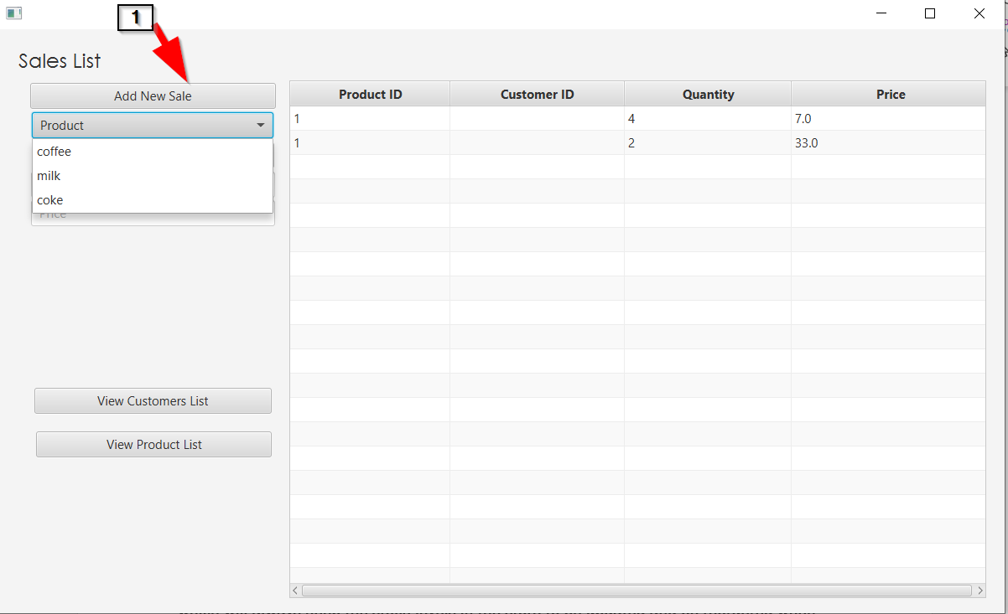

1. The system will be able to add a new sales transaction which will update the quantity on hand of the selected product real time.

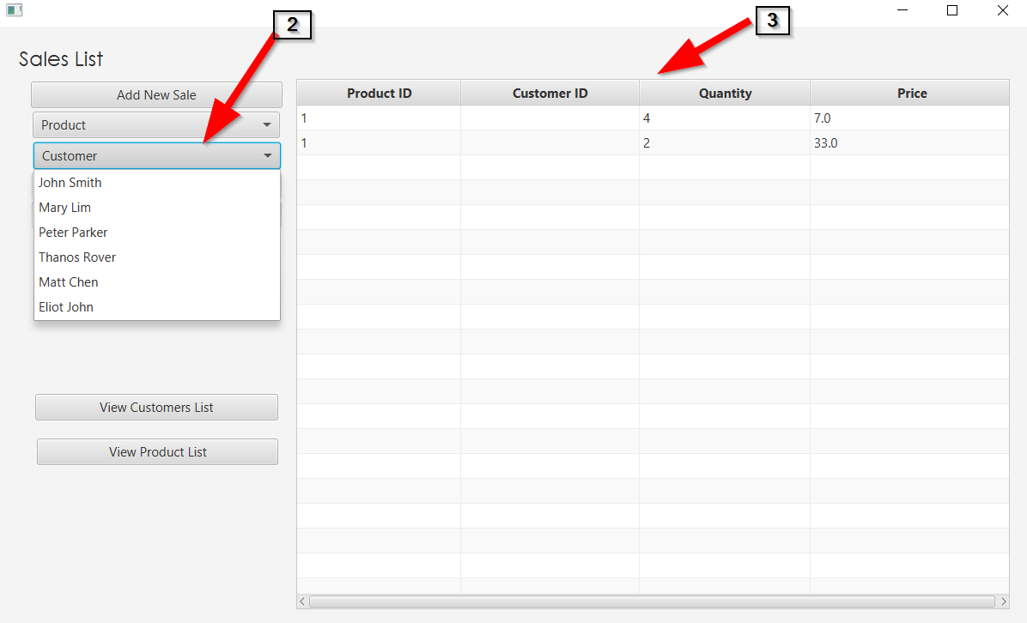

1. The system will centralize which customer the sales was completed with based on the Customer table.
2. The new sale will be recorded and updated real-time in the table.

# Business benefits

The system will allow the business to easily look up for any contact details required to run the business efficiently. It will also be able to log all the sales and purchase transactions which will always keep the stock levels in the store to be updated and be reordered when necessary.

# Data Model

