**影像元件練習**

1. 請參考投影片內容，建立以下的Android應用程式

並請將1.**建立過程**; 2.程式**執行結果**截圖; 2.程式**原始檔 copy&paste**置入作業中

1. 請參考投影片的猜拳遊戲範例，設計另一遊戲程式 – 數字比大小
   1. 使用者由數字1~6中選一數字，使用ImageButton顯示數字供使用者點選
   2. 電腦亂數1~6，使用ImageView顯示數字
   3. 比對結果，輸出輸贏結果
   4. 並請設計良好的使用者介面

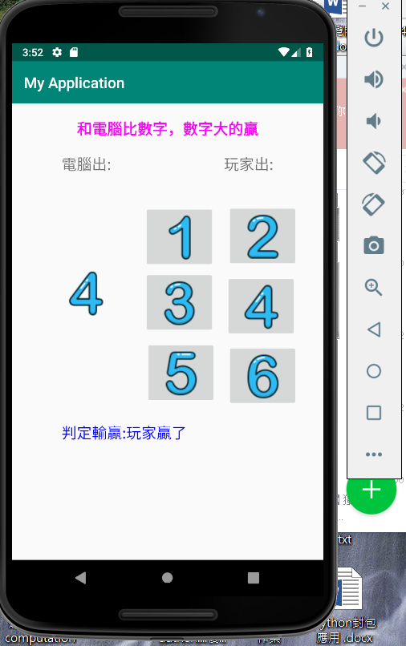

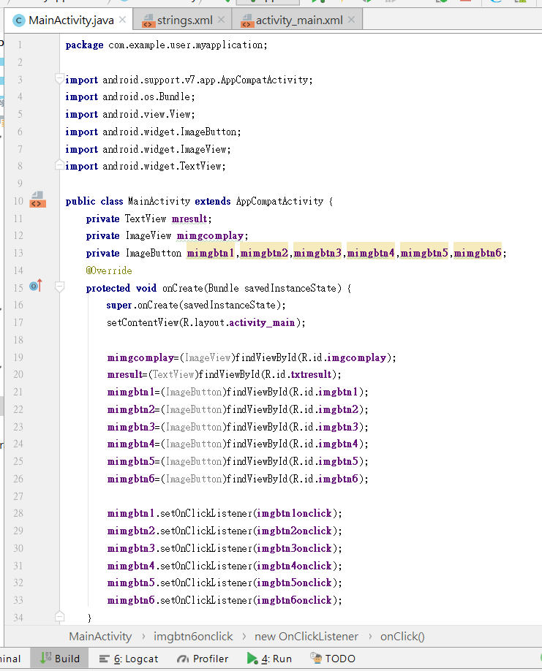

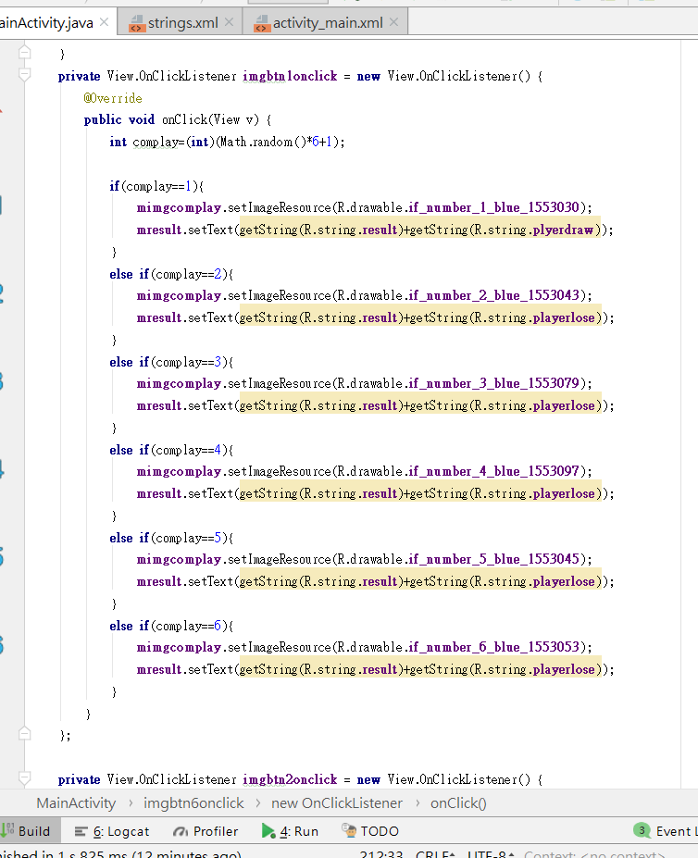

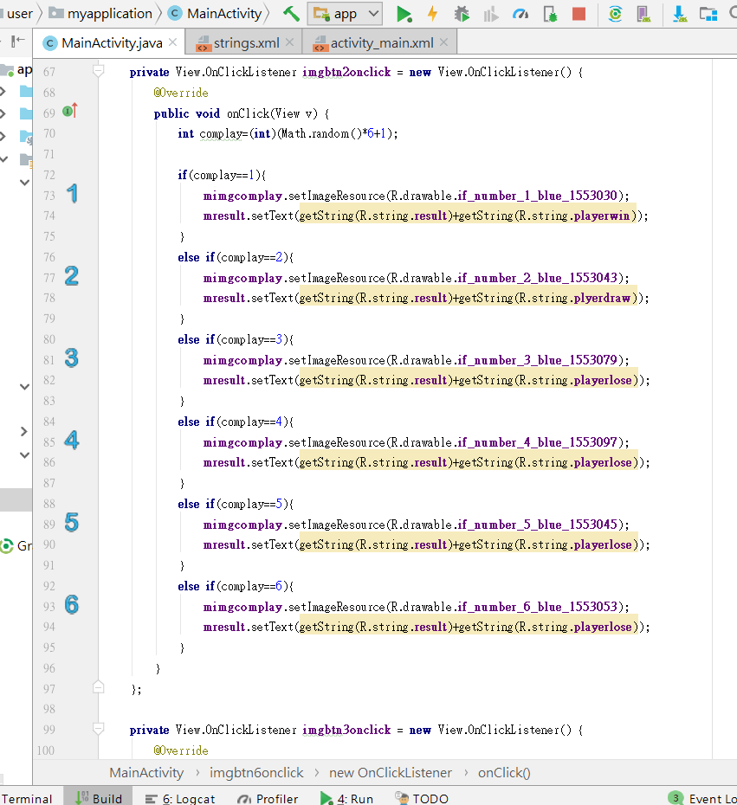

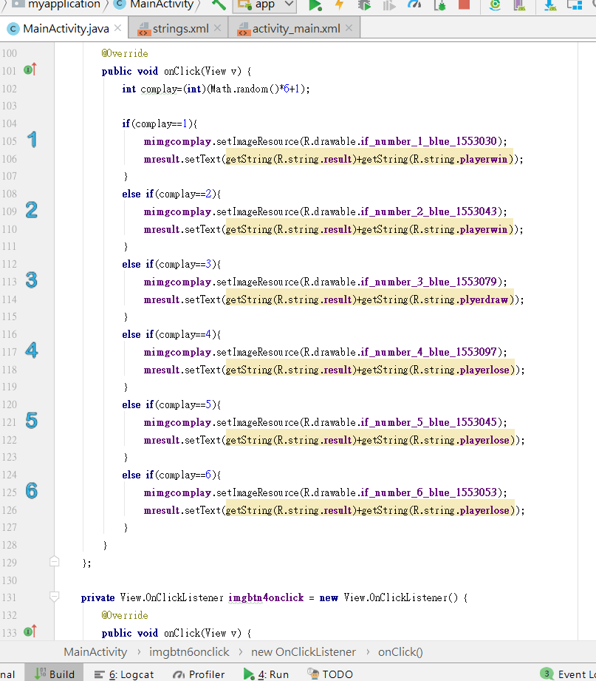

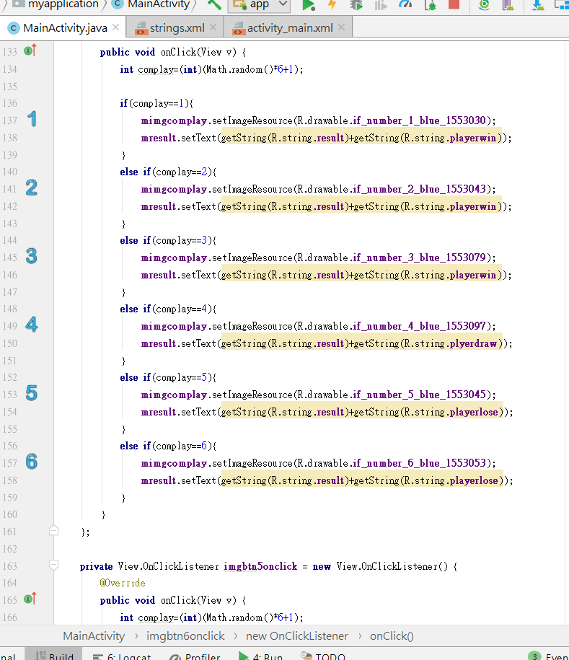

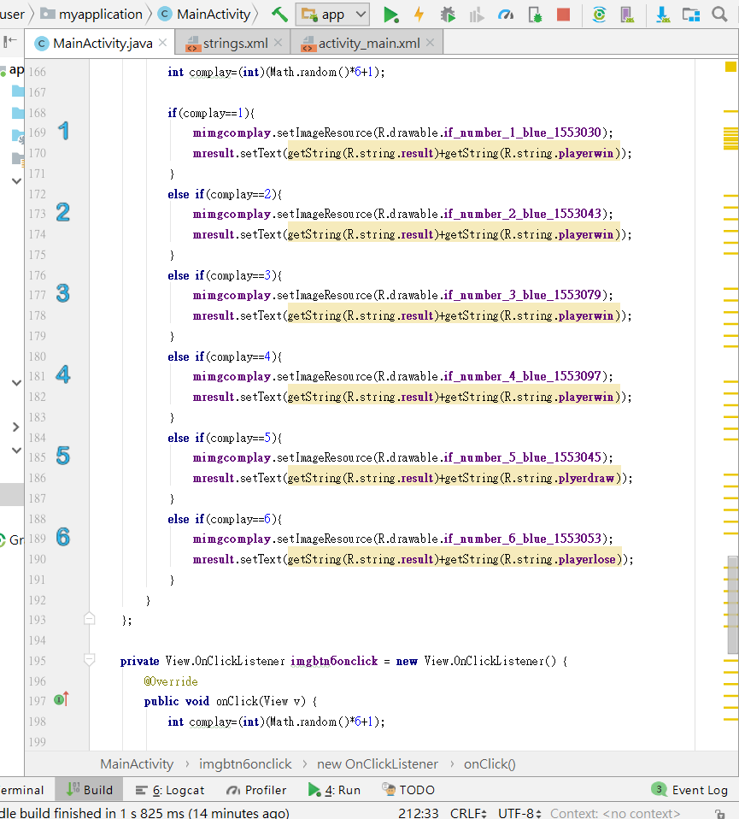

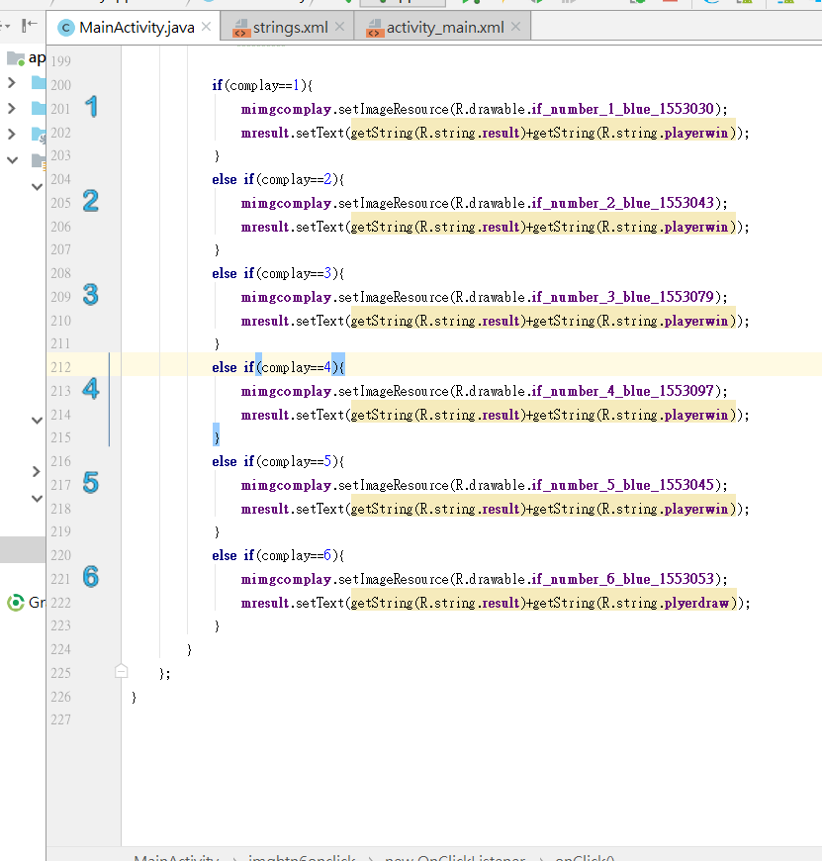

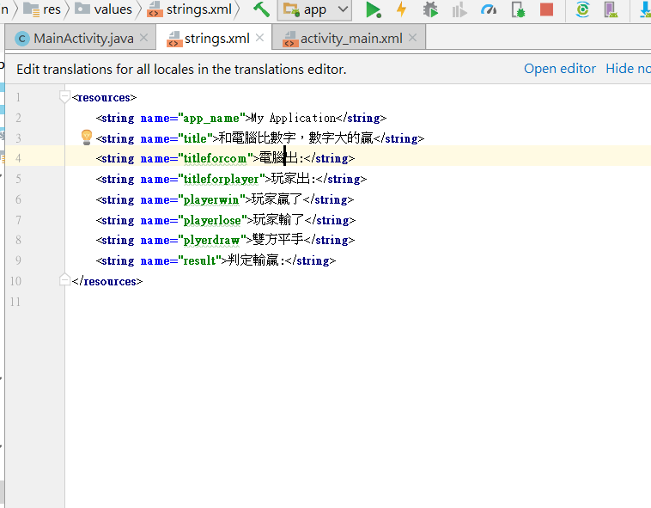

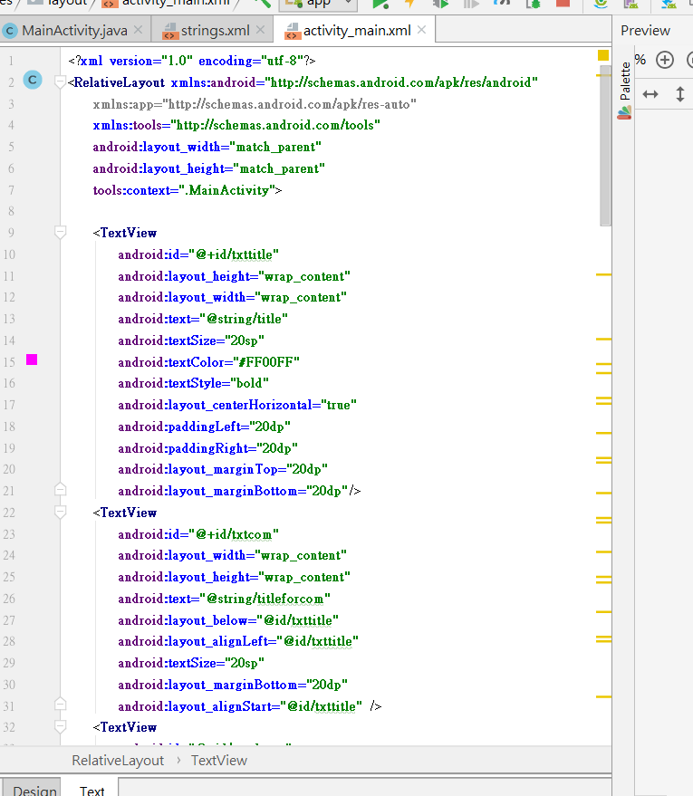

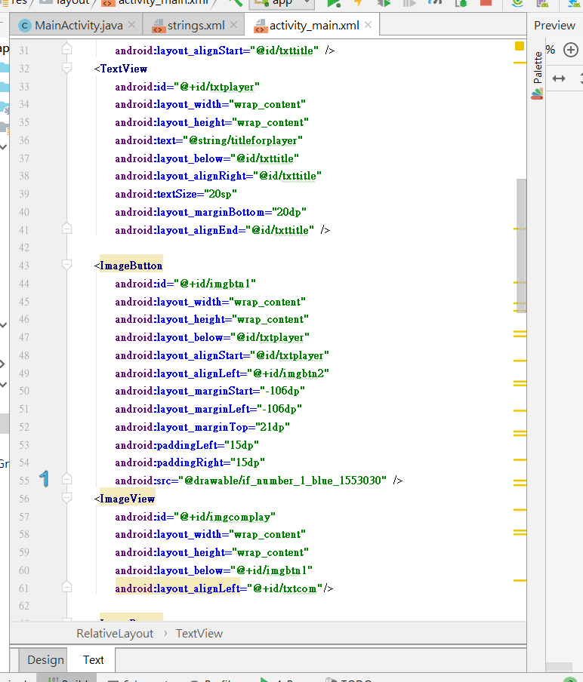

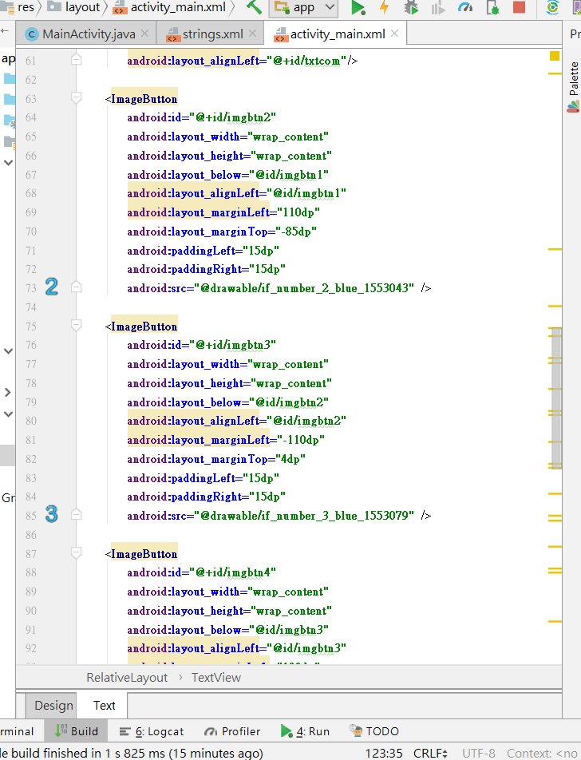

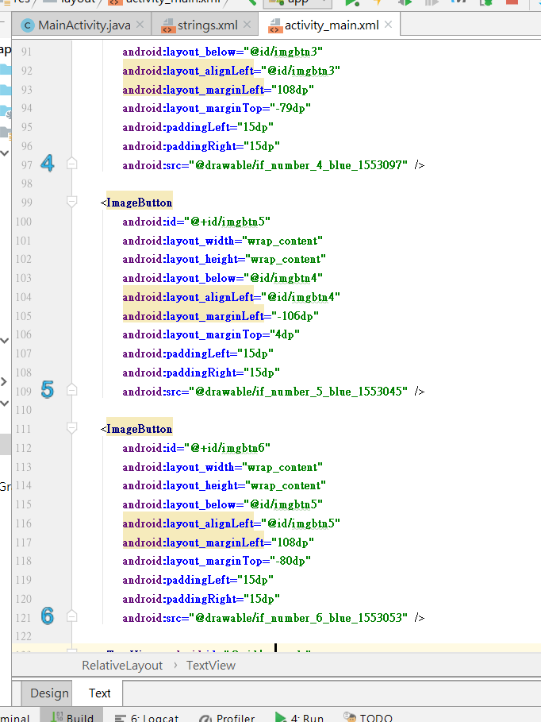

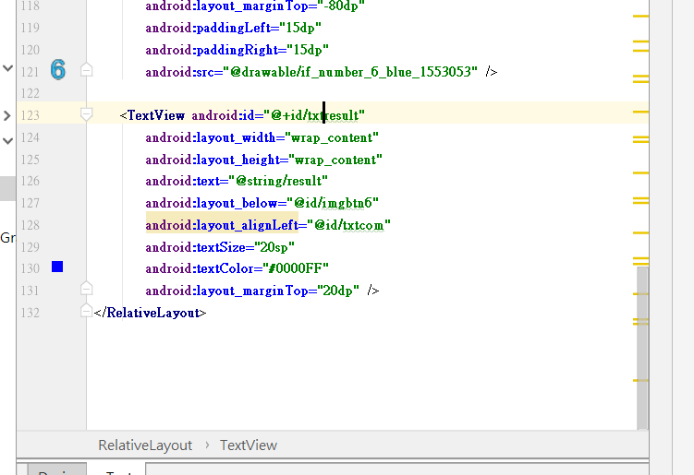

=======================================================================================

**package** com.example.user.myapplication;  
  
**import** android.support.v7.app.AppCompatActivity;  
**import** android.os.Bundle;  
**import** android.view.View;  
**import** android.widget.ImageButton;  
**import** android.widget.ImageView;  
**import** android.widget.TextView;  
  
**public class** MainActivity **extends** AppCompatActivity {  
 **private** TextView **mresult**;  
 **private** ImageView **mimgcomplay**;  
 **private** ImageButton **mimgbtn1**,**mimgbtn2**,**mimgbtn3**,**mimgbtn4**,**mimgbtn5**,**mimgbtn6**;  
 @Override  
 **protected void** onCreate(Bundle savedInstanceState) {  
 **super**.onCreate(savedInstanceState);  
 setContentView(R.layout.***activity_main***);  
  
 **mimgcomplay**=(ImageView)findViewById(R.id.***imgcomplay***);  
 **mresult**=(TextView)findViewById(R.id.***txtresult***);  
 **mimgbtn1**=(ImageButton)findViewById(R.id.***imgbtn1***);  
 **mimgbtn2**=(ImageButton)findViewById(R.id.***imgbtn2***);  
 **mimgbtn3**=(ImageButton)findViewById(R.id.***imgbtn3***);  
 **mimgbtn4**=(ImageButton)findViewById(R.id.***imgbtn4***);  
 **mimgbtn5**=(ImageButton)findViewById(R.id.***imgbtn5***);  
 **mimgbtn6**=(ImageButton)findViewById(R.id.***imgbtn6***);  
  
 **mimgbtn1**.setOnClickListener(**imgbtn1onclick**);  
 **mimgbtn2**.setOnClickListener(**imgbtn2onclick**);  
 **mimgbtn3**.setOnClickListener(**imgbtn3onclick**);  
 **mimgbtn4**.setOnClickListener(**imgbtn4onclick**);  
 **mimgbtn5**.setOnClickListener(**imgbtn5onclick**);  
 **mimgbtn6**.setOnClickListener(**imgbtn6onclick**);  
 }  
 **private** View.OnClickListener **imgbtn1onclick** = **new** View.OnClickListener() {  
 @Override  
 **public void** onClick(View v) {  
 **int** complay=(**int**)(Math.*random*()*6+1);  
  
 **if**(complay==1){  
 **mimgcomplay**.setImageResource(R.drawable.***if_number_1_blue_1553030***);  
 **mresult**.setText(getString(R.string.***result***)+getString(R.string.***plyerdraw***));  
 }  
 **else if**(complay==2){  
 **mimgcomplay**.setImageResource(R.drawable.***if_number_2_blue_1553043***);  
 **mresult**.setText(getString(R.string.***result***)+getString(R.string.***playerlose***));  
 }  
 **else if**(complay==3){  
 **mimgcomplay**.setImageResource(R.drawable.***if_number_3_blue_1553079***);  
 **mresult**.setText(getString(R.string.***result***)+getString(R.string.***playerlose***));  
 }  
 **else if**(complay==4){  
 **mimgcomplay**.setImageResource(R.drawable.***if_number_4_blue_1553097***);  
 **mresult**.setText(getString(R.string.***result***)+getString(R.string.***playerlose***));  
 }  
 **else if**(complay==5){  
 **mimgcomplay**.setImageResource(R.drawable.***if_number_5_blue_1553045***);  
 **mresult**.setText(getString(R.string.***result***)+getString(R.string.***playerlose***));  
 }  
 **else if**(complay==6){  
 **mimgcomplay**.setImageResource(R.drawable.***if_number_6_blue_1553053***);  
 **mresult**.setText(getString(R.string.***result***)+getString(R.string.***playerlose***));  
 }  
 }  
 };  
  
 **private** View.OnClickListener **imgbtn2onclick** = **new** View.OnClickListener() {  
 @Override  
 **public void** onClick(View v) {  
 **int** complay=(**int**)(Math.*random*()*6+1);  
  
 **if**(complay==1){  
 **mimgcomplay**.setImageResource(R.drawable.***if_number_1_blue_1553030***);  
 **mresult**.setText(getString(R.string.***result***)+getString(R.string.***playerwin***));  
 }  
 **else if**(complay==2){  
 **mimgcomplay**.setImageResource(R.drawable.***if_number_2_blue_1553043***);  
 **mresult**.setText(getString(R.string.***result***)+getString(R.string.***plyerdraw***));  
 }  
 **else if**(complay==3){  
 **mimgcomplay**.setImageResource(R.drawable.***if_number_3_blue_1553079***);  
 **mresult**.setText(getString(R.string.***result***)+getString(R.string.***playerlose***));  
 }  
 **else if**(complay==4){  
 **mimgcomplay**.setImageResource(R.drawable.***if_number_4_blue_1553097***);  
 **mresult**.setText(getString(R.string.***result***)+getString(R.string.***playerlose***));  
 }  
 **else if**(complay==5){  
 **mimgcomplay**.setImageResource(R.drawable.***if_number_5_blue_1553045***);  
 **mresult**.setText(getString(R.string.***result***)+getString(R.string.***playerlose***));  
 }  
 **else if**(complay==6){  
 **mimgcomplay**.setImageResource(R.drawable.***if_number_6_blue_1553053***);  
 **mresult**.setText(getString(R.string.***result***)+getString(R.string.***playerlose***));  
 }  
 }  
 };  
  
 **private** View.OnClickListener **imgbtn3onclick** = **new** View.OnClickListener() {  
 @Override  
 **public void** onClick(View v) {  
 **int** complay=(**int**)(Math.*random*()*6+1);  
  
 **if**(complay==1){  
 **mimgcomplay**.setImageResource(R.drawable.***if_number_1_blue_1553030***);  
 **mresult**.setText(getString(R.string.***result***)+getString(R.string.***playerwin***));  
 }  
 **else if**(complay==2){  
 **mimgcomplay**.setImageResource(R.drawable.***if_number_2_blue_1553043***);  
 **mresult**.setText(getString(R.string.***result***)+getString(R.string.***playerwin***));  
 }  
 **else if**(complay==3){  
 **mimgcomplay**.setImageResource(R.drawable.***if_number_3_blue_1553079***);  
 **mresult**.setText(getString(R.string.***result***)+getString(R.string.***plyerdraw***));  
 }  
 **else if**(complay==4){  
 **mimgcomplay**.setImageResource(R.drawable.***if_number_4_blue_1553097***);  
 **mresult**.setText(getString(R.string.***result***)+getString(R.string.***playerlose***));  
 }  
 **else if**(complay==5){  
 **mimgcomplay**.setImageResource(R.drawable.***if_number_5_blue_1553045***);  
 **mresult**.setText(getString(R.string.***result***)+getString(R.string.***playerlose***));  
 }  
 **else if**(complay==6){  
 **mimgcomplay**.setImageResource(R.drawable.***if_number_6_blue_1553053***);  
 **mresult**.setText(getString(R.string.***result***)+getString(R.string.***playerlose***));  
 }  
 }  
 };  
  
 **private** View.OnClickListener **imgbtn4onclick** = **new** View.OnClickListener() {  
 @Override  
 **public void** onClick(View v) {  
 **int** complay=(**int**)(Math.*random*()*6+1);  
  
 **if**(complay==1){  
 **mimgcomplay**.setImageResource(R.drawable.***if_number_1_blue_1553030***);  
 **mresult**.setText(getString(R.string.***result***)+getString(R.string.***playerwin***));  
 }  
 **else if**(complay==2){  
 **mimgcomplay**.setImageResource(R.drawable.***if_number_2_blue_1553043***);  
 **mresult**.setText(getString(R.string.***result***)+getString(R.string.***playerwin***));  
 }  
 **else if**(complay==3){  
 **mimgcomplay**.setImageResource(R.drawable.***if_number_3_blue_1553079***);  
 **mresult**.setText(getString(R.string.***result***)+getString(R.string.***playerwin***));  
 }  
 **else if**(complay==4){  
 **mimgcomplay**.setImageResource(R.drawable.***if_number_4_blue_1553097***);  
 **mresult**.setText(getString(R.string.***result***)+getString(R.string.***plyerdraw***));  
 }  
 **else if**(complay==5){  
 **mimgcomplay**.setImageResource(R.drawable.***if_number_5_blue_1553045***);  
 **mresult**.setText(getString(R.string.***result***)+getString(R.string.***playerlose***));  
 }  
 **else if**(complay==6){  
 **mimgcomplay**.setImageResource(R.drawable.***if_number_6_blue_1553053***);  
 **mresult**.setText(getString(R.string.***result***)+getString(R.string.***playerlose***));  
 }  
 }  
 };  
  
 **private** View.OnClickListener **imgbtn5onclick** = **new** View.OnClickListener() {  
 @Override  
 **public void** onClick(View v) {  
 **int** complay=(**int**)(Math.*random*()*6+1);  
  
 **if**(complay==1){  
 **mimgcomplay**.setImageResource(R.drawable.***if_number_1_blue_1553030***);  
 **mresult**.setText(getString(R.string.***result***)+getString(R.string.***playerwin***));  
 }  
 **else if**(complay==2){  
 **mimgcomplay**.setImageResource(R.drawable.***if_number_2_blue_1553043***);  
 **mresult**.setText(getString(R.string.***result***)+getString(R.string.***playerwin***));  
 }  
 **else if**(complay==3){  
 **mimgcomplay**.setImageResource(R.drawable.***if_number_3_blue_1553079***);  
 **mresult**.setText(getString(R.string.***result***)+getString(R.string.***playerwin***));  
 }  
 **else if**(complay==4){  
 **mimgcomplay**.setImageResource(R.drawable.***if_number_4_blue_1553097***);  
 **mresult**.setText(getString(R.string.***result***)+getString(R.string.***playerwin***));  
 }  
 **else if**(complay==5){  
 **mimgcomplay**.setImageResource(R.drawable.***if_number_5_blue_1553045***);  
 **mresult**.setText(getString(R.string.***result***)+getString(R.string.***plyerdraw***));  
 }  
 **else if**(complay==6){  
 **mimgcomplay**.setImageResource(R.drawable.***if_number_6_blue_1553053***);  
 **mresult**.setText(getString(R.string.***result***)+getString(R.string.***playerlose***));  
 }  
 }  
 };  
  
 **private** View.OnClickListener **imgbtn6onclick** = **new** View.OnClickListener() {  
 @Override  
 **public void** onClick(View v) {  
 **int** complay=(**int**)(Math.*random*()*6+1);  
  
 **if**(complay==1){  
 **mimgcomplay**.setImageResource(R.drawable.***if_number_1_blue_1553030***);  
 **mresult**.setText(getString(R.string.***result***)+getString(R.string.***playerwin***));  
 }  
 **else if**(complay==2){  
 **mimgcomplay**.setImageResource(R.drawable.***if_number_2_blue_1553043***);  
 **mresult**.setText(getString(R.string.***result***)+getString(R.string.***playerwin***));  
 }  
 **else if**(complay==3){  
 **mimgcomplay**.setImageResource(R.drawable.***if_number_3_blue_1553079***);  
 **mresult**.setText(getString(R.string.***result***)+getString(R.string.***playerwin***));  
 }  
 **else if**(complay==4){  
 **mimgcomplay**.setImageResource(R.drawable.***if_number_4_blue_1553097***);  
 **mresult**.setText(getString(R.string.***result***)+getString(R.string.***playerwin***));  
 }  
 **else if**(complay==5){  
 **mimgcomplay**.setImageResource(R.drawable.***if_number_5_blue_1553045***);  
 **mresult**.setText(getString(R.string.***result***)+getString(R.string.***playerwin***));  
 }  
 **else if**(complay==6){  
 **mimgcomplay**.setImageResource(R.drawable.***if_number_6_blue_1553053***);  
 **mresult**.setText(getString(R.string.***result***)+getString(R.string.***plyerdraw***));  
 }  
 }  
 };  
}

=======================================================================================

<**resources**>  
 <**string name="app_name"**>My Application</**string**>  
 <**string name="title"**>和電腦比數字，數字大的贏</**string**>  
 <**string name="titleforcom"**>電腦出:</**string**>  
 <**string name="titleforplayer"**>玩家出:</**string**>  
 <**string name="playerwin"**>玩家贏了</**string**>  
 <**string name="playerlose"**>玩家輸了</**string**>  
 <**string name="plyerdraw"**>雙方平手</**string**>  
 <**string name="result"**>判定輸贏:</**string**>  
</**resources**>

=======================================================================================

*<?***xml version="1.0" encoding="utf-8"***?>*<**RelativeLayout xmlns:android="http://schemas.android.com/apk/res/android"  
 xmlns:app="http://schemas.android.com/apk/res-auto"  
 xmlns:tools="http://schemas.android.com/tools"  
 android:layout_width="match_parent"  
 android:layout_height="match_parent"  
 tools:context=".MainActivity"**>  
  
 <**TextView  
 android:id="@+id/txttitle"  
 android:layout_height="wrap_content"  
 android:layout_width="wrap_content"  
 android:text="@string/title"  
 android:textSize="20sp"  
 android:textColor="#FF00FF"  
 android:textStyle="bold"  
 android:layout_centerHorizontal="true"  
 android:paddingLeft="20dp"  
 android:paddingRight="20dp"  
 android:layout_marginTop="20dp"  
 android:layout_marginBottom="20dp"**/>  
 <**TextView  
 android:id="@+id/txtcom"  
 android:layout_width="wrap_content"  
 android:layout_height="wrap_content"  
 android:text="@string/titleforcom"  
 android:layout_below="@id/txttitle"  
 android:layout_alignLeft="@id/txttitle"  
 android:textSize="20sp"  
 android:layout_marginBottom="20dp"  
 android:layout_alignStart="@id/txttitle"** />  
 <**TextView  
 android:id="@+id/txtplayer"  
 android:layout_width="wrap_content"  
 android:layout_height="wrap_content"  
 android:text="@string/titleforplayer"  
 android:layout_below="@id/txttitle"  
 android:layout_alignRight="@id/txttitle"  
 android:textSize="20sp"  
 android:layout_marginBottom="20dp"  
 android:layout_alignEnd="@id/txttitle"** />  
  
 <**ImageButton  
 android:id="@+id/imgbtn1"  
 android:layout_width="wrap_content"  
 android:layout_height="wrap_content"  
 android:layout_below="@id/txtplayer"  
 android:layout_alignStart="@id/txtplayer"  
 android:layout_alignLeft="@+id/imgbtn2"  
 android:layout_marginStart="-106dp"  
 android:layout_marginLeft="-106dp"  
 android:layout_marginTop="21dp"  
 android:paddingLeft="15dp"  
 android:paddingRight="15dp"  
 android:src="@drawable/if_number_1_blue_1553030"** />  
 <**ImageView  
 android:id="@+id/imgcomplay"  
 android:layout_width="wrap_content"  
 android:layout_height="wrap_content"  
 android:layout_below="@+id/imgbtn1"  
 android:layout_alignLeft="@+id/txtcom"**/>  
  
 <**ImageButton  
 android:id="@+id/imgbtn2"  
 android:layout_width="wrap_content"  
 android:layout_height="wrap_content"  
 android:layout_below="@id/imgbtn1"  
 android:layout_alignLeft="@id/imgbtn1"  
 android:layout_marginLeft="110dp"  
 android:layout_marginTop="-85dp"  
 android:paddingLeft="15dp"  
 android:paddingRight="15dp"  
 android:src="@drawable/if_number_2_blue_1553043"** />  
  
 <**ImageButton  
 android:id="@+id/imgbtn3"  
 android:layout_width="wrap_content"  
 android:layout_height="wrap_content"  
 android:layout_below="@id/imgbtn2"  
 android:layout_alignLeft="@id/imgbtn2"  
 android:layout_marginLeft="-110dp"  
 android:layout_marginTop="4dp"  
 android:paddingLeft="15dp"  
 android:paddingRight="15dp"  
 android:src="@drawable/if_number_3_blue_1553079"** />  
  
 <**ImageButton  
 android:id="@+id/imgbtn4"  
 android:layout_width="wrap_content"  
 android:layout_height="wrap_content"  
 android:layout_below="@id/imgbtn3"  
 android:layout_alignLeft="@id/imgbtn3"  
 android:layout_marginLeft="108dp"  
 android:layout_marginTop="-79dp"  
 android:paddingLeft="15dp"  
 android:paddingRight="15dp"  
 android:src="@drawable/if_number_4_blue_1553097"** />  
  
 <**ImageButton  
 android:id="@+id/imgbtn5"  
 android:layout_width="wrap_content"  
 android:layout_height="wrap_content"  
 android:layout_below="@id/imgbtn4"  
 android:layout_alignLeft="@id/imgbtn4"  
 android:layout_marginLeft="-106dp"  
 android:layout_marginTop="4dp"  
 android:paddingLeft="15dp"  
 android:paddingRight="15dp"  
 android:src="@drawable/if_number_5_blue_1553045"** />  
  
 <**ImageButton  
 android:id="@+id/imgbtn6"  
 android:layout_width="wrap_content"  
 android:layout_height="wrap_content"  
 android:layout_below="@id/imgbtn5"  
 android:layout_alignLeft="@id/imgbtn5"  
 android:layout_marginLeft="108dp"  
 android:layout_marginTop="-80dp"  
 android:paddingLeft="15dp"  
 android:paddingRight="15dp"  
 android:src="@drawable/if_number_6_blue_1553053"** />  
  
 <**TextView android:id="@+id/txtresult"  
 android:layout_width="wrap_content"  
 android:layout_height="wrap_content"  
 android:text="@string/result"  
 android:layout_below="@id/imgbtn6"  
 android:layout_alignLeft="@id/txtcom"  
 android:textSize="20sp"  
 android:textColor="#0000FF"  
 android:layout_marginTop="20dp"** />  
</**RelativeLayout**>

=======================================================================================

1. 請參考投影片的影像畫廊範例，設計另一影像展示程式
   1. 將圖片全部換成學校相關的圖片(圖像,建築物,學生,老師…等)
   2. 圖片的顯示請使用動畫效果,每一次圖片的顯示由下列動畫效果中隨機選取
      1. 進入: 看不見圖片 -> 看的見圖片 , 位置由下到中

離開: 看的見圖片 -> 看不見圖片 , 位置由中到上

* + 1. 進入: 圖片由小到大 , 旋轉進入

離開: 圖片由大到小 , 旋轉離開

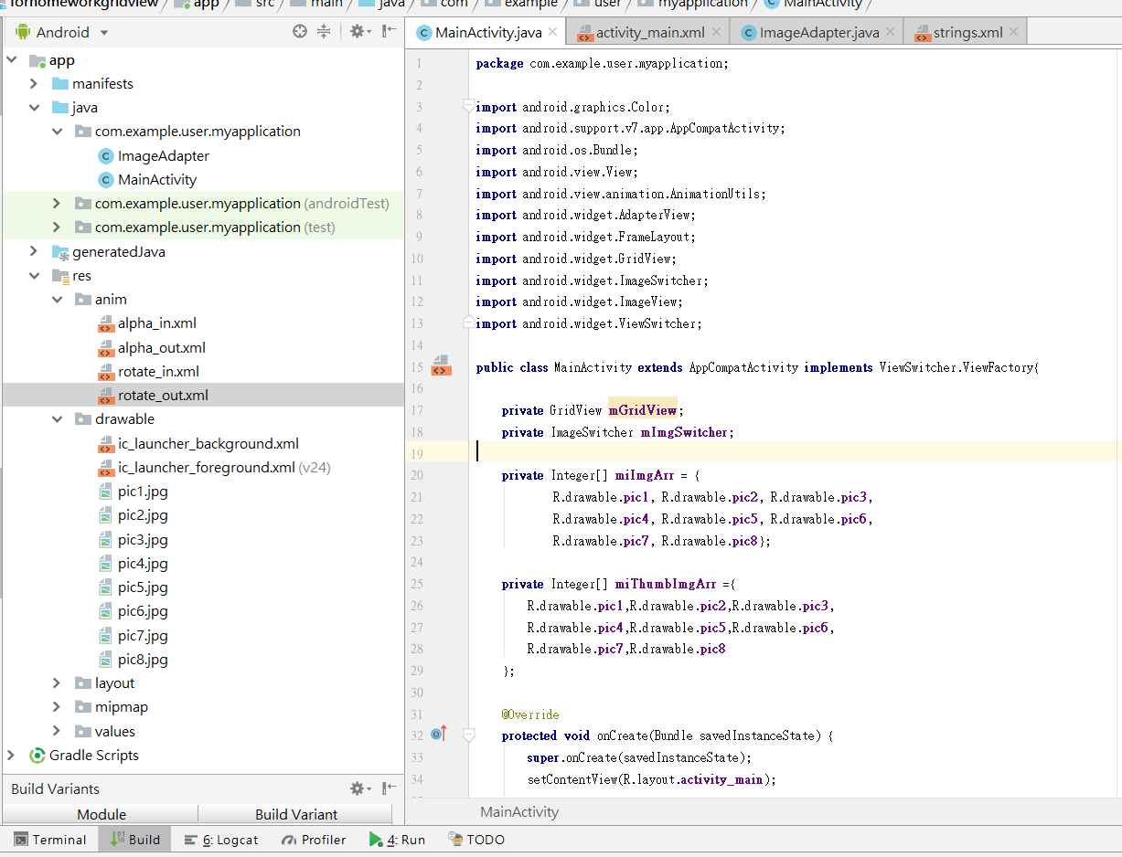

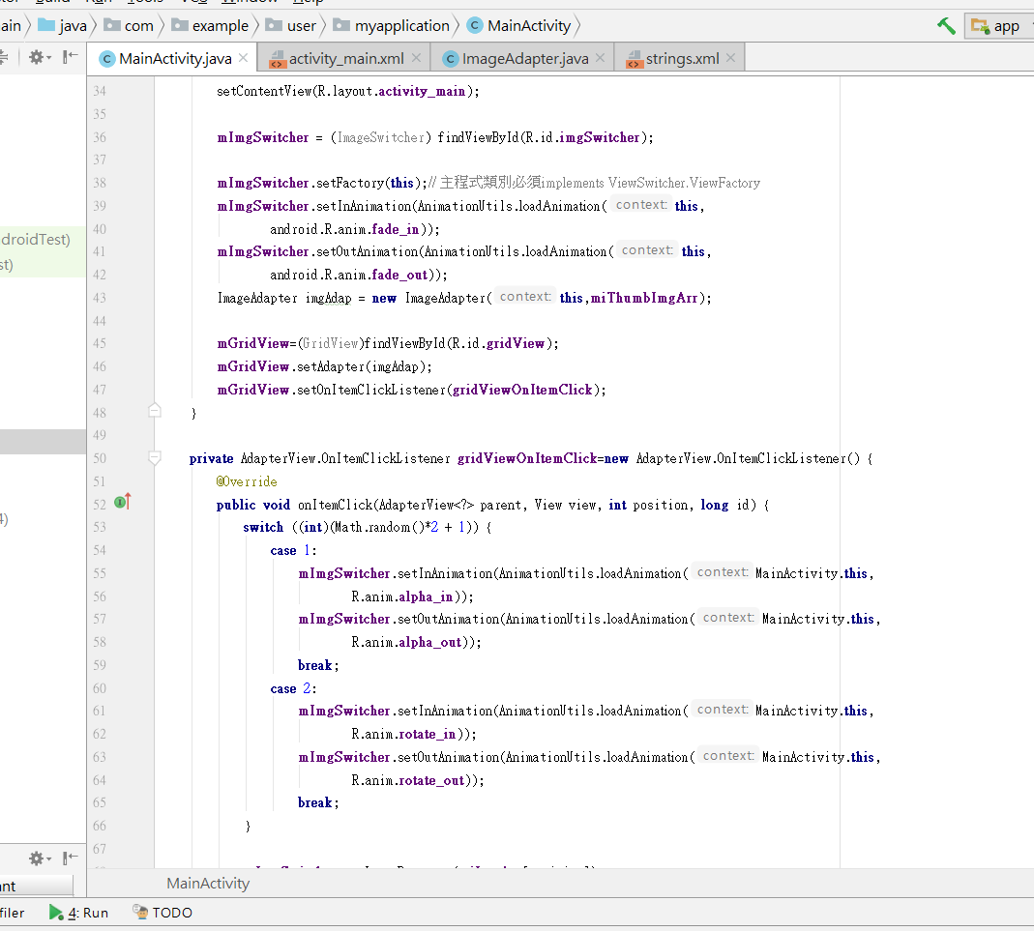

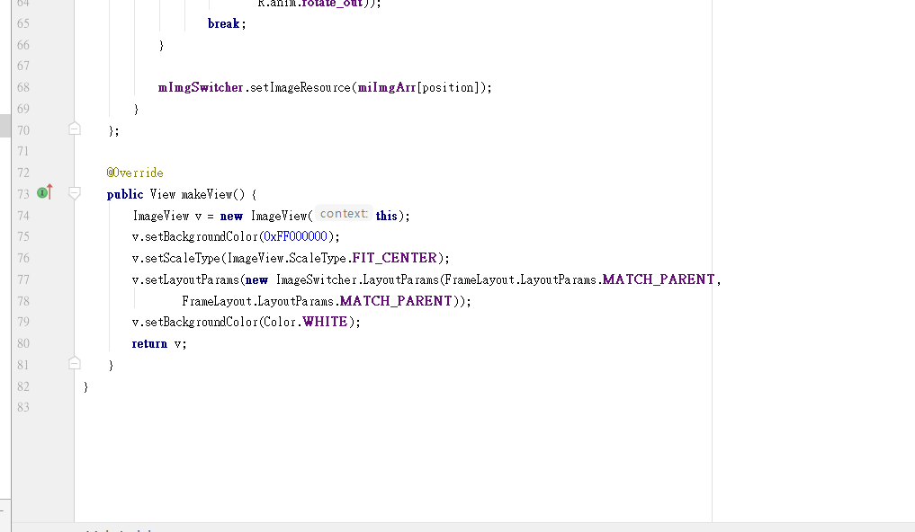

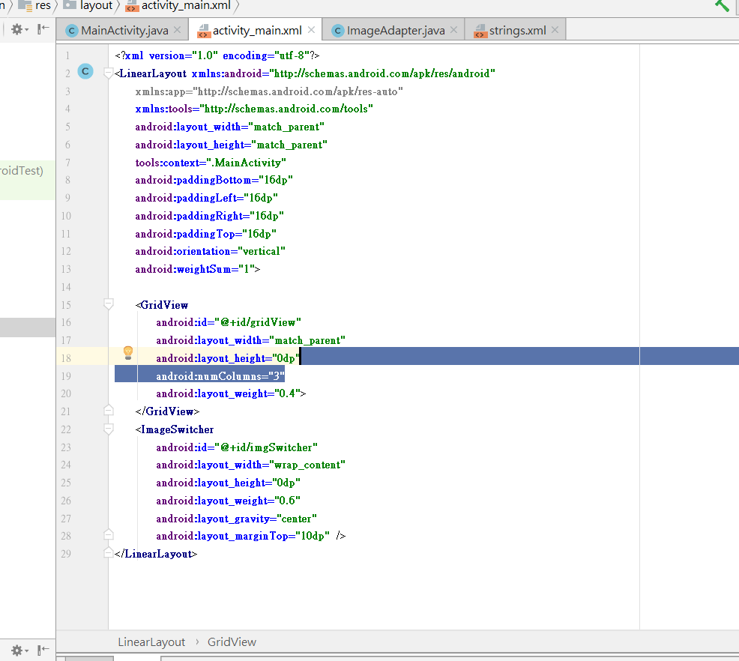

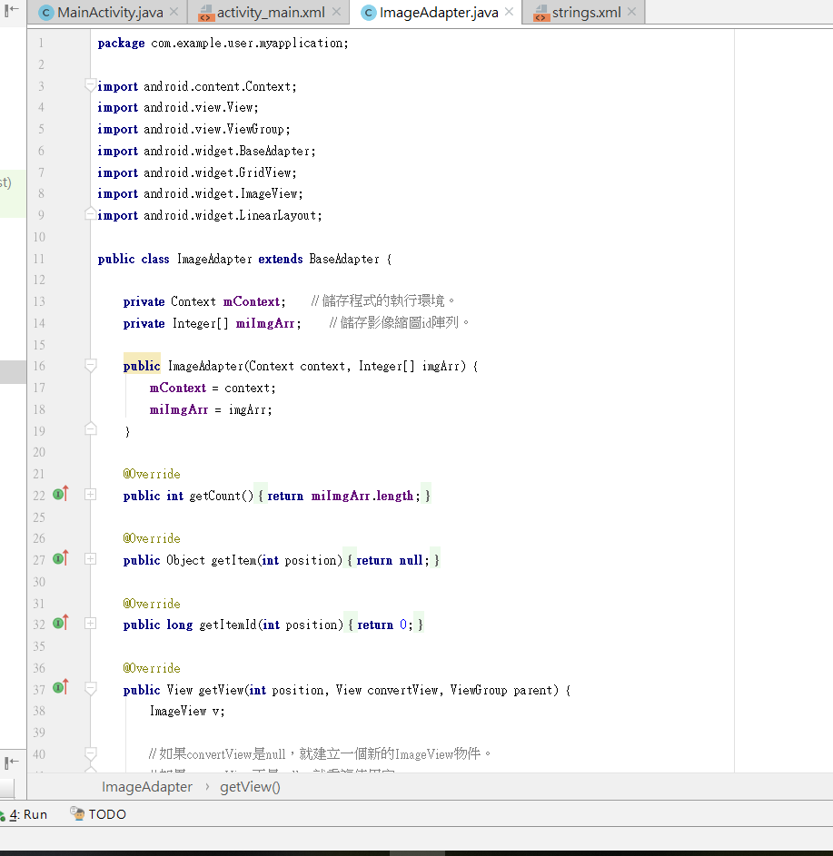

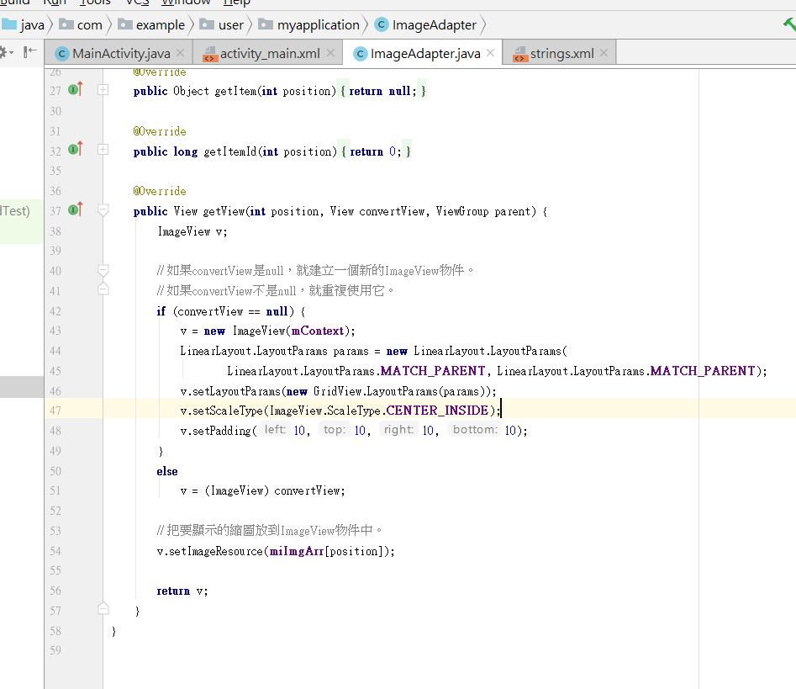

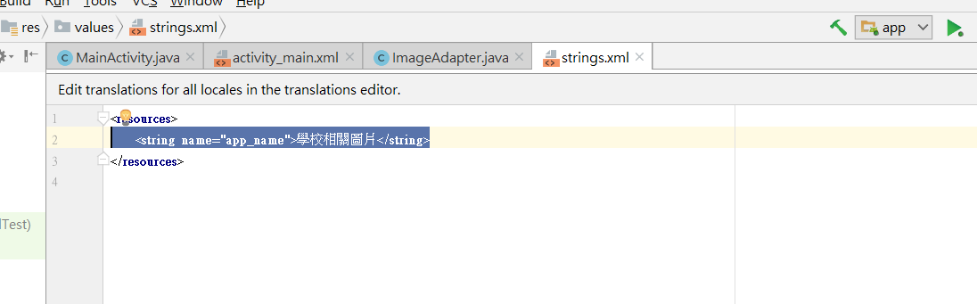

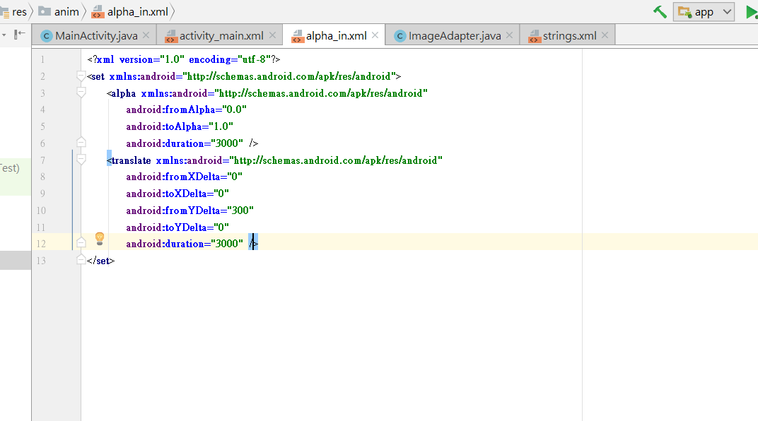

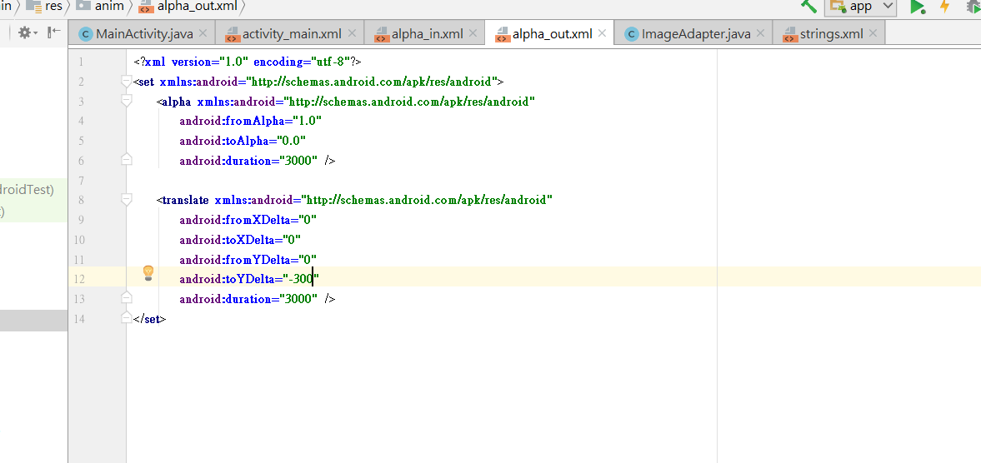

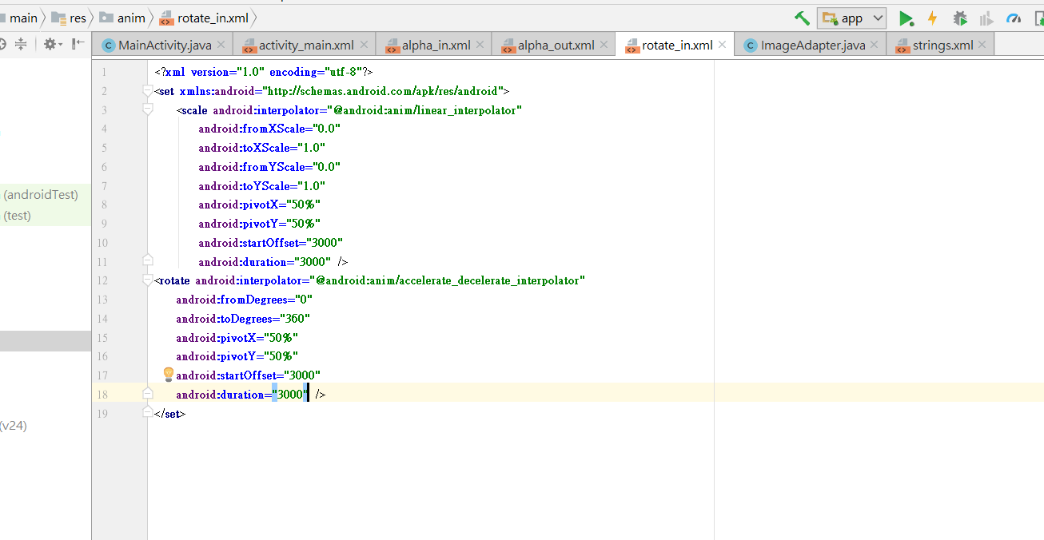

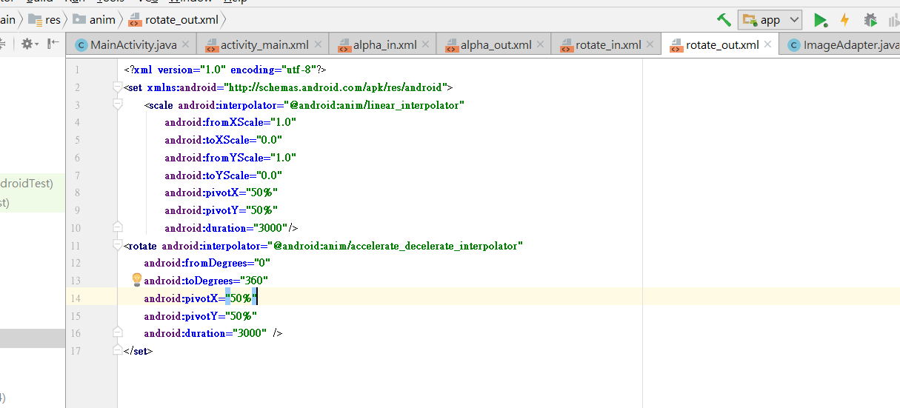

=========================================================================

**package** com.example.user.myapplication;  
  
**import** android.graphics.Color;  
**import** android.support.v7.app.AppCompatActivity;  
**import** android.os.Bundle;  
**import** android.view.View;  
**import** android.view.animation.AnimationUtils;  
**import** android.widget.AdapterView;  
**import** android.widget.FrameLayout;  
**import** android.widget.GridView;  
**import** android.widget.ImageSwitcher;  
**import** android.widget.ImageView;  
**import** android.widget.ViewSwitcher;  
  
**public class** MainActivity **extends** AppCompatActivity **implements** ViewSwitcher.ViewFactory{  
  
 **private** GridView **mGridView**;  
 **private** ImageSwitcher **mImgSwitcher**;  
  
 **private** Integer[] **miImgArr** = {  
 R.drawable.***pic1***, R.drawable.***pic2***, R.drawable.***pic3***,  
 R.drawable.***pic4***, R.drawable.***pic5***, R.drawable.***pic6***,  
 R.drawable.***pic7***, R.drawable.***pic8***};  
  
 **private** Integer[] **miThumbImgArr** ={  
 R.drawable.***pic1***,R.drawable.***pic2***,R.drawable.***pic3***,  
 R.drawable.***pic4***,R.drawable.***pic5***,R.drawable.***pic6***,  
 R.drawable.***pic7***,R.drawable.***pic8*** };  
  
 @Override  
 **protected void** onCreate(Bundle savedInstanceState) {  
 **super**.onCreate(savedInstanceState);  
 setContentView(R.layout.***activity_main***);  
  
 **mImgSwitcher** = (ImageSwitcher) findViewById(R.id.***imgSwitcher***);  
  
 **mImgSwitcher**.setFactory(**this**); *// 主程式類別必須implements ViewSwitcher.ViewFactory* **mImgSwitcher**.setInAnimation(AnimationUtils.*loadAnimation*(**this**,  
 android.R.anim.***fade_in***));  
 **mImgSwitcher**.setOutAnimation(AnimationUtils.*loadAnimation*(**this**,  
 android.R.anim.***fade_out***));  
 ImageAdapter imgAdap = **new** ImageAdapter(**this**,**miThumbImgArr**);  
  
 **mGridView**=(GridView)findViewById(R.id.***gridView***);  
 **mGridView**.setAdapter(imgAdap);  
 **mGridView**.setOnItemClickListener(**gridViewOnItemClick**);  
 }  
  
 **private** AdapterView.OnItemClickListener **gridViewOnItemClick**=**new** AdapterView.OnItemClickListener() {  
 @Override  
 **public void** onItemClick(AdapterView<?> parent, View view, **int** position, **long** id) {  
 **switch** ((**int**)(Math.*random*()*2 + 1)) {  
 **case** 1:  
 **mImgSwitcher**.setInAnimation(AnimationUtils.*loadAnimation*(MainActivity.**this**,  
 R.anim.***alpha_in***));  
 **mImgSwitcher**.setOutAnimation(AnimationUtils.*loadAnimation*(MainActivity.**this**,  
 R.anim.***alpha_out***));  
 **break**;  
 **case** 2:  
 **mImgSwitcher**.setInAnimation(AnimationUtils.*loadAnimation*(MainActivity.**this**,  
 R.anim.***rotate_in***));  
 **mImgSwitcher**.setOutAnimation(AnimationUtils.*loadAnimation*(MainActivity.**this**,  
 R.anim.***rotate_out***));  
 **break**;  
 }  
  
 **mImgSwitcher**.setImageResource(**miImgArr**[position]);  
 }  
 };  
  
 @Override  
 **public** View makeView() {  
 ImageView v = **new** ImageView(**this**);  
 v.setBackgroundColor(0xFF000000);  
 v.setScaleType(ImageView.ScaleType.***FIT_CENTER***);  
 v.setLayoutParams(**new** ImageSwitcher.LayoutParams(FrameLayout.LayoutParams.***MATCH_PARENT***,  
 FrameLayout.LayoutParams.***MATCH_PARENT***));  
 v.setBackgroundColor(Color.***WHITE***);  
 **return** v;  
 }  
}

=============================================================================

*<?***xml version="1.0" encoding="utf-8"***?>*<**LinearLayout xmlns:android="http://schemas.android.com/apk/res/android"  
 xmlns:app="http://schemas.android.com/apk/res-auto"  
 xmlns:tools="http://schemas.android.com/tools"  
 android:layout_width="match_parent"  
 android:layout_height="match_parent"  
 tools:context=".MainActivity"  
 android:paddingBottom="16dp"  
 android:paddingLeft="16dp"  
 android:paddingRight="16dp"  
 android:paddingTop="16dp"  
 android:orientation="vertical"  
 android:weightSum="1"**>  
  
 <**GridView  
 android:id="@+id/gridView"  
 android:layout_width="match_parent"  
 android:layout_height="0dp"  
 android:numColumns="3"  
 android:layout_weight="0.4"**>  
 </**GridView**>  
 <**ImageSwitcher  
 android:id="@+id/imgSwitcher"  
 android:layout_width="wrap_content"  
 android:layout_height="0dp"  
 android:layout_weight="0.6"  
 android:layout_gravity="center"  
 android:layout_marginTop="10dp"** />  
</**LinearLayout**>

=============================================================================

**package** com.example.user.myapplication;  
  
**import** android.content.Context;  
**import** android.view.View;  
**import** android.view.ViewGroup;  
**import** android.widget.BaseAdapter;  
**import** android.widget.GridView;  
**import** android.widget.ImageView;  
**import** android.widget.LinearLayout;  
  
**public class** ImageAdapter **extends** BaseAdapter {  
  
 **private** Context **mContext**; *// 儲存程式的執行環境。* **private** Integer[] **miImgArr**; *// 儲存影像縮圖id陣列。* **public** ImageAdapter(Context context, Integer[] imgArr) {  
 **mContext** = context;  
 **miImgArr** = imgArr;  
 }  
  
 @Override  
 **public int** getCount() {  
 **return miImgArr**.**length**;  
 }  
  
 @Override  
 **public** Object getItem(**int** position) {  
 **return null**;  
 }  
  
 @Override  
 **public long** getItemId(**int** position) {  
 **return** 0;  
 }  
  
 @Override  
 **public** View getView(**int** position, View convertView, ViewGroup parent) {  
 ImageView v;  
  
 *// 如果convertView是null，就建立一個新的ImageView物件。  
 // 如果convertView不是null，就重複使用它。* **if** (convertView == **null**) {  
 v = **new** ImageView(**mContext**);  
 LinearLayout.LayoutParams params = **new** LinearLayout.LayoutParams(  
 LinearLayout.LayoutParams.***MATCH_PARENT***, LinearLayout.LayoutParams.***MATCH_PARENT***);  
 v.setLayoutParams(**new** GridView.LayoutParams(params));  
 v.setScaleType(ImageView.ScaleType.***CENTER_INSIDE***);  
 v.setPadding(10, 10, 10, 10);  
 }  
 **else** v = (ImageView) convertView;  
  
 *// 把要顯示的縮圖放到ImageView物件中。* v.setImageResource(**miImgArr**[position]);  
  
 **return** v;  
 }  
}

=============================================================================

<**resources**>  
 <**string name="app_name"**>學校相關圖片</**string**>  
</**resources**>

=============================================================================

*<?***xml version="1.0" encoding="utf-8"***?>*<**set xmlns:android="http://schemas.android.com/apk/res/android"**>  
 <**alpha xmlns:android="http://schemas.android.com/apk/res/android"  
 android:fromAlpha="0.0"  
 android:toAlpha="1.0"  
 android:duration="3000"** />  
 <**translate xmlns:android="http://schemas.android.com/apk/res/android"  
 android:fromXDelta="0"  
 android:toXDelta="0"  
 android:fromYDelta="300"  
 android:toYDelta="0"  
 android:duration="3000"** />  
</**set**>

=============================================================================

*<?***xml version="1.0" encoding="utf-8"***?>*<**set xmlns:android="http://schemas.android.com/apk/res/android"**>  
 <**alpha xmlns:android="http://schemas.android.com/apk/res/android"  
 android:fromAlpha="1.0"  
 android:toAlpha="0.0"  
 android:duration="3000"** />  
  
 <**translate xmlns:android="http://schemas.android.com/apk/res/android"  
 android:fromXDelta="0"  
 android:toXDelta="0"  
 android:fromYDelta="0"  
 android:toYDelta="-300"  
 android:duration="3000"** />  
</**set**>

=============================================================================

*<?***xml version="1.0" encoding="utf-8"***?>*<**set xmlns:android="http://schemas.android.com/apk/res/android"**>  
 <**scale android:interpolator="@android:anim/linear_interpolator"  
 android:fromXScale="0.0"  
 android:toXScale="1.0"  
 android:fromYScale="0.0"  
 android:toYScale="1.0"  
 android:pivotX="50%"  
 android:pivotY="50%"  
 android:startOffset="3000"  
 android:duration="3000"** />  
<**rotate android:interpolator="@android:anim/accelerate_decelerate_interpolator"  
 android:fromDegrees="0"  
 android:toDegrees="360"  
 android:pivotX="50%"  
 android:pivotY="50%"  
 android:startOffset="3000"  
 android:duration="3000"** />  
</**set**>

=============================================================================

*<?***xml version="1.0" encoding="utf-8"***?>*<**set xmlns:android="http://schemas.android.com/apk/res/android"**>  
 <**scale android:interpolator="@android:anim/linear_interpolator"  
 android:fromXScale="1.0"  
 android:toXScale="0.0"  
 android:fromYScale="1.0"  
 android:toYScale="0.0"  
 android:pivotX="50%"  
 android:pivotY="50%"  
 android:duration="3000"**/>  
<**rotate android:interpolator="@android:anim/accelerate_decelerate_interpolator"  
 android:fromDegrees="0"  
 android:toDegrees="360"  
 android:pivotX="50%"  
 android:pivotY="50%"  
 android:duration="3000"** />  
</**set**>

=============================================================================