電通二乙微處理器實驗 實驗結報

實驗名稱 | Lab 11 – MCS Cloud
組別 | 35 | 組員 | 蘇世光

- 實驗目的
- MCS 控制 LED 閃爍
- 上傳A0資料

- 實驗步驟
- MCS新增ON/OFF 控制器/顯示器各一個 修改 MCS_GET code, 加入 MCS Remote
- 請新增 Integer顯示頻道，id “Temp”一樣要建立 test device將 A0 電阻值上傳

- 程式碼
a.
#include <LWiFi.h>
#include "MCS.h"

char _lwifi_ssid[] = "aguang";
char _lwifi_pass[] = "07130713";
MCSDevice mcs("DvgycIhc", "7tQLDu1lRoIqtUAu");

MCSControllerOnOff led("LED");
MCSDisplayOnOff remote("ledledledled");

void setup()
{
Serial.begin(9600);

Serial.println("Connect to Wifi");
while (WiFi.begin(_lwifi_ssid, _lwifi_pass) != WL_CONNECTED) {
Serial.println("Wifi Reconnecting..");
delay(1000);
}

Serial.println("Connect to MCS...");
while (!mcs.connected()) {
Serial.println("MCS Reconnecting..");
mcs.connect();
}
Serial.println("MCS Connected!");
mcs.addChannel(led);
mcs.addChannel(remote);
while(!mcs.connected())
{
Serial.println("MCS.connect()...");
mcs.connect();
}

pinMode(7, OUTPUT);

}

void loop()
{
while(!led.valid())
{
Serial.println("read LED value from MCS...");
led.value(); //取得MCS數值
}
Serial.print("done, LED value = ");
Serial.println(led.value()); //顯示出來
digitalWrite(7, led.value() ? HIGH : LOW);

while (!mcs.connected()) {
mcs.connect();
if (mcs.connected()) {
Serial.println("MCS Reconnect");
}
}
mcs.process(1000);

if (led.value() == 1) {
digitalWrite(7, HIGH);

} else {
digitalWrite(7, LOW);

}
delay(200);
if(!remote.set(led.value()))
{
Serial.print("Failed to update remote");
Serial.println(remote.value());
}
}
b.
#include <LWiFi.h>
#include "MCS.h"

char _lwifi_ssid[] = "aguang";
char _lwifi_pass[] = "07130713";
MCSDevice mcs("Da5TMV6D", "AWg8m03DKTNA5JoY");

MCSDisplayInteger Temp("Temp");

void setup()
{
Serial.begin(9600);

Serial.println("Connect to Wifi");
while (WiFi.begin(_lwifi_ssid, _lwifi_pass) != WL_CONNECTED) {
Serial.println("Wifi Reconnecting..");
delay(1000);
}

Serial.println("Connect to MCS...");
while (!mcs.connected()) {
Serial.println("MCS Reconnecting..");
mcs.connect();
}
Serial.println("MCS Connected!");

mcs.addChannel(Temp);

}

void loop()
{
while (!mcs.connected()) {
mcs.connect();
if (mcs.connected()) {
Serial.println("MCS Reconnect");
}
}
mcs.process(1000);

int sensor = analogRead(A0);

Temp.set(sensor);
Serial.println("Add sensor value.");
delay(200);
}
- 實驗結果及分析
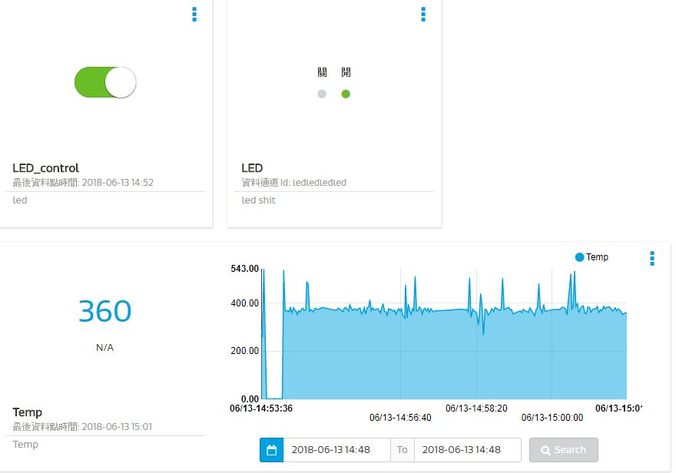
- 心得討論
這次實驗學習到mcs的各項使用方式 覺得很特別

- 修正程式碼
a.
#include <LWiFi.h>
#include "MCS.h"

char _lwifi_ssid[] = "aguang";
char _lwifi_pass[] = "07130713";
MCSDevice mcs("DvgycIhc", "7tQLDu1lRoIqtUAu");

MCSControllerOnOff led("LED");
MCSDisplayOnOff remote("ledledledled");

void setup()
{
Serial.begin(9600);

Serial.println("Connect to Wifi");
while (WiFi.begin(_lwifi_ssid, _lwifi_pass) != WL_CONNECTED) {
Serial.println("Wifi Reconnecting..");
delay(1000);
}

Serial.println("Connect to MCS...");
while (!mcs.connected()) {
Serial.println("MCS Reconnecting..");
mcs.connect();
}
Serial.println("MCS Connected!");
mcs.addChannel(led);
mcs.addChannel(remote);
while(!mcs.connected())
{
Serial.println("MCS.connect()...");
mcs.connect();
}

pinMode(7, OUTPUT);

}

void loop()
{
while(!led.valid())
{
Serial.println("read LED value from MCS...");
led.value(); //取得MCS數值
}
Serial.print("done, LED value = ");
Serial.println(led.value()); //顯示出來
digitalWrite(7, led.value() ? HIGH : LOW);

while (!mcs.connected()) {
mcs.connect();
if (mcs.connected()) {
Serial.println("MCS Reconnect");
}
}
mcs.process(1000);

if (led.value() == 1) {
digitalWrite(7, HIGH);

} else {
digitalWrite(7, LOW);

}
delay(200);
if(!remote.set(led.value()))
{
Serial.print("Failed to update remote");
Serial.println(remote.value());
}
}
b.
#include <LWiFi.h>
#include "MCS.h"

char _lwifi_ssid[] = "aguang";
char _lwifi_pass[] = "07130713";
MCSDevice mcs("Da5TMV6D", "AWg8m03DKTNA5JoY");

MCSDisplayInteger Temp("Temp");

void setup()
{
Serial.begin(9600);

Serial.println("Connect to Wifi");
while (WiFi.begin(_lwifi_ssid, _lwifi_pass) != WL_CONNECTED) {
Serial.println("Wifi Reconnecting..");
delay(1000);
}

Serial.println("Connect to MCS...");
while (!mcs.connected()) {
Serial.println("MCS Reconnecting..");
mcs.connect();
}
Serial.println("MCS Connected!");

mcs.addChannel(Temp);

}

void loop()
{
while (!mcs.connected()) {
mcs.connect();
if (mcs.connected()) {
Serial.println("MCS Reconnect");
}
}
mcs.process(1000);

int sensor = analogRead(A0);

Temp.set(sensor);
Serial.println("Add sensor value.");
delay(200);
}

