NEWWWWWWWWWWWWW

Steps to reproduce the Unicode git commit message issue:

1. Use the git client to create a commit in the local workspace
2. Enter the string: ΈΏØØØÕÕÐÐÑÑææææããã in the git commit message.

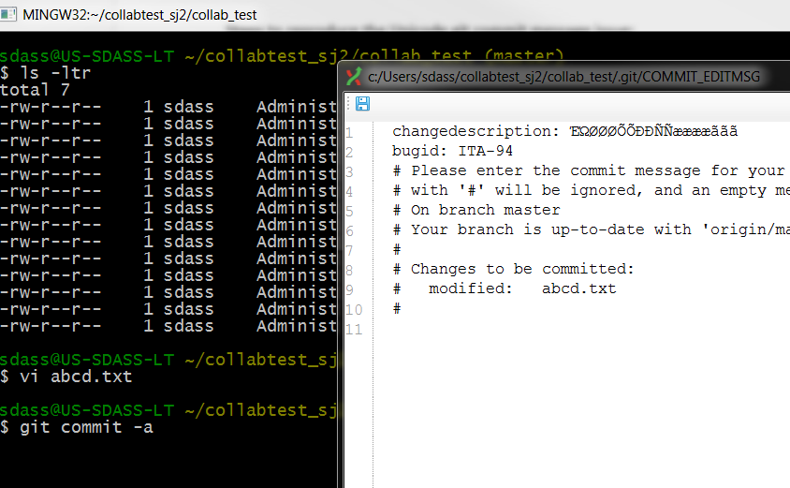

1. Once the commit is done, you will be able to use git log to see the commit as below:

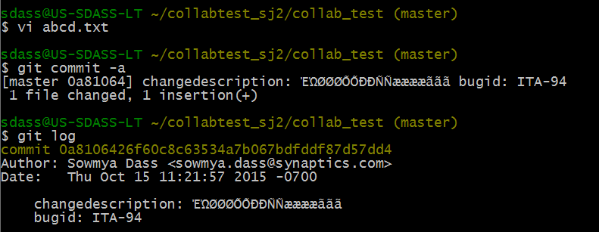

1. We have a Python script that does auto review creation and uploads the git commit to the review:

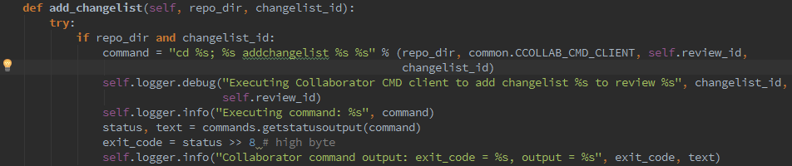

Where the variable repo_dir is the git repository location in our git server, CCOLLAB_CMD_CLIENT contains the command line client executable, review_id is the review to which the review materials will be uploaded, and changelist_id contains the commit id that contains the review materials that will be attached to the review.

The command string is assembled as specified in the previous paragraph and is executed via the commands standard python library; after the command is executed we just get the command output and send it to log.

1. We get a notification regarding the review creation

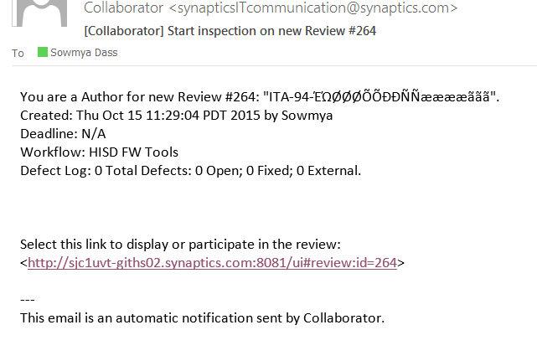

1. I get to see the review on the web interface:

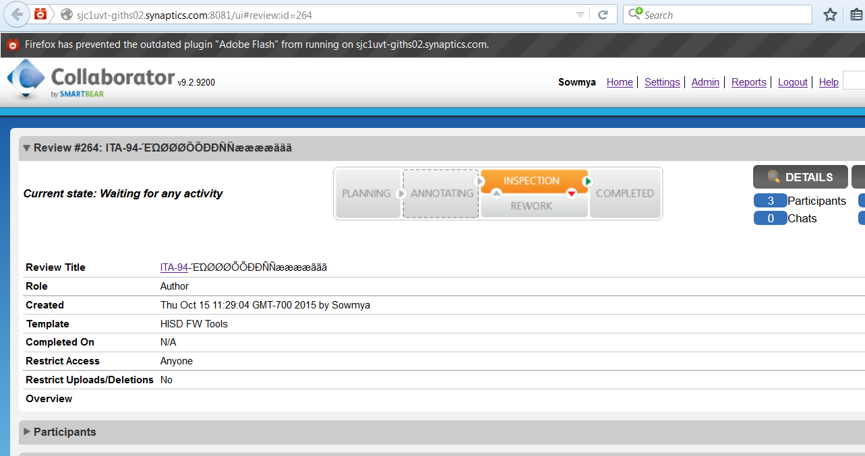

1. Although the review of the title (that includes the git commit message) displays the Unicode characters properly, the review materials section does not display it right:

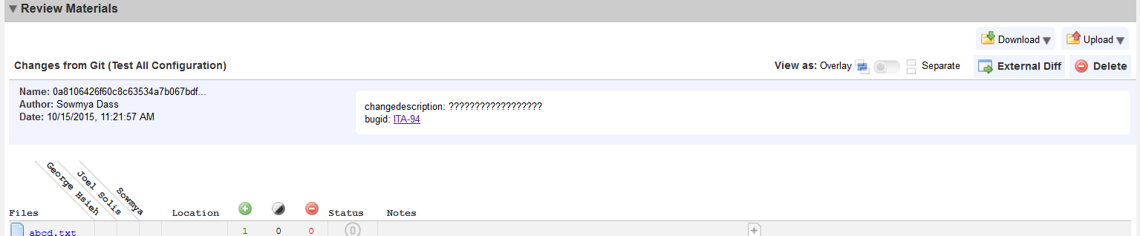

There are ????? embedded instead of the actual message.