[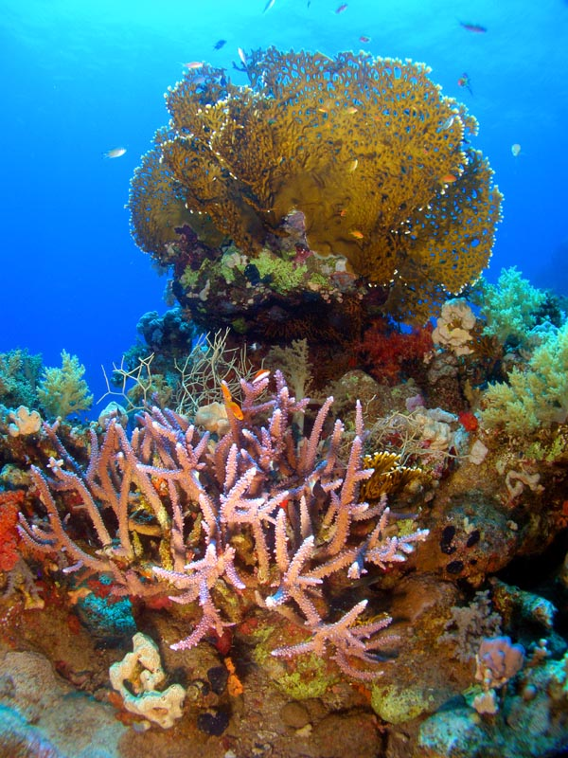](http://www.google.co.il/url?sa=i&rct=j&q=&esrc=s&frm=1&source=images&cd=&cad=rja&docid=hypFKJzOjnjRtM&tbnid=AOMuouqKWtmfEM:&ved=0CAUQjRw&url=http://www.diving.org.il/index2.php?id%3D98%26lang%3DHEB&ei=gDNNUqHJL8mRtQaK4IDIAQ&bvm=bv.53537100,d.d2k&psig=AFQjCNE1WQzLsz2UQgD3JhfHZSVZA7vJXQ&ust=1380877556158067)[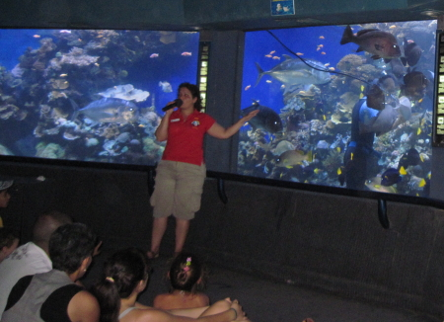](http://www.google.co.il/url?sa=i&rct=j&q=&esrc=s&frm=1&source=images&cd=&cad=rja&docid=UYjA4YvlAhIZnM&tbnid=lbCNo-Jk3ZAm5M:&ved=0CAUQjRw&url=http://www.imaba.co.il/article.php?pid%3D1158&ei=BzBNUpGgJZSM0wXny4EY&bvm=bv.53537100,d.d2k&psig=AFQjCNFbj5eRXGBYZuttEcpn6ijkQ3WOmQ&ust=1380876540019309)

[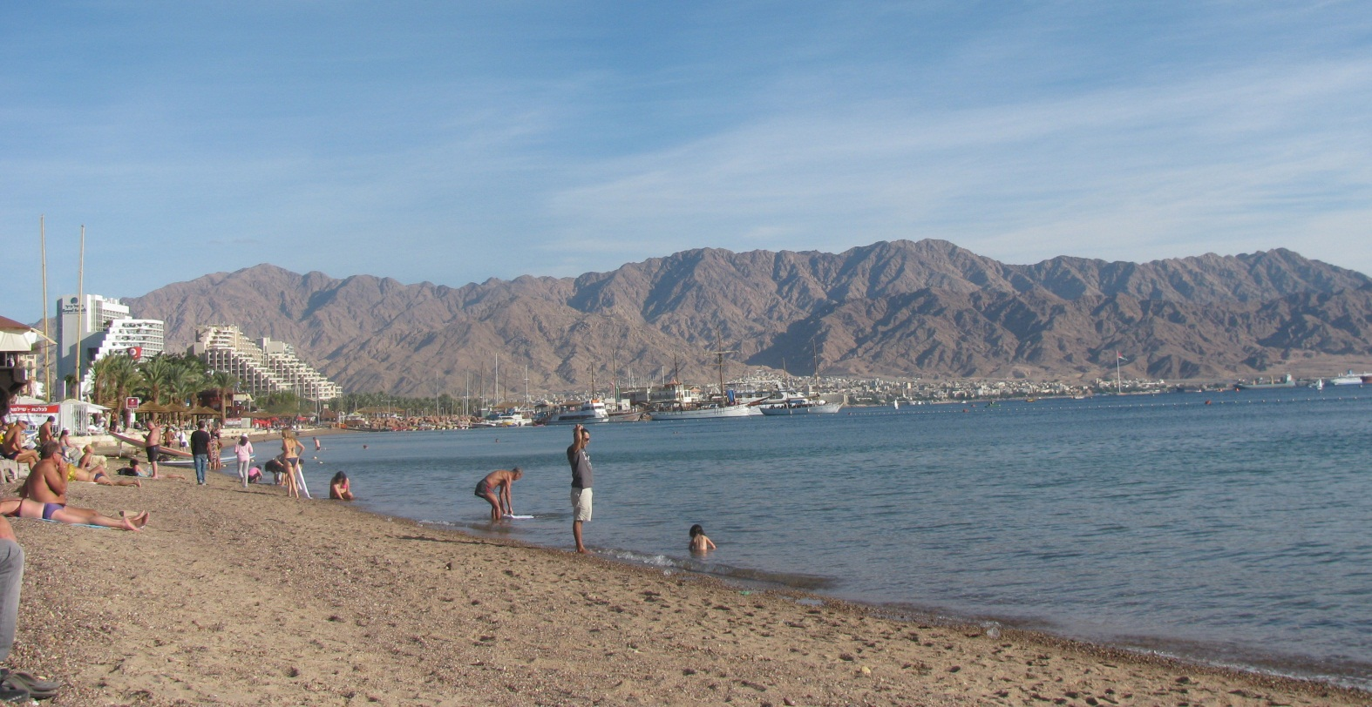](http://www.google.co.il/url?sa=i&rct=j&q=&esrc=s&frm=1&source=images&cd=&cad=rja&docid=qQPMoN-wZbXepM&tbnid=LikzrKLc7Y1T1M:&ved=0CAUQjRw&url=http://2012thelandlovers.wordpress.com/2012/12/14/serve-learn-and-grow-a-ministry-report/eilat-1/&ei=ETpNUq67DoqK0AWBqYHoCQ&bvm=bv.53537100,d.d2k&psig=AFQjCNFtlH323T9tbRm38xtLdKfnDhmjjA&ust=1380879219481940)[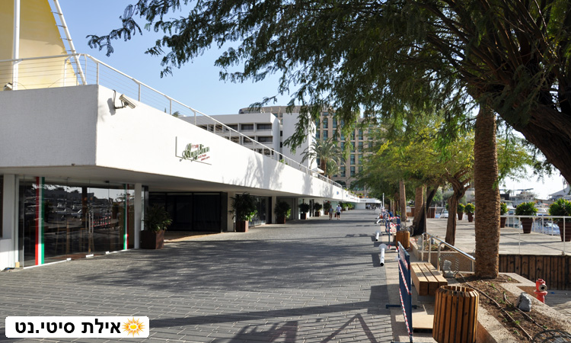](http://www.google.co.il/url?sa=i&rct=j&q=&esrc=s&frm=1&source=images&cd=&cad=rja&docid=VC92nXTx1-aApM&tbnid=_W26Akg6j_uBrM:&ved=0CAUQjRw&url=http://www.eilat-city.net/Article.aspx?ArticleId%3D504&ei=AjNNUuLHFcnItQa-x4CICA&bvm=bv.53537100,d.d2k&psig=AFQjCNHMkXzRMkZLZDhfbWMvHnMK26HYxg&ust=1380877293163978)

[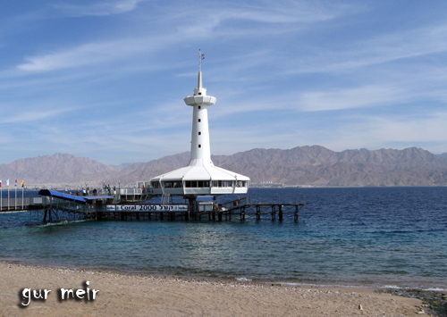](http://www.google.co.il/url?sa=i&rct=j&q=&esrc=s&frm=1&source=images&cd=&cad=rja&docid=6ueIw6BRmOBblM&tbnid=hK4L1NOyWngHsM:&ved=0CAUQjRw&url=http://www.tapuz.co.il/blog/net/viewentry.aspx?entryId%3D1377762&ei=hDBNUovZEqek0QWJhIGwBg&bvm=bv.53537100,d.d2k&psig=AFQjCNFbj5eRXGBYZuttEcpn6ijkQ3WOmQ&ust=1380876540019309)

[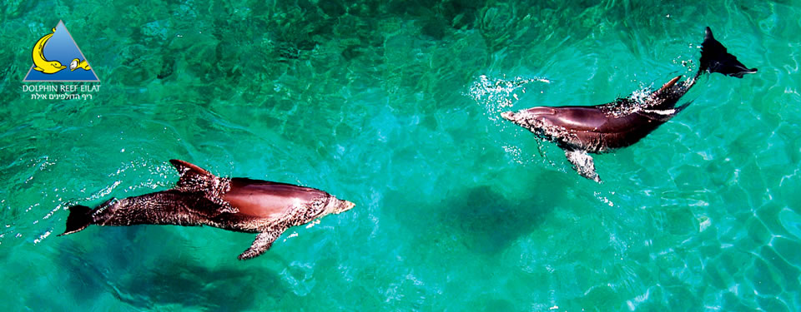](http://www.google.co.il/url?sa=i&rct=j&q=&esrc=s&frm=1&source=images&cd=&cad=rja&docid=S_0HCGsyWSl_7M&tbnid=3pBRNAEAVwPYpM:&ved=0CAUQjRw&url=http://hebrew.dolphinreef.co.il/&ei=WDFNUpWkBYGOtAbPo4CgDQ&bvm=bv.53537100,d.d2k&psig=AFQjCNFDUEbxJKzCNrmBRjkDJMC41AV0wA&ust=1380876956034139)

[](http://www.google.co.il/url?sa=i&rct=j&q=&esrc=s&frm=1&source=images&cd=&cad=rja&docid=fyGOB0eHqVQe9M&tbnid=s-96OjwM0nwmpM:&ved=0CAUQjRw&url=http://www.amitkadosh.co.il/?categoryId%3D34872&ei=xDFNUtbPIcXbtAaImYCACg&bvm=bv.53537100,d.d2k&psig=AFQjCNFDUEbxJKzCNrmBRjkDJMC41AV0wA&ust=1380876956034139)

[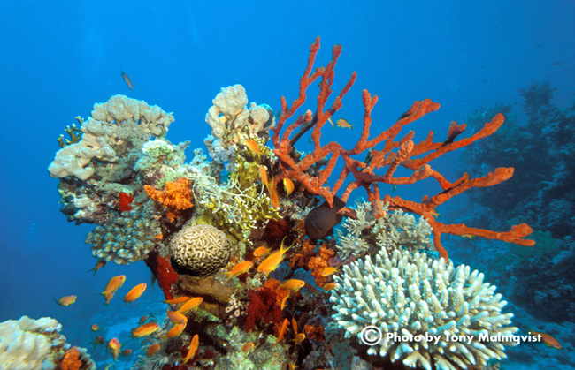](http://www.google.co.il/url?sa=i&rct=j&q=&esrc=s&frm=1&source=images&cd=&cad=rja&docid=x6SxbAT1rTPeDM&tbnid=rQu21hsnQiBD2M:&ved=0CAUQjRw&url=http://www.coralworld.co.il/he/ArticleItem/144&ei=MDJNUouWCIzRsgbUgoCIBQ&bvm=bv.53537100,d.d2k&psig=AFQjCNH8nA8J2u3HO2bNAF84cFlHcFvKNg&ust=1380877181909986)

[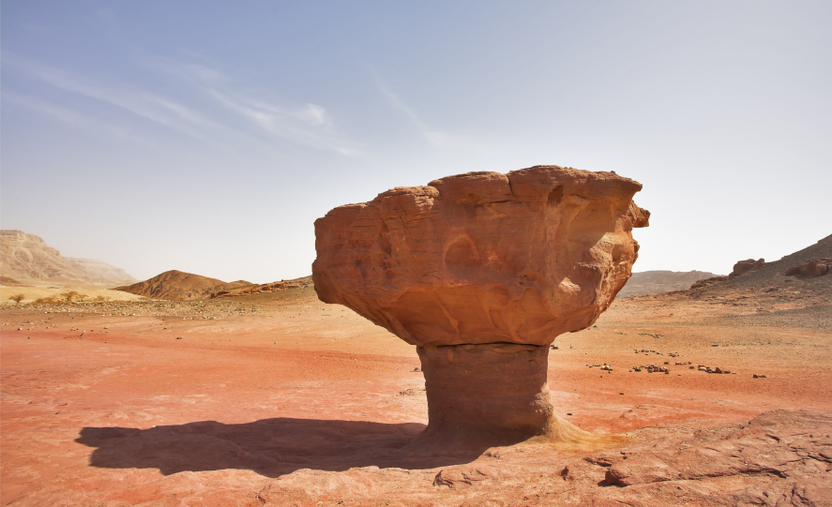](http://www.google.co.il/url?sa=i&rct=j&q=&esrc=s&frm=1&source=images&cd=&cad=rja&docid=zwkMlUDuaOHqkM&tbnid=qZBwa47N8zOlBM:&ved=0CAUQjRw&url=http://www.eilot.org.il/%D7%9B%D7%A0%D7%A1-%D7%91%D7%99%D7%A0%D7%9C%D7%90%D7%95%D7%9E%D7%99-%D7%9C%D7%97%D7%A7%D7%A8-%D7%A4%D7%90%D7%A8%D7%A7-%D7%AA%D7%9E%D7%A0%D7%A2-%D7%9C%D7%96%D7%9B%D7%A8-%D7%A4%D7%A8%D7%95%D7%A4/&ei=QzVNUuX3N8XWtAauyIGIBQ&bvm=bv.53537100,d.d2k&psig=AFQjCNH-ZAO2O84G7PcCcRsquzIvW6JGOw&ust=1380877805640207)

[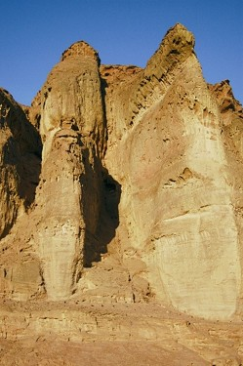](http://www.google.co.il/url?sa=i&rct=j&q=&esrc=s&frm=1&source=images&cd=&cad=rja&docid=it0s-CeqAiCCrM&tbnid=QooY0qfmlKdoGM:&ved=0CAUQjRw&url=http://www.zimmer.co.il/premium.asp?site_id%3D2660&ei=1zVNUr3rHcWAtAakzYGoDw&bvm=bv.53537100,d.d2k&psig=AFQjCNH-ZAO2O84G7PcCcRsquzIvW6JGOw&ust=1380877805640207)

[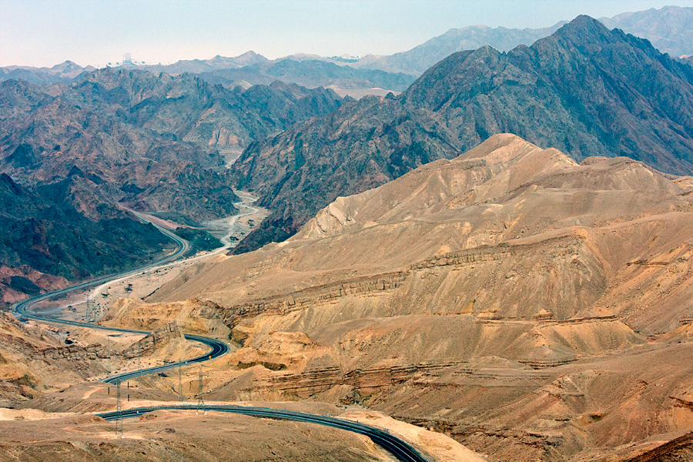](http://www.google.co.il/url?sa=i&rct=j&q=&esrc=s&frm=1&source=images&cd=&cad=rja&docid=c58ngS2AAp16AM&tbnid=y7qvGLnTYbi9yM:&ved=0CAUQjRw&url=http://www.photolight.co.il/show_photo/637829.html&ei=JDRNUp74OIXTsga1_YCQDQ&bvm=bv.53537100,d.d2k&psig=AFQjCNHkiMb8HWDDL5ixfJPZqLo5FjHCNQ&ust=1380877654872901)[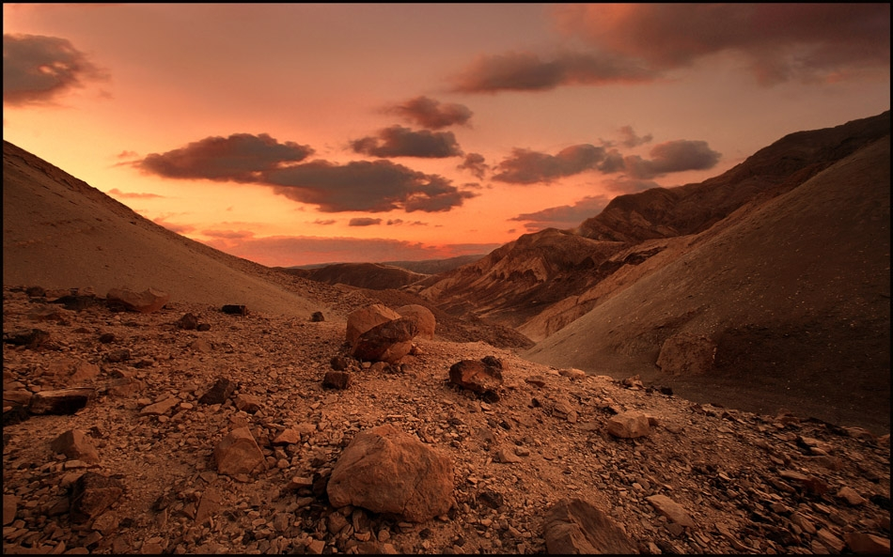](http://www.google.co.il/url?sa=i&rct=j&q=&esrc=s&frm=1&source=images&cd=&cad=rja&docid=c58ngS2AAp16AM&tbnid=y7qvGLnTYbi9yM:&ved=0CAUQjRw&url=http://photolight.co.il/show_photo/250007.html&ei=-jNNUtXuCYmRtQaT_IC4Dw&bvm=bv.53537100,d.d2k&psig=AFQjCNHkiMb8HWDDL5ixfJPZqLo5FjHCNQ&ust=1380877654872901)