#### GUstavo garzón

#### D:\ggarzon_200x200.jpgEducation

Ms(c) Systems Engineering

B.Sc, Systems Engineering

Tech. Web Development

#### Contact Info

#### [gustavo.garzon@saber.uis.edu.co](mailto:gustavo.garzon@saber.uis.edu.co)

#### [gustavogarzonuis@gmail.com](mailto:gustavogarzonuis@gmail.com)

Gustavo Garzón is currently a candidate for Master in Systems Engineering and Informatics at [Universidad Industrial de Santander](http://www.uis.edu.co/) (Colombia). His research interests include: action recognition, pattern recognition, computer vision, motion analysis, image processing and machine learning. He works at BIVLab as Research Assistant and helps with student advising on computer vision related areas.

**Current research**

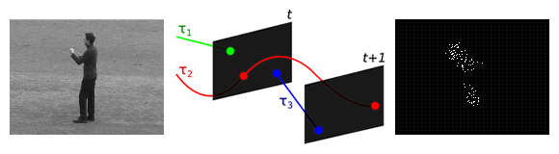***An efficient Spatio-temporal strategy for action recognition***

This work proposes an efficient gesture recognition descriptor that processes salient points represented from improved motion trajectories on each frame. A Poisson grid is adjusted and point-ocurrences are stored into a histogram. Histograms of Optical Flow (HOOF) and Motion Boundary (MBH) are then added for robustness, resulting in a joint spatio-temporal motion descriptor. The proposed motion descriptor shows to be competitive to represent gestures in videos, robust to local changes on movement and shows a low computational cost.

**Publications**

**A local Poisson-salient point representation to efficiently characterize human actions.**

Gustavo Garzón, Fabio Martínez.

Status: pending revision.

**Frame-Level Covariance Descriptor for Action Recognition.**

Wilson Moreno, Gustavo Garzón, Fabio Martínez. Colombian Conference on Computing, 13CCC 2018.

DOI: https://doi.org/10.1007/978-3-319-98998-3\_22

**Reconocimiento autómatico de acciones utilizando puntos salientes espacio-temporales analizados en una piramide espacial y codificados con la distribución de poisson.**

Gustavo Garzón, Fabio Martínez. Memorias II Congreso Internacional de Investigación y II Encuentro Regional de Semilleros de investigación 2017. ISSN: 2538-9947.

#### JEFFERSON RODRÍGUEZ

#### 

#### Education

Ms(c) Systems Engineering

B.Sc, Systems Engineering

#### Contact Info

#### contact.me@jeffersonrodriguez.co

jefferson.rodriguez2@saber.uis.edu.co

#### I’m from Bucaramanga in Colombia. Passionate about computer vision, technology, travel, football and cycling. Currently, I’m a Master’s student in Computer Science and I work at Biomedical imaging, Vision and Learning Laboratoy (BivLab).

#### Interests: Artificial intelligence, Machine learning, Gesture recognition, Image and video processing

**Current research**

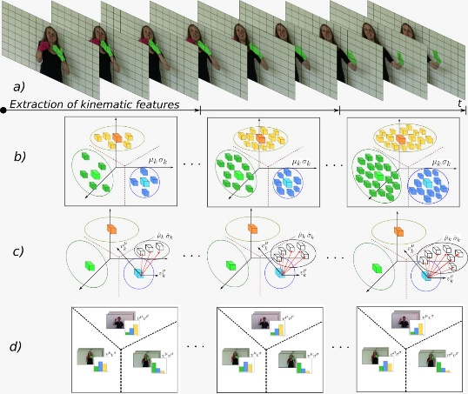

***Reconocimiento continuo de expresiones cortas en el lenguaje de señas registrado en secuencias de vídeo.***

Las actuales propuestas para el reconocimiento de gestos en el lenguaje de señas están enfocadas tanto en análisis globales como locales, realizando segmentaciones totales de los articuladores y utilizando representaciones de puntos de interés para capturar información local. Por otro lado, un problema de interés con complejidad adicional es el reconocimiento continuo de gestos o expresiones cortas. Su dificultad radica en relacionar los gestos que componen cada expresión, los cuales tienen coherencia temporal y gramatical. Nuevos enfoques que trabajan este desafío se basan en métodos estadísticos que modelan cada seña. La presente propuesta busca desarrollar una estrategia computacional para el reconocimiento continuo de señas registradas en vídeos, teniendo en cuenta tanto la variabilidad local de cada gesto como la variación a lo largo de su descripción gramatical. El proceso se inicia capturando secuencias de videos que registran diferentes sentencias gramaticales en el lenguaje. Estas secuencias serán analizadas para determinar las características espacio-temporales que permitan una apropiada representación de los gestos durante el video. Una vez los gestos son caracterizados localmente, se desarrollarán métodos que permitan capturar la coherencia temporal de los gestos para reconocer frases cortas. El modelo de caracterización continuo será mapeado a un algoritmo de aprendizaje de máquina, previamente entrenado, para obtener una clasificación automática de las señas.

**Publications**

**A kinematic gesture representation based on Shape Difference VLAD for Sign language recognition.**

Jefferson Rodríguez, Fabio Martínez.

In ICCVG, Published, 2018.

**Towards on-line sign language recognition using cumulative SD-VLAD descriptors.**

Jefferson Rodríguez, Fabio Martínez.

In 13CCC, Published, 2018.

#### ISAIL SALAZAR

#### 

#### Education

Ms(c) Systems Engineering

B.Sc, Electronic Engineering

#### Contact Info

#### isail.salazar@saber.uis.edu.co

isail1995@hotmail.com

#### Isail Salazar is currently a candidate for Master in Systems Engineering and Informatics at Universidad Industrial de Santander (Colombia), where he's associated at Biomedical Imaging, Vision and Learning Laboratory (BIVLab) and Motion Analysis and Computer Vision (MACV) collective. His research work has been focused mainly in image segmentation, RGB-D image processing, eye movement analysis and motion magnification.

**Projects**

***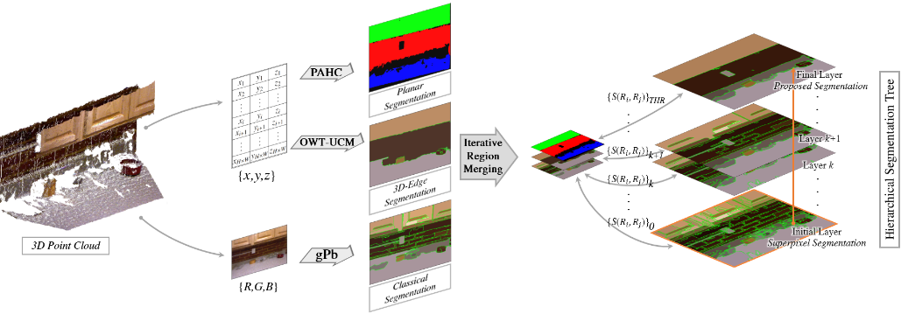***

***A Methodology for Image Segmentation Using Superpixels and Depth Information***

In the last few years, the availability of low cost color-plus-depth (RGB-D) cameras (e.g., Microsoft's Kinect) has opened up new research possibilities. This work presents a methodology that allows the integration of depth information to the segmentation problem. The color image is over-segmented into several superpixels to thereafter be processed by a depth-aware region merging approach. A 3D point cloud is reconstructed from the depth information to detect relevant 3D features: planes and contours. These features are then translated into coarse segmentations which serve as support to the merging process. The output is a final segmentation from superpixels.

**Publications**

**A Methodology for Image Segmentation Using Superpixels and Depth Information**

Isail Salazar, Fabio Martínez, Said Pertuz.

Status: pending revision.

**Parkinsonian Hand Tremor Characterization from Magnified Video Sequences**

Sergio Contreras, Isail Salazar, Fabio Martínez. 14th International Symposium on Medical Information Processing and Analysis, SIPAIM 2018.

#### WILSON MORENO

#### Education

B.Sc, Systems Engineering

#### Contact Info

#### widamo\_456@hotmail.com

widamo456@gmail.com

#### Actualmente soy estudiante de pregrado de décimo semestre en Ingeniería de Sistemas en la Universidad Industrial de Santander, Colombia. Pertenezco al semillero de Análisis de Movimiento y Visión por Computador (MACV) como tesista en el proyecto de grado "Reconocimiento de actividades utilizando la covarianza como un descriptor espacio-temporal" y ayudo con el asesoramiento estudiantil en áreas relacionadas con la visión por computador. Mis áreas de interés en investigación incluyen: reconocimiento de actividades, visión por computador, análisis de movimiento, procesamiento en vídeo y aprendizaje automático.

**Current research**

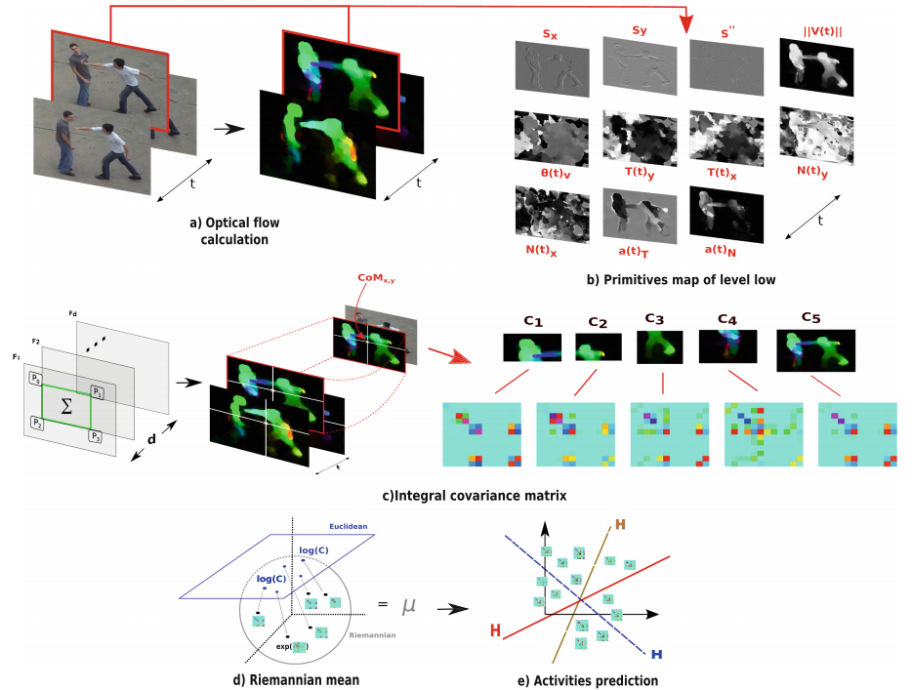***Frame-Level Covariance Descriptor for Action Recognition***

This work proposes a spatio-temporal descriptor that model human activities by using a fast regional covariance representation for each frame. At each frame, a set of motion and geometrical map measures are quantified into a pyramidal regional structure to describe the instantaneous action. Such low-level primitive maps are codified into a integral covariance that allows a fast and compact description of local correlation among features. The set of pyramidal-frame-covariances along the video sequence represent a manifold that coexist in a positive Riemannian space. Then, a set of means are approximated in Riemannian space for each regional covariance sequence to represent a very compact action descriptor. The proposed action descriptor is mapped to a Euclidean space to perform an automatic classification using a Support vector Machine. The proposed approach was evaluated in two different public datasets: (1) in UT-Interaction with a k-fold cross-validation scheme was achieved a 70.8% of accuracy with a descriptor size of just 10 features per video sequence and (2) in UCF Sports achieve an accuracy of 71.7% using 13 features.

**Publications**

**Frame-Level Covariance Descriptor for Action Recognition.**

Wilson Moreno, Gustavo Garzón, Fabio Martínez. Colombian Conference on Computing, 13CCC 2018.

DOI: https://doi.org/10.1007/978-3-319-98998-3\_22

#### LUIS CARLOS GUAYACÁN

#### 

#### Education

B.Sc, Electronic Engineering

#### Contact Info

#### lucaguch@gmail.com

luisguayacan@correo.uis.edu.co

#### Electronic Engineer of the Universidad Industrial de Santander, Colombia. Active member of the Motion Analysis and Computer Vision (MACV) group. He is currently working on the project "Regional kinematic characterization of motion trajectories to classify gait patterns". Student advisor in areas related to computer vision and electronic systems. His areas of research interest include: activity recognition, computer vision, machine learning, motion analysis, video processing and digital image processing.

**Current research**

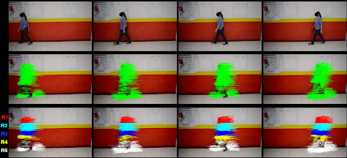

***Parkinsonian Gait Characterization from Regional Kinematic Trajectories***

The diagnosis and treatment of parkinsonian patients at different stages is typically supported by a Kinematic analysis. In clinical routine, such analysis is related with the quantitative and qualitative description of body segment displacements, computed from a reduced set of markers. Nevertheless, classical markers-based analysis has strong limitations to capture local and regional dynamic relationships associated with shuffling gait patterns. Particularly, the sparse set of markers lost sensitivity to detect progression of disease and commonly this kinematic characterization is restricted only to advanced stages. This work introduces a new hierarchical parkinsonian gait descriptor that coded kinematics at local and regional levels. At local level, a patial Kinematic Pattern (SKP) is computed as circular binary occurrence vectors, along trajectories. Regionally, such local vectors are grouped to describe body segments motions. Each of these regions coarsely correspond to the head, trunk and limbs. From each independent region is possible to describe kinematic patterns associated with the disease.

**Publications**

**Parkinsonian Gait Characterization from Regional Kinematic Trajectories**

Luis Carlos Guayacán, Brayan Valenzuela, Fabio Martínez. 14th International Symposium on Medical Information Processing and Analysis, SIPAIM 2018.