|  |  |
| --- | --- |
| TOURNAMENT PLANNER  Project 2 | **Victor Andres Guijarro Montalvo** |

CONTENT

Installation 3

Requirements 3

Steps 3

What is the solution for the problem? 4

Key insights from your user testing and validation. 4

User guide 5

PROJECT NAME 5

DESIGN SPRING CHALLENGE 5

DELIVERABLES 5

LOGISTICS 5

Who: 5

Where: 5

When: 5

TIMELINE 5

Current state of the project 5

What’s been created already? 5

Vision for the project 5

Roadblocks or gaps 5

What could prevent the team from reaching success? What are their gaps in knowledge or lack of support? 5

PATH FROM THE SPRINT TO PROTOTYPE 5

Sprint Ends: 5

Deliverables Due: 5

How does the sprint point the team towards a prototype to use for user research? You want to leverage sprints to achieve real progress. 6

SPRINT AGENDA 6

High Level Scheduled 6

Detailed Level Scheduled 6

Design Sprint Deliverables 6

Feedback for User Testing 6

What do users like? 6

Do users know what the product is with little prompting? 6

How did users describe the product? 6

What will you change based on where users got confused, did something unexpected, or asked for additional features? 6

Three Metrics to Measure 6

Reference: 6

TOURNAMENT PLANNER

# Installation

## Requirements

* virtualenv (<https://virtualenv.readthedocs.org/en/latest/installation.html)>.
* Postgres

## Steps

1. Go to <https://github.com/aguijarro/tournament_web> and get the last version

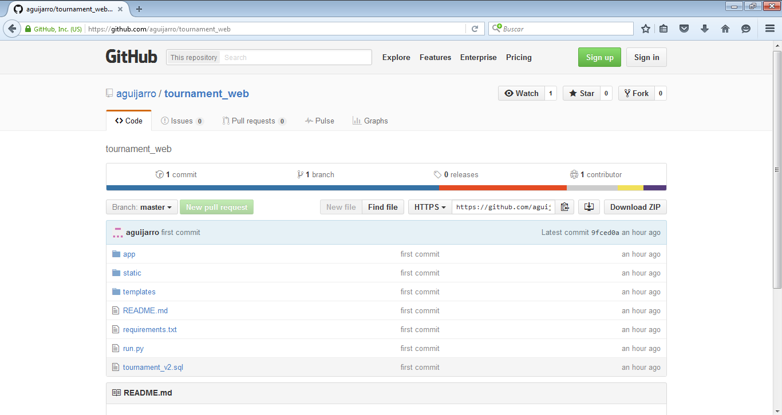

1. Unzip the project in a local location
2. Open a command line and then go to that location

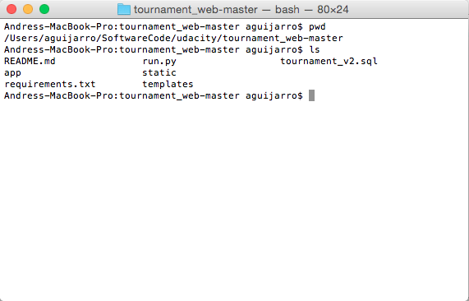

1. Create a virtualenv directory executing: ***virtualenv env***

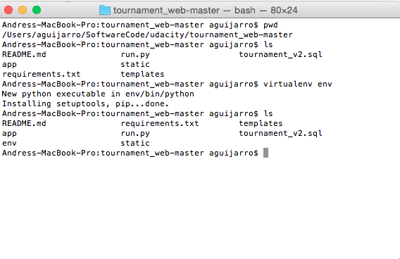

1. Activate script with: source env/bin/activate

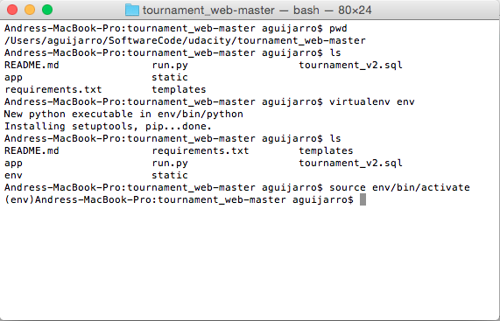

1. Install requirements: pip install -r requirements.txt

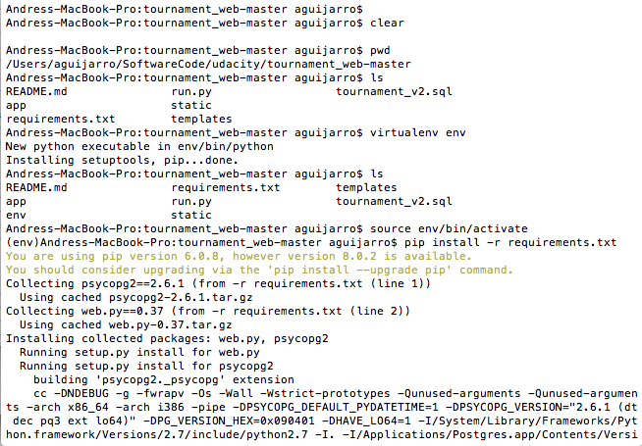

1. Execute psql command to call a psql command line

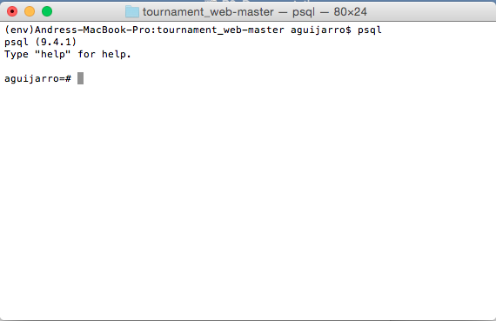

1. Execute \i tournament_v2.sql to create a database objects

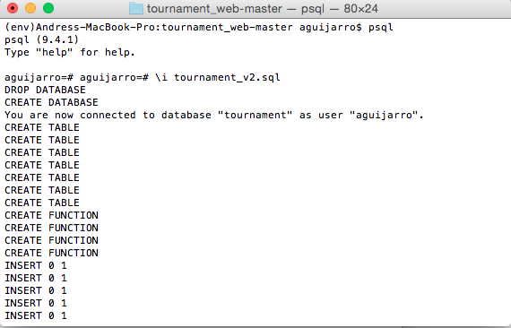

1. Run app: python run.py

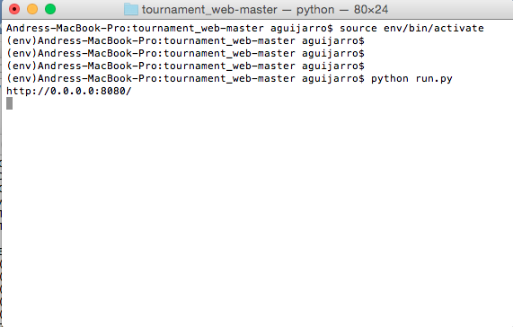

1. Go to browser: http://localhost:8080/

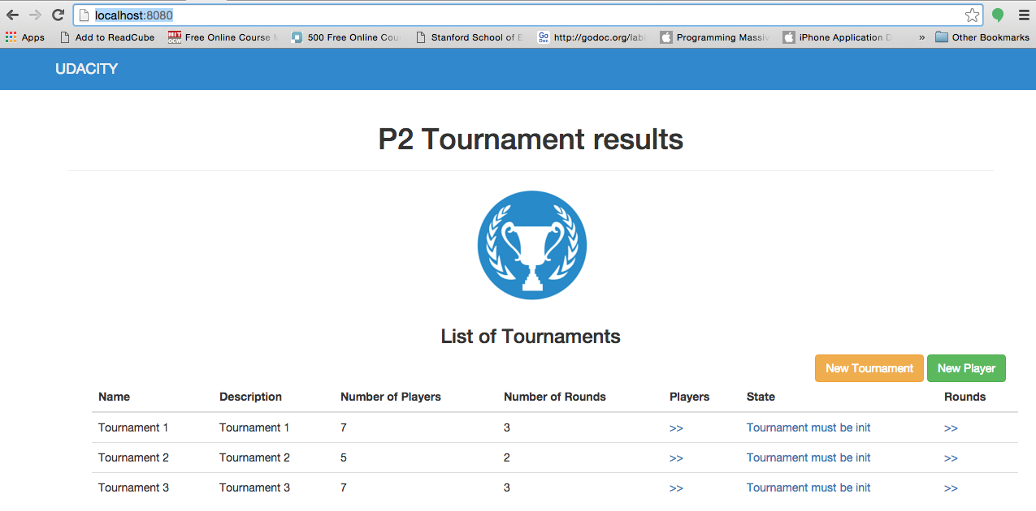

# User guide

## Create Tournament

* To create tournament, go to new Tournament, fill the required information and press process.

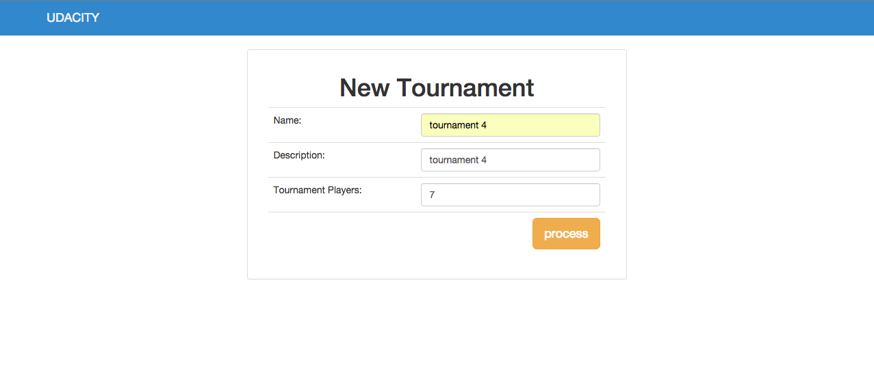

* The field Tournament Players contain the allowed number that a tournament will have.

## Create Player

* To create players, go to new Player, fill the required information and press save.

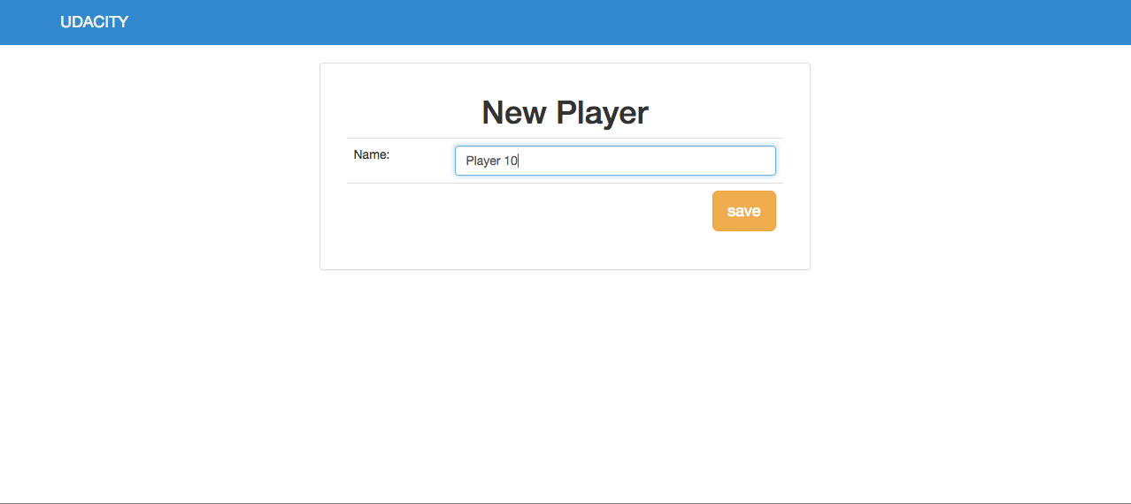

## Assign players to a tournament

* To assign players to a tournament, go to Players.

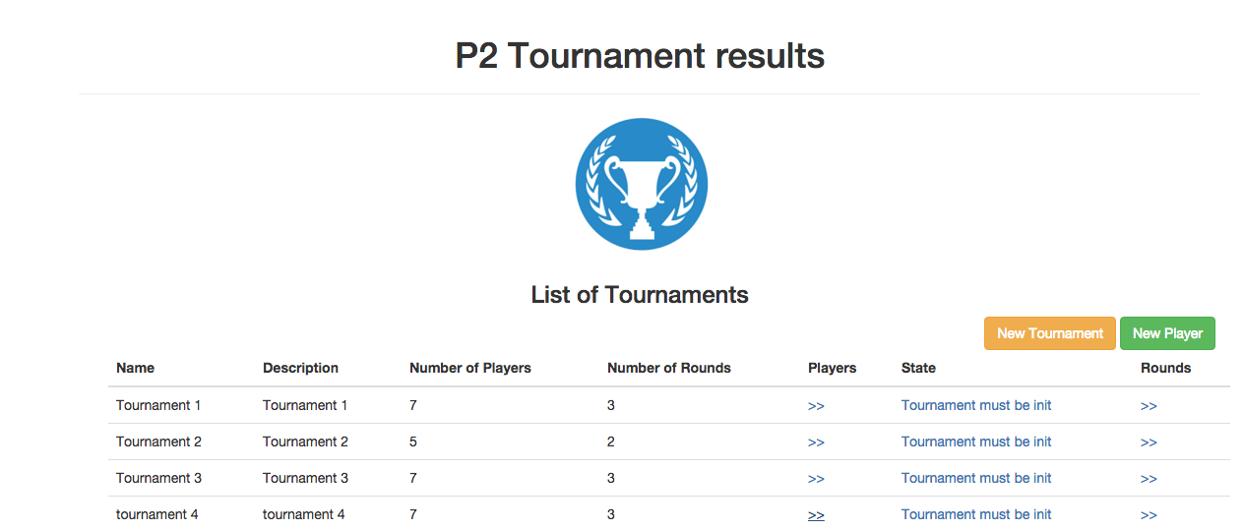

* Press Assign Players

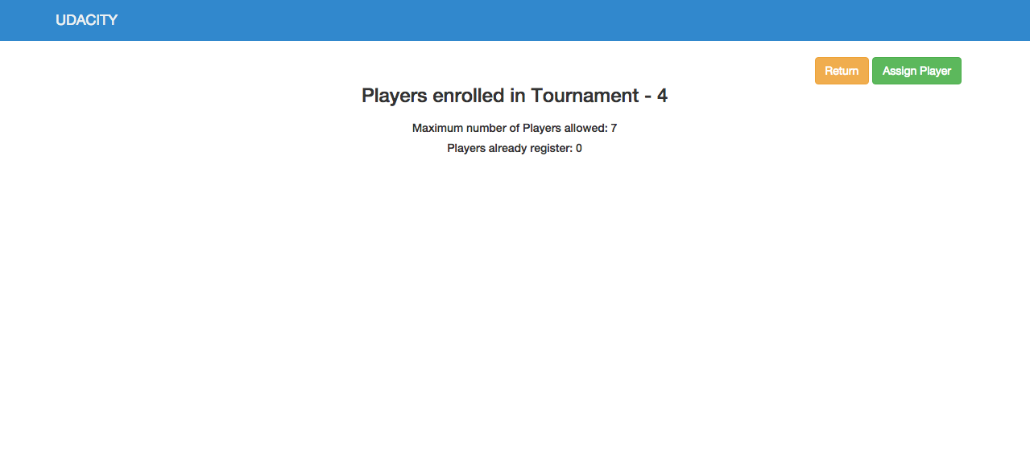

* Select the players that you will want to assign a tournament. You can select all players or one player each time. Press save.

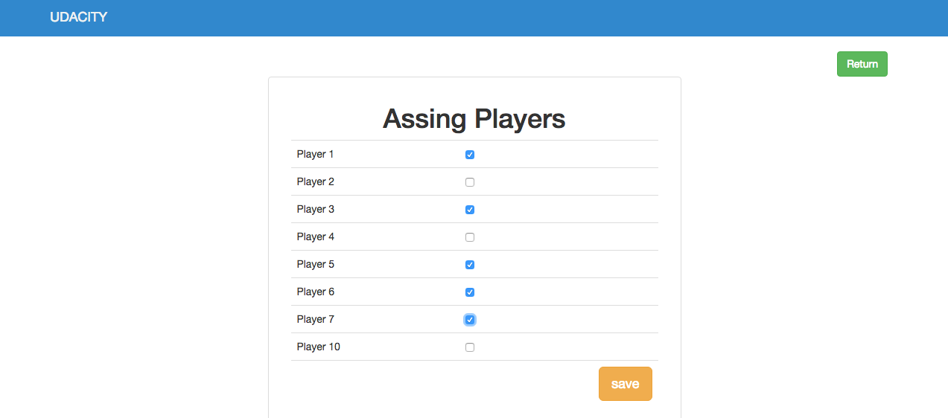

* Now you can see the players registered. It is important to select the number of players that the tournament allow, because the number of rounds depends of this number.

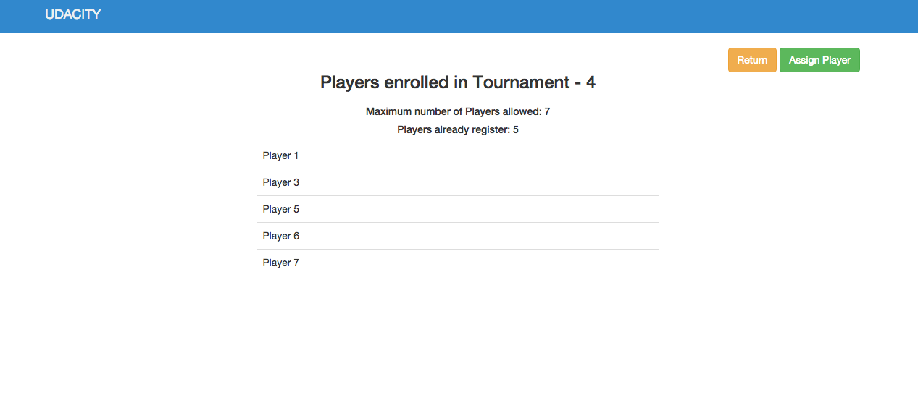

## Initializes tournament configuration

* Initialized a tournament clicking the link below the column state: Tournament must be started.

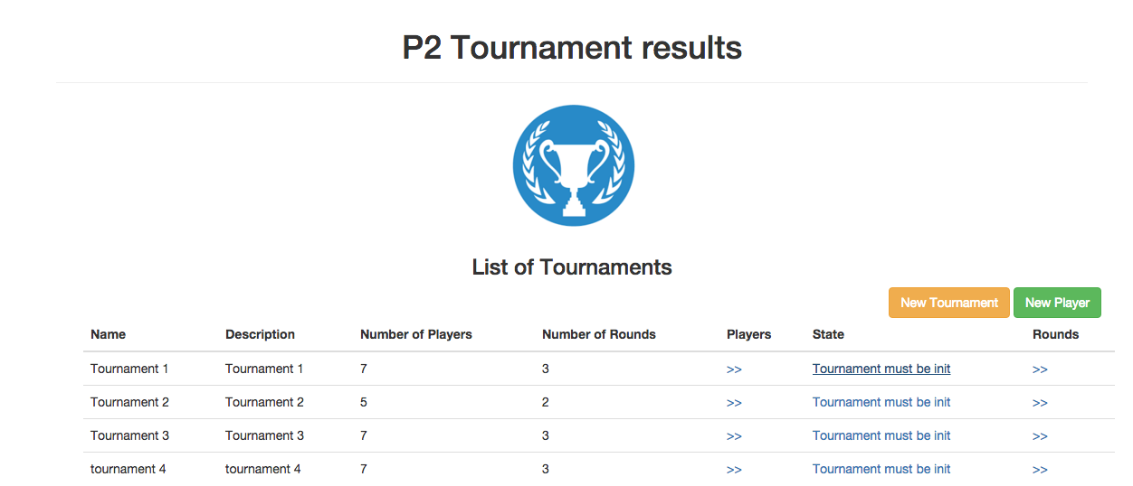

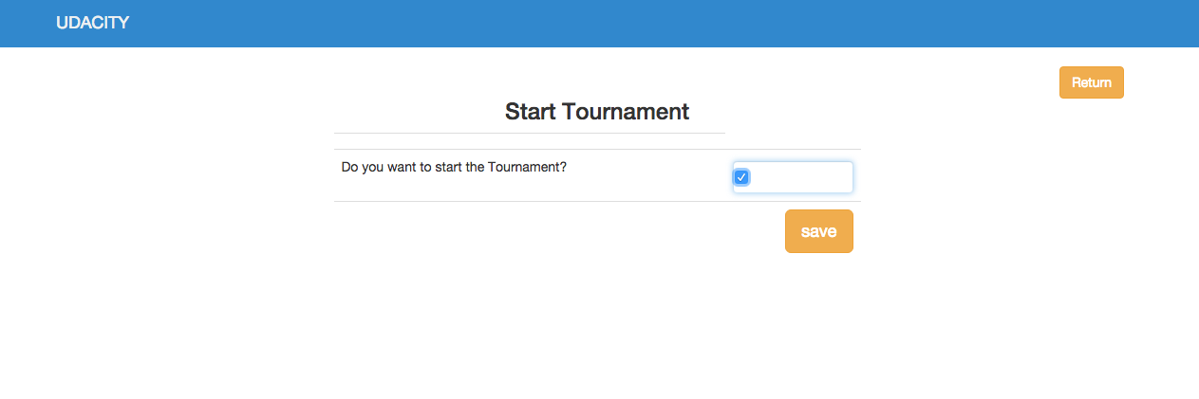

## Create rounds

## 

* After a tournament was initialized you can fill information about the rounds. Click Rounds. The formula to calculate the number of rounds is equal to: n = log(number of players)/log 2

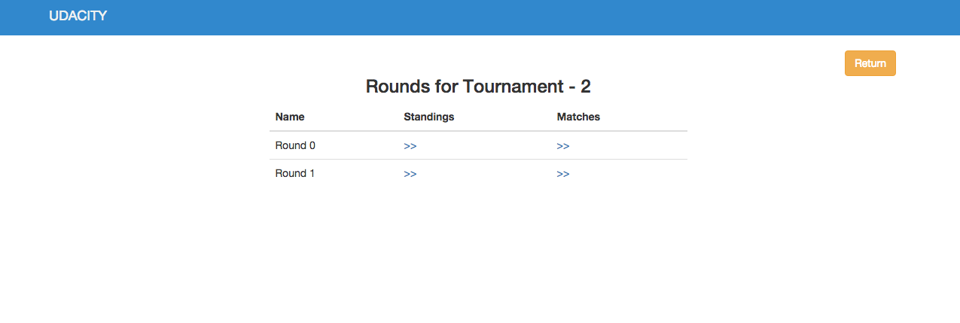

* Click standings to see results obtained until that moment. Press Return to go back to menu.

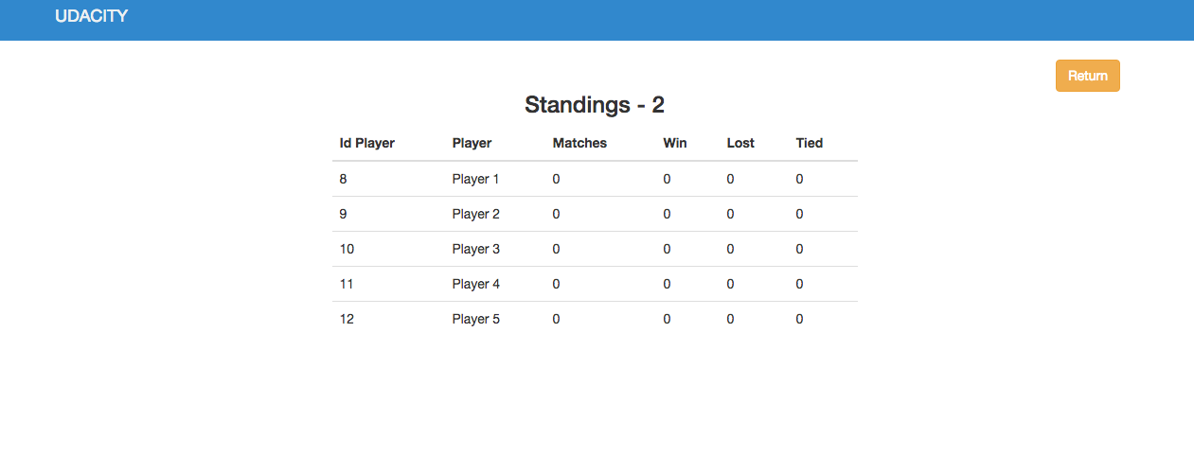

* Click Matches to generate matches depending the numbers of players. If there is an odd number of players, the app will be safe in a bye table.

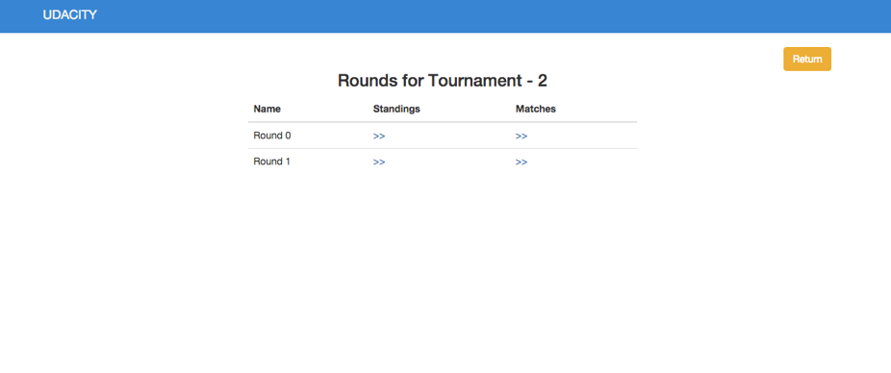

* Click New Match to make a Swiss Pairs and send a player to a bye when is an odd number of players

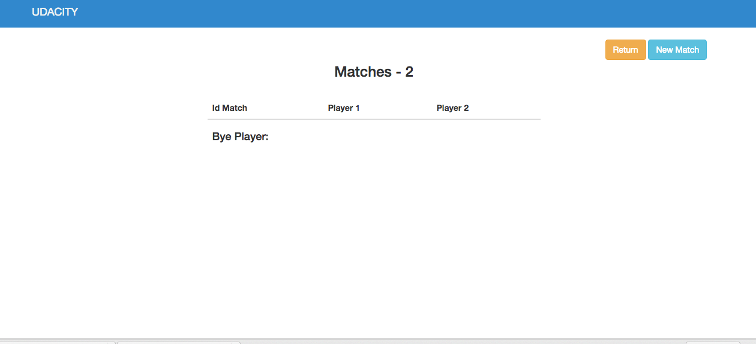

* Push save to generate a new match

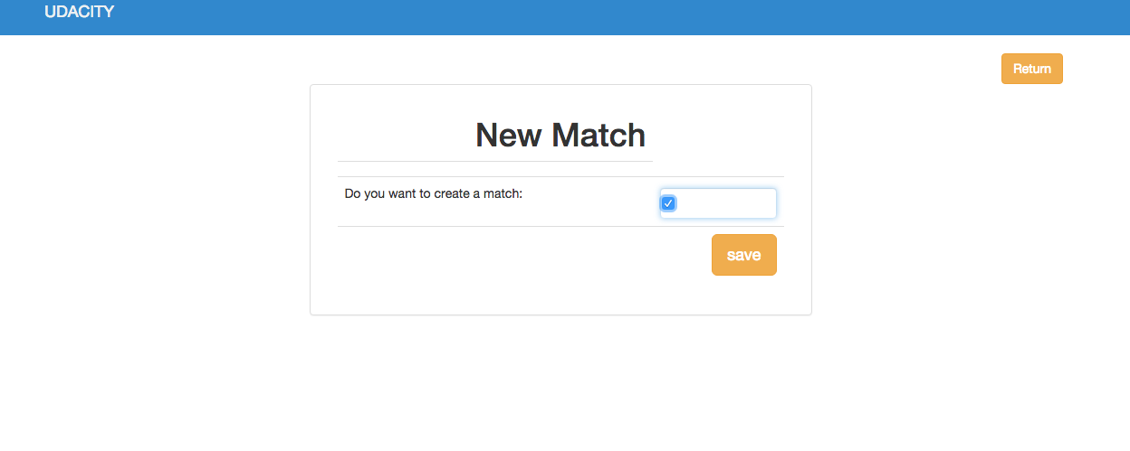

* See the generate matches.

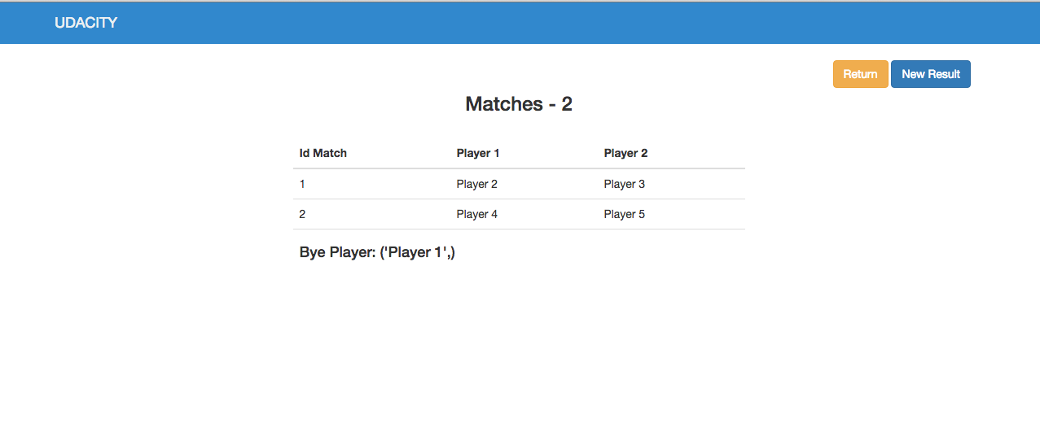

## Create results

* Click New Result. Select the results for each match. You can choose a winner or a tied.

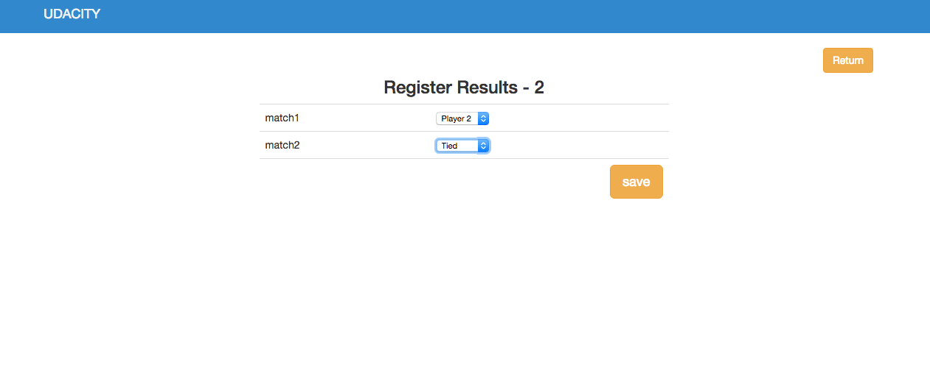

* Press return.

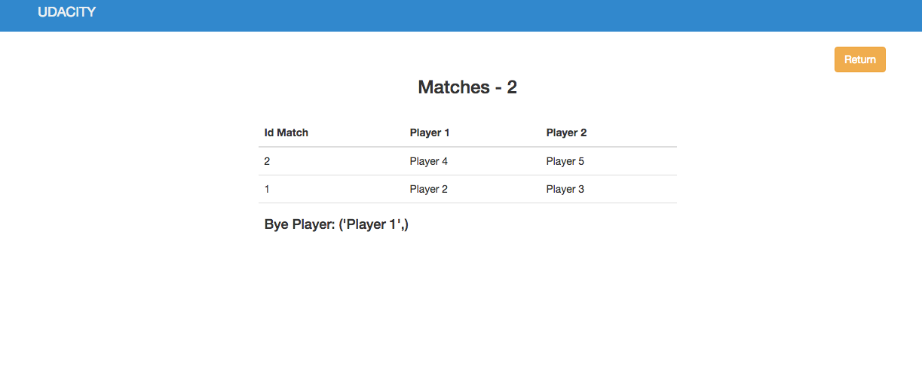

## Verify standings

* Push the link below to Standings



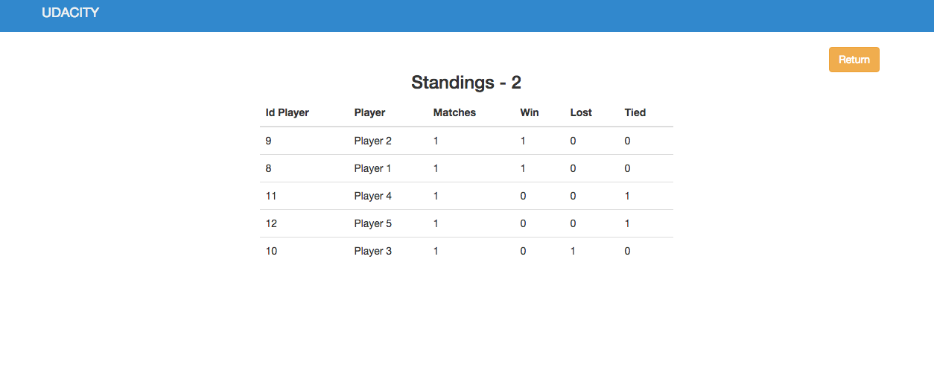

* Repeat the process for each round.

