

|  |
| --- |
| dicaAndroid19Febrero |
| 20/02/18 12:40 |
| **Author:** John Doe  **File name:** dicaAndroid19Febrero.vp  **Version** 1.0 |

|  |
| --- |
| Site Map |
|  |

|  |
| --- |
|  |

01. Site Map / dicaAndroid19Febrero 

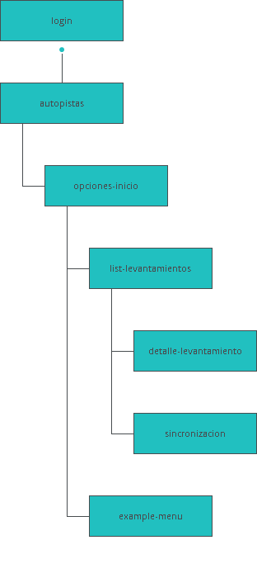

|  |
| --- |
| Screens |
|  |

|  |
| --- |
|  |

02. Screens / dicaAndroid19Febrero 

login

|  |
| --- |
|  |

02. Screens / dicaAndroid19Febrero 

autopistas

|  |
| --- |
|  |

Interactions

|  |  |
| --- | --- |
| 2 | **on Click:** goes to 'opciones-inicio' 🡪 |

02. Screens / dicaAndroid19Febrero 

example-menu

|  |
| --- |
|  |

Interactions

|  |  |
| --- | --- |
| 3 | **on Click:** goes to 'login' with effect: turn 🡪 |
| 4 | **on Click:** goes to 'example-menu' 🡪 |
| 5 | **on Click:** goes to 'list-levantamientos' 🡪 |
| 6 | **on Click:** goes to 'example-menu' 🡪 |
| 7 | **on Click:** goes to 'list-levantamientos' 🡪 |
| 8 | **on Click:** goes to 'list-levantamientos' 🡪 |
| 9 | **on Click:** goes to 'sincronizacion' with effect: pop 🡪 |
| 10 | **on Click:** goes to 'autopistas' with effect: slide left 🡪 |

02. Screens / example-menu 

Other states

|  |  |
| --- | --- |
|  |  |

02. Screens / dicaAndroid19Febrero 

list-levantamientos

|  |
| --- |
|  |

Interactions

|  |  |
| --- | --- |
| 11 | **on Click:** goes to 'login' with effect: turn 🡪 |
| 12 | **on Click:** goes to 'detalle-levantamiento' 🡪 |
| 13 | **on Click:** goes to 'detalle-levantamiento' 🡪 |
| 14 | **on Click:** goes to 'detalle-levantamiento' 🡪 |
| 15 | **on Click:** goes to 'detalle-levantamiento' 🡪 |
| 16 | **on Click:** goes to 'list-levantamientos' 🡪 |
| 17 | **on Click:** goes to 'example-menu' 🡪 |
| 18 | **on Click:** goes to 'list-levantamientos' with effect: pop 🡪 |
| 19 | **on Click:** goes to 'list-levantamientos' with effect: pop 🡪 |
| 20 | **on Click:** goes to 'sincronizacion' with effect: pop 🡪 |
| 21 | **on Click:** goes to 'autopistas' with effect: slide left 🡪 |

02. Screens / list-levantamientos 

Other states

|  |  |
| --- | --- |
|  |  |

02. Screens / dicaAndroid19Febrero 

opciones-inicio

|  |
| --- |
|  |

02. Screens / opciones-inicio 

Other states

|  |  |
| --- | --- |
|  |  |
|  | Interactions   |  |  | | --- | --- | | 22 | **on Click:** goes to 'list-levantamientos' with effect: slide and fade 🡪 | | 23 | **on Click:** goes to 'example-menu' with effect: slide right 🡪 | | 24 | **on Click:** goes to 'list-levantamientos' 🡪 | |

02. Screens / dicaAndroid19Febrero 

detalle-levantamiento

|  |
| --- |
|  |

Interactions

|  |  |
| --- | --- |
| 25 | **on Click:** goes to 'list-levantamientos' 🡪 |

02. Screens / dicaAndroid19Febrero 

sincronizacion

|  |
| --- |
|  |

02. Screens / sincronizacion 

Other states

|  |  |
| --- | --- |
|  |  |
|  | Interactions   |  |  | | --- | --- | | 26 | **on Click:** goes to 'list-levantamientos' with effect: slide left 🡪 | |

|  |
| --- |
| Templates |
|  |

|  |
| --- |
|  |

03. Templates / dicaAndroid19Febrero 

Template 1

|  |
| --- |
|  |

|  |
| --- |
| Scenarios |
|  |

|  |
| --- |
|  |

04. Scenarios / dicaAndroid19Febrero 

default

|  |
| --- |
|  |