**HOW TO PLAN YOUR NEW WEB/APP PROJECT**

1. **STRATEGY**

Building a website or app is a serious investment, and it can be all too easy to mistake features for strategy. It is very important to take several steps back and plan. Even if your organization has a good idea of what it wants its website to deliver, there is a high risk the initial website will not meet expectations without a comprehensive analysis.

A clear project scope specification is the key to project success as it clarifies the requirements of the most important stakeholder – the client and it will also help us to assess success of the project

You will be given a copy per group of the **Project Scope**. Together with your group go through the different points on the checklist and discuss it with your team. Once finished, you will have to give an oral report.

**2. STAKEHOLDERS**

After you have clearly articulated the goals and strategy of your website or app and created a vision statement, define all the people involved in the project. This includes the people who will help create and optimize your digital property as well as the people who will use it.

Who exactly are my stakeholders?

What do I want from each stakeholder?

**But who are the stakeholders?**

**Watch and listen to the following explanation:** [**https://youtu.be/rdOddxckmWQ**](https://youtu.be/rdOddxckmWQ)

There are many different ways people talk about stakeholders. Here you can find 2 and choose the one that suits you.

**Option 1**

**A STAKEHOLDER**  is a person, group or organization that has interest or concern in an organization. Stakeholders can affect or be affected by the organization's actions, objectives and policies. Some examples of key stakeholders are creditors, directors, employees, government (and its agencies), owners (shareholders), suppliers, unions, and the community from which the business draws its resources.

Let’s look at this perspective

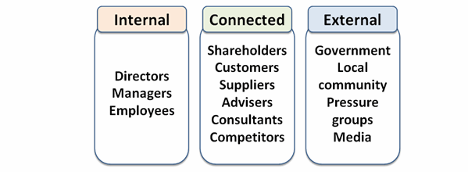

Option 2

When talking about an app or website we can say:

**Internal stakeholders** are the people who work for and with the company and are associated with the website's or app’s creation. Both your own staff and your partners fall into this category.

**External stakeholders** are outside users who will be engaging with the website.