Raul Aguilar

Professor Paulding

CS 220 2148

December 18, 2020

Final Exam – Programming Exercises

Push220

// Initialize SP to 20

@20

D = A

@SP

M = D

// Get 220

@220

D = A

// Set RAM[20] to 220

@SP

AM = M + 1 // Increment SP by 1

A = A - 1 // Go back to RAM[20]

M = D // RAM[20] = 220

// Infinite Loop

(END)

@END

0;JMP

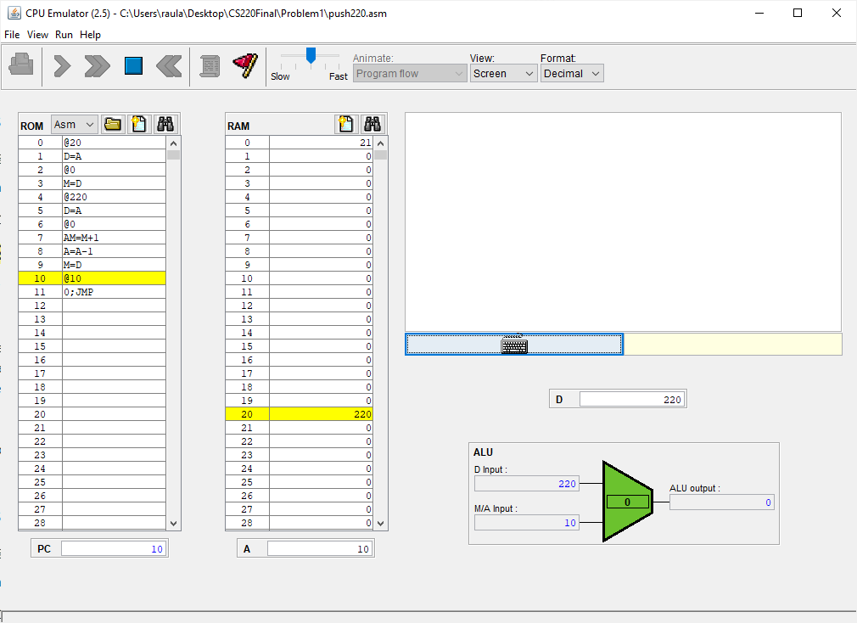

popLocal5

// Initialize SP to 20

@20

D = A

@SP

M = D

// Initialize LCL to 10

@10

D = A

@LCL

M = D

// Push 113 to stack

@113

D = A

// Set RAM[20] to 113

@SP

AM = M + 1 // Increment SP by 1

A = A - 1 // Go back to RAM[20]

M = D // RAM[20] = 113

// Pop 113 into local 5

@SP

AM = M - 1

D = M

@LCL

A = M + 1

A = A + 1

A = A + 1

A = A + 1

A = A + 1

M = D

// Infinite Loop

(END)

@END

0;JMP

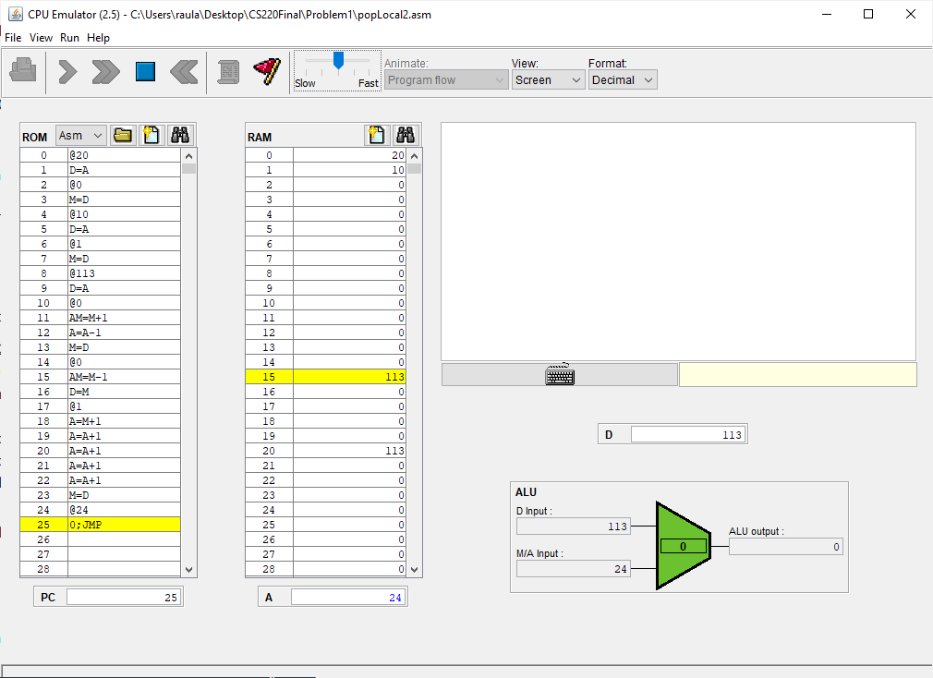

Add

// Initialize SP to 20

@20

D = A

@SP

M = D

// Push 113 to stack

@113

D = A

// Set RAM[20] to 113

@SP

AM = M + 1 // Increment SP by 1 == RAM[21]

A = A - 1 // Go back to RAM[20]

M = D // RAM[20] = 113

// Push 107 to stack

@107

D = A

@SP

AM = M + 1 // Increment SP by 1 == RAM[22]

A = A - 1 // Go back to RAM[21]

M = D // RAM[21] = 107

// Add 113 + 107

@SP // RAM[22]

AM = M - 1 // RAM[21]

D = M // RAM[21] Get 107

A = A - 1 // RAM[20]

M = M + D // RAM[20] + 107 == 113 + 107

// Infinite Loop

(END)

@END

0;JMP

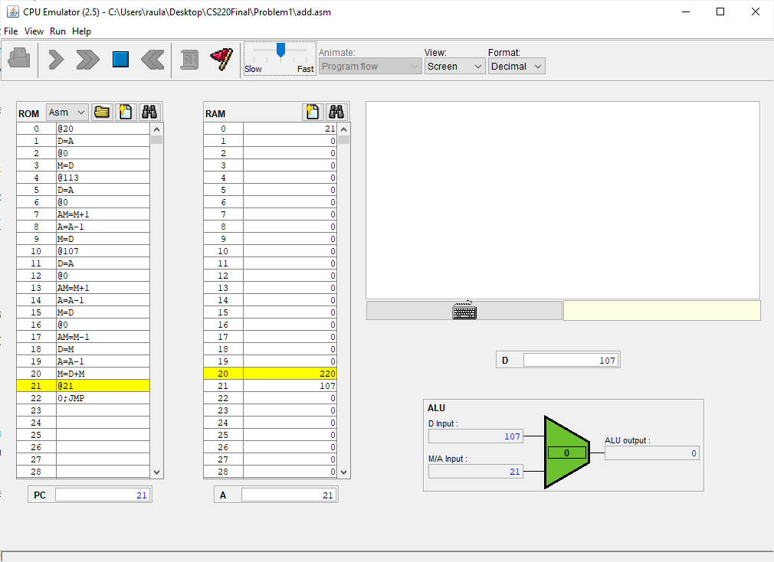

Eq

// Initialize SP to 20

@20

D = A

@SP

M = D

// Push 113 to stack

@113

D = A

@SP

AM = M + 1 // Increment SP by 1

A = A - 1 // Go back to RAM[20]

M = D // RAM[20] = 113

// Push 220 to stack

@220

D = A

@SP

AM = M + 1 // RAM[22]

A = A - 1 // Go back to RAM[21]

M = D // RAM[21] = 220

// Compare Equality

@SP // RAM[22]

AM = M - 1 // Decrement SP and move back 1

D = M // RAM[21] == 220

A = A - 1 // RAM[20]

D = D - M // D = 220 - 113

@true

D;JEQ // if 220 - 133 == 0 then jump to (true)

@else // else fall through

D = -1 // D = false

0;JMP

(true)

D = 0 // D = true

(else)

@SP // RAM[21]

A = M - 1 // RAM[20]

M = D // RAM[20] == false

// Infinite Loop

(END)

@END

0;JMP

